­­­­­

|  |  |
| --- | --- |
|  |  |



Solution Design

Document

Table of Contents

I. Purpose 3

II. Automated process details 4

3 Runtime guide 5

3.1 Architectural structure of the Master Project 5

3.2 Master Project Runtime Details 5

3.3 Project name 1 6

3.4 Project(s) workflows 6

3.5 Packages 7

3.6 Architectural structure of the Master Project 7

4 Other Details 8

Future Improvements 8

Other Remarks 8

5 Glossary 9

# Purpose



RPA Solution Documentation

Overview:

The RPA solution aims to automate the process of retrieving relevant salon ratings from the Stailer platform, comparing them with Google ratings, and generating an output Excel file. The key functionalities include:

1. Inbox Monitoring:

The robot monitors the Outlook inbox for unread emails with the subject "Rating Relevance on Stailer."

1. Input File Processing:

For each unread email, the robot downloads the attached Excel file containing location and service category data from the Stailer platform.

1. Salon Data Extraction:

The robot extracts location and service category information from the input file and identifies the top 10 salons offering the specified services in each location on the Stailer platform.

1. Rating Comparison:

For each identified salon, the robot retrieves the Stailer rating and searches for the salon on Google Maps to obtain the Google rating.

1. Output File Generation:

The output Excel file comprises a sheet for each pair of data (location + service category) from the input file.

Each sheet includes columns for Salon Name, Stailer Rating Grade, Google Rating Grade, and a column indicating whether the Stailer rating is relevant (YES/NO) based on a difference threshold of <0.4.

1. Google Drive Integration:

The output Excel file is optionally uploaded to Google Drive for convenient access and sharing.

Focus Areas:

1. Robustness:

Implement error handling to address variations in email content and attachment formats.

Ensure the solution can adapt to changes in the Stailer platform's data structure.

1. Scalability:

Design the solution to handle varying volumes of emails and data processing efficiently.

Consider optimizing processing time for large datasets.

1. Efficiency:

Optimize the data extraction and rating comparison algorithms for speed and resource utilization.

Explore caching mechanisms for repeated data retrieval tasks.

1. Reusability:

Encourage the development of reusable components or libraries for similar automation tasks.

Document guidelines for incorporating changes in service categories or adding new locations.

Target Audience:

This documentation is intended for developers involved in implementing, maintaining, and enhancing the RPA solution. It provides guidance on the solution's architecture, functionalities, and considerations for seamless execution.

# Automated process details

Details filled in need to reflect the actual information for the Master Project released for production. The following table will be populated:

|  |  |
| --- | --- |
| Item | Description |
| Master Project Name | Rating Relevance on Stailer |
| Robot Type | Mix |
| Orchestrator used? | Yes |
| Scalable | Yes |
| UiPath version used | UiPath Studio 2023.4.4 |

# Runtime guide

## Architectural structure of the Master Project

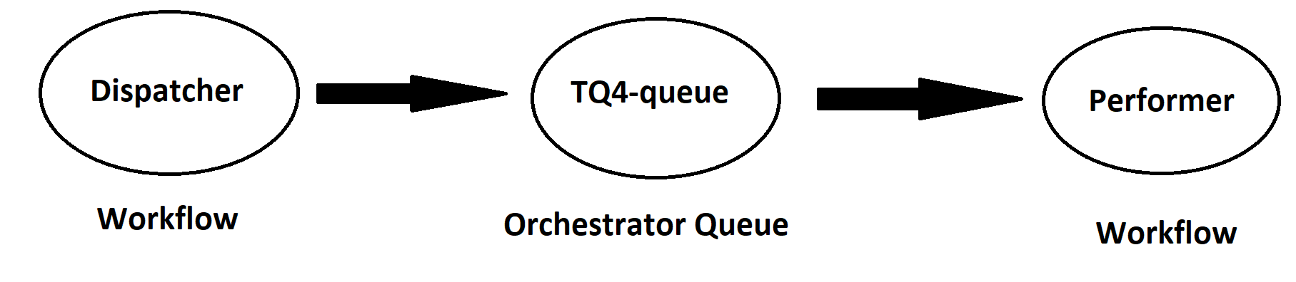

## Master Project Runtime Details

Outlines the details of the automated process by filling in the table below.

|  |  |
| --- | --- |
| ITEM NAME | DESCRIPTION |
| Production environment details | ***n/a*** |
| Prerequisites to run | *Unread received email on Outlook*  *Having Google Chrome on the machine*  *Having Excel on the machine* |
| Input Data | *One valid excel file InputFile.xlsx* |
| Expected output | *One Excel file uploaded on Drive* |
| How to start the automated process | *Manually* |
| Reporting  (queues reporting, Kibana or another platform) | *n/a.* |
| How is Orchestrator used? | ***n/a*** |
| Password policies  (mention any specific compliance requests) | *Outlook and Drive passwords* |
| Stored credentials  (Never use hardcoded credentials in the workflow!) | *n/a* |
| List of queues names  (Naming convention: ProcessName_QueueName) | *TQA4-queue* |
| Schedule Details | *n/a* |
| Multiple Resolutions Supported?  (in case of image automation / Citrix and VDI) | *No* |
| Recommended Resolution | *n/a* |

## Project name

|  |  |
| --- | --- |
| ITEM NAME | DESCRIPTION |
| Environment used for development  (name, location, configuration details etc) | *UiPath computer* |
| Environment prerequisites  (OS details, libraries, required apps) | *Windows 10, Studio license, Microsoft Excel* |
| Repository for project  (where is the developed project stored) | *https://github.com/davidalexandru1370/UniversityThirdYear/tree/main/RPA* |
| Configuration method  (assets, excel file, Json file) | *Excel file* |
| List of reused components | *n/a* |
|
| List of new reusable components | *n/a* |

## Project(s) workflows

Workflows specific to: Rating Relevance on Stailer

|  |  |
| --- | --- |
| Workflow Name | Description |
| Main | *Calling the other workflows* |
| Dispatcher | *Taking the input data from the Outlook mail and*  *Adding it to the queue* |
| Performer | *Taking the data from the queue and performing the searches*  *On Stailer and Google and creating the output Excel file and*  *Uploading it to Drive* |

# Other Details

### Future Improvements

*• Implement process error recovery (retry)*

*• Enable support for multiple template files*

*Enable use of multiple search engines and browsers*

*Handle more business exceptions*

*Modify the output file as a CSV file*

# Glossary

The main terms used in the Solution Architecture Document are defined below:

**Master project** - the overall output of the development, containing one or multiple projects that together cover the scope of the robotic process automation. There is a 1 to 1 connection between the Master Project and the Process to be automated (As presented in the PDD).

**Project** - an UiPath Studio project containing one or multiple workflow files. A project can be converted to a package and run independently, covering a particular scope within the master project. Or multiple projects can be converted into one package depending on the aims and restrictions of the automation. The project is used when defining the development and support phase of the automation.

**Package** - the output of compiling one or multiple projects. A package can be deployed on the robot machine and be executed by the robot service. Only one package can be executed at a given time by a robot. The package is used when defining the running phase of the automation.

Workflow - a component of the package, the workflow encapsulates a part of the project logic. The workflow can be of type: sequence, flowchart or state machine. A workflow is saved as an .xaml file inside the project folder. A workflow file can be invoked from another workflow and by default there is an initial workflow file that will run when executing the package.

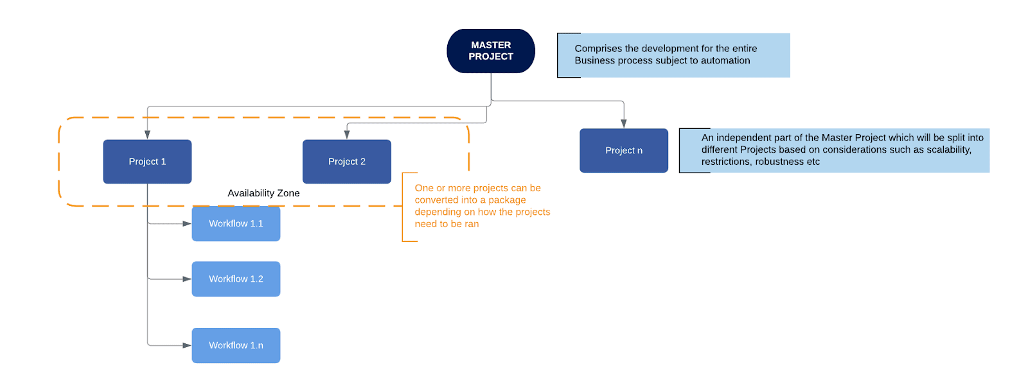

**Activity** - an action that the robot executes.

**Sequence** - a workflow where activities are executed one after another, in a sequential order

**Flowchart** - a workflow where activities are connected by arrows and the logic of the workflow can be easily followed in a visual manner. The flowchart can also be exported as an image from UiPath studio.

**State machine** - a more advanced way of organizing a workflow, similar to a flowchart.

**BOR** - Back office robot

**FOR** – Front office robot

**Orchestrator** – Enterprise architecture server platform supporting: release management, centralized logging, reporting, auditing and monitoring tools, remote control, centralized scheduling, queue/robot workload management, assets management.