Sali Arnold – Reitler Alex – Pop David Alexandru - 936

**Pynguin: Automated Unit Test Generation for Python**

**doi: 10.1145/3510454.3516829**

**Stephan Lukasczyk - Gordon Fraser**

Pynguin is a tool for Python to generate unit tests for a method. Before starting to use Pynguin we must have a CLI such as WSL or PowerShell, a python interpreter installed and a python package manager, in this example we will use Pip. To start with Pynguin we go to the main [website](https://pynguin.readthedocs.io/en/latest/) and get the install command using Pip, *pip install* *pynguin*. This is the easiest way to start with this package. After this, we will create a new Python project and define a simple method in this package. In this example we will create a method for triangle to check its sides and return the type of the triangle (isosceles, equilateral, scalene).

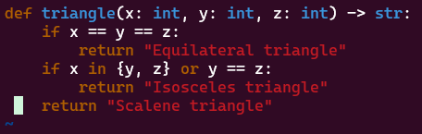

*Figure 1. Triangle method*

After we define the above method, we will open the terminal, change the path to our project and type the following command *pynguin –-project-path . --output-path . --module-name main -v*. This command will take the method from the main program and create the tests for this method. The new file created is call *test_main.py*, here are the tests created.

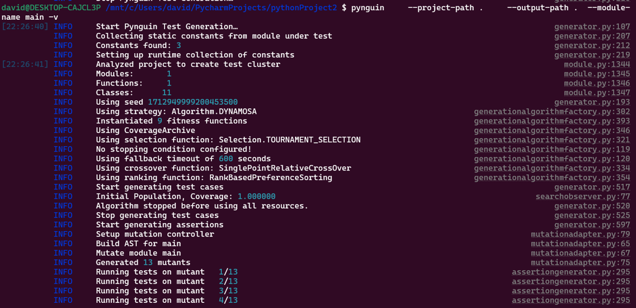

*Figure 2. The output of pynguin command*

To check the results of tests we can check and run the file *test_main.py*.

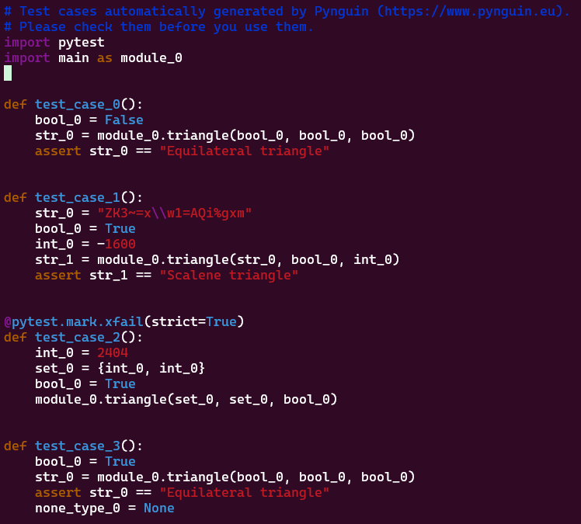

*Figure 3. Tests generated*