Bayesian Perception

Use the functions:

drawproj(theta,spin)

theta: Original angle

spin: angle of the physical stimulus (between 0 and 90)

spin

bayesper(obs,prior)
obs: observed angle phi

prior: shape of the prior distribution
1: uniform from 0 to 180
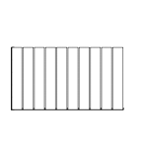
2: Gaussian bounded by 0 and 180, mean 90, sd 30
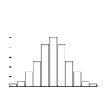
3: Gaussian bounded by 0 and 180, mean 90, sd 10
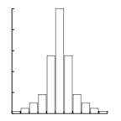

4: U shaped
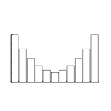

The drawproj() function will draw a graph with the stimulus (thin lines) and the view of the observer (thick lines).

- Play with drawproj function, and write down your observations (about one paragraph).

The bayesper() function will generate a histogram of the likelihood function given an observed angle.

- Try reproducing Figures 1.3 and 1.5 (the numbers in the y axis might change but the shape of the histogram should be roughly the same). What parameters did you use?
- What happens if the observed angle (phi) is say, about 10 degrees? What do you predict? What should be the highest value in the likelihood function? Run the code, and compare your predictions with the results. Explain any disagreement between you prediction and your results.
- Run simulations using different combinations of observed angle and prior. Write down the results.
- Can you think of any situation in which a Bayesian model of perception could be used?

