A.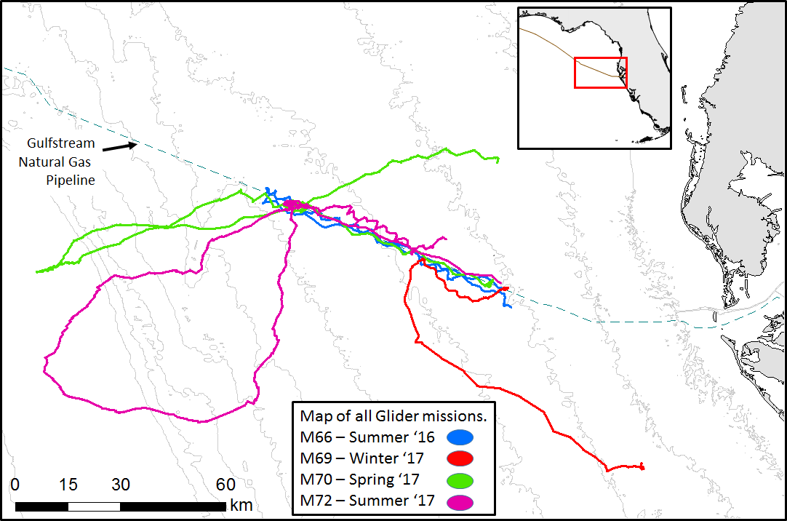**B.**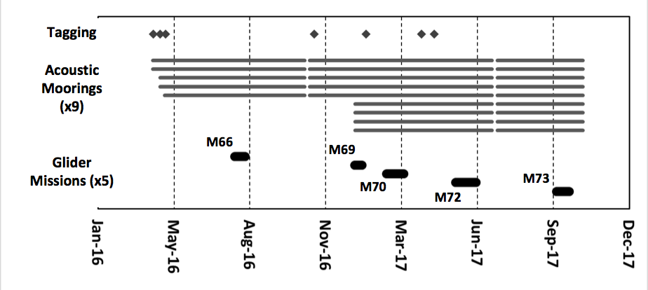

Figure 1. A. Tracklines of all glider missions relative to the pipeline. B.Timeline of fish tagging activities, deployments and recoveries of the acoustic moorings, and glider deployments. Breaks in the mooring data sets are exaggerated for clarity, actual time with mooring out of the water was less than an hour per mooring.

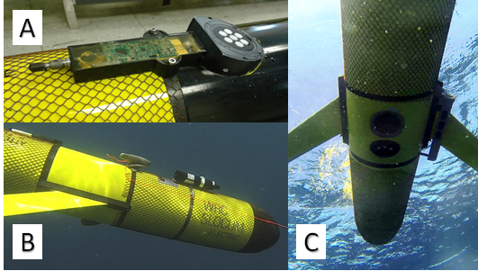

Figure 2. Slocum glider equipped with the following acoustic technologies: A. an externally mounted passive acoustic recorder B. tag telemetry receiver. C. water-column biomass echosounder.

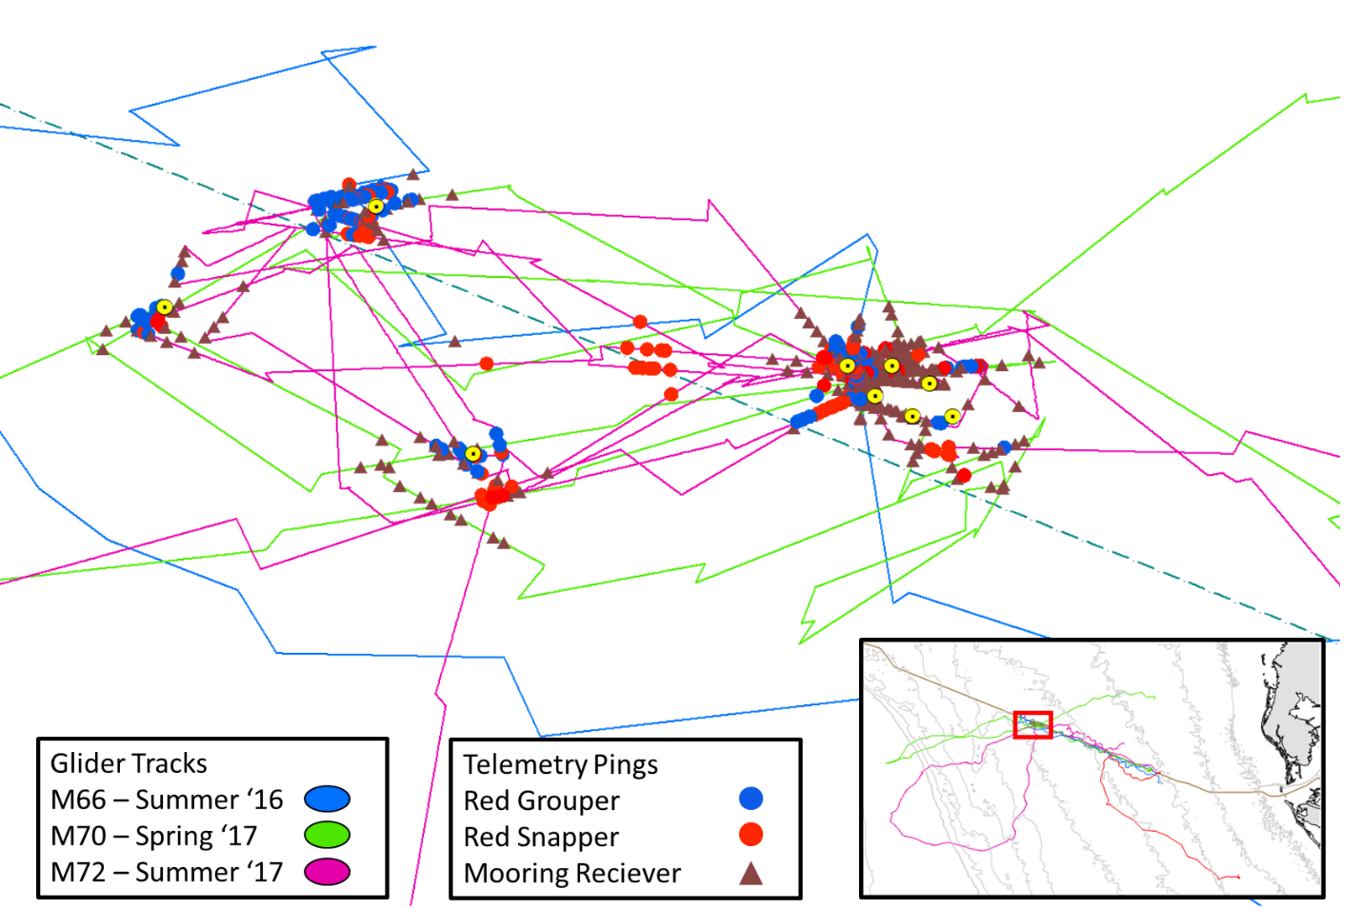

Figure 3. Detection of red grouper (blue circles), red snapper (red circles), and moored receiver pings (brown triangles, receivers represented by yellow circles) by glider-mounted telemetry receiver at the sites along the pipeline where fish were tagged.

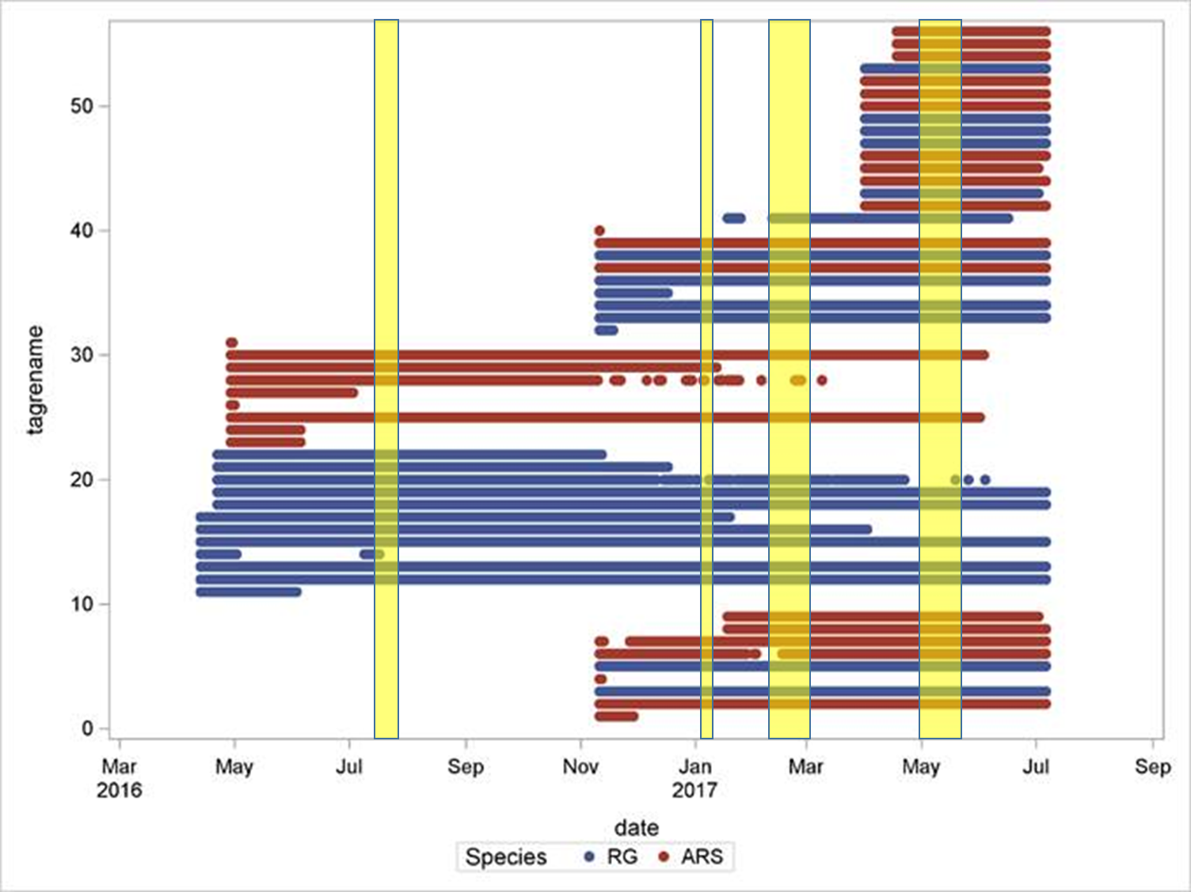

Figure 4: Detections of tagged Red Grouper (blue) and Red Snapper (red) by any of the moorings over the duration of the effort. Yellow overlay represents times glider was deployed

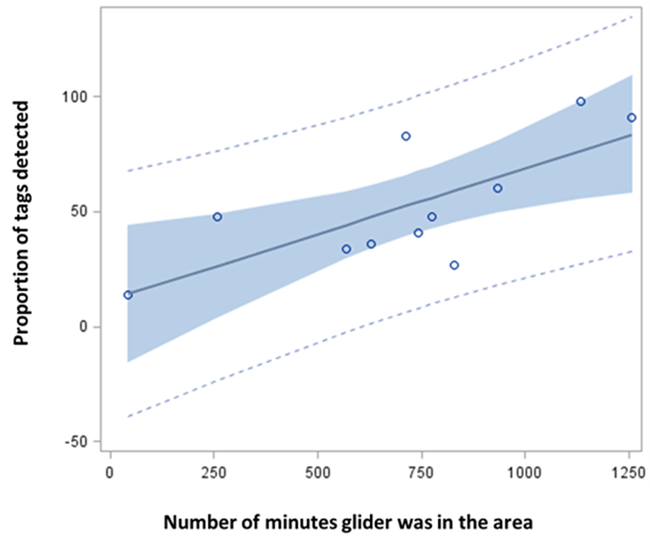

Figure 5: Comparison of fixed receiver and glider-mounted receiver for fish detections.

The glider consistently detected fewer receivers and fish than the moored receivers, but performance improved with piloting the glider to loiter in the tagging region for longer periods of time.

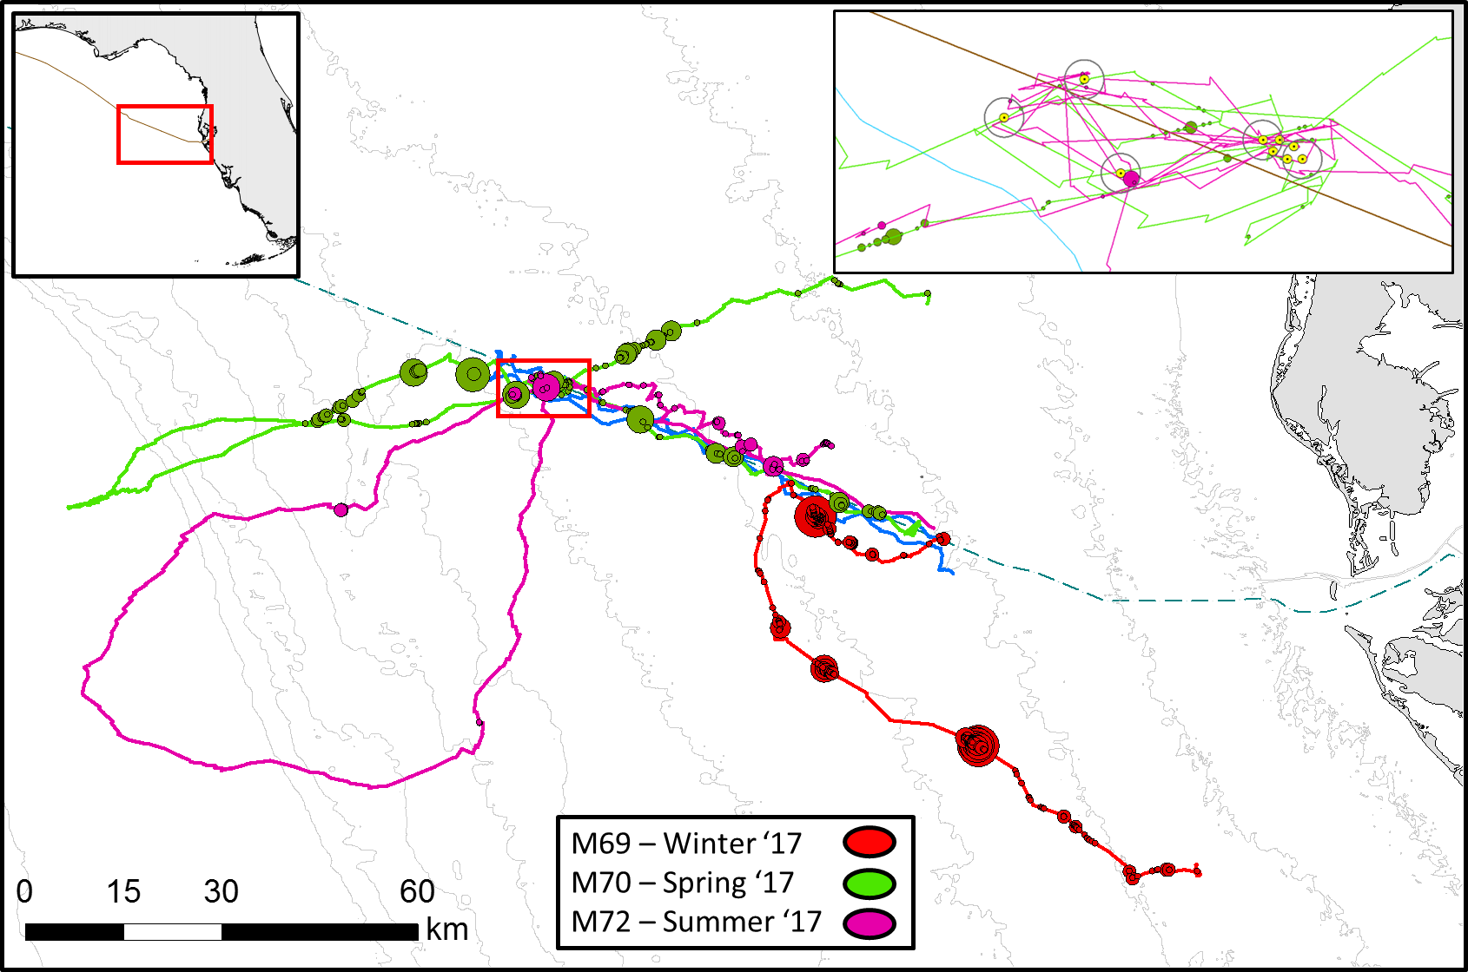

Figure 6. Passive acoustic monitoring results from glider. All missions for entire tracks and area corresponding to location where fish were tagged for telemetry (inset), larger bubbles indicate more grouper calls recorded.

1. 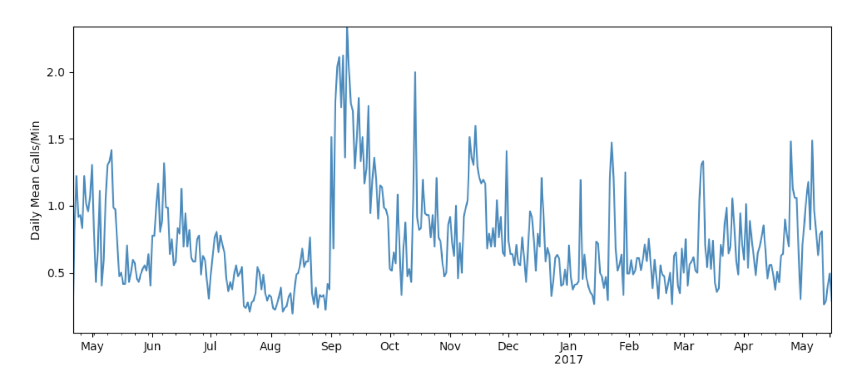
2. 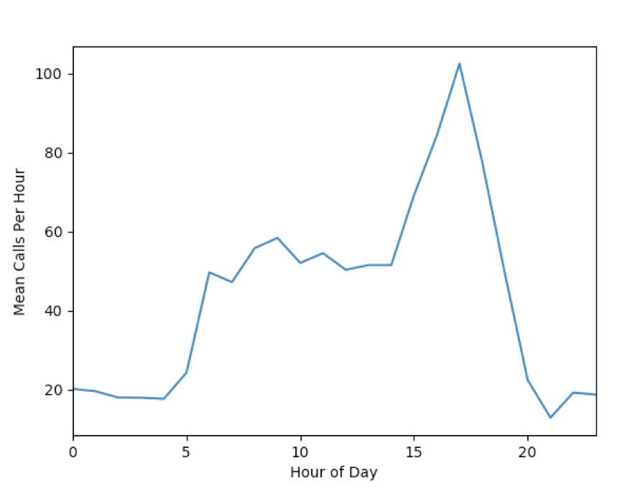

Figure 7. Variability in red grouper sound production at a fixed receiver located along the pipeline. A. Time series of calls per hour at one location. B. Mean daily calls per hour shows that calls are most commonly produced at dusk (Eastern Time).

1. 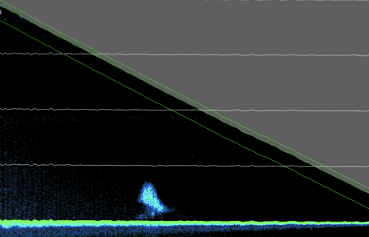
2. 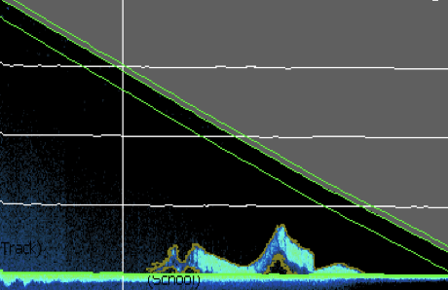

Figure 8. Example echograms shown fish schools close to the seafloor along a glider dive. Part B shows faint background noise from glider mechanical or electrical systems.

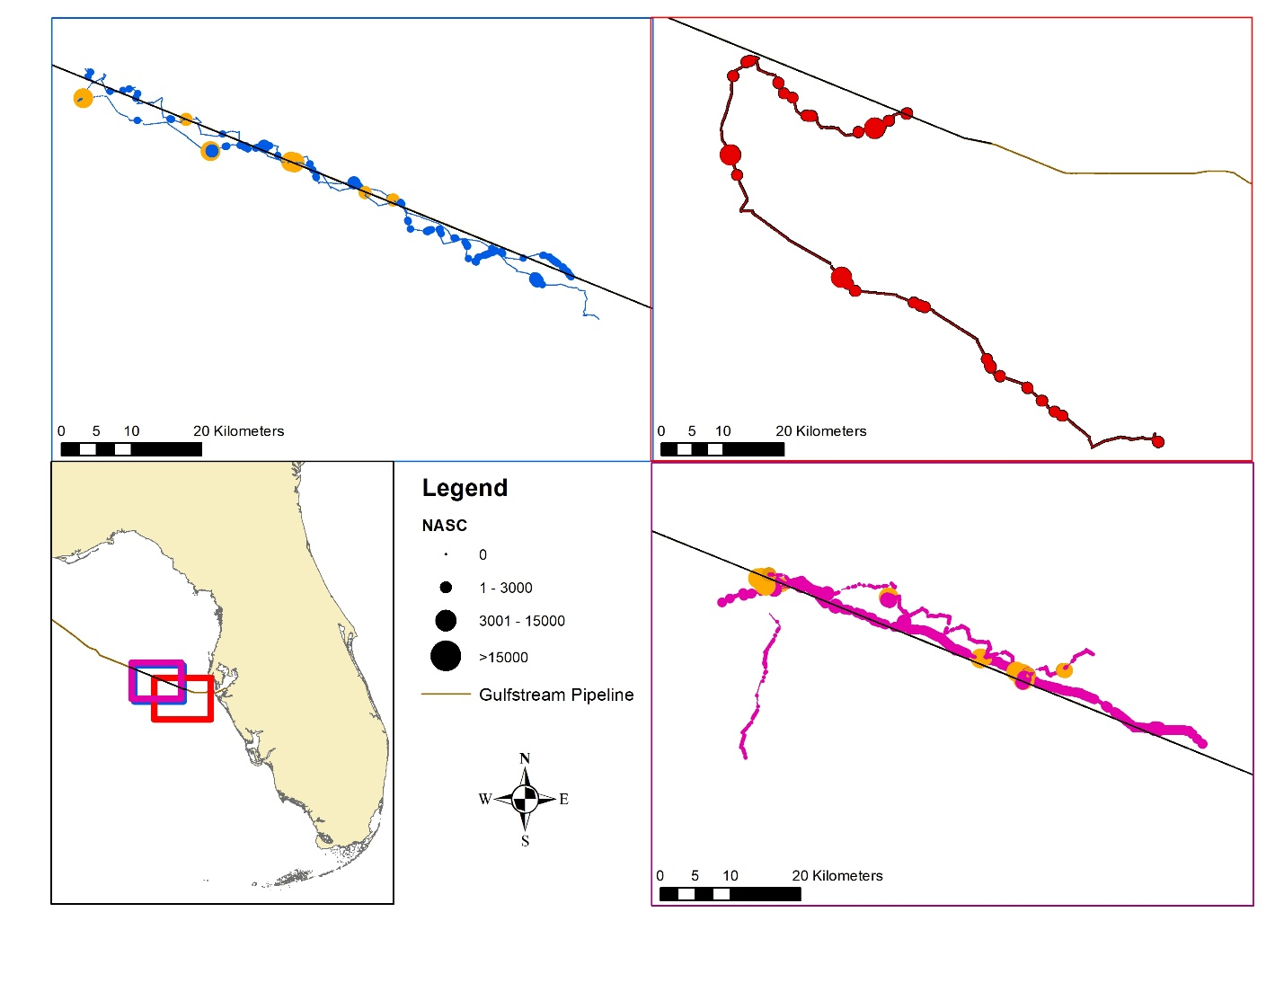

Figure 9. Acoustic density values along path of glider. Mission 66 (upper left). Mission 69 (upper right), and Mission 72 (lower right). Insets in map show location of bounding boxes for each mission. Acoustic density (in NASC) are represented by dots of varying size proportional to the NASC value at each interval. Significant hotspots of high density are colored orange-red. Absence of detected fish or fish school are shown as small black dots.