Use this form to tell us important information about this document, then start the text on the following page. All information you give in this form will appear in the document.

Document Information
Document Title | Created (YYYY-MM-DD) | Updated (YYYY-MM-DD) | Revised (YYYY-MM-DD)  (GeneReviews Project) | Label | Indicate “chapter” or “appendix” | Alternate Form (pdf)
Semantic Network |  |  |  | 5 | Chapter | Pdf

Author Information
Given Name(s) | Last Name | Suffix | Degrees | Affiliation | Email | Corr. Au. ?  (Yes) | Au. Footnote

Use one row for each author. List authors in order of appearance in the document. Add rows to add more authors.

Semantic Network
The Semantic Network consists of (1) a set of broad subject categories, or Semantic Types, that provide a consistent categorization of all concepts represented in the UMLS Metathesaurus, and (2) a set of useful and important relationships, or Semantic Relations, that exist between Semantic Types. This section of the documentation provides an overview of the Semantic Network, and describes the files of the Semantic Network. Sample records illustrate structure and content of these files.
The Semantic Network is distributed as one of the UMLS Knowledge Sources and as an open source resource available on the Semantic Network Web site, subject to these terms and conditions.

5.1 Overview
The purpose of the Semantic Network is to provide a consistent categorization of all concepts represented in the UMLS Metathesaurus and to provide a set of useful relationships between these concepts. All information about specific concepts is found in the Metathesaurus. The Network provides information about the set of basic semantic types, or categories, which may be assigned to these concepts, and it defines the set of relationships that may hold between the semantic types. The Semantic Network contains 135 semantic types and 54 relationships. The Semantic Network serves as an authority for the semantic types that are assigned to concepts in the Metathesaurus. The Network defines these types, both with textual descriptions and by means of the information inherent in its hierarchies.
The semantic types are the nodes in the Network, and the relationships between them are the links. There are major groupings of semantic types for organisms, anatomical structures, biologic function, chemicals, events, physical objects, and concepts or ideas. The current scope of the UMLS semantic types is quite broad, allowing for the semantic categorization of a wide range of terminology in multiple domains.
The Metathesaurus consists of terms from its source vocabularies. The meaning of each term is defined by its source, explicitly by definition or annotation; by context (its place in a hierarchy); by synonyms and other stated relationships between terms; and by its usage in description, classification, or indexing. Each Metathesaurus concept is assigned at least one semantic type. In all cases, the most specific semantic type available in the hierarchy is assigned to the concept. For example, the concept "Macaca" receives the semantic type "Mammal" because there is not a more specific type "Primate" available in the Network. The level of granularity varies across the Network. This has important implications for interpreting the meaning (i.e., semantic type) that has been assigned to a Metathesaurus concept. For example, a sub-tree under the node "Physical Object" is "Manufactured Object". It has only two child nodes, "Medical Device" and "Research Device". It is clear that there are manufactured objects other than medical devices and research devices. Rather than proliferate the number of semantic types to encompass multiple additional subcategories for these objects, concepts that are neither medical devices nor research devices are simply assigned the more general semantic type "Manufactured Object".
Figure 1 illustrates a portion of the Network. The semantic type "Biologic Function" has two children, "Physiologic Function" and "Pathologic Function", and each of these in turn has several children and grandchildren. Each child in the hierarchy is linked to its parent by the "isa" link.
The primary link in the Network is the "isa" link. This establishes the hierarchy of types within the Network and is used for deciding on the most specific semantic type available for assignment to a Metathesaurus concept. In addition, a set of non-hierarchical relations between the types has been identified. These are grouped into five major categories, which are themselves relations: "physically related to", "spatially related to", "temporally related to", "functionally related to", and "conceptually related to".
Figure 2 illustrates a portion of the hierarchy for Network relationships. The "affects" relationship, one of several functional relationships, has six children, including "manages", "treats", and "prevents".
The relations are stated between high level semantic types in the Network whenever possible and are generally inherited via the "isa" link by all the children of those types. Thus, for example, the relation "process of" is stated to hold between the semantic types "Biologic Function" and "Organism". Therefore, it also holds between "Organ or Tissue Function" (which is a "Physiologic Function", which is, in turn, a "Biologic Function") and "Animal" (which is an "Organism"). The relations are stated between semantic types and do not necessarily apply to all instances of concepts that have been assigned to those semantic types. That is, the relation may or may not hold between any particular pair of concepts. So, though the relation "evaluation of" holds between the semantic types "Sign" and "Organism Attribute", a particular sign or a particular attribute may not be linked by this relation. Thus, signs such as "overweight" and "fever" are evaluations of the organism attributes "body weight" and "body temperature", respectively. However, "overweight" is not an evaluation of "body temperature", and "fever" is not an evaluation of "body weight".
In some cases there will be a conflict between the placement of types in the Network and the link to be inherited. If so, the inheritance of the link is said to be blocked. For example, by inheritance, the type "Mental Process" would be "process of" "Plant". Since plants are not sentient beings, this link is explicitly blocked. In other cases the nature of the relation is such that it should not be inherited by the children of the types that it links. In that case, the relation is defined for the two semantic types it explicitly links, but blocked for all the children of those types. For example, "conceptual part of" links "Body System" and "Fully Formed Anatomical Structure", but it should not link "Body System" to all the children of "Fully Formed Anatomical Structure", such as "Cell" or "Tissue".
Several portions of the MeSH hierarchy have been labeled with child to parent semantic relationships. All of the anatomy, diseases, and psychiatry and psychology sections have been labeled, as well as a portion of the biological sciences section. The links that are expressed between MeSH terms are, with a few exceptions, reflected in the Semantic Network. That is, if two MeSH terms are linked by a certain relation, then that link is expressed in the Network as a link between the semantic types that have been assigned to those MeSH terms. For example, "Amniotic Fluid", which is a "Body Substance", is a child of "Embryo", which is an "Embryonic Structure". The labeled relationship between "Amniotic Fluid" and its parent "Embryo" is "surrounds". This is allowable, since the relation "Body Substance surrounds Embryonic Structure" is represented in the Network.
Figure 3 shows a portion of the Semantic Network, illustrating the relations, either hierarchical or associative, that exist between semantic types.
The UMLS Semantic Network is provided in two formats: a relational table format and a unit record format.

5.2 Semantic Network ASCII Relational Format
There are two basic tables, two ancillary tables, and two bookkeeping tables included in this format. The two basic tables contain exactly the same information as the unit record file, but the information is presented differently. One table contains definitional information about the semantic types and relations; the other contains information about the structure of the Network. Each semantic type and each relation has been assigned a four character unique identifier (UI). These are of the form "T001", "T002", etc. The ancillary tables are expansions of the table that contains the Network structure. They give the fully inherited set of links represented in the Network. The first table is expressed as triples of UI's. The second is expressed as triples of names. The two bookkeeping tables describe the relational files and their fields. Fields in all tables are separated by a "|". All tables are listed and described below:
Table | Description
SRDEF | Basic information about the Semantic Types and Relations.
SRSTR | Structure of the Network.
SRSTRE1 | Fully inherited set of Relations (UI's).
SRSTRE2 | Fully inherited set of Relations (names).
SRFIL | Description of each table.
SRFLD | Description of each field and the table(s) in which it is found.

Specific Descriptions of each Table:
Table: SRDEF
Field | Description
RT: | Record Type (STY = Semantic Type or RL = Relation).
UI: | Unique Identifier of the Semantic Type or Relation.
STY/RL: | Name of the Semantic Type or Relation.
STN/RTN: | Tree Number of the Semantic Type or Relation.
DEF: | Definition of the Semantic Type or Relation.
EX: | Examples of Metathesaurus concepts with this Semantic Type (STY records only).
UN: | Usage note for Semantic Type assignment (STY records only).
NH: | The Semantic Type and its descendants allow the non-human flag (STY records only).
ABR: | Abbreviation of the Relation Name or Semantic Type.
RIN: | Inverse of the Relation (RL records only).

Table: SRSTR
Field | Description
STY/RL: | Argument 1 (Name of a Semantic Type or Relation).
RL: | Relation ("isa" or the name of a non-hierarchical Relation).
STY/RL: | Argument 2 (Name of a Semantic Type or Relation); if this field is blank this means that the Semantic Type or Relation is one of the top nodes of the Network.
LS: | Link Status (D = Defined for the Arguments and its children; B = Blocked; DNI = Defined but Not Inherited by the children of the Arguments).  N.B.: The relations expressed in this table are binary relations and the arguments are ordered pairs. The relations are stated only for the top-most node of the "isa" hierarchy of the Semantic Types to which they may apply.

Table: SRSTRE1 or SRSTRE2
Field | Description
UI/STY: | Argument 1 (UI or name of a Semantic Type).
UI/RL: | Relation (UI or name of a nonhierarchical Relation).
UI/STY: | Argument 2 (UI or name of a Semantic Type).  N.B.: The relations expressed in this table are binary relations and the arguments are ordered pairs. All relations have been fully inherited in this table.

Table: SRFIL
Field | Description
FIL: | File Name.
DES: | Description of the file.
FMT: | Format of the file (fields in a comma-separated list).
CLS: | Number of columns in the file.
RWS: | Number of rows in the file.
BTS: | Number of bytes in the file.

Table: SRFLD
Field | Description
COL: | Field name.
DES: | Description of the field.
REF: | Cross-reference to the documentation.
FIL: | File name(s) in which the field is found.

Sample Relational Records
::::::::::::::
SRDEF
::::::::::::::
STY|T020|Acquired Abnormality|A1.2.2.2|An abnormal structure,
or one that is abnormal in size or location, found in or deriving
from a previously normal structure. Acquired abnormalities are
distinguished from diseases even though they may result in pathological
functioning (e.g., "hernias incarcerate").|Abscess of
prostate; Hemorrhoids; Hernia, Femoral; Varicose Veins|||||
STY|T052|Activity|B1|An operation or series of operations that
an organism or machine carries out or participates in.|Social
Planning; Expeditions; Information Distribution; Return Migration|Few
concepts will be assigned to this broad type. Wherever possible,
one of the more specific types from this hierarchy will be chosen.
For concepts assigned to this type, the focus of interest is
on the activity. When the focus of interest is the individual
or group that is carrying out the activity, then a type from the
'Behavior' hierarchy will be chosen. In general, concepts will
not receive a type from both the 'Activity' and the 'Behavior'
hierarchies.||||
STY|T100|Age Group|A2.9.4|An individual or individuals classified
according to their age.|Adult; Infant, Premature; Adolescents;
Aged, 80 and over|||||
STY|T003|Alga|A1.1.1.1|A chiefly aquatic plant that contains chlorophyll,
but does not form embryos during development and lacks vascular
tissue.|Chlorella; Laminaria; Seaweed|||||
RL|T173|adjacent_to|R2.2|Close to, near or abutting another physical
unit with no other structure of the same kind intervening. This
includes adjoins, abuts, is contiguous to, is juxtaposed, and
is close to.||||AD|adjacent_to|
RL|T151|affects|R3.1|Produces a direct effect on. Implied
is the altering or influencing of an existing condition, state,
situation, or entity. This includes has a role in, alters, influences,
predisposes, catalyzes, stimulates, regulates, depresses, impedes,
enhances, contributes to, leads to, and modifies.||||AF|affected_by|
::::::::::::::
SRSTR
::::::::::::::
Acquired Abnormality|co-occurs_with|Injury or Poisoning|D|
Acquired Abnormality|isa|Anatomical Abnormality|D|
Acquired Abnormality|result_of|Behavior|D|
Activity|isa|Event|D|
Age Group|isa|Group|D|
Alga|isa|Plant|D|
::::::::::::::
SRSTRE1
::::::::::::::
T020|T186|T190|
T020|T186|T017|
T020|T186|T072|
T052|T186|T051|
T052|T165|T090|
T052|T165|T091|
T100|T186|T096|
T100|T186|T077|
T100|T186|T071|
T003|T186|T002|
T003|T186|T001|
T003|T186|T072|
::::::::::::::
SRSTRE2
::::::::::::::
Acquired Abnormality|isa|Anatomical Abnormality|
Acquired Abnormality|isa|Anatomical Structure|
Acquired Abnormality|isa|Physical Object|
Acquired Abnormality|isa|Entity|
Acquired Abnormality|affects|Alga|
Acquired Abnormality|affects|Amphibian|
Acquired Abnormality|affects|Animal|
Acquired Abnormality|affects|Bacterium|
Acquired Abnormality|affects|Bird|
Acquired Abnormality|affects|Cell Function|
Acquired Abnormality|affects|Fish|
Acquired Abnormality|affects|Fungus|
Acquired Abnormality|affects|Genetic Function|
Acquired Abnormality|affects|Human|
Acquired Abnormality|affects|Invertebrate|
Acquired Abnormality|affects|Mammal|
Acquired Abnormality|affects|Mental Process|
Acquired Abnormality|affects|Molecular Function|
Acquired Abnormality|affects|Organ or Tissue Function|
Acquired Abnormality|affects|Organism Function|
Acquired Abnormality|affects|Organism|
Acquired Abnormality|affects|Physiologic Function|
Acquired Abnormality|affects|Plant|
Acquired Abnormality|affects|Reptile|
Acquired Abnormality|affects|Rickettsia or Chlamydia|
Acquired Abnormality|affects|Vertebrate|
Acquired Abnormality|affects|Virus|
Activity|isa|Event|
Age Group|isa|Group|
Age Group|isa|Conceptual Entity|
Age Group|isa|Entity|
Alga|isa|Plant|
Alga|isa|Organism|
Alga|isa|Physical Object|
Alga|isa|Entity|

5.3 Semantic Network ASCII Unit Record Format
The file "SU" contains individual records for both semantic types and relations.
Each record begins with a unique identifier field (UI) which contains the four character UI. These are of the form "T001", "T002", etc. Each field in a record begins on a new line and may continue over several lines. Some fields are optional.
Semantic Type records contain the following fields:
Field | Description
UI: | Unique Identifier of the Semantic Type.
STY: | Name of the Semantic Type.
STN: | Tree Number of the Semantic Type.
DEF: | Definition of the Semantic Type.
EX: | Examples of Metathesaurus concepts with this Semantic Type (optional field).
UN: | Usage note for Semantic Type assignment (optional field).
NH: | Semantic Type and its descendants allow the non-human flag (optional field).
HL: | Hierarchical links of the Semantic Type to its parent({isa})and its children ({inverse_isa}). If there are no hierarchical links, then the value <none> is assigned.

Relation records contain the following fields:
Field | Description
UI: | Unique Identifier of the Relation.
RL: | Name of the Relation.
ABR: | Abbreviation of the Relation.
RIN: | Name of the inverse of the Relation.
RTN: | Tree Number of the Relation.
DEF: | Definition of the Relation.
INH: | "N" if the relation is not inherited (optional field).
HL: | Hierarchical links of the Relation to its parent ({isa}) and its children ({inverse_isa}). If there are no hierarchical links, then the value <none> is assigned.
STL: | Semantic Types linked by this Relation.  N.B.: These are binary relations and the arguments are ordered pairs. The relations are stated only for the top-most node of the "isa" hierarchy of the Semantic Types to which they may apply. This field does not appear in the "isa" relation record since its values can be computed from the "HL" field. If there are no semantic types linked by this Relation, then the value <none> is assigned.
STLB: | Semantic Types linked by this Relation are blocked (optional field).

Sample Unit Records
::::::::::::::
SU
::::::::::::::
UI: | T020
STY: | Acquired Abnormality
STN: | A1.2.2.2
DEF: | An abnormal structure, or one that is abnormal in size or location, found in or deriving from a previously normal structure. Acquired abnormalities are distinguished from diseases even though they may result in pathological functioning (e.g., "hernias incarcerate").
EX: | Abscess of prostate; Hemorrhoids; Hernia, Femoral; Varicose Veins
HL: | {isa} Anatomical Abnormality

UI: | T052
STY: | Activity
STN: | B1
DEF: | An operation or series of operations that an organism or machine carries out or participates in.
EX: | Social Planning; Expeditions; Information Distribution; Return Migration
UN: | Few concepts will be assigned to this broad type. Wherever possible, one of the more specific types from this hierarchy will be chosen. For concepts assigned to this type, the focus of interest is on the activity. When the focus of interest is the individual or group that is carrying out the activity, then a type from the 'Behavior' hierarchy will be chosen. In general, concepts will not receive a type from both the 'Activity' and the 'Behavior' hierarchies.
HL: | {isa} Event;  {inverse_isa} Behavior;  {inverse_isa} Daily or Recreational Activity;  {inverse_isa} Occupational Activity;  {inverse_isa} Machine Activity

UI: | T100
STY: | Age Group
STN: | A2.9.4
DEF: | An individual or individuals classified according to their age. EX: Adult; Infant, Premature; Adolescents; Aged, 80 and over
HL: | {isa} Group

UI: | T003
STY: | Alga
STN: | A1.1.1.1
DEF: | A chiefly aquatic plant that contains chlorophyll, but does not form embryos during development and lacks vascular tissue.
EX: | Chlorella; Laminaria; Seaweed
HL: | {isa} Plant

UI: | T173
RL: | adjacent_to
ABR: | AD
RIN: | adjacent_to
RTN: | R2.2
DEF: | Close to, near or abutting another physical unit with no other structure of the same kind intervening. This includes adjoins, abuts, is contiguous to, is juxtaposed, and is close to.
HL: | {isa} spatially_related_to
STL: | [Body Location or Region|Body Location or Region];  [Body Location or Region|Body Part, Organ, or Organ Component];  [Body Location or Region|Body Space or Junction];  [Body Part, Organ, or Organ Component|Body Part, Organ, or Organ Component];  [Body Part, Organ, or Organ Component|Body Space or Junction];  [Body Part, Organ, or Organ Component|Cell];  [Body Part, Organ, or Organ Component|Tissue];  [Body Space or Junction|Body Space or Junction];  [Cell Component|Body Space or Junction];  [Cell Component|Cell Component];  [Cell|Cell];  [Tissue|Body Space or Junction];  [Tissue|Tissue]

UI: | T151
RL: | affects
ABR: | AF
RIN: | affected_by
RTN: | R3.1
DEF: | Produces a direct effect on. Implied here is the altering or influencing of an existing condition, state, situation, or entity. This includes has a role in, alters, influences, predisposes, catalyzes, stimulates, regulates, depresses, impedes, enhances, contributes to, leads to, and modifies.
HL: | {isa} functionally_related_to;  {inverse_isa} manages;  {inverse_isa} treats;  {inverse_isa} disrupts;  {inverse_isa} complicates;  {inverse_isa} interacts_with;  {inverse_isa} prevents
STL: | [Natural Phenomenon or Process|Natural Phenomenon or Process];  [Anatomical Abnormality|Physiologic Function];  [Biologic Function|Organism];  [Anatomical Abnormality|Organism];  [Health Care Activity|Biologic Function];  [Diagnostic Procedure|Patient or Disabled Group];  [Therapeutic or Preventive Procedure|Patient or Disabled Group];  [Chemical|Natural Phenomenon or Process];  [Gene or Genome|Physiologic Function];  [Cell Component|Physiologic Function];  [Physiologic Function|Organism Attribute];  [Food|Biologic Function];  [Behavior|Behavior];  [Behavior|Mental Process];  [Mental Process|Behavior];  [Mental or Behavioral Dysfunction|Behavior];  [Research Activity|Mental Process];  [Regulation or Law|Group];  [Regulation or Law|Organization]

5.4 Hierarchies for Semantic Types and Relations in the Semantic Network
Semantic Types and Relations hierarchies in the Semantic Network can be found on the UMLS Web site:
Semantic Types
Relations

Figures, Tables and Boxes Appendix (do not delete)
Place numbered figures, tables and boxes (referred to from the main text) below.
“In-line” figures (e.g. equations) and tables should be placed within the main text in their desired final location.
Boxes can have a single level of sections; the titles for these sections should be marked up in “Box subhead” style.

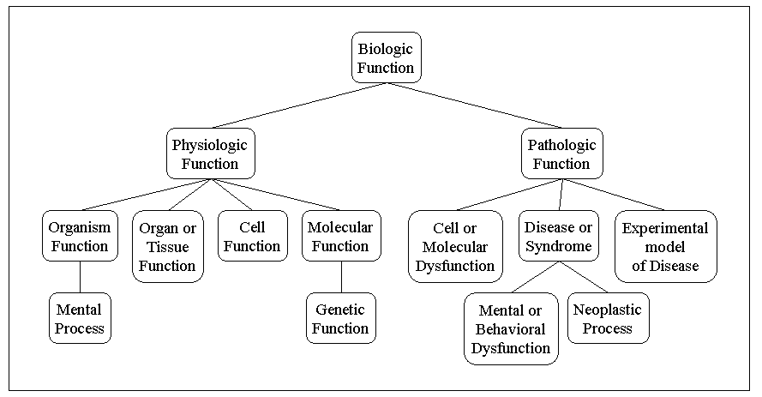
Figure 1. A Portion of the UMLS Semantic Network: “Biologic Function” Hierarchy

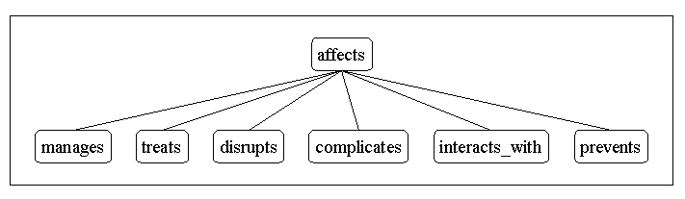
Figure 2. A Portion of the UMLS Semantic Network: “affects” Hierarchy

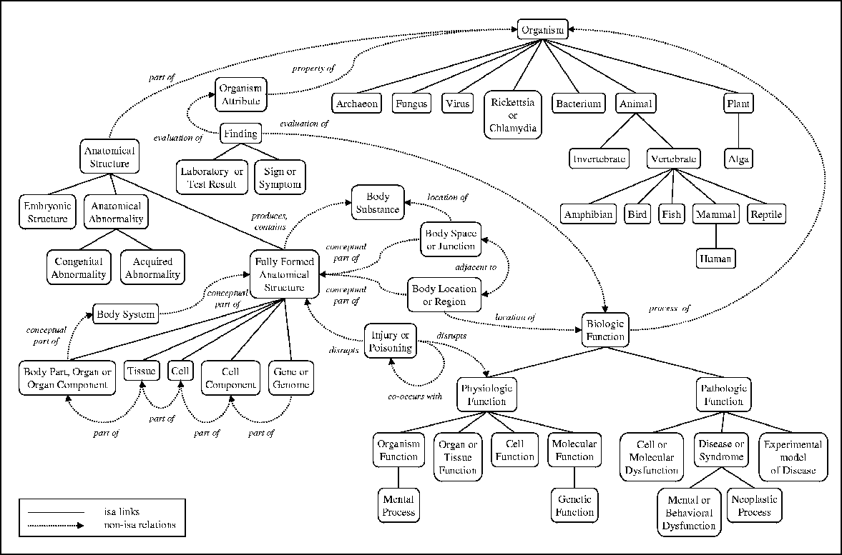
Figure 3. A Portion of the UMLS Semantic Network: Relations

