Benjamin Hansen’s article Punishment and Deterrence: Evidence from Drunk Driving seeks to examine the effectiveness of blood alcohol content thresholds. More specifically, it seeks to answer the question of whether harsher punishments are effective in reducing drunk driving, which works due to the fact that the alcohol content thresholds are used to determine punishment severity. In order to do the research, Hansen uses administrative records on alcohol content tests in Washington. He uses regression discontinuity as the design of the research. As a result of the project, Hansen concludes that there is evidence that having a blood alcohol content over the thresholds is connected with a decline in future drunk driving.

Using a McCrary test as described in the article, I found a p-value of 0.69 rather than the 0.59 described in the article, but this does not change any of the implications. Both have p-values high enough to not have reason to worry about sorting of the running variable.Chart, histogram

|  |  |  |  |  |
| --- | --- | --- | --- | --- |
|  | (1) | (2) | (3) | (4) |
| Table 1 | Accident | White | Male | Age |
|  |  |  |  |  |
| RD_Estimate | -0.000208 | 0.00729 | -0.00827 | -0.0994 |
|  | (0.00613) | (0.00746) | (0.00880) | (0.226) |
|  |  |  |  |  |
| Observations | 214,558 | 214,558 | 214,558 | 214,558 |

The covariates are balanced at the cutoff, though the results are not exactly the same as what Hansen got.

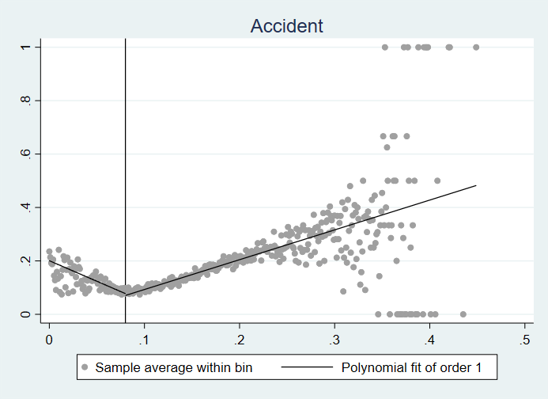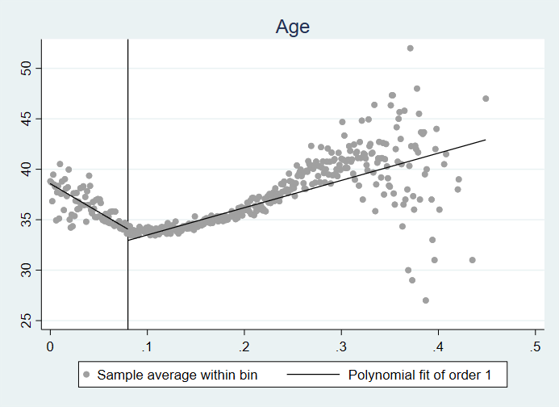

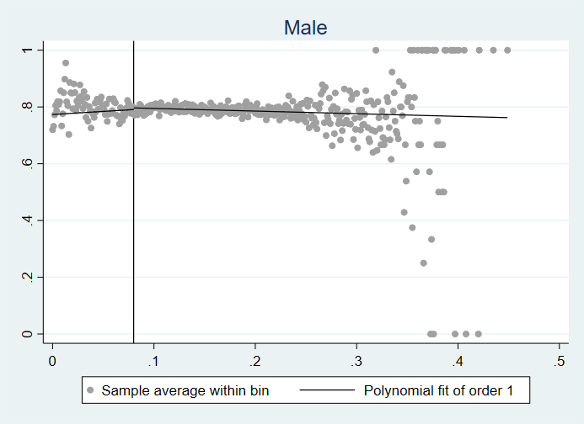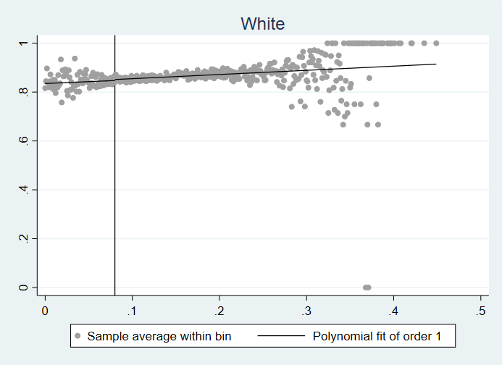

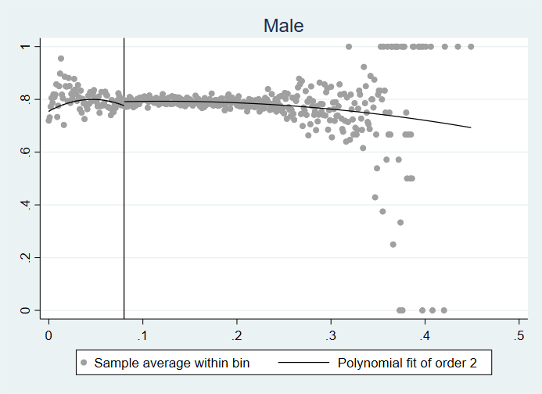

On a sharp graph, they appear to have some separation, but it is quite clear that there isn’t truly an unbalance at the cutoff, though it appears to be an inflection point on most of the graphs. It is similar, but not identical to what is found in Hansen’s paper.

|  |  |  |  |
| --- | --- | --- | --- |
|  | (1) | (2) | (3) |
| Panel A | Linear | Linear with Cutoff | Quadratic with Cutoff |
|  |  |  |  |
| bac1 | -0.0546 | -0.0187*** | -0.0188*** |
|  | (0.0483) | (0.00478) | (0.00652) |
|  |  |  |  |
| Observations | 89,967 | 214,558 | 214,558 |
|  |  |  |  |
|  | (1) | (2) | (3) |
| Panel B | Linear | Linear with Cutoff | Quadratic with Cutoff |
|  |  |  |  |
| bac1 | -0.442*** | -0.0197*** | -0.0194*** |
|  | (0.112) | (0.00416) | (0.00568) |
| Observations | 46,957 | 214,558 | 214,558 |
|  |  |  |  |

|  |  |  |  |
| --- | --- | --- | --- |
|  | (1) | (2) | (3) |
| Panel A | Linear | Linear with Cutoff | Quadratic with Cutoff |
|  |  |  |  |
| bac1 | -0.0546 | -0.0201*** | -0.0183*** |
|  | (0.0483) | (0.00495) | (0.00685) |
|  |  |  |  |
| Observations | 89,967 | 124,642 | 124,642 |
|  | (1) | (2) | (3) |
| Panel B | Linear | Linear with Cutoff | Quadratic with Cutoff |
|  |  |  |  |
| bac1 | -0.442*** | -0.0209*** | -0.0180*** |
|  | (0.112) | (0.00429) | (0.00595) |
|  |  |  |  |
| Observations | 46,957 | 124,642 | 124,642 |

In this exercise, we learned the process of performing a regression discontinuity study. As part of the study, we rejected the null hypothesis that the BAC threshold has no effect on recidivism. Hansen’s conclusion by itself, namely that there is evidence that the BAC threshold, and thus increased punishment, has an effect on recidivism seem to be clearly true. However, the broader implications of that are more questionable. This is because, though the threshold appears to deliver an immediate downward effect on recidivism, the trend is that it increases with BAC, and eventually it reaches aa point chaotic enough I am skeptical that an additional threshold would have an effect.