**GAME DESIGN DOCUMENT**

Dungen

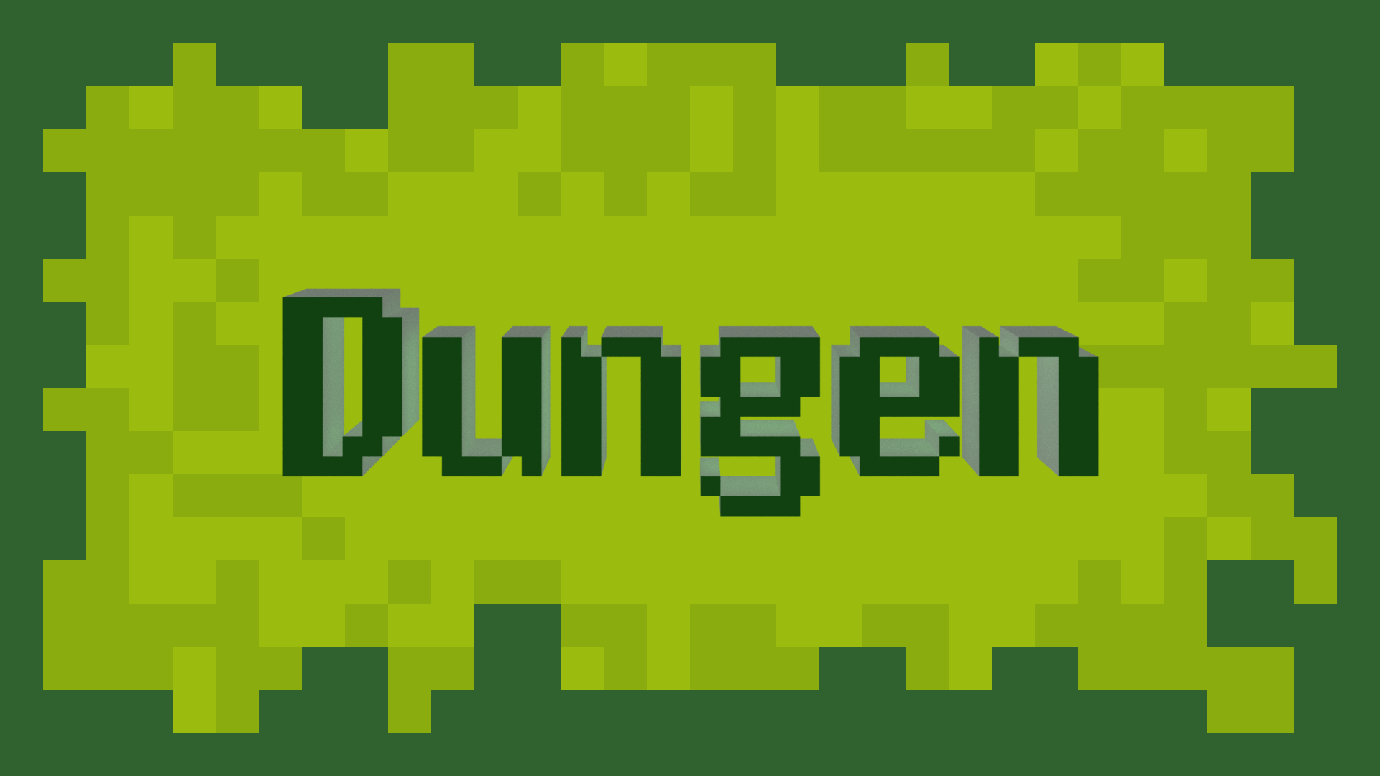

(Working Title)

**Last Updated:**

6/1/17

**Prepared By:**

David Barsamian

**TABLE OF CONTENTS**

Game Analysis 3

Mission Statement 3

Genre 3

Platforms 3

Target Audience 3

Storyline & Characters 4

Gameplay 5

Overview of Gameplay 5

Player Experience 5

Gameplay Guidelines 5

Game Objectives & Rewards 5

Gameplay Mechanics 5

Level Design 6

Control Scheme 7

Game Aesthetics & User Interface 7

Schedule & Tasks 8

# Game Analysis

Dungen is a game for mobile platforms iOS and Android. The purpose of the game is to go as far into an endless, procedurally generated dungeon as possible. The fun of the game comes from the challenge of adapting to an increasing difficulty curve. The player controls their avatar, customizable, around obstacles and fight oncoming monsters. The player is always moving forward, and stops when approaching an obstacle or monster. If the player is pushed off the bottom of the screen, the game is over.

# Mission Statement

Go as far as you can in Dungen, an endless dungeon crawler. Overcome obstacles and fight off monsters to delve further into an endless vault of loot.

# Genre

Casual, Adventure, Endless

# Platforms

iOS, Android

# Target Audience

The target audience is males and females aged between 12-17, 18-24, 25-34, and 35-44. The game will appeal to those who appreciate or are nostalgic of retro, pixel art styles of gaming reminiscent of the late 1900s.

# Storyline & Characters

This is where you present a story synopsis, and discuss how the story will unfold as the player makes his or her way through the game. Include information on the key characters in the game, including descriptions, abilities, characteristics, how they fit into the story, how they affect gamplay, what the player will learn from them, etc.

|  |  |  |  |
| --- | --- | --- | --- |
| Character | Description | Characteristics | Misc. Info |
| Character Name | Describe the character. It is a playable character or NPC. How does this character fit into the story, etc. | Describe the character’s abilities, personality and so forth. | Present any other notes about the character. |

# Gameplay

## Overview of Gameplay

Include information on the game genre and how it is different, similar, or a hybrid of existing genres. Discuss what platform the game will be on, if it is going to be on multiple platforms discuss ways the game will be modified for each platform. Also, provide a general overview of the game modes available in single player and multiplayer. Also, list the Key Gameplay Features (selling features) of the game.

## Player Experience

Provide a general overview of how the player experiences the game. Walk them through the screens they will see, what the level looks like and what their character can do. Give them a brief idea of objectives & hazards they will face. This should be in a second-person point of view using the word “you” to tell a story to the audience (players).

## Gameplay Guidelines

This is a set of guidelines that the game must adhere to throughout the development process. These include rules for what is allowed and not allowed in the game. For instance, if you are creating a game for children, you will want to define guidelines for the level of violence presented in the game, what language can be used, and so on.

## Game Objectives & Rewards

This is where you present more details on how the gameplay will motivate the player to progress through the game. Discuss rewards and penalties and the difficulty level. You can use the table below to help break down objectives and rewards.

|  |  |  |
| --- | --- | --- |
| Rewards | Penalties | Difficulty Levels |
| List ways of how the player is rewarded and when. | Discuss things that hinder the player on progressing | Discuss the difficulty levels within the game |

## Gameplay Mechanics

This is the where you start getting more specific on how some of the systems in the game will work. This includes how characters move in the game, what gameplay actions are available, item inventory and attributes, and how the game progresses from level to level.

|  |  |
| --- | --- |
| **Character Attributes** |  |
| **Character** | **Movement Abilities / Actions Available** |
| Name of character | List the characters abilities & how the player can perform them |
|  |  |
| **Game Modes** |  |
| Game Mode / Difficulty Name | Describe the objectives, hazards in the game mode. And discuss how the player progresses from level to level |
| **Scoring System** |  |
| **Points/Coins/Stars/Grades/Etc.** | **How it’s Awarded & Benefits** |
| List the scoring attribute | Describe how the player obtains this and the benefits. For instance, does getting more points unlock a special level. |

## Level Design

Discuss the levels. How many levels will the game have, what will be included in each level. Include overall look and feel, hazards the level presents, difficulty, objectives, etc.

|  |  |
| --- | --- |
| **Levels** |  |
| Level name and/or pic of it | List or describe the level’s look, difficulty, hazards, and objectives. |

# Control Scheme

Describe the control setup for the game. Does your game use touch input, a controller, or mouse & keyboard? Discuss the functionality of each button/touch. It may help to insert a diagram/pic to help explain the actions.

|  |  |
| --- | --- |
| **Button/ Touch Input** | **Action it Performs** |
| List the button | Describe what functionality the button press has within the game. |

# Game Aesthetics & User Interface

Discuss the design techniques to be used. Describe the look & shape of the characters, environment and pathways. Will the game look realistic or have some other art style. Discuss what type of theme the game will have & what type of emotional impact you are hoping players experience. Discuss how the player’s gestures/interactivity has an affect on the visual experience.

Present a general overview of the UI. How will the buttons be laid out, how will the HUD work, how does the menu system function, and so on. It is a good idea to insert photos, diagrams or concept art to help explain the UI.

# Schedule & Tasks

List the tasks that need to be completed along with the basic timeline to complete them by. The task list can be as detailed as you like to fit your studio’s needs. The table below can be substituted for the excel file. This table is a great start but the tasks should be much more detailed.

|  |  |  |  |  |
| --- | --- | --- | --- | --- |
| **Tasks to Complete & Schedule** | | | | |
| **Tasks** | **Task Lead** | **Start** | **End** | **% Complete** |
| **Development Phase** | | | | |
| Design |  |  |  |  |
| Storyline | John Doe | 9/4/15 | 9/8/15 | 0 % |
| Level Mechanics |  |  |  |  |
| Art |  |  |  |  |
| Level 1 |  |  |  |  |
| Special FX |  |  |  |  |
| UI |  |  |  |  |
| Engineering |  |  |  |  |
| Production Pipeline |  |  |  |  |
| Prototypes |  |  |  |  |
| Audio |  |  |  |  |
| Sound Design |  |  |  |  |
| Milestone: GamePlay Features & Music |  |  |  |  |
| **Testing Phase** | | | | |
| Test Plan |  |  |  |  |
| Beta Testing |  |  |  |  |
| Milestone: QA Testing |  |  |  |  |
| **Deploying Phase** |  |  |  |  |
| "Go Live" Plans |  |  |  |  |
| Milestone: Ready for Usage |  |  |  |  |