Q1. a.
For the extraction of the features, I used already existing MATLAB code.

I then tried to use SVMlight for linear SVM, but it doesn't lend itself to Multiclass. So I used a multiclass implementation of it for the linear problem. (http://svmlight.joachims.org/svm_multiclass.html)
But SVMMulti was very slow for Poly and RBF.
So I wrote and ECOC multiclass wrapped for SVMlight, ran it on 6000 training points and then tested it on all the 10000 testing points.
The ECOC is 1 function for every bit (0/1 prediction). Each class has 15 bits.

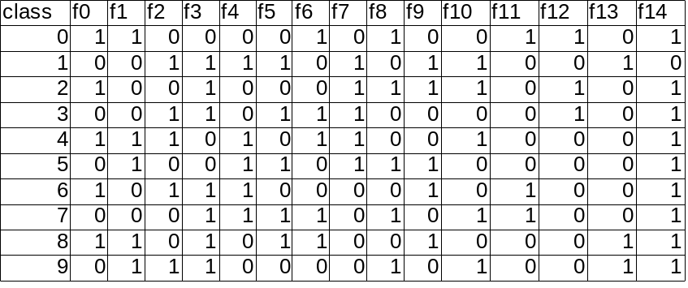

Results -

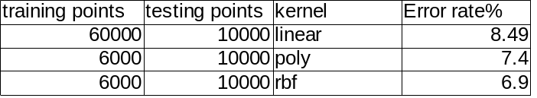

Q1. b.
I used the QP form cvxopt for python to solve for alphas.
I implemented the Linear, Poly, and RBF kernels, and observed that the larger the training set I train over, the better the results I get.
I used the All-vs-1 method for multiclass (greater the value, greater the confidence).
I also optimized my code as much as was possible, so that I can run the 6000 training points 10000 testing, in about an hour. (Testing takes longer than training).
I could theoretically do all 60000 points, but my RAM wasn't enough to accommodate a 60000x60000 matrix.

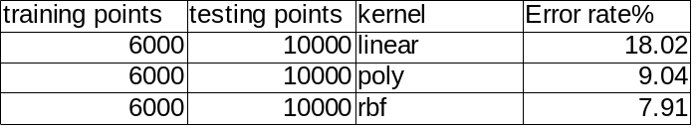

Q2 ANN (extra credits)

I modified the ANN code from the previous HW to apply to the images data set. I used all kinds of optimizations like ECOC from the table above (here each function is an output node of ANN [and not a separate ANN]). I also used momentums and BIAS. I tried 300 and 500 hidden nodes and ran the code for hours.
What I observed was that after about 80 iterations, the ANN stopped converging. The error rate started jumping about and not decreasing.I tried to change the learning rate and momentum, but to no avail.
I finally ended up with an error rate of about 20% with 500 (1 layer) hidden nodes.

