Problem 2.
I used the values pi =0.8, p = 0.75 and r = 0.4 to generate 1000, 10 coin toss sets. I then used this data to compute the following values.
 | Test1 |  | Test2 |  | Test3 |  | Test4
Name | Used | Observed | Used | Observed | Used | Observed | Used | Observed
pi | 0.1 | 0.797358 | 0.9 | 0.797358 | 0.1 | 0.202642 | 0.9 | 0.202642
p | 0.3 | 0.744871 | 0.3 | 0.744871 | 0.1 | 0.385265 | 0.1 | 0.385265
r | 0.1 | 0.385265 | 0.1 | 0.385265 | 0.3 | 0.744871 | 0.3 | 0.744871

I observed that if we input p > r, then the probabilities generated would be exact.
If p < r, then the probabilities generated would be= 1 – actual_probability.
The program does generate sensible outputs for p = r and needs them to be different.

Problem 3.
For discrete missing data (“?”), I substituted the values using a Naïve Bayes based on just the label. In the case of continuous values, I substituted the missing values (“?”) with the mean.

I used decision stumps based on minimum error, where error is the number of misclassified points.

I used k-folds with 9 folds for training and 1 fold for testing. I average the accuracy across all the folds.

To handle multi classes, I used the One-vs-All (ECOC does not work well for less than 5 classes, and the data given had at most 4 classes).

The results averaged across all folds that I obtained are show in the table below

% data | VOTE | CAR | CRX
5 | 91.93 | 81.19 | 83.48
10 | 95.68 | 87.5 | 83.77
15 | 95 | 87.39 | 83.19
20 | 94.26 | 87.96 | 85.07
30 | 94.29 | 88.66 | 84.93
50 | 95.45 | 88.77 | 84.93
80 | 95 | 89.24 | 86.81

Problem 3 Extra Credits.
Boosting output for the extra credit data sets is in the table below.

% data | AGR | BAL | BAND | CMC | MONK | NUR | TIC
5 | 99.46 | 68.22 | 58.97 | 42.42 | 52.34 | 90.87 | 71.9
10 | 99.7 | 79.62 | 62.32 | 47.58 | 57.4 | 91.33 | 80.98
15 | 99.88 | 84.63 | 64.93 | 46.92 | 56.02 | 91.04 | 83.61
20 | 99.91 | 88.26 | 64.76 | 48.67 | 60.66 | 91.48 | 85.68
30 | 99.94 | 90.02 | 66.98 | 51.25 | 59.02 | 91.43 | 88.71
50 | 99.99 | 91.81 | 69.57 | 52.46 | 59 | 91.36 | 89.77
80 | 99.98 | 91.95 | 71.6 | 52.55 | 58.8 | 91.53 | 89.55

Problem 4.
I use k-folds (k=10) for active learning as well. I start with 5% of the training set (for a fold), and then tried adding 1 point at a time. For the VOTE, CRX and CAR data sets, I grew the data set to only about 20% because after that the error seemed to stabilize.
For the extra credit dataset, growing at 1 data point would take too long, so I grew at 1% of the training data set for every iteration (m). [MONK and CMC did not seem to fare any better with active learning]
For each iteration, I ran ‘T’ active boosting iterations and then picked the next set of points.

The graphs below are the %error vs %data values averaged across all folds for different data sets.

VOTE –
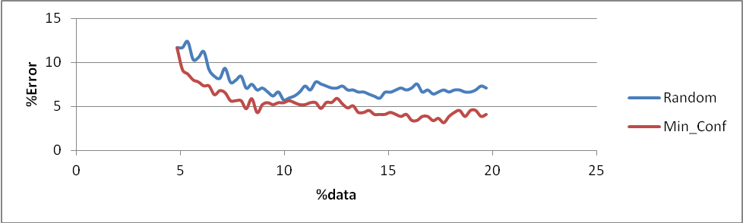

CAR –
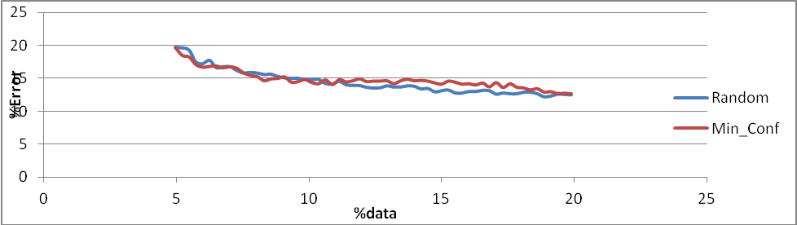
CRX –
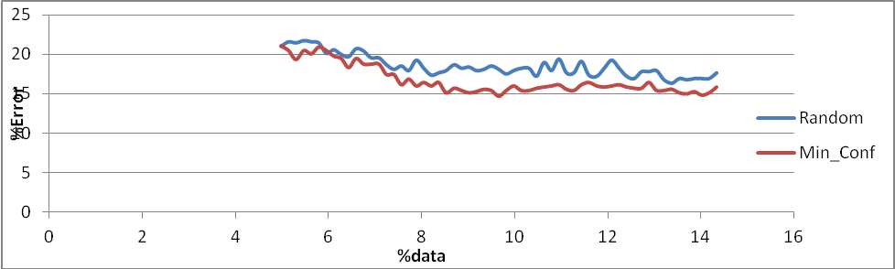

Problem 4 extra credit data sets-
AGR –
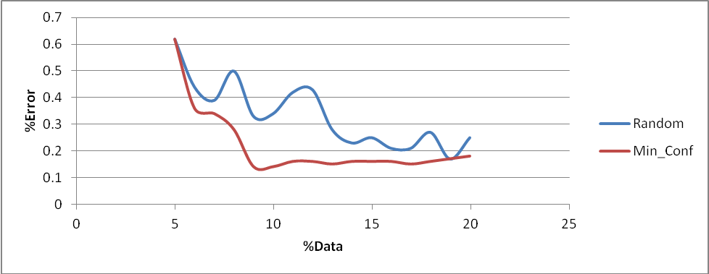

BAL –
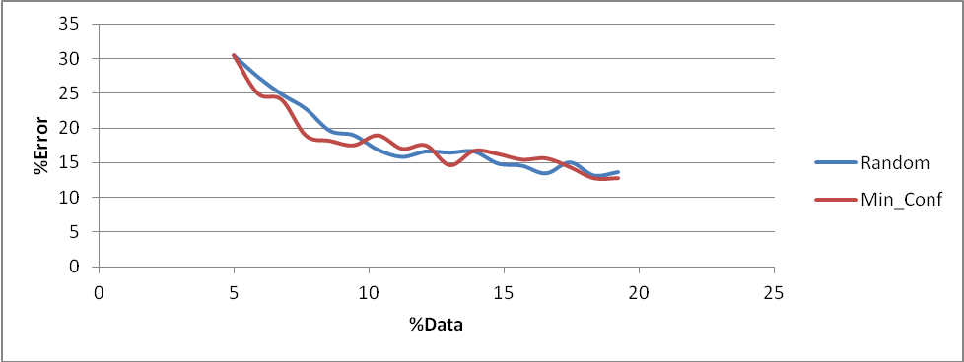

BAND –
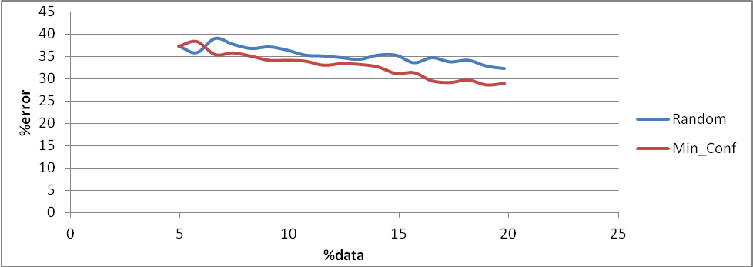

NUR –
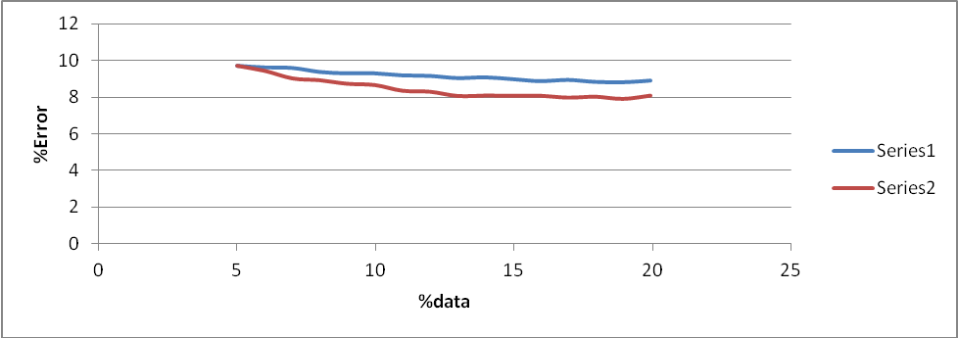

TIC –
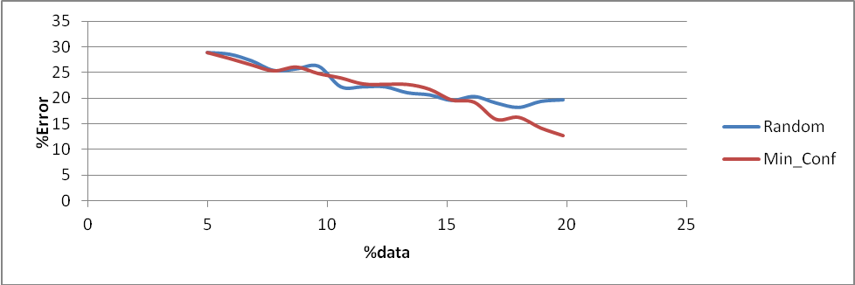

Problem 5.
a) unions of two rectangles – VC dimension = 5 (rotatable rectangles) (It cannot shatter 6 collinear alternating points)
b) circles – VC dimension = 3
c) triangles – VC dimension = 3
d) multidimensional "sphere" given by f(x) = sign [(x-c)(x-c) -b] in the Euclidian space with m dimensions ℝ m . Justify your answers !
VC dimension of an m-dimension sphere is at most m^2.

