Use-Case Diagram

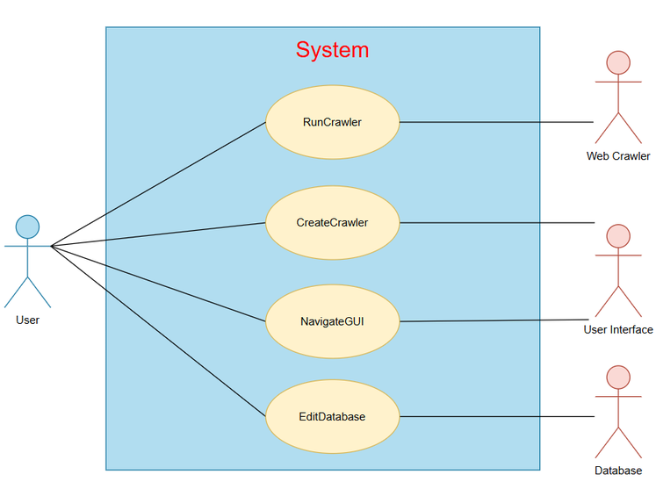
The above use-case diagram highlights the app user as the primary actor. Secondary actors include the web crawler, user interface and database. Use cases revolve around GUI navigation, database operations, crawler setup and execution within the system’s boundaries.

UC-Number | UC-Description
UC-1 | User executes a crawler script.
UC-2 | User creates or modifies a crawler script.
UC-3 | User traverses the graphical user interface.
UC-4 | User operates a MySQL database.
Table 3

Use-Case Description.

Use Case ID: | UC-1
Use Case Name: | RunCrawler
Created By: | Roko | Last Updated By: | Roko
Date Created | 22 May 2026 | Last Updated Date | 24 May 2026

Description: | User executes a crawler script.
Actors:  Primary  Secondary | Primary – User  Secondary – Web Crawler
Triggers: | User presses the “Crawl” button in the main menu.
Pre-conditions: | A crawler script has been written.
Post-Conditions: | The main menu displays HTML responses.
Normal Flow: | - User navigates to the main menu.  - User selects a crawler from the combo box.  - User presses the crawl button.
Alternate Flows: | A1: SQL Credentials Input – User must key in their database credentials before the normal flow may resume.
Exceptions: | E1: Access Denied – The website being visited might not allow crawlers.  E2: Invalid SQL Syntax – The database throws an error unable to parse the crawler’s SQL statement.  E3: Invalid Python Syntax – The Python interpreter fails to execute a snippet of the script.
Includes: | GET Request  Print Results
Extends: | Write File  Run Python  Connect to Database
Priority: | High
Special Conditions: | User’s PC must have sufficient resources for web crawling.
Assumptions: | User has an active internet connection.
Notes and Issues: | Thread handling would allow multiple crawlers to run simultaneously.

Use Case ID: | UC-2
Use Case Name: | CreateCrawler
Created By: | Roko | Last Updated By: | Roko
Date Created | 22 May 2026 | Last Updated Date | 24 May 2026

Description: | User creates or modifies a crawler script.
Actors:  Primary  Secondary | Primary – User  Secondary - User Interface
Triggers: | User presses the “OK” button in the scripting menu.
Pre-conditions: | The application must be running.
Post-Conditions: | The .dat file containing web crawler data is rewritten.
Normal Flow: | - User selects “New Crawler...” from the combo box then navigates to the Crawler Editor.  - User defines the agent’s name, crawl delay and the crawler’s designation.  - User enters the scripting menu and puts together a sequence of commands.
Alternate Flows: | A1: Edit Crawler – User selects an existing crawler from the combo box instead.
Exceptions: | E1: I/O Error – The application does not have write or read access to the PC.
Includes: | Enter Command  Edit Command
Extends: | Parse Search Results
Priority: | Medium
Special Conditions: | User is expected to comply with data protection standards and crawling etiquette.
Assumptions: | User must understand what individual commands do.  User must know the correct syntax for SQL statements when passing values.
Notes and Issues: | User could also write scripts using a text editor instead of the app’s GUI.

Use Case ID: | UC-3
Use Case Name: | NavigateGUI
Created By: | Roko | Last Updated By: | Roko
Date Created | 22 May 2026 | Last Updated Date | 24 May 2026

Description: | User traverses the graphical user interface.
Actors:  Primary  Secondary | Primary – User  Secondary - User Interface
Triggers: | User presses a panel transition button.
Pre-conditions: | The user’s system GUI is currently focused on the application.
Post-Conditions: | The main JFrame switches to a different panel which appears as a different menu to the user.
Normal Flow: | - User runs the app.  - The app displays the landing page or main menu.  - The user clicks a navigation button.
Alternate Flows: | A1: Popup Menu – User is led to a different screen after pressing a non-navigational button.
Exceptions: | E1: Disabled Button – Navigation is precluded owing to the user’s behaviour or non-fulfilment of functional prerequisites.
Includes: | Move Mouse  Click Mouse
Extends: | Exit Application
Priority: | High
Special Conditions: | The user’s OS must support a graphical user interface.
Assumptions: | User has no accessibility issues e.g. colour-blindness.
Notes and Issues: | The app could lend itself to a command-line interface for some features.

Use Case ID: | UC-4
Use Case Name: | EditDatabase
Created By: | Roko | Last Updated By: | Roko
Date Created | 22 May 2026 | Last Updated Date | 24 May 2026

Description: | User operates a MySQL database.
Actors:  Primary  Secondary | Primary - User  Secondary - Database
Triggers: | Web crawler executes a SQL statement.  User creates a MySQL table in the application.
Pre-conditions: | The SQL syntax must be correct.  User must have entered their SQL credentials.  User must have configured the MySQL connection.
Post-Conditions: | The database is modified.
Normal Flow: | - User configures the database settings.  - User navigates to the SQL table editor.  - User defines a table schema.  - User enters their SQL credentials.  - User confirms table creation.
Alternate Flows: | A1: Web Crawler – User defines a SQL statement that the crawler executes during runtime.
Exceptions: | E1: Invalid Database Settings – The application cannot connect to the database.  E2: Invalid SQL Credentials – The application finds the database, but access is forbidden.  E3: Invalid SQL Syntax – The web crawler fails to execute user-defined SQL commands.
Includes: | Create Table  Update Table  Query Table
Extends: | Export Table  Visualise Table
Priority: | Low
Special Conditions: | User must have access privileges for the MySQL database.
Assumptions: | User is well-versed with SQL syntax and relational databases.
Notes and Issues: | An automated proofreader or parser would reduce the number of SQL errors.

