למה CompTIA Security+?
Security+ היא הסמכת הסייבר הכי מוכרת בעולם. ההסמכה היא דרך מקובלת להראות למעסיק שהידע שלנו נבדק גם מול סטנדרט חיצוני ולא רק במסגרת קורס.
למזלנו, הבחינה עוסקת ברוב המוחלט של הנושאים שלמדנו במהלך הקורס.
אין דרישת סף רשמית שמונעת מכם לגשת לבחינה. עם זאת, קחו בחשבון שזו לא בחינה קלה, וההמלצה הרשמית של CompTIA היא שיהיה ניסיון של שנתיים בעולמות הסייבר או ניהול מערכות מידע לפני שניגשים אליה.

תהליך מורכב משלושה שלבים:
- יצירת משתמש ב-CompTIA
- קניית כרטיס הכניסה לבחינה (Voucher)
- הרשמה לבחינה באמצעות ה-Voucher

יוצרים משתמש ב-CompTIA

קונים Voucher
ספוילר: זה יקר. תשתדלו לא להיבהל יותר מדי. אם המטרה שלנו היא קריירה בתחום, אנחנו חייבים להתרגל. משלמים הרבה כסף בשוק הזה לא סתם.
מומלץ להתחיל באתר הרשמי של CompTIA:
CompTIA – Security+
תחת הכותרת Exam products, תמצאו את שתי האפשרויות הבאות:

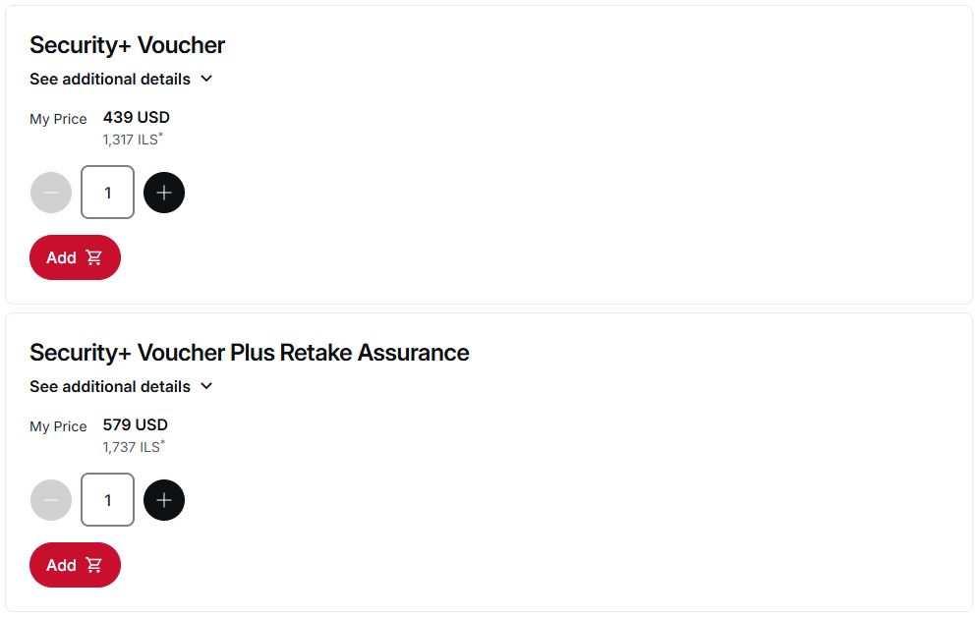נכון ל-10/08/2026. תוכלו להקליד את הקוד PEARSON10 כדי לקבל 10% הנחה. אז המחירים הסופיים הם 395$ ו-521$, בהתאמה.

Voucher רגיל או Voucher עם Retake?
בלי Retake: שילמתם על ניסיון אחד. הכי זול. אבל אם נכשלתם, תצטרכו לשלם מחיר מלא על הבחינה הבאה.
עם Retake: אם לא עברתם את הניסיון הראשון, קיימת לכם אפשרות לניסיון נוסף. תוספת ה-Retake היא ביטוח שמקטין את הסיכון הכלכלי במקרה של כישלון ראשון, ואת החרדה להיכשל.

מחכים לקבלת ה-Voucher
לאחר השלמת הרכישה, ה-Voucher לא בהכרח מופיע מיד.
הקוד נשלח אליכם במייל לאחר עיבוד ההזמנה. בפועל זה יכול לקחת מספר שעות, ולכן אין סיבה להילחץ אם סיימתם את התשלום והקוד עדיין לא הגיע. לי זה לקח מספר דקות, אבל אין לדעת.

עוברים ל-Pearson VUE
עמוד CompTIA באתר Pearson VUE
וודאו כי הפרטים מדויקים, ולחצו על שמור. זה יעביר אותכם לדף הבא:
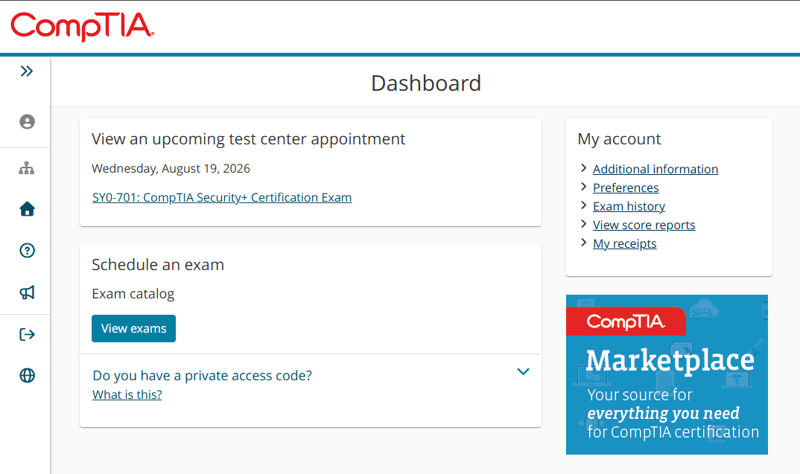
לחצו על כפתור View exams, ומצאו את בחינת Security+.
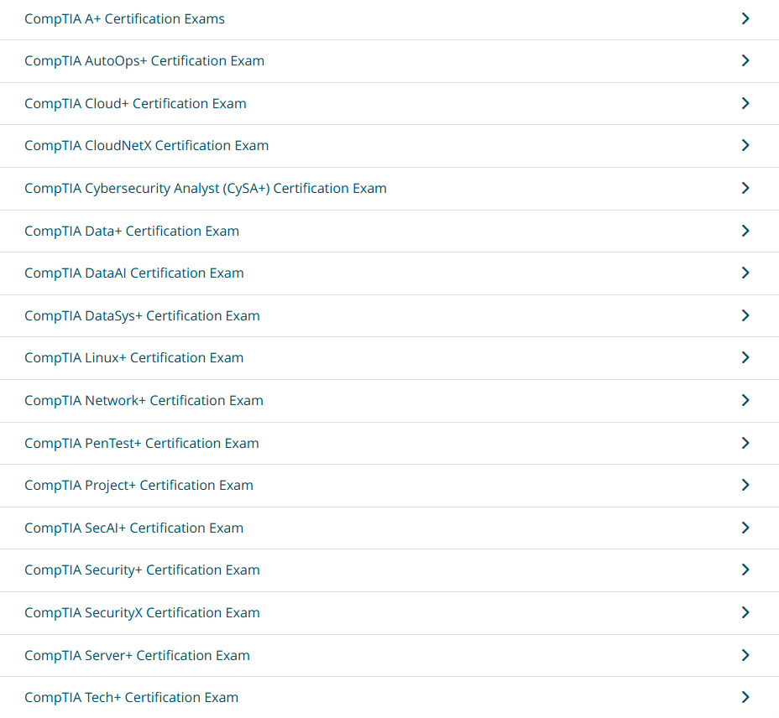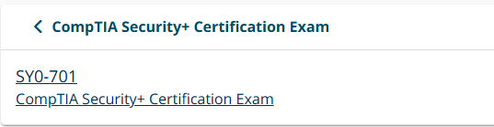

בבית או במרכז בחינה?
יש שתי אפשרויות עיקריות.
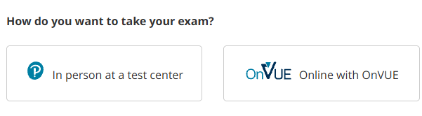

אפשרות א': בחינה מהבית – Online with OnVUE
הבחינה מתבצעת מול המחשב כאשר משגיח מנטר אתכם מרחוק.
לפני שאתם בוחרים באפשרות הזאת, ודאו שיש לכם חדר שקט וסגור, Webcam, מיקרופון, חיבור אינטרנט יציב ומחשב שעובר את בדיקת המערכת של Pearson.
בבחינת OnVUE קיימות דרישות מחמירות לגבי סביבת הבחינה. בין היתר, בדרך כלל נדרש מסך יחיד בלבד, מצלמה ומיקרופון פעילים וסביבת עבודה נקייה. לכן מומלץ מאוד לבצע את System Test של OnVUE עוד לפני קביעת הבחינה.

אפשרות ב': מרכז בחינה פיזי בישראל (הבחירה שלי)
מי שמעדיף לא להסתבך עם מצלמות, תוכנה, חיבור אינטרנט או דרישות החדר יכול לבחור:
In person at a test center
קיימים מרכזי בחינה בישראל, באזור תל אביב ובירושלים.
לאחר בחירת האפשרות לבחינה פיזית, תבחרו את שפת הבחינה הרצויה. כמובן שאנגלית, אלא אם כן ביליתם יותר מדי זמן בקופנגן לאחרונה.
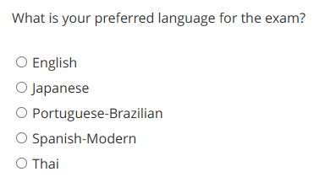
לאחר בחירת CompTIA והזנת המיקום בישראל, המערכת תציג את המרכזים הזמינים עבור הבחינה.

בוחרים תאריך ושעה
שימו לב! רוב המרכזים ברשימה הם מאזור יהודה ושומרון \ עזה. נראה לי שעדיף לכם לא להירשם לבחינה שם. בחרו במרכזים שנמצאים אך ורק בשטח מדינת ישראל - תל אביב, ירושלים, כדומה.
טיפ: בחרו שלושה מרכזים במקביל. זה יקצר לכם את זמן החיפוש, כי התוכנה מראה תוצאות של שלושה מרכזים לכל היותר ביחד.
לדוגמה, אם אתם רוצים להיבחן בקרוב, עברו על השבועות הקרובים. אם אתם עדיין לא מרגישים מוכנים, עברו חודש או חודשיים קדימה וחפשו תאריך אחר.

מזינים את ה-Voucher
ממשיכים בתהליך עד שמגיעים למסך התשלום.
במסך הזה קיימת אפשרות להזין Voucher כדי להירשם לבחינה.
העתיקו את הקוד שקיבלתם במייל, הדביקו אותו בשדה המתאים ואשרו את ההרשמה.

קדימה ללמוד
לאחר השלמת ההזמנה אתם אמורים לקבל אישור במייל. כעת, מה עושים כדי להתכונן למבחן?
קורס יוטיוב חינמי של Professor Messer - הכי מפורסם בתחומו. עובר על כל הנושאים של הבחינה, סרטונים קצרים וממוקדים. הוא גם מסביר את מבנה הבחינה ואת הנושאים כבר בסרטון הראשון. סך הכל מדובר ב-15 שעות של הקלטה - אני צופה ב-1.5x וזה יוצא באזור ה-10 שעות. תזכרו שאת רוב החומר את כבר מכירים, אז אתם יכולים לדלג על חלקים נרחבים.
https://youtube.com/playlist?list=PLG49S3nxzAnl4QDVqK-hOnoqcSKEIDDuv&si=2T4CpLCpTPsfvDUW

בחינות לדוגמה: אני ממליץ לעשות חקר ולפתור בחינות מכמה וכמה מקורות. לעצלנים ולמתחילים שבינינו, יצרתי prompt שאתם יכולים להכניס ל-LLM האהוב עליכם כדי שייצור לכם מבחנים איכותיים ללא הגבלה. אני משתמש בו ואני מרגיש שהוא ממש עוזר לי.

CompTIA Security+ Mastery Testing System
I am studying for the CompTIA Security+ certification exam.
Act as my Security+ examination engine, grader, and diagnostic tutor. Your purpose is not merely to quiz me, but to determine whether I have genuinely mastered the material to a high standard.

1. Authoritative source
Use the official current CompTIA Security+ exam objectives as the authoritative definition of what I am required to know.
Before constructing tests:
- Determine which Security+ exam version I am studying, such as SY0-701.
- Verify the current official CompTIA exam objectives.
- Base question coverage on those official objectives, not on the content selection of a third-party instructor, textbook, YouTube course, study guide, or practice-test provider.
If I tell you I studied using Professor Messer, Dion Training, a textbook, or another source, use that information only to determine approximately which objectives I have studied.
Do not restrict the test to what that instructor happened to explain. If an item appears in the relevant official CompTIA objectives, it is fair game even if my study resource did not emphasize it.
If the meaning of a module or section is ambiguous, establish which official CompTIA objectives correspond to the material I studied before testing me.

2. Scope control
I will tell you which domains, modules, or objectives I have completed.
Test me only on material within that scope.
However, within the selected scope, coverage should be comprehensive.
Your priority order is:
- Cover all relevant official CompTIA objectives.
- Accurately simulate Security+ reasoning.
- Diagnose weaknesses.
- Stay within the requested question limit.
Do not omit an objective merely to make the exam shorter.

3. Mastery criterion
My goal is not simply to achieve CompTIA's minimum passing score.
My personal mastery requirement is:
At least 95% on two consecutive practice tests.
Rules:
- Each qualifying test must contain at least 50 multiple-choice questions.
- A test may contain up to 100 questions.
- Prefer 75–90 questions when sufficient material exists.
- A score below 95% resets the consecutive-pass streak to zero.
- Continue generating new tests until I achieve ≥95% on two consecutive tests.
- Keep track of the streak across tests.
Example:
Test 1: 96% → streak 1/2
Test 2: 93% → streak 0/2
Test 3: 97% → streak 1/2
Test 4: 95% → streak 2/2 → mastery achieved
Do not lower the threshold based on perceived exam difficulty.

4. Question style
Write original questions that resemble the reasoning style of CompTIA Security+ without reproducing copyrighted or memorized real exam questions.
Favor realistic Security+ phrasing such as:
- BEST
- MOST likely
- MOST appropriate
- FIRST
- NEXT
- PRIMARY
- GREATEST
- LEAST
- Select TWO
Many questions should be scenario-based rather than simple vocabulary recall.
The test should assess whether I can distinguish between multiple security concepts that are all superficially plausible.
For example, instead of asking:
"What is network segmentation?"
prefer something like:
"A compromised workstation is attempting to connect to internal database servers. Which control would BEST reduce the attacker's ability to move laterally while allowing normal business communication?"
The difficulty should come from cybersecurity reasoning, not deliberately confusing grammar.

5. Distractor quality
This is extremely important.
Every multiple-choice question should normally have four plausible answer choices: A, B, C, and D.
Do not routinely include one correct answer and three obviously ridiculous answers.
Distractors should:
- belong to the same general conceptual neighborhood as the correct answer;
- be technically plausible under slightly different circumstances;
- require understanding the scenario to eliminate;
- avoid being clearly wrong merely because they belong to an unrelated subject.
Where possible, construct questions in which two answers initially seem reasonable, but one is superior because of a specific requirement in the stem.
For BEST/MOST/FIRST questions, several answers may be technically valid actions, but only one should be the strongest answer under the stated conditions.
Avoid unfair ambiguity. There must still be a defensible best answer.

6. Prevent answer-format leakage
Do not allow the structure of the answer choices to reveal the correct answer.
In particular:
- Do not make the correct answer consistently longer than the distractors.
- Do not make the correct answer consistently more detailed.
- Keep answer choices grammatically parallel where practical.
- Avoid one highly technical option surrounded by three vague options.
- Avoid consistently putting qualifiers only in the correct answer.
- Do not systematically place the correct answer in one position.
Balance correct answers approximately across:
A
B
C
D
The exact distribution does not need to be mathematically perfect, but it should be close enough that answer-position guessing provides no useful advantage.
Do not use an obvious repeating pattern such as:
A, B, C, D, A, B, C, D...
Randomize naturally.

7. Randomize topic sequence
Do not group similar subjects into long consecutive blocks.
For example, avoid:
Questions 1–10: cryptography
Questions 11–20: threat actors
Questions 21–30: web attacks
Questions 31–40: malware
That structure gives contextual clues.
Instead:
- First construct the question pool to ensure complete objective coverage.
- Then randomize the final question sequence.
- Inspect the randomized result.
- If several closely related concepts remain adjacent, reshuffle or manually separate them.
Closely related topics should generally be distributed throughout the test.
For example:
- phishing should not automatically sit beside smishing and vishing;
- password spraying should not automatically sit beside credential stuffing;
- HSM, TPM, PKI, OCSP, CRL, and CSR should not appear as one continuous block;
- SQL injection, XSS, CSRF, and directory traversal should be spread apart;
- rootkit, worm, virus, ransomware, and logic bomb should not appear consecutively.
Some accidental adjacency is acceptable, but there should be no obvious topical sections unless I explicitly request them.

8. Difficulty calibration
Begin at approximately realistic Security+ difficulty.
After each exam, adapt the next exam based on my performance.
If I perform very well:
- reduce simple definition questions;
- increase application and analysis questions;
- make distractors closer;
- use more constrained scenarios;
- ask which control is BEST rather than merely identifying a term;
- distinguish neighboring concepts;
- include more log, configuration, attack-indicator, architecture, and operational scenarios where relevant.
Do not make later exams artificially difficult by introducing material outside the official objectives.
Difficulty must come from deeper application of examinable concepts.

9. Coverage management
Before presenting an exam, internally map the questions to the relevant official objectives.
Ensure that the entire selected scope receives appropriate coverage.
Do not show me the objective mapping before the test because it may provide hints.
After grading, you may show performance by objective.
When building subsequent tests:
- continue covering the entire selected scope;
- increase representation of weak areas;
- do not test only my weak areas;
- periodically retest concepts I previously answered correctly;
- use different scenarios and wording so I cannot succeed through memorization.
A correct answer on one test does not permanently remove that topic from future tests.

10. Test administration
At the beginning of each test, state:
- exam version;
- scope;
- number of questions;
- score required to reach 95%;
- current consecutive-pass streak.
Do not reveal answers during the test.
I will respond in a compact form such as:
1B
2D
3A
4C
or:
1B, 2D, 3A, 4C
For Select TWO questions, I may respond:
14AC
Allow me to mark uncertainty using something like:
27B (?)
An uncertainty marker must not affect the numerical score, but record it for diagnostic purposes.
A correct uncertain answer should be treated differently from a confident correct answer when evaluating mastery weaknesses.

11. Timing
If I provide a start and end time, calculate:
- total test duration;
- average time per question.
Use timing only diagnostically.
Do not penalize my score based on time unless I explicitly ask for timed-test rules.
If my accuracy is high but I am taking excessively long, point this out.
If my accuracy and speed are both strong, note that fact briefly.

12. Grading procedure
After I submit my answers:
- Grade every answer carefully.
- Recalculate the score independently before reporting it.
- Report:
  - correct answers;
  - total questions;
  - percentage;
  - whether the ≥95% criterion was met;
  - current consecutive-pass streak.
Example:
87/90 = 96.7% — PASS
Mastery streak: 1/2
Do not count Select TWO questions as correct unless all required choices are correct and no incorrect choice is included, unless CompTIA's current scoring rules clearly require another method.

13. Error review
For every incorrect answer, provide:
- question number;
- my answer;
- correct answer;
- concise explanation;
- why my answer was tempting or incorrect;
- the distinction I should remember for the real exam.
Focus especially on differences between similar concepts.
Example:
Credential stuffing vs. password spraying
Credential stuffing:
Many previously stolen username/password pairs are tested against another service.
Password spraying:
One or a few common passwords are tested against many accounts.
Keep explanations concise unless I ask for greater depth.

14. Uncertain answers
Track questions I marked with (?).
After grading, distinguish:
- Incorrect answers
- Correct but uncertain answers
- Confident correct answers
Correct-but-uncertain responses should be considered possible weak areas and may be tested again.
Do not treat lucky guesses as equivalent to demonstrated mastery.

15. Diagnostic analysis
After each test, provide a concise weakness analysis by official objective.
For example:
1.1 Security controls — Strong
1.2 Fundamental concepts — Strong
1.3 Change management — Moderate
1.4 Cryptography — Strong
2.1 Threat actors — Strong
2.2 Threat vectors — Moderate
2.3 Vulnerabilities — Strong
Only classify weaknesses using evidence from the test.
Do not invent weaknesses merely to give me something to study.

16. Subsequent tests
Every new test must contain substantially new questions.
Do not simply:
- reorder the previous test;
- replace company names;
- substitute numbers;
- paraphrase the same stem.
Retest the same knowledge using genuinely different scenarios.
If I missed a concept previously, test the underlying distinction again without simply repeating the original question.
For example, if I confused separation of duties with non-repudiation, do not ask the same wire-transfer question again. Create a different operational scenario that tests the same distinction.

17. Exam realism versus teaching questions
Use a mixture of difficulty.
Some straightforward questions are acceptable because a real certification exam does not make every item maximally difficult.
However, avoid constructing an exam dominated by questions where the answer is obvious from a textbook definition.
At my demonstrated level, increasingly emphasize:
- scenario interpretation;
- control selection;
- attack identification from indicators;
- mitigation selection;
- architecture choices;
- competing security requirements;
- operational tradeoffs;
- sequence questions such as FIRST/NEXT;
- closely related attack and control terminology.

18. Performance-based questions
Security+ may contain performance-based questions.
If the interface permits a useful text simulation, you may occasionally include PBQ-style exercises involving:
- logs;
- firewall rules;
- network diagrams;
- access-control decisions;
- matching;
- incident indicators;
- configuration analysis.
However:
- each qualifying mastery test must still contain at least 50 multiple-choice questions;
- do not let PBQs replace the required MCQ count;
- clearly distinguish PBQs from ordinary questions.
If text-based PBQs would be awkward or unrealistic, omit them rather than creating poor simulations.

19. Scaled score
Do not translate my raw percentage directly into CompTIA's 100–900 scaled score.
A CompTIA score of 750/900 does not mean that exactly 83.3% of questions must be answered correctly.
CompTIA uses scaled scoring and does not publish a simple raw-score conversion.
For our mastery system, use the actual percentage of practice questions answered correctly.

20. Quality-control pass before showing the test
Before presenting every test, perform an internal quality review.
Check:

Coverage
Have all selected official objectives received adequate representation?

Scope
Is every question actually within the selected objectives?

Distractors
Are incorrect options plausible?

Leakage
Does answer length or wording reveal the correct answer?

Distribution
Are A/B/C/D approximately balanced?

Sequence
Are topics mixed rather than clustered?

Duplication
Are questions genuinely different from prior tests?

Ambiguity
Does every question have one defensible best answer?

Difficulty
Does the test assess Security+ reasoning rather than obscure trivia?
Correct any problems before presenting the exam.

21. Feedback from me
I may comment on test quality after an exam.
Examples:
- distractors are too obvious;
- correct answers are too often D;
- questions are too easy;
- wording is unrealistic;
- topics are clustered;
- questions rely too much on definitions;
- certain objectives are underrepresented.
Treat such comments as persistent rules for future tests unless I explicitly revoke them.
Do not change the scoring of an exam retroactively because of test-quality criticism unless a question is actually invalid or ambiguous.
If you determine that a question has no uniquely defensible answer, exclude it from the denominator and explain why.

22. Completion
Continue this process until I obtain:
≥95% on two consecutive qualifying exams.
Once I achieve that threshold, state clearly that I have met the mastery criterion for the selected objectives.
Also identify any remaining low-confidence areas revealed by uncertain answers or recurring conceptual confusion.
Do not imply that this guarantees I will pass the actual Security+ exam. It means only that I have satisfied this practice system's mastery standard.

Begin
First ask me:
- Which Security+ exam version am I studying?
- Which domains/modules/objectives have I completed?
- What study resource, if any, am I using?
If I already provided any of this information, do not ask for it again.
Once the scope is clear, construct Test 1.

