David Bell

CS 499

Eportfolio / Databases

Enhancement of Data Mining the Bubba Gump Shrimp Company

*Initially taken from class DAT 220 February 2020*

**Business Problem**

In 1994, the movie Forrest Gump premiered. It garnered massive praise and popularity and won many awards. The movie was a household name in America and a favorite among all generations young and old. The Bubba Gump restaurant brand was able to monopolize on the movies popularity. The exposure catapulted it into new markets. After a few years of growth, the sales began to plateau and eventually slow. Now sales have declined at a steady rate and the business wants to use its collected data to find ways to increase its profits.

**Further Analysis - February 2021**

In doing further research into how to improve the visits to the webstore, we should possibly try a push for more webstore visits via those restaurants with a good webstore visit record. So, I looked at the web store spending comparing state and restaurants with their visits and then order them by state. I wanted to see a comparison of data between web store spending patterns and the restaurant visitation. I used JMP to create two plots for each of those parameters.

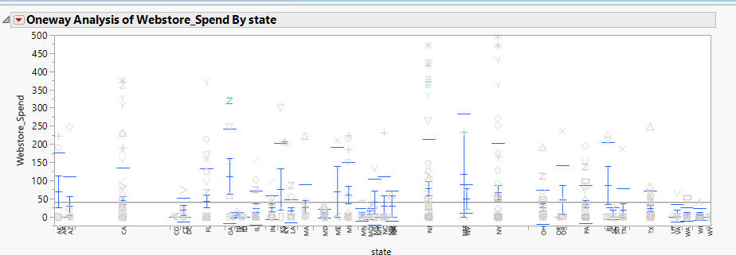

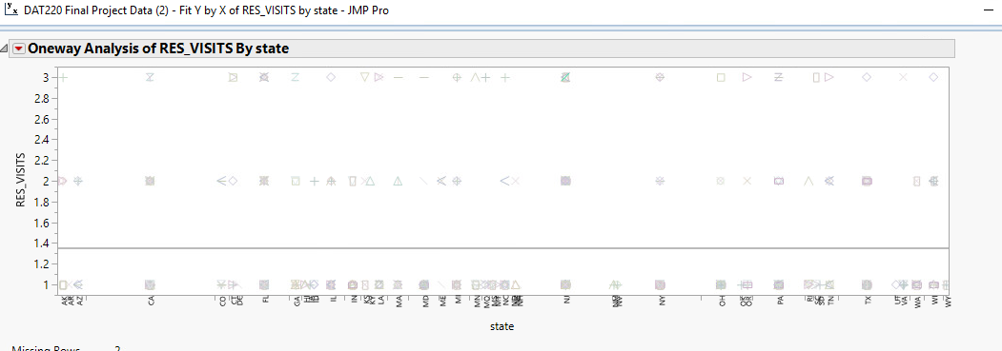

I then wanted to pick a couple of the states that had a high volume of visits and web store spending for further comparison. I used histograms to compare the income of the visitors, the age of the visitors, the web store spending and the basic visitation of the restaurant. I concluded that there were three strong states that would be good choices for a new campaign to push the web store and increase its revenue.

**Georgia**

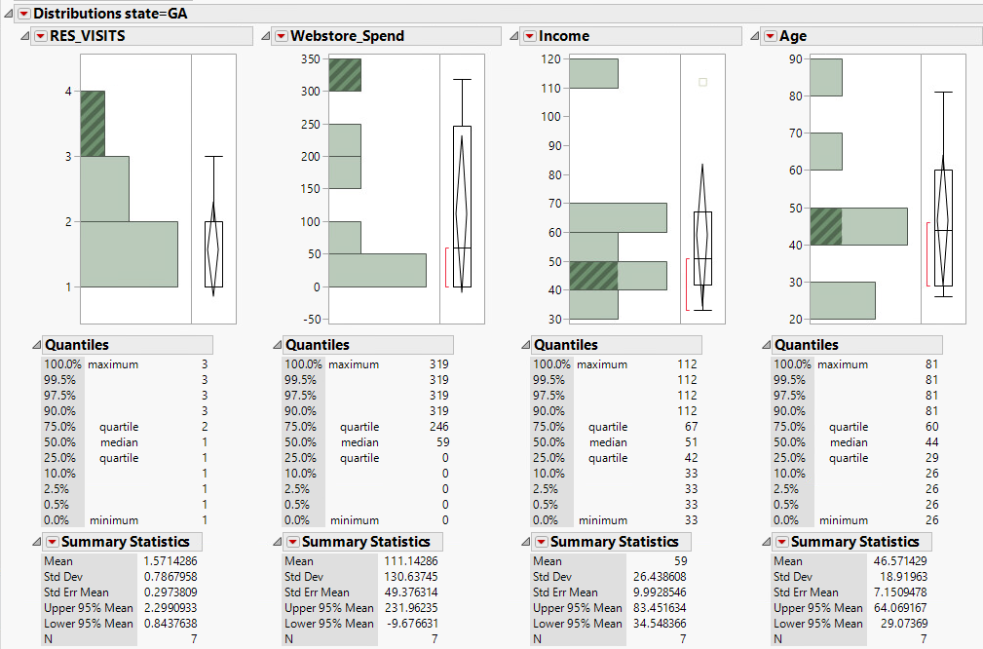

**Kentucky**

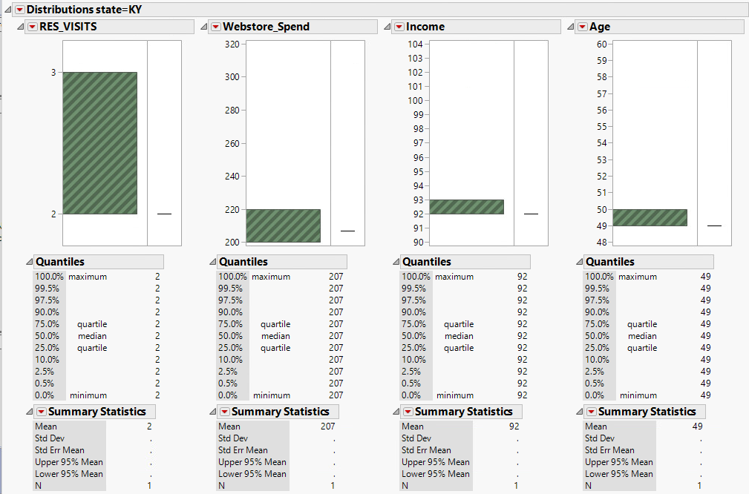

**Oregon**

