David Elliott

Evan Yeh

EE125 Homework #2

Problem 1: Multiple Detector

VHDL Code:



Simulation Results:

Tests cases:

* a = 0 : 0 is a multiple of all numbers (except 0)
* b = 0 : No number can be a multiple of 0
* a > b
* a < b
* random test cases



Problem 2: Absolute difference calculator

VHDL Code:

absolute_difference.vhd



user_types.vhd



Simulation Results:

Test cases:

* maximum absolute difference
* zero absolute difference and zero input
* zero absolute difference
* random test cases

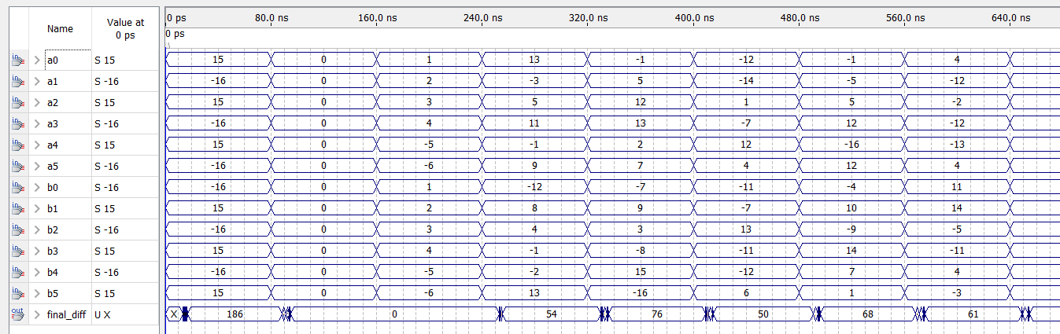

Problem 3: Leading-ones counter

VHDL Code:



Simulation Results:

Test cases:

* given cases
* random cases

