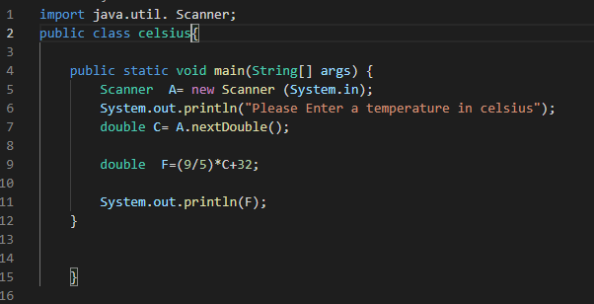

import java.util.Scanner;

public class Circle{

     public static void main(String[] args) {

         Scanner R= new Scanner (System.in);

        System.out.println("Please Enter the radius of a circle");

        double radius =R.nextDouble();

        double area= 2\*3.14159\*radius\*radius;

        double circumference= 2\*5\*radius;

        double circlediamiter=2\*radius;

        System.out.println(area);

        System.out.println(circumference);

        System.out.println(circlediamiter);

     }

    }

import java.util.Scanner;

public class Example

{

    public static void main (String []args)

    {

        double d1;

        double d2;

        Scanner abc = new Scanner(System.in);

        System.out.println("Please Enter the first number:   ");

        d1 = abc.nextDouble();

        System.out.println("Please Enter the second number:   ");

        d2 = abc.nextDouble();

        double sum = d1+d2;

        double mult = d1\*d2;

        System.out.println("the sum of the numbers is:   "+sum);

        System.out.println("the multiply of two numbers is:   "+mult);

    }

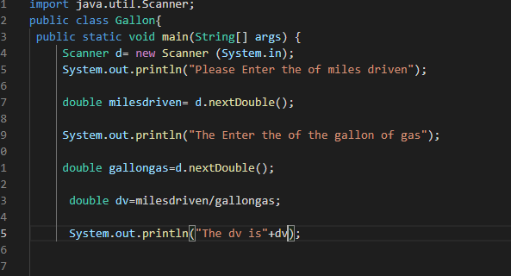 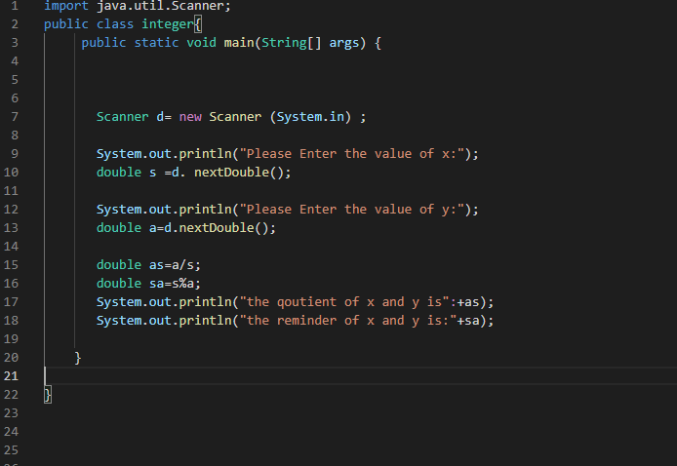

import java.util.Scanner;

public class Land{

    public static void main(String[] args){

        Scanner d = new Scanner (System.in);

        System.out.println("Please Enter the total square");

        int acre;

        acre=d.nextInt();

        int sq=43560;

       double d=acre/sq;

       System.out.println(d);

    }

}