Food Ordering System
Microservices — Technical Design

1. Overview
Three independent Spring Boot microservices, each with its own PostgreSQL database, fronted by an API Gateway. Services communicate over REST. JWT tokens are issued by the User Service and validated by calling it from downstream services.

Service | Port | Responsibility | Database
User Service | :8081 | Auth, JWT, profiles | user_db
Menu Service | :8082 | Restaurants and menu items | menu_db
Order Service | :8083 | Orders, status, pricing | order_db
API Gateway | :8080 | Single entry point, request forwarding | —

2. Class Diagram
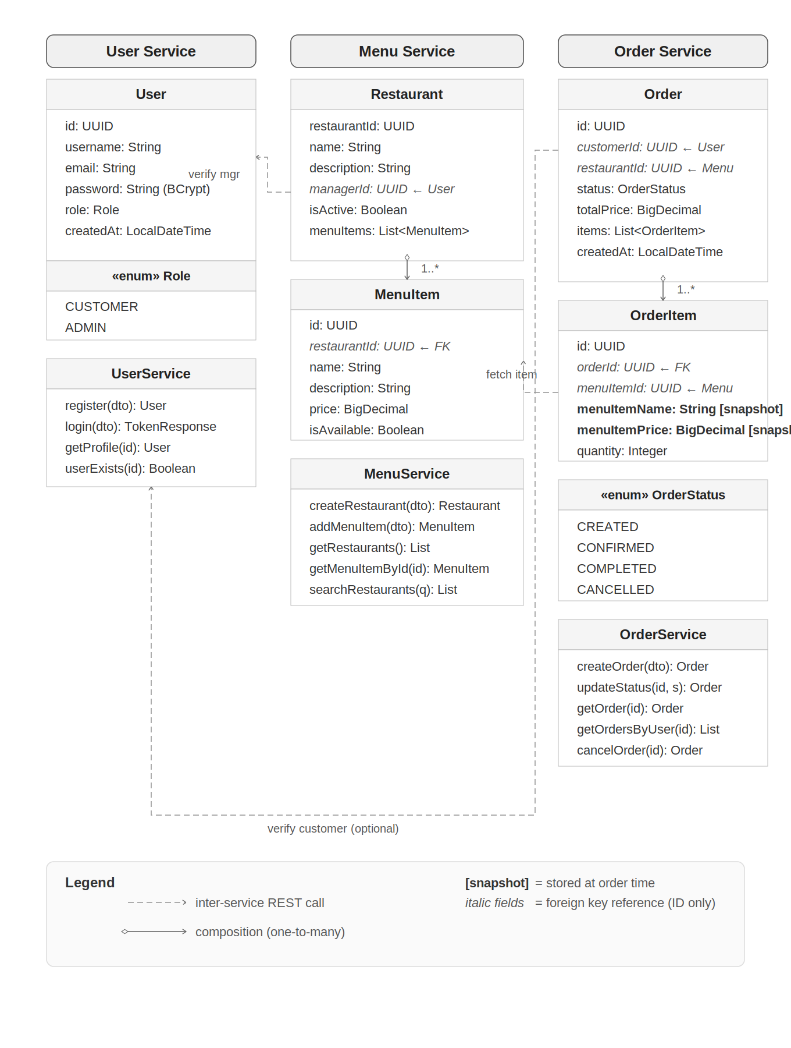
Figure 1 — Class diagram. Dashed arrows = inter-service REST calls. Italic fields = snapshot pattern.

3. Database Diagram
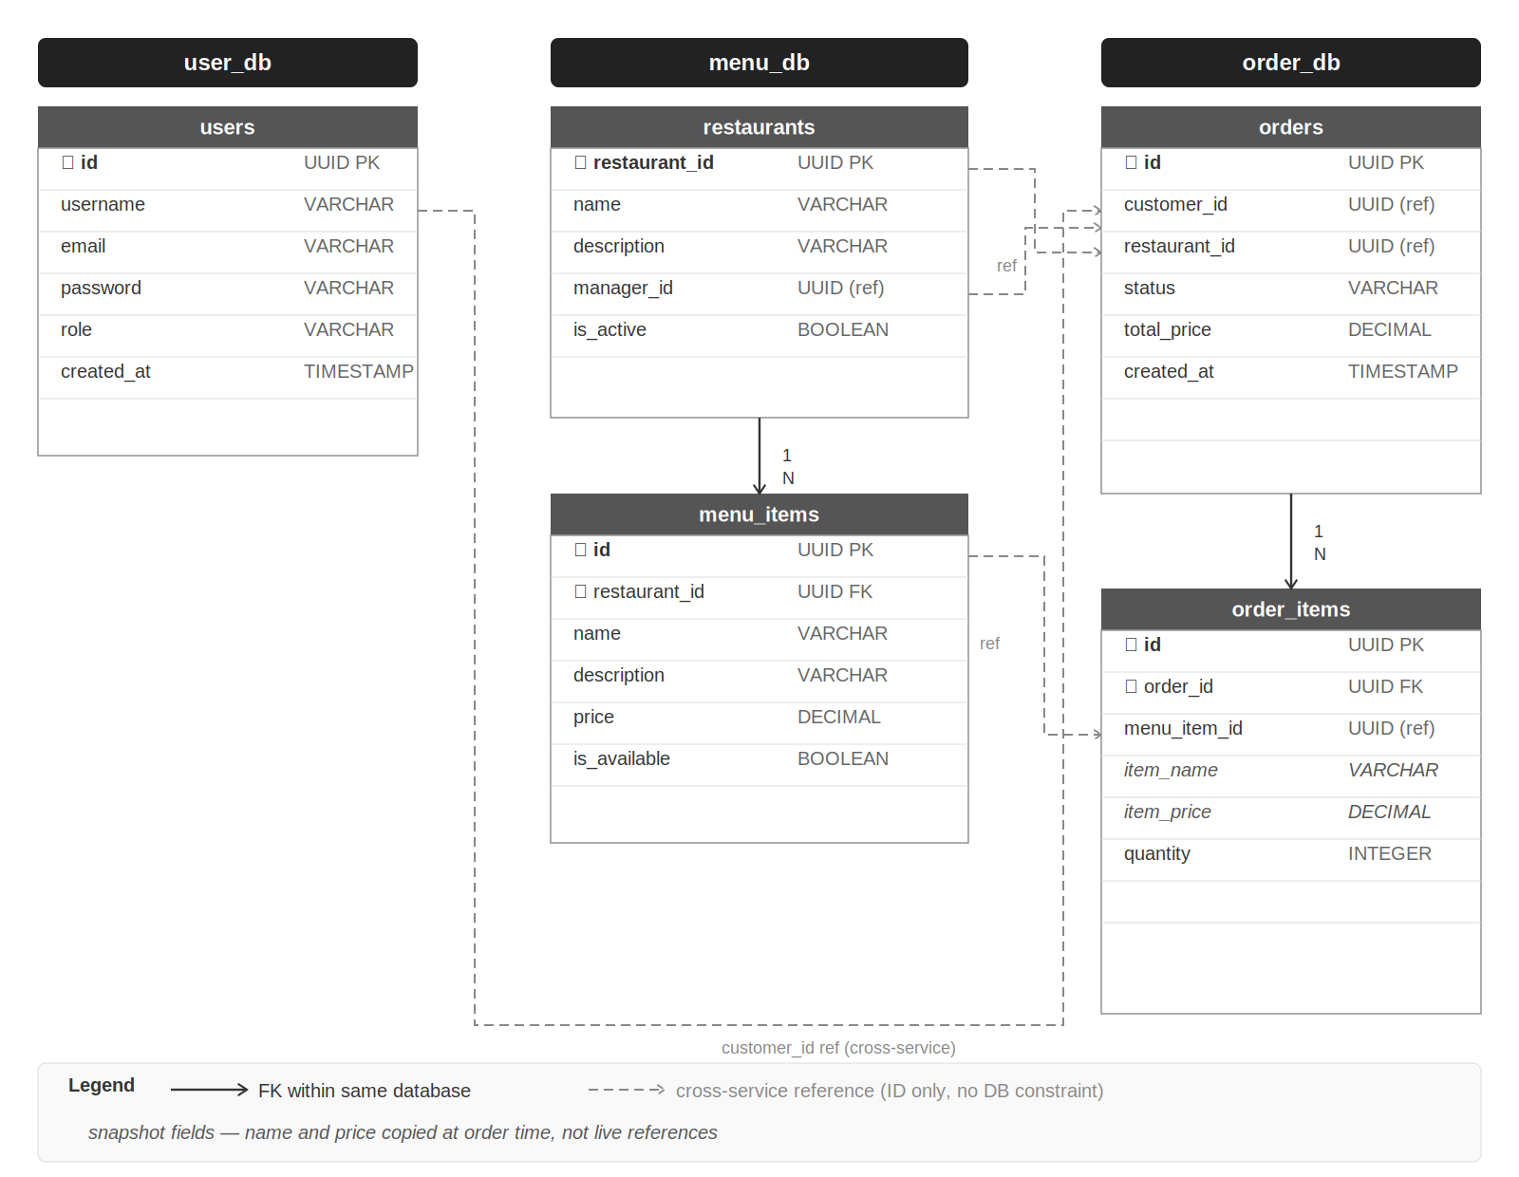
Figure 2 — Database schema. Solid arrows = FK within same DB. Dashed = cross-service ID reference (no DB constraint). ✦ = snapshot.

4. Data Models

User Service — user_db
Field | Type | Notes
id | UUID | PK
username | VARCHAR | Unique
email | VARCHAR | Unique
password | VARCHAR | BCrypt hash — never returned in responses
role | VARCHAR | CUSTOMER | ADMIN
created_at | TIMESTAMP

Menu Service — menu_db

restaurants
Field | Type | Notes
restaurant_id | UUID | PK
name | VARCHAR
description | VARCHAR
manager_id | UUID | Cross-service ref to users.id — validated on creation
is_active | BOOLEAN | Soft-disable without deleting

menu_items
Field | Type | Notes
id | UUID | PK
restaurant_id | UUID | FK → restaurants
name | VARCHAR
description | VARCHAR
price | DECIMAL
is_available | BOOLEAN | Order Service checks this before accepting the item

Order Service — order_db

orders
Field | Type | Notes
id | UUID | PK
customer_id | UUID | Cross-service ref to users.id — extracted from JWT
restaurant_id | UUID | Cross-service ref to restaurants.restaurant_id
status | VARCHAR | CREATED → CONFIRMED → COMPLETED | CANCELLED
total_price | DECIMAL | Calculated at order time
created_at | TIMESTAMP

order_items
Field | Type | Notes
id | UUID | PK
order_id | UUID | FK → orders
menu_item_id | UUID | Cross-service ref to menu_items.id
item_name | VARCHAR | SNAPSHOT — copied from Menu Service at order time
item_price | DECIMAL | SNAPSHOT — copied from Menu Service at order time
quantity | INTEGER

5. API Contracts
All endpoints are prefixed with /api. The Gateway on :8080 forwards traffic with no modification. Include JWT as: Authorization: Bearer <token>.

User Service :8081
Method | Path | Description | Auth
POST | /api/users/register | Register a new user | Public
POST | /api/users/login | Login, returns JWT | Public
GET | /api/users/me | Get own profile | CUSTOMER | ADMIN
PUT | /api/users/me | Update own profile | CUSTOMER | ADMIN
GET | /api/users/{id}/exists | Internal: does this user exist? | Internal
GET | /api/users/{id}/validate-token | Internal: validate JWT, return user info | Internal
GET | /api/users | List all users | ADMIN

Menu Service :8082
Method | Path | Description | Auth
GET | /api/menu/restaurants | List / search restaurants | Public
GET | /api/menu/restaurants/{id} | Get restaurant + full menu | Public
POST | /api/menu/restaurants | Create restaurant | ADMIN
PUT | /api/menu/restaurants/{id} | Update restaurant / toggle active | ADMIN
POST | /api/menu/restaurants/{id}/items | Add menu item | ADMIN
PUT | /api/menu/items/{id} | Update item (price, availability) | ADMIN
GET | /api/menu/items/{id} | Internal: fetch item for order | Internal

Order Service :8083
Method | Path | Description | Auth
POST | /api/orders | Place a new order | CUSTOMER
GET | /api/orders/{id} | Get order by ID | CUSTOMER (own) | ADMIN
GET | /api/orders/my | All orders for logged-in user | CUSTOMER
PATCH | /api/orders/{id}/status | Advance order status | ADMIN
PATCH | /api/orders/{id}/cancel | Cancel order (only if CREATED) | CUSTOMER | ADMIN
GET | /api/orders | List all orders | ADMIN

API Gateway :8080
Gateway path | Forwards to | Port
/api/users/** | user-service | :8081
/api/menu/** | menu-service | :8082
/api/orders/** | order-service | :8083

6. Team Responsibilities
Student | Primary responsibility
1 | User Service + Spring Security + JWT
2 | Menu Service
3 | Order Service + inter-service calls
4 | API Gateway + Docker + Kubernetes

