- Refer this website and the landing page with the backend of the Things the are flowing like a galaxy is what we want to use here too - https://subhshantiwealth.com/ but keep the color to mint green and the other colors as per the front page of the website
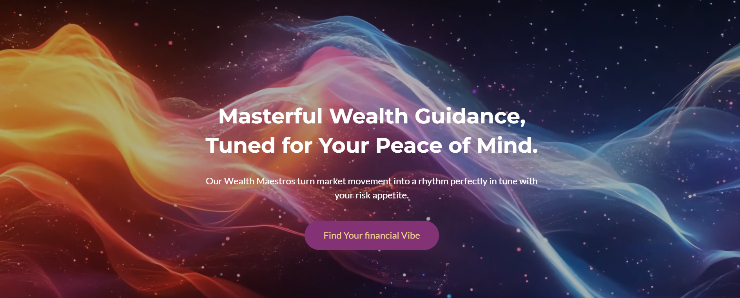

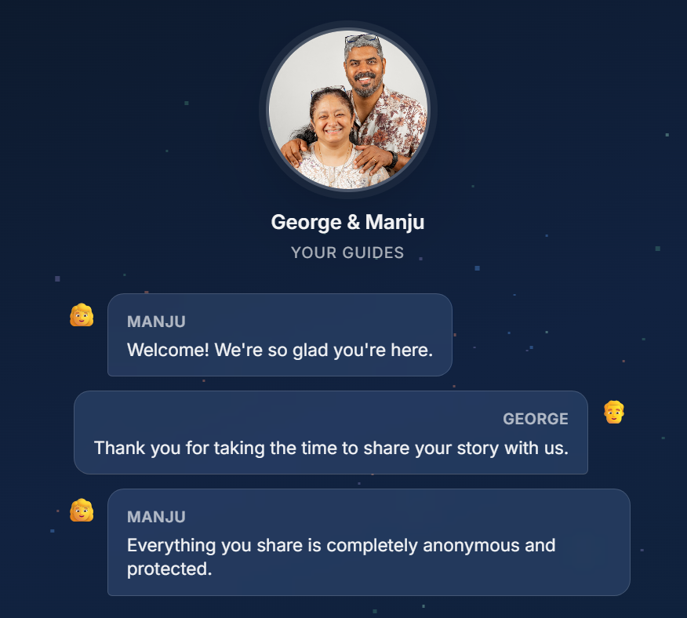
- Instead of the Emoji I want the Individual photos that is in the folder. For Manju use Manju_P and for George use George_P
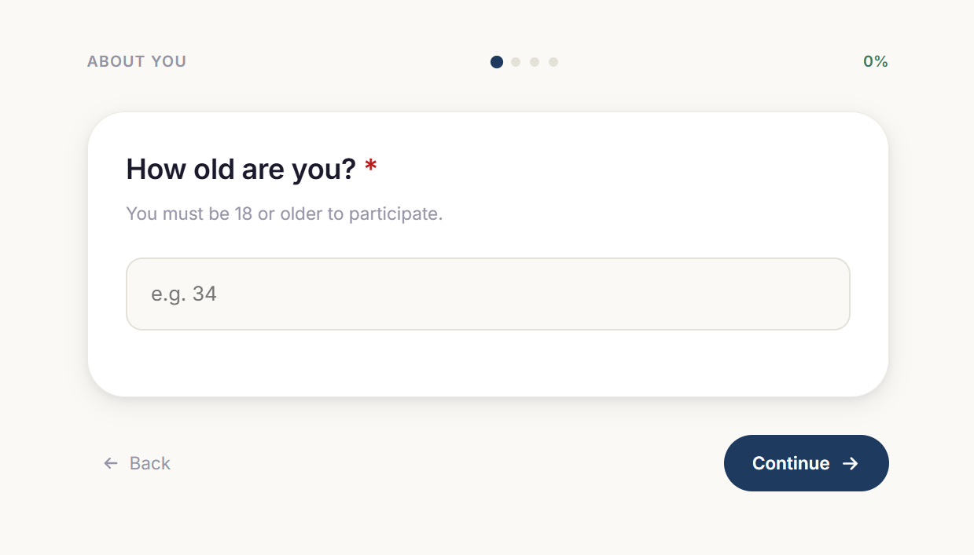
We need a validation criteria here like How Old are you? Remove You must be 18 or older to participate – Add The age matters to understand the ability of your thinking to make decisions of your story
In the box add month and Year of Birth and the system will automatically pull the age of the individual with the number of days old. While you show an example it needs to be a simple UI that we get this information quickly and move on but its mandatory to get

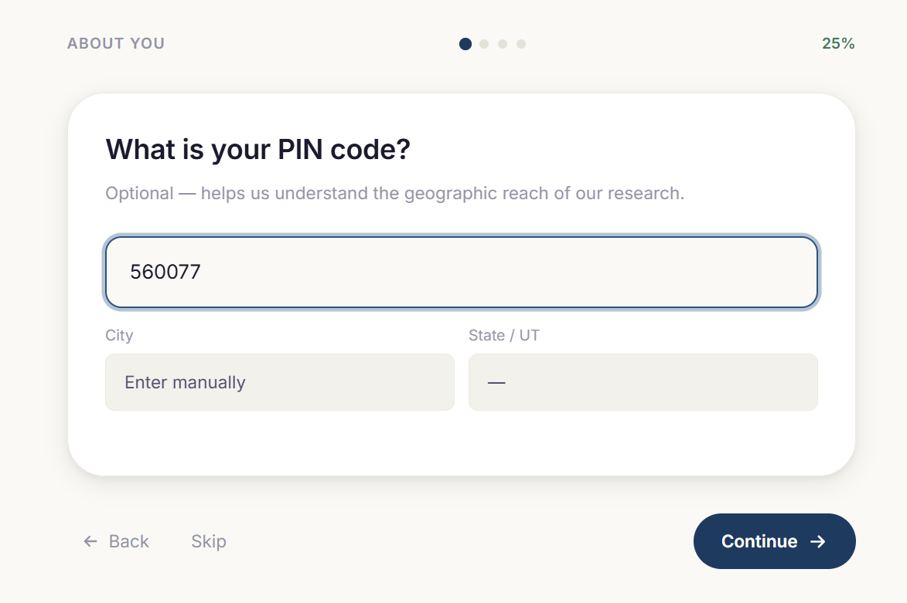
The Pin code is entered and the other information is not extracting we need to fix it find solutions and fix it. Or can we use the IP Address from where there are clicking from and automatically sink their City and State or find a database online which will help us sink this data based on the Postcode that they share for India as a country
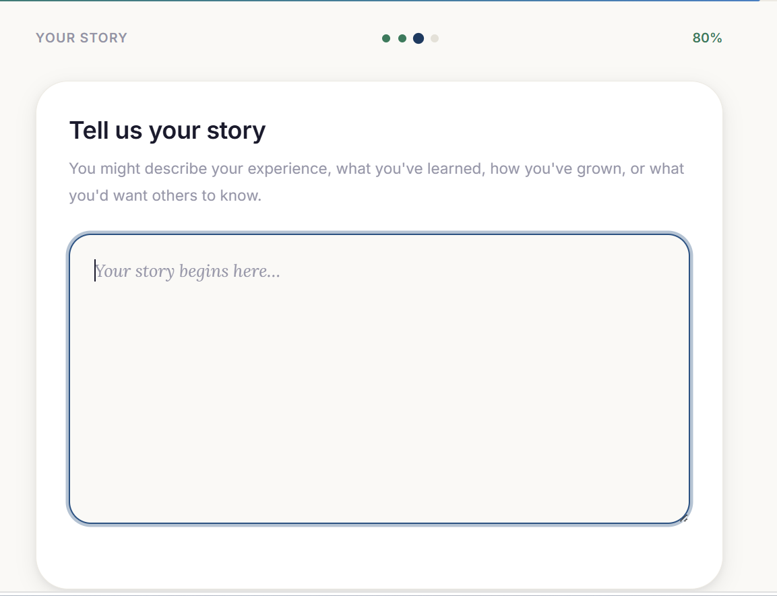
Can we add a Speech to text API that is available for free as an option so that humans can speak and the data can be captured which will give the human to ability to be detailed in the story
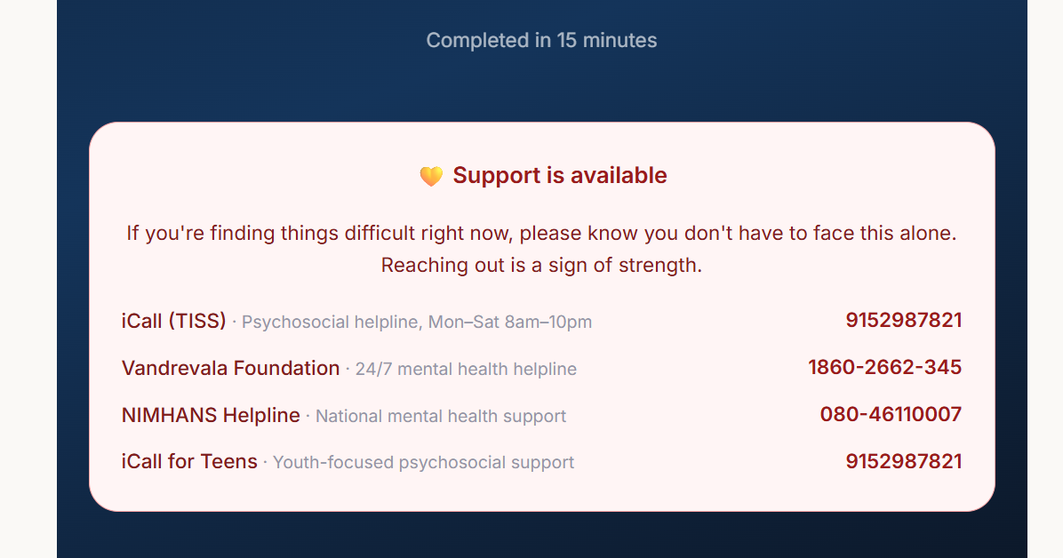
Support is available immediately and I need to give the Toll Free Number for Santhosa Samsara which is 1800-203-3545. Remove the other information and only use this information and make the font really big and bold.

