Type of the Paper (Article, Review, Communication, etc.)

Title

Firstname Lastname 1, Firstname Lastname 2 and Firstname Lastname 2,*

|  |
| --- |
| **Citation:** To be added by editorial staff during production.  Academic Editor: Firstname Lastname  Received: date  Revised: date  Accepted: date  Published: date    **Copyright:** © 2024 by the authors. Submitted for possible open access publication under the terms and conditions of the Creative Commons Attribution (CC BY) license (https://creativecommons.org/licenses/by/4.0/). |

1 Affiliation 1; e-mail@e-mail.com

2 Affiliation 2; e-mail@e-mail.com

**\*** Correspondence: e-mail@e-mail.com; Tel.: (optional; include country code; if there are multiple corresponding authors, add author initials)

**Abstract:**

**Keywords:**

1. Introduction

2. Materials and Methods

2.1. Data Collection

This study utilizes control and schizophrenia patient data from the Function Biomedical Informatics Research Network (FBIRN) repository [34], preprocessed according to the description given in [35]. To summarize, a statistical parametric mapping package ([SPM12](http://www.fil.ion.ucl.ac.uk/spm/)) was used to correct for subject head motion and slice timing differences, to warp subject anatomy to the Montreal Neurological Institute (MNI) echo planar imaging (EPI) template space, to resample the collected data to mm3 isotropic voxels, and to smooth the resampled fMRI images with a Gaussian kernel with a full width at half maximum (FWHM) of mm. Subjects with head motion greater than were excluded from the study, as were subjects whose full brains could not be normalized due to incomplete imaging data. These criteria led to a final dataset of 151 schizophrenia (SZ) patients and 160 healthy controls (HCs).

To the author’s surprise, the review article for the FBIRN dataset does not contain certain data parameters of interest, such as the time-to-repetition of each dataset [1]. It will be necessary for the author to locate the article which first published the schizophrenia dataset. Time-to-repetition, in particular, is necessary to accurately estimate mode frequencies using dynamic mode decomposition.

2.2. Estimation of the Spatial Functional Networks

Spatial functional networks were estimated using NeuroMark’s adaptive independent component analysis (adaptive ICA) [35], which extends spatially constrained independent component analysis [36,37] to map known fMRI network templates to novel subject data. This requires balancing two competing goals: to maximize the spatial independence of networks in each subject and to ensure that the network maps in each subject correspond to known group-level templates. Here, we use the multi-objective optimized ICA with reference (MOO-ICAR) approach, which maximizes two competing objective functions in turn until a solution is achieved. This allows adaptive ICA to capture subject-unique characteristics while maintaining comparable functional networks across datasets. It should be noted that this method allows us to capture both the internal structure of brain functional connectivity networks and the extent of inter-network connectivity via static and sliding-window functional connectivity estimates.

2.3. Estimation of the Functional Network Connectivity

Before estimating the functional network connectivity (FNC), Du et al. [35] chose to remove noise sources from each functional network’s subject-level time series. The removal of noise sources involved four steps: first, the removal of linear, quadratic, and cubic trends in the data; second, multiple regressions of the six realignment parameters and their temporal derivatives to control for in-scanner motion; third, de-spiking to remove outliers; and fourth, band-pass filtration to select for signals in the 0.01–0.15 Hz frequency bands. Once these steps were completed, subject-level static functional network connectivity (sFNC) was computed via Pearson correlation. Other measures of statistical similarity could have been used; for instance, mutual information has been proposed due to its sensitivity to nonlinear interactions [38,39]. However, Pearson correlation’s simplicity, interpretability, and ease of computation means it remains the dominant method for estimating functional connectivity.

While the static FNC provides valuable information on the extent of inter-network communication, its poor time resolution makes it unable to capture the dynamics of this communication. The two most notable methods proposed to circumvent this problem are the sliding time window approach [25,27,40] and coherence-based connectivity [41–43], [44]. The present study uses the sliding window approach. As the name suggests, this method slides a window over the time series of each ICN in small steps, thus segmenting the total time series into many short, overlapping time series. The functional network connectivity of each time series window is computed in the same way as for static FNC, and the resulting connectivity matrices are concatenated into an array ( being the number of functional networks and the number of time series windows). This study convolved a normal distribution with a mean of zero and a standard deviation of three with a rectangle 40-times-to-repetition (TRs) long [35] to generate its selection window.

2.4. Estimation of the Dynamic Mode Decomposition

The authors’ goal is to identify spatial modes which recur at specific frequencies in the functional network connectivity. To achieve this, we employ dynamic mode decomposition (DMD), a dimensionality reduction method developed in 2008. Unlike more well-established dimensionality reduction methods such as principal component analysis (PCA) or independent component analysis (ICA), which assume ergodic, time-independent data sources, DMD accounts for the time dependence present in functional neuroimaging data. More specifically, DMD estimates a set of spatial modes, each of which is associated with an oscillation frequency and amplitude. Conceptually, it bears some resemblance to classic Fourier analysis, although the underlying theory differs substantially.

At its core, dynamic mode decomposition is a method for finding a low-dimensional representation of a complex, often nonlinear dynamic system . To achieve this, the user collects system inputs and outputs such that and attempts to find a linear approximation of such that . While it seems implausible that a linear operator can even approximately capture the dynamics of a nonlinear system, it has been shown that such an operator does exist for any such system [2]. DMD may be considered a numerical approximation to a spectral analysis of the true Koopman operator [3], losing some precision in exchange for algorithmic tractability. It is through this lens—as a linear approximation to true system dynamics—that the authors chose to apply DMD.

2.4.1. Standard (SVD) DMD

DMD is most often e

2.4.2. Exact DMD

3. Results

3.1. Frequency Spectrum

The selected patient’s dynamic mode decomposition (DMD) displays sixty-eight (68) unique finite frequencies in addition to the constant component of frequency zero (0). Each frequency is associated with a spatial connectivity mode (map) and spatial phase mode (map), and power. Examining the frequency power spectrum reveals an exponential decrease as a function of frequency, in line with the power law hypothesis. Initial fits of the form suggest coefficients of and (95% confidence). The power-law substantially overestimates the power of the distribution’s tail, however. As such, an exponential fit of the form was also tested, producing coefficients of and (95% confidence). Fit of the power spectrum’s tail notably improved with this second version, with rising from to .

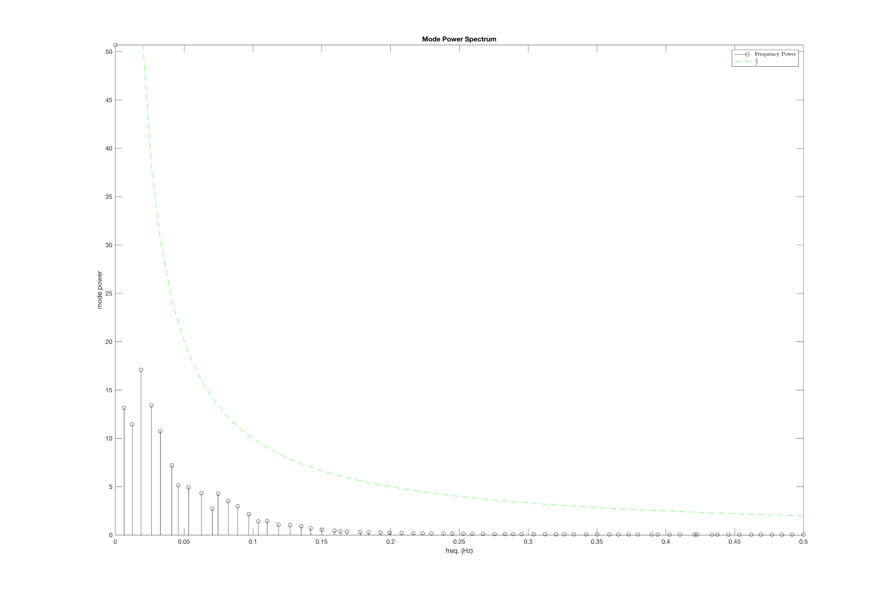

3.2. Mode Eigenvalues

The selected patient possesses 136 eigenvalues, of which 134 are complex conjugate pairs (67 pairs). This results in 67 unique complex conjugate pairs of eigenvalues, plus two unpaired eigenvalues corresponding to the lowest and highest frequencies. Of these 136 eigenvalues, only these unpaired eigenvalues are real numbers and respectively). The remaining 67 complex conjugate pairs are scattered across the unit circle in the complex plane. All but three eigenvalues have magnitudes less than unity, indicating decaying oscillations. The remaining three, corresponding to the frequencies and , have magnitudes slightly above unity ( and respectively), suggesting a weak increase in amplitude over the course of the scan. It must be observed, however, that all eigenvalues lie in the vicinity of the unit circle, indicating that modes are relatively stable.

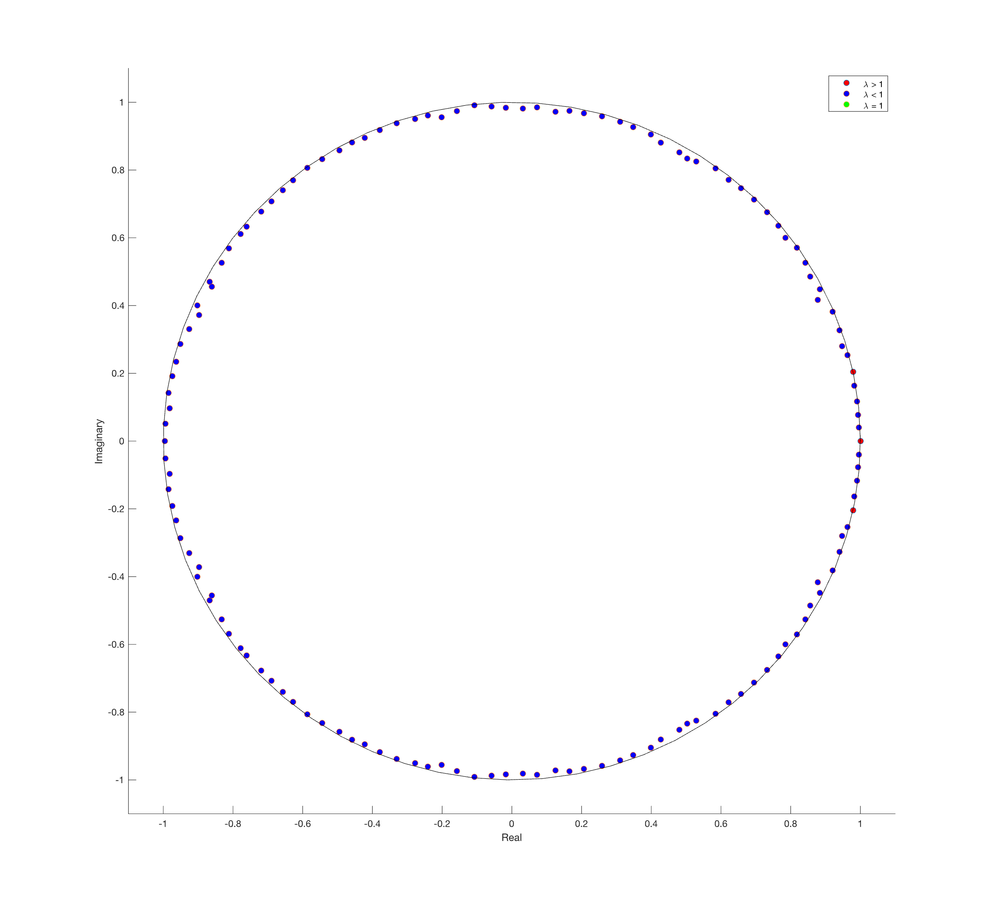

3.3. Mean Squared Error of the Samples

The mean squared error (MSE) per fully reconstructed sample (time point) is universally quite small , a fact reflected in the excellent visual agreement between original and reconstructed sFNC. However, the time-resolve MSE contains a quasiperiodic peaks-and-valleys structure that resembles a periodic function. The period is irregular, with gaps between peaks separated by anywhere from 15 to 31 time points. It may be a linear combination of functions with different frequencies, which could also explain why the last error “peak” has a gap of two samples in its center.

When only the three modes with the highest power are used for reconstruction, mean squared error increases by about a factor of 20 . Subtracting the partial reconstruction from the full reconstruction confirms that using three modes changes values by at most 10% over the entire connectivity map. However, this difference map displays considerable structure, suggesting that despite the contributing only a small amount of total power, higher-frequency modes contain considerable information that may be of interest to researchers. For this reason, the author recommends continued examination of higher-frequency modes, although he is not immediately certain how this might be done.

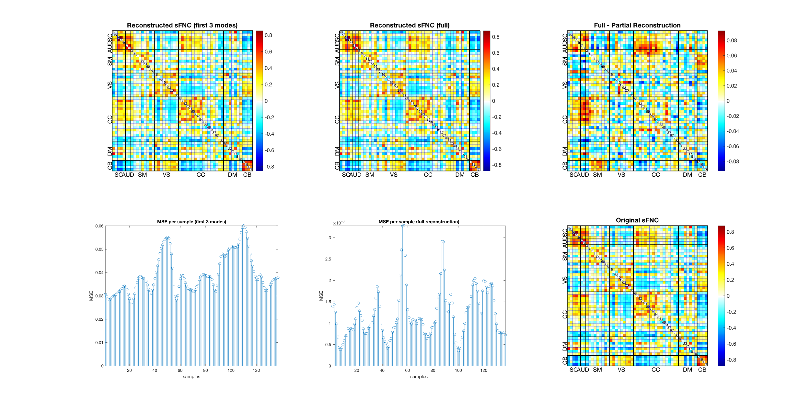

3.4. Functional Timecourses

To confirm the findings of eigenvalue analysis (Sec. 3.2), the author has elected to plot the time courses of the auditory cortex for the first six non-stationary modes, corresponding to the frequencies . Specifically, he selected the correlation values of networks 58 and 3 with those of 53, 98, 99, and 45 (rows 6 and 7, columns 2, 3, and 4). The original FNC values for the selected patient are plotted for comparison.

The intensity of the modes corresponding to the first three frequencies show a weak exponential decay, as predicted by eigenvalue analysis. The remaining three also display decay, but this decay is not smoothly exponential. Instead, FNC value oscillations appears to display both a fast main frequency and a notably slower envelope frequency, with the envelope frequency increasing along with the main frequency. This, along with the choppy nature of some faster oscillations, may indicate an aliasing effect. Depending on the time-to-repetition, it would not be entirely surprising to find that some modes exceed the data’s Nyquist limit. The author would be surprised to find this to be the case for such low-frequency modes, but the possibility should not be ignored.

It is worth nothing that all the visualized modes display decay over the course of the scan. This is despite the fact that the original FNC values do not display an overall loss in amplitude during the scan cycle. The author must wonder about the origin of the additional power in the signal. As mode power generally declines with frequency, the additional power is unlikely to come from high frequencies. Further, one of the displayed frequencies, , had an eigenvalue greater than unity, which should indicate *increasing* power over the course of the scan. Reconstruction of this mode, however, suggests the opposite.

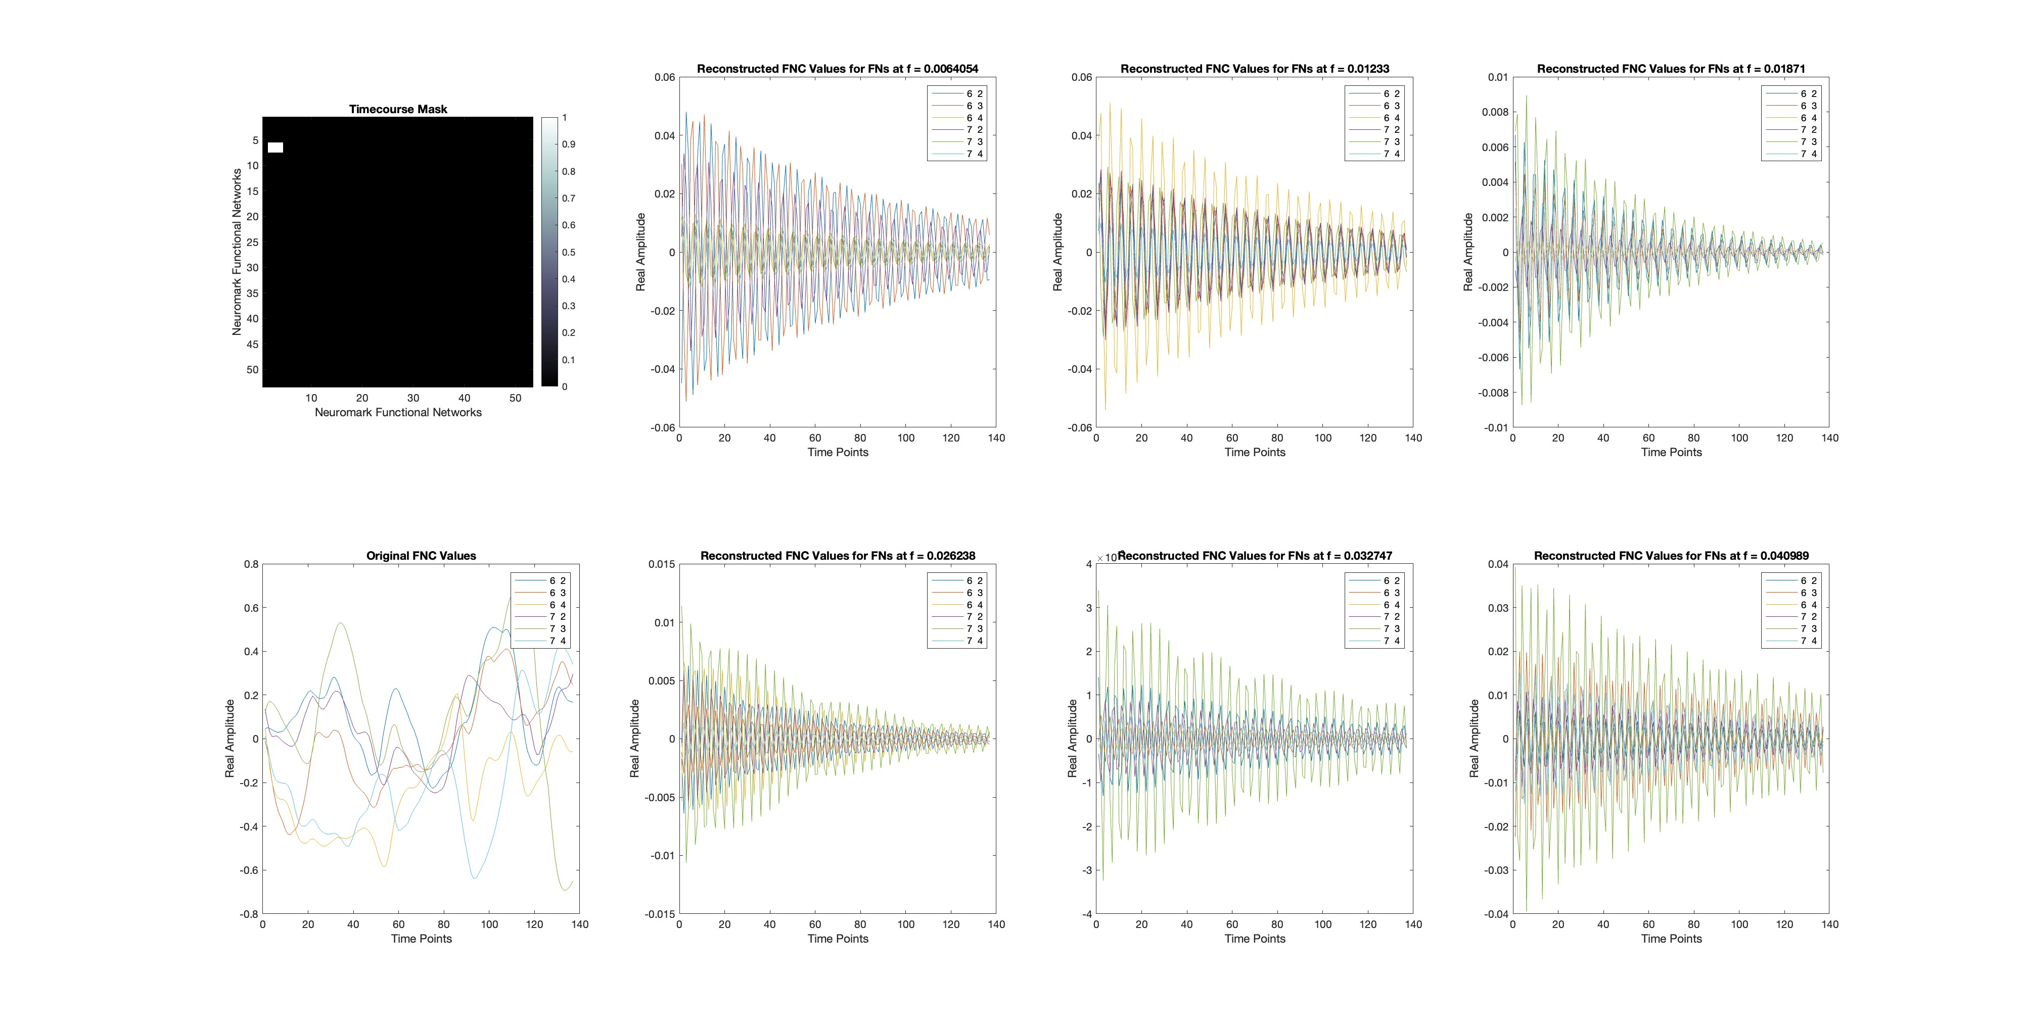

4. Next Steps

4.1. Study-Level Modes and their Spectra

An obvious next step in the present study is to extract DMD modes from all subjects in the FBIRN dataset and search for notable differences in power spectra between groups. This may show whether the disorders contained in the FBIRN data affect the dynamic evolution of dFNC. It may also be worth comparing spectra to clinical or behavioral scores to determine whether any frequencies have clear behavioral effects. This second analysis may need to account for interaction effects.