Type of the Paper (Article, Review, Communication, etc.)
Title
Firstname Lastname ¹, Firstname Lastname ² and Firstname Lastname ^{2,}*
Citation: To be added by editorial staff during production.
Academic Editor: Firstname Lastname
Received: date
Revised: date
Accepted: date
Published: date

Copyright: © 2024 by the authors. Submitted for possible open access publication under the terms and conditions of the Creative Commons Attribution (CC BY) license (https://creativecommons.org/licenses/by/4.0/).
¹ Affiliation 1; e-mail@e-mail.com
² Affiliation 2; e-mail@e-mail.com
* Correspondence: e-mail@e-mail.com; Tel.: (optional; include country code; if there are multiple corresponding authors, add author initials)
Abstract:
Keywords:

1. Introduction

2. Materials and Methods

2.1. Data Collection
This study utilizes control and schizophrenia patient data from the Function Biomedical Informatics Research Network (FBIRN) repository [34], preprocessed according to the description given in [35]. To summarize, a statistical parametric mapping package (SPM12) was used to correct for subject head motion and slice timing differences, to warp subject anatomy to the Montreal Neurological Institute (MNI) echo planar imaging (EPI) template space, to resample the collected data to $3×3×3$ mm³ isotropic voxels, and to smooth the resampled fMRI images with a Gaussian kernel with a full width at half maximum (FWHM) of $6$ mm. Subjects with head motion greater than $3°$ were excluded from the study, as were subjects whose full brains could not be normalized due to incomplete imaging data. These criteria led to a final dataset of 151 schizophrenia (SZ) patients and 160 healthy controls (HCs).
To the author’s surprise, the review article for the FBIRN dataset does not contain certain data parameters of interest, such as the time-to-repetition of each dataset [1]. It will be necessary for the author to locate the article which first published the schizophrenia dataset. Time-to-repetition, in particular, is necessary to accurately estimate mode frequencies using dynamic mode decomposition.

2.2. Estimation of the Spatial Functional Networks
Spatial functional networks were estimated using NeuroMark’s adaptive independent component analysis (adaptive ICA) [35], which extends spatially constrained independent component analysis [36,37] to map known fMRI network templates to novel subject data. This requires balancing two competing goals: to maximize the spatial independence of networks in each subject and to ensure that the network maps in each subject correspond to known group-level templates. Here, we use the multi-objective optimized ICA with reference (MOO-ICAR) approach, which maximizes two competing objective functions in turn until a solution is achieved. This allows adaptive ICA to capture subject-unique characteristics while maintaining comparable functional networks across datasets. It should be noted that this method allows us to capture both the internal structure of brain functional connectivity networks and the extent of inter-network connectivity via static and sliding-window functional connectivity estimates.

2.3. Estimation of the Functional Network Connectivity
Before estimating the functional network connectivity (FNC), Du et al. [35] chose to remove noise sources from each functional network’s subject-level time series. The removal of noise sources involved four steps: first, the removal of linear, quadratic, and cubic trends in the data; second, multiple regressions of the six realignment parameters and their temporal derivatives to control for in-scanner motion; third, de-spiking to remove outliers; and fourth, band-pass filtration to select for signals in the 0.01–0.15 Hz frequency bands. Once these steps were completed, subject-level static functional network connectivity (sFNC) was computed via Pearson correlation. Other measures of statistical similarity could have been used; for instance, mutual information has been proposed due to its sensitivity to nonlinear interactions [38,39]. However, Pearson correlation’s simplicity, interpretability, and ease of computation means it remains the dominant method for estimating functional connectivity.
While the static FNC provides valuable information on the extent of inter-network communication, its poor time resolution makes it unable to capture the dynamics of this communication. The two most notable methods proposed to circumvent this problem are the sliding time window approach [25,27,40] and coherence-based connectivity [41–43], [44]. The present study uses the sliding window approach. As the name suggests, this method slides a window over the time series of each ICN in small steps, thus segmenting the total time series into many short, overlapping time series. The functional network connectivity of each time series window is computed in the same way as for static FNC, and the resulting $N×N$ connectivity matrices are concatenated into an $N×N×T$ array ($N$ being the number of functional networks and $T$ the number of time series windows). This study convolved a normal distribution with a mean of zero and a standard deviation of three $\left(N\left(μ=0, σ=3\right)\right)$ with a rectangle 40-times-to-repetition (TRs) long [35] to generate its selection window.

2.4. Estimation of the Dynamic Mode Decomposition
The authors’ goal is to identify spatial modes which recur at specific frequencies in the functional network connectivity. To achieve this, we employ dynamic mode decomposition (DMD), a dimensionality reduction method developed in 2008. Unlike more well-established dimensionality reduction methods such as principal component analysis (PCA) or independent component analysis (ICA), which assume ergodic, time-independent data sources, DMD accounts for the time dependence present in functional neuroimaging data. Specifically, DMD estimates a set of spatial modes, each of which is associated with an oscillation frequency and amplitude. Conceptually, it bears some resemblance to classic Fourier analysis, although the underlying theory differs substantially.
At its core, dynamic mode decomposition is a method for finding a low-dimensional representation of a complex, often nonlinear dynamic system $f$. To achieve this, the user collects system inputs $\left(X\right)$ and outputs $\left(Y\right)$ such that $y_{k}=f\left(x_{k}\right)$ and attempts to find a linear approximation $A$ of $f$ such that $Y=AX$. While it seems implausible that a linear operator can even approximately capture the dynamics of a nonlinear system, it has been shown that such an operator does exist for any such system [2]. DMD may be considered a numerical approximation to a spectral analysis of the true Koopman operator [3], losing some precision in exchange for algorithmic tractability. It is through this lens—as a linear approximation to true system dynamics—that the authors chose to apply DMD.

2.4.1. Standard (SVD) DMD
As a method arising from fluid dynamics, it should come as no surprise that DMD is most often used to analyze sequential, time-resolved data. This means that the standard DMD algorithm assumes that any data matrix $Z$ contains both the inputs and outputs of the system $f$ under analysis: $z_{k+1}=f\left(z_{k}\right)$. $f$ is generally unknown and may be nonlinear; however, Koopman operator theory states that a linear operator $A$ which approximates these dynamics exists. This operator is usually found via an extension of singular value decomposition (SVD) [4], which has proven more stable than the original companion matrix-based formulation [3]. The researcher separates the data matrix $Z$ into inputs $X= \left[z_{1}…z_{m-1}\right]$ and outputs $Y= \left[z_{2}…z_{m}\right]$. He then computes the singular value decomposition of $X \left(X=UΣV^{*}\right)$ and defines a new matrix $\tilde{A}≜U^{*}YVΣ^{-1}$. This matrix $\tilde{A}$ defines the dynamic mode decomposition modes $φ$ and eigenvalues $λ$ according to $\tilde{A}w=λw$ and $φ≜Uw$. Each mode’s eigenvalue $λ$ defines its characteristic frequency $f$ according to the relation $f= \frac{\ln{λ}}{2πΔt}$, with $Δt$ as the interval between data samples.

2.4.2. Exact DMD
While standard DMD assumes a sequential data matrix $Z$, such that $z_{k+1}=f\left(z_{k}\right)$, the mathematics do not necessarily require such an arrangement. Indeed, so far as the linear algebra is concerned, $z_{k+1}$ need not relate to $z_{k}$ at all. It is entirely possible to formulate inputs $X$ and outputs $Y$ with any order of columns $k$, so long as that order is consistent between $X$ and $Y$. This reformulation of DMD as an analysis of data pairs $\left\{\left(x_{k},y_{k}\right)\right\}$, rather than sequential data, greatly expands applicability of dynamic mode decomposition. Most notably for this study, it allows the researcher to concatenate data from multiple experimental runs or subjects, which can dramatically improve spectral and modal resolution. Much of the present study uses this feature to detect group-level effects which may be obscured in subject-level analysis.
Mathematically, the exact DMD algorithm [5] is mostly identical to the SVD approach described in Section 2.4.1. The main difference arises in the definition of the modes $φ$, which exact DMD defines as $φ=\frac{YVΣ^{-1}}{λ}w$ for each eigenvector $w$. This alternative definition is shown to be equivalent up to a projection to the standard definition $φ≜Uw$.

2.4.3. Comparison of standard vs. exact DMD modes
Tu et. al. go to some pains to explain that standard DMD and exact DMD modes are identical up to a projection. Taking exact DMD modes $φ$ as the “true” modes, standard DMD modes $\hat{φ}$ must satisfy the relation $\hat{φ}=P_{X}φ$, with $P_{X}$ representing the orthogonal projection onto the image of the input matrix $X$. By the same token, the “true” modes $φ$ lie in the image of the output matrix $Y$. In the present case, where $y_{t}=x_{t+1}$ it is probable that these images are similar enough to be visually and computationally indistinguishable. However, it is likely worth comparing the two to confirm that both methods produce similar results.

2.5. Group-Level Decomposition

2.5.1. Comparison of Group-Level Modes

2.5.2. Comparison of Group-Level Spectra

2.6. Subject-Level Decomposition

2.6.1. Comparison of Subject-Level Modes

2.6.2. Comparison of Subject-Level Spectra

2.6.3. Comparing Subject Modes to Group Modes

2.6.4. Comparing Subject Spectra to Group Spectra

2.7. Independent Mode Decomposition

2.7.1.

3. Results

3.1. Frequency Spectrum
The selected patient’s dynamic mode decomposition (DMD) displays sixty-eight (68) unique finite frequencies in addition to the constant component of frequency zero (0). Each frequency is associated with a spatial connectivity mode (map) and spatial phase mode (map), and power. Examining the frequency power spectrum reveals an exponential decrease as a function of frequency, in line with the power law hypothesis. Initial fits of the form $P=af^{b}$ suggest coefficients of $a=0.4494±0.1510$ and $b=-0.7383±0.0798$ (95% confidence). The power-law substantially overestimates the power of the distribution’s tail, however. As such, an exponential fit of the form $P=ae^{bf}$ was also tested, producing coefficients of $a=18.0687±1.0994$ and $b=-21.0140±1.7465$ (95% confidence). Fit of the power spectrum’s tail notably improved with this second version, with $R^{2}$ rising from $0.7222$ to $0.9346$.

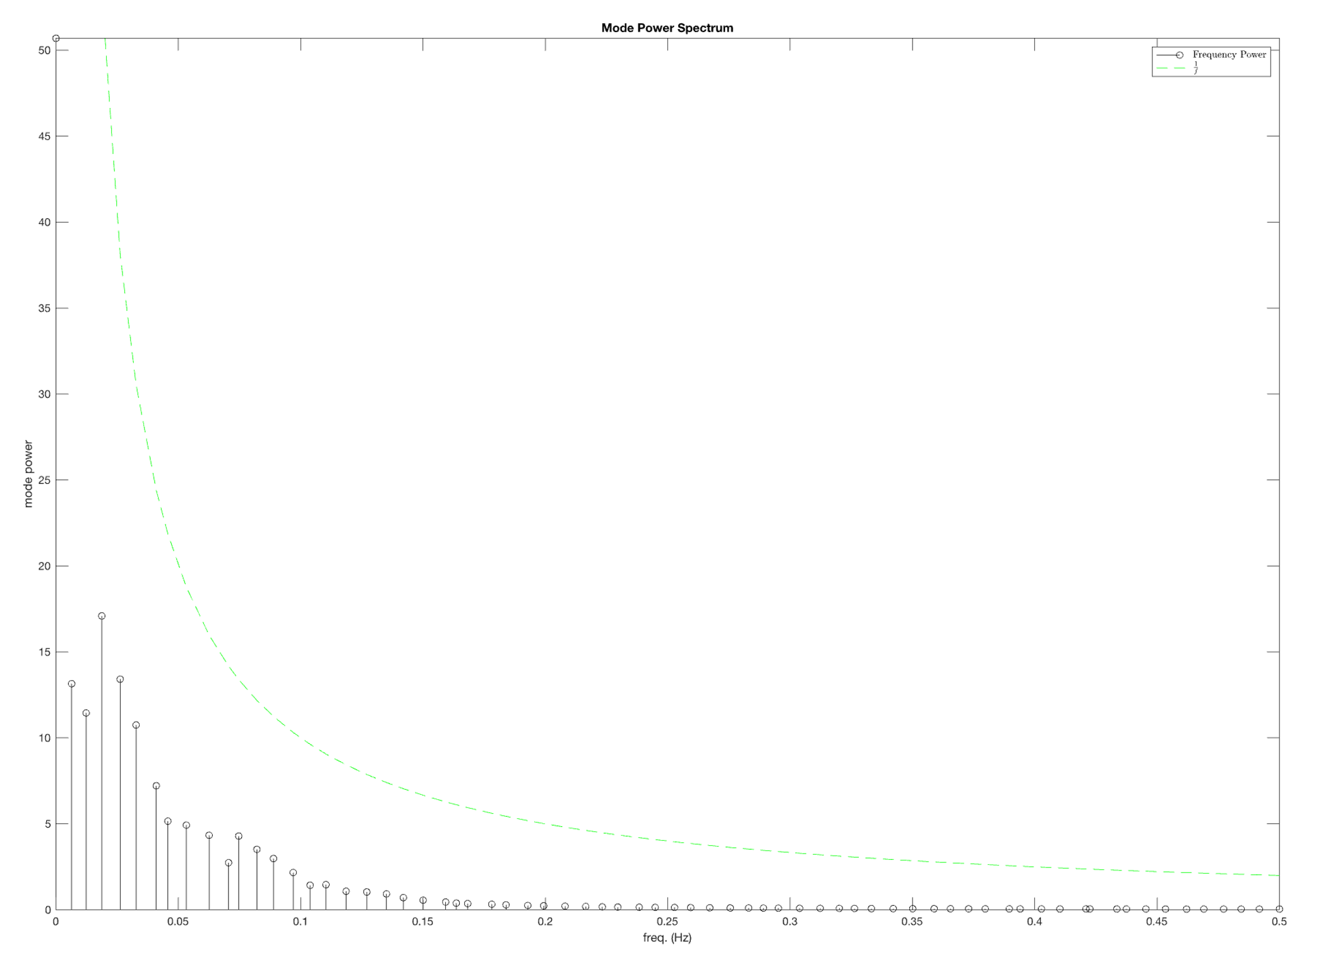

3.2. Mode Eigenvalues
The selected patient possesses 136 eigenvalues, of which 134 are complex conjugate pairs (67 pairs). This results in 67 unique complex conjugate pairs of eigenvalues, plus two unpaired eigenvalues corresponding to the lowest $\left(ω=0\right)$ and highest $\left(ω=π\right)$ frequencies. Of these 136 eigenvalues, only these unpaired eigenvalues are real numbers $\left(λ=1.0006\right.$ and $λ=-0.9955$ respectively). The remaining 67 complex conjugate pairs are scattered across the unit circle in the complex plane. All but three eigenvalues have magnitudes less than unity, indicating decaying oscillations. The remaining three, corresponding to the frequencies $ω=0$ $\left(f=0\right)$ and $ω=0.0654π$ $\left(f=0.0327\right)$, have magnitudes slightly above unity ($\left|λ\right|=1.0006$ and $\left|λ\right|=1.0004$ respectively), suggesting a weak increase in amplitude over the course of the scan. It must be observed, however, that all eigenvalues lie in the vicinity of the unit circle, indicating that modes are relatively stable.

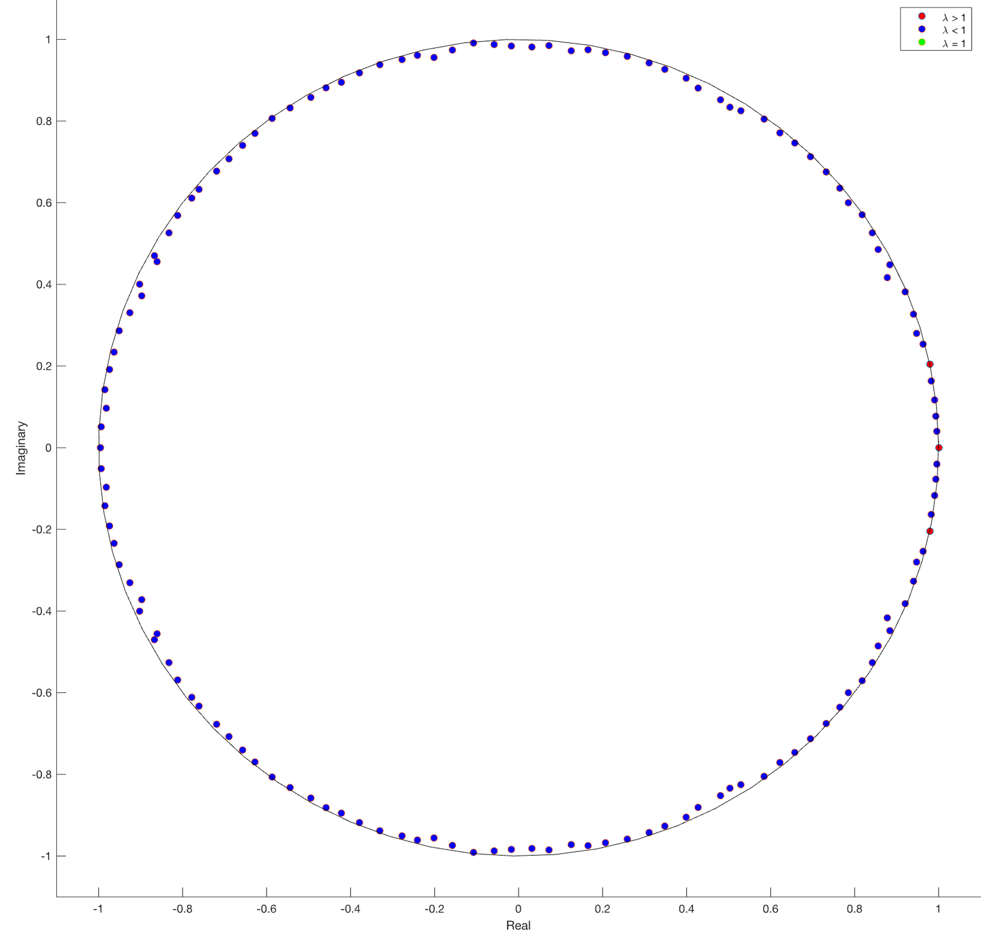

3.3. Mean Squared Error of the Samples
The mean squared error (MSE) per fully reconstructed sample (time point) is universally quite small $\left(O\left({10}^{-3}\right)\right)$, a fact reflected in the excellent visual agreement between original and reconstructed sFNC. However, the time-resolve MSE contains a quasiperiodic peaks-and-valleys structure that resembles a periodic function. The period is irregular, with gaps between peaks separated by anywhere from 15 to 31 time points. It may be a linear combination of functions with different frequencies, which could also explain why the last error “peak” has a gap of two samples in its center.
When only the three modes with the highest power are used for reconstruction, mean squared error increases by about a factor of 20 $\left(O\left({10}^{-2}\right)\right)$. Subtracting the partial reconstruction from the full reconstruction confirms that using three modes changes values by at most 10% over the entire connectivity map. However, this difference map displays considerable structure, suggesting that despite the contributing only a small amount of total power, higher-frequency modes contain considerable information that may be of interest to researchers. For this reason, the author recommends continued examination of higher-frequency modes, although he is not immediately certain how this might be done.

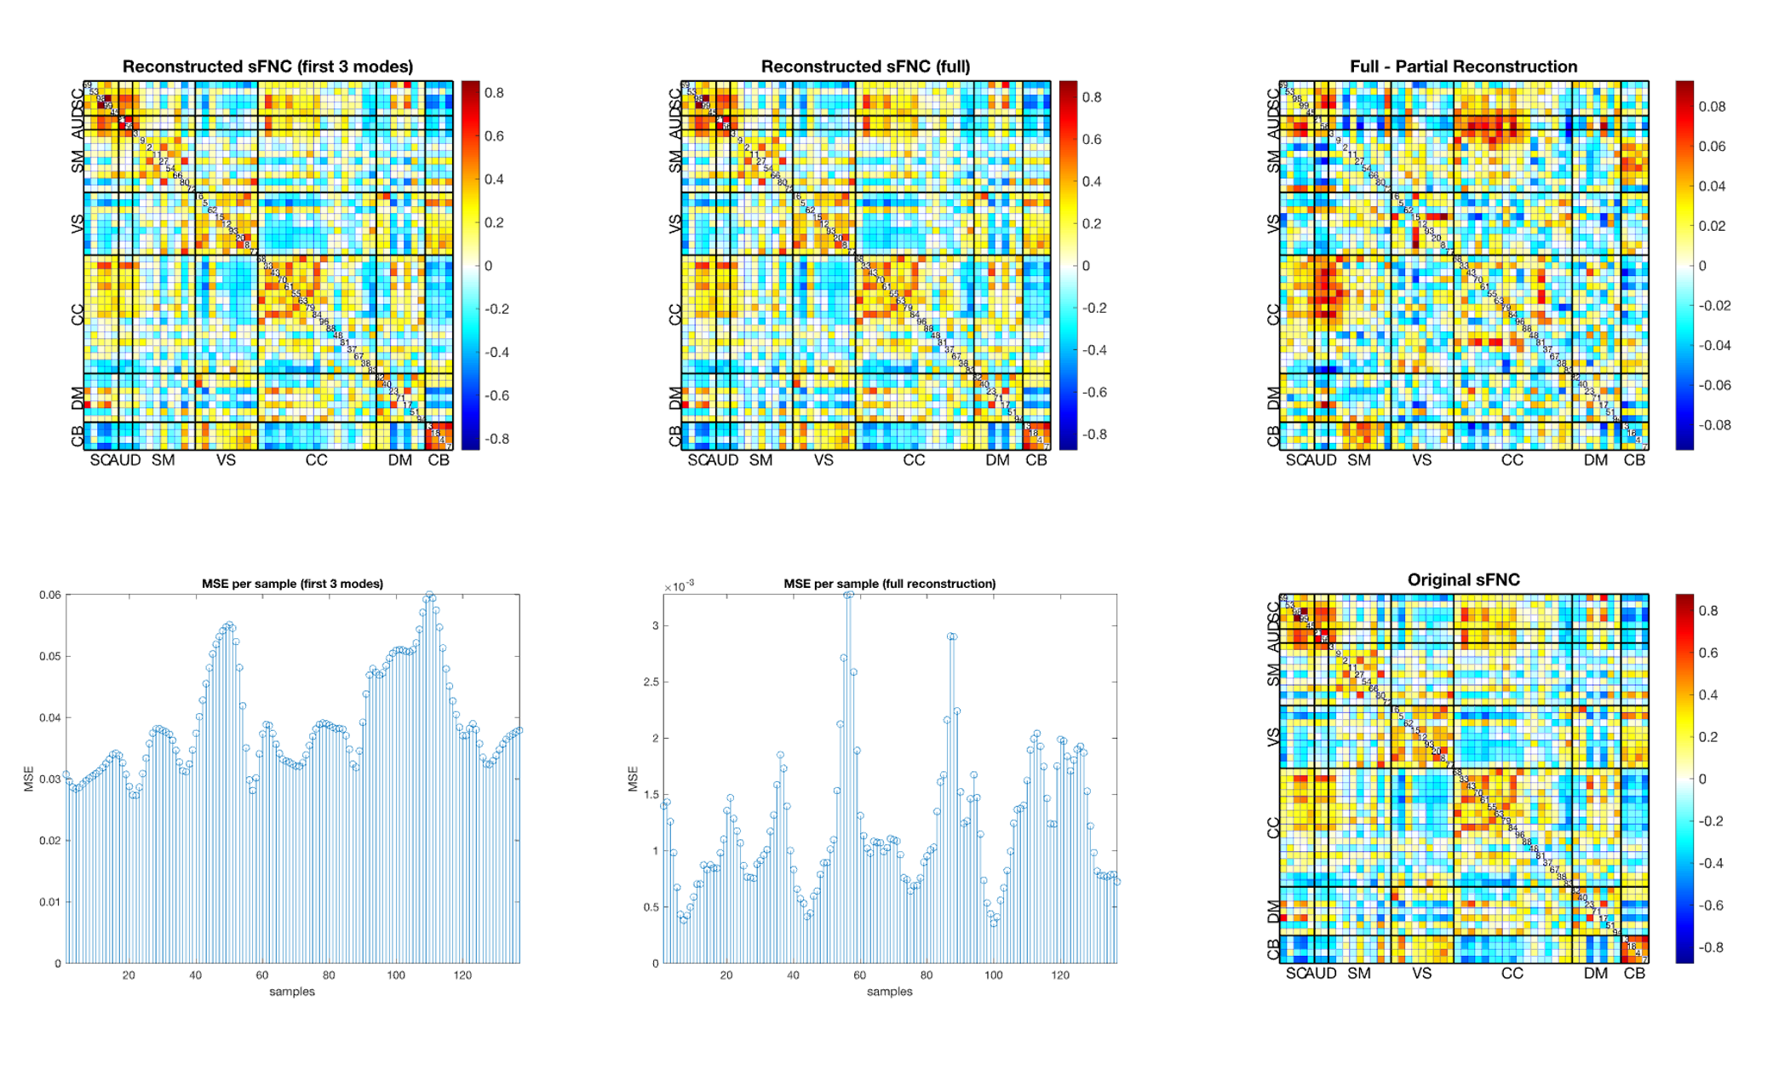

3.4. Functional Timecourses
To confirm the findings of eigenvalue analysis (Sec. 3.2), the author has elected to plot the time courses of the auditory cortex for the first six non-stationary modes, corresponding to the frequencies $f=\left[0.0064, 0.0123, 0.187, 0.0262, 0.0327, 0.0410\right]$. Specifically, he selected the correlation values of networks 58 and 3 with those of 53, 98, 99, and 45 (rows 6 and 7, columns 2, 3, and 4). The original FNC values for the selected patient are plotted for comparison.
The intensity of the modes corresponding to the first three frequencies show a weak exponential decay, as predicted by eigenvalue analysis. The remaining three also display decay, but this decay is not smoothly exponential. Instead, FNC value oscillations appears to display both a fast main frequency and a notably slower envelope frequency, with the envelope frequency increasing along with the main frequency. This, along with the choppy nature of some faster oscillations, may indicate an aliasing effect. Depending on the time-to-repetition, it would not be entirely surprising to find that some modes exceed the data’s Nyquist limit. The author would be surprised to find this to be the case for such low-frequency modes, but the possibility should not be ignored.
It is worth nothing that all the visualized modes display decay over the course of the scan. This is despite the fact that the original FNC values do not display an overall loss in amplitude during the scan cycle. The author must wonder about the origin of the additional power in the signal. As mode power generally declines with frequency, the additional power is unlikely to come from high frequencies. Further, one of the displayed frequencies, $f=0.0327$, had an eigenvalue greater than unity, which should indicate increasing power over the course of the scan. Reconstruction of this mode, however, suggests the opposite.

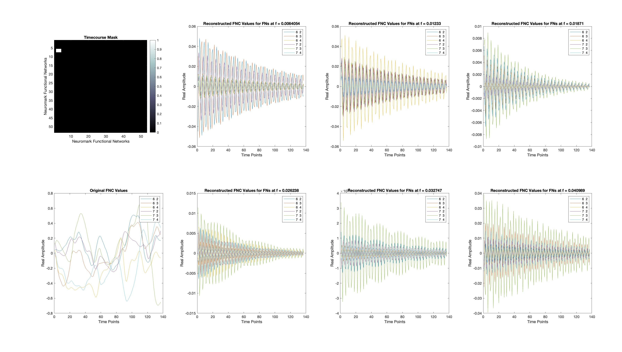

4. Next Steps

4.1. Group Distributions
Subject-level analyses will produce subject-level modes and spectra. Some means of analyzing the distributions of these modes and spectra will likely prove very useful. However, as both spectra and modes are high-dimensional variables (136 and 1378 dimensions, respectively), the multiple-comparison problem and central limit theorems may complicate the comparison of their distributions.
Comparing mode distributions may be feasible via the network-based statistic [6], [7], [8] or simple application of a multiple comparison correction to group-level differences in connectivity maps. The author recalls that several members of the group, most notably Amritha and KuaiKuai, have conducted such analyses in the past.

4.2. Large-Scale Modes and their Spectra
It may be worth comparing subject-level spectra to clinical or behavioral scores to determine whether any frequencies show links to behavioral effects. If so, an examination of the affected modes could provide useful insights into connectivity biomarkers for such behaviors. This analysis may need to account for interaction effects.

4.3. Independent Mode Decomposition
As presently formulated, dynamic mode decomposition does not guarantee the independence of different modes. This may be by design. Mode $A$, with frequency $f_{A}=a$ is likely to display a temporal relationship with mode $B$ of frequency $f_{B}=2a$. Nonetheless, that it is possible to separate such modes using standard DMD suggests that increased independence is at least plausible. The author will need to consider how to best approach such a problem. Among other questions, he must ask along which dimension(s) he should maximize independence. Should the modes be independent along the spatial or temporal axes?

