GitHub Link:
https://github.com/davidboatright-hub/CS449Projec-t/tree/main
- Demonstration
Panopto Link:
https://umsystem.hosted.panopto.com/Panopto/Pages/Viewer.aspx?id=a7b79977-7953-4cef-8b41-b40f017019d9
2. Summary of Source Code:
Source code file name | Production or test code? | # lines of code
Board.java | Production | 124
PegSolitaireGui.java | Production | 142
TestGameLogic | Test | 184

- Production Code vs User stories/Acceptance Criteria
(User stories 1 and 2 are no longer required for this sprint, and they will be completed as part of sprint 3)
1. Choose a board size (incomplete, to be done in Sprint 3)
2. Choose the board type (incomplete, to be done in Sprint 3)

- Start a new game of the chosen board size and type

AC ID / Desc | Class Name(s) | Method Name(s) | Status (completed,  toDo, inProgress) | Notes (optional)
AC 3.1 – Start new game initializes board correctly  Given the player has selected a board size and board type  When the player clicks the “New Game” button  Then a new game board is displayed  And the board matches the selected size and type | Board  PegSoliaireGUI | Board-handles board class  PegSolitaireGUI- Initializes a new board | Completed | Partially complete. The code currently can only implement an English board of variable size
AC 3.2 – Initial board configuration is valid  Given a new game has started  When the board is displayed  Then the center hole on the board is left empty  And all other valid board positions contain pegs | Board | Board | Completed
AC 3.3 – Previous game state is cleared  Given a game is currently in progress  When the player clicks the “New Game” button  Then the current board state is cleared  And a new board is initialized according to the selected size and type | Board | Board | Completed

- Make a move in a game
AC ID / Desc | Class Name(s) | Method Name(s) | Status (completed,  toDo, inProgress) | Notes
AC 4.1 – Select a peg to move  Given a game is in progress  When the player selects a peg on the board  Then the selected peg is visually highlighted  And the system waits for the player to select a destination hole | PegSolitaireGUI | handleClick | Completed
AC 4.2 – Perform a valid move  Given a peg is selected  When a player next selects an empty position that is two squares away from the selected peg diagonally or orthogonally  And there is a peg between the destination position and the selected peg  Then the selected peg is removed  And the jumped peg is removed from the board  And a peg is added to the destination position | PegSolitaireGUI  Board | handleClick  makeMove | Completed
AC 4.3 – Reject an invalid move  Given a peg is selected  When a player next selects an empty position that is two squares away from the selected peg  And there is not a peg between the destination position and the selected peg  Then the selected peg is unselected  And no change is made to the board | Board | isValidMove | Completed
AC 4.4 – Reject Invalid jump distance  Given a peg is selected  When the player selects a space that is less than or greater than 2 spaces away from the selected peg  Then the selected peg is unselected  And no change is made to the board. | Board | isValidMove | Completed

- A game is over
AC ID / Desc | Class Name(s) | Method Name(s) | Status (completed,  toDo, inProgress) | Notes
AC 5.1 – Detect no remaining valid moves  Given a game is in progress  When a player makes a move that results in a board with no more valid moves remaining  Then the game is over | Board | isGameOver | Completed
AC 5.2 – Display game-over message  Given the system has detected that no valid moves remain  When the board is evaluated  Then a “Game Over” message is displayed to the player | PegSolitaireGUI | endGame | Completed
AC 5.3 – Display performance rating  Given the game is over  When the number of remaining pegs is calculated  Then the system displays a rating based on the number of pegs left | PegSolitaireGUI | endGame | Completed
AC 5.4 – Prevent further moves after game over  Given the game is over  When the player attempts to select a peg  Then the system prevents the selection  And the board state remains unchanged | PegSolitaireGUI | endGame | Completed

4.1 Automated tests directly corresponding to the acceptance criteria of the above user stories
(User Stories 1 and 2 are not required this sprint so their test code will be written alongside the production code in the next sprint)
3. Start a new game of the chosen board size and type

Acceptance Criteria ID | Class Names of the Test Code | Method Names of Test Code | Status (Pass/Fail/In  Progress)
3.1 | TestGameLogic | test7EngBoard | Pass
3.2 | TestGameLogic | test7EngBoard | Pass
3.3 | TestGameLogic | test7EngBoard | Pass

4. Make a move in a game

Acceptance Criteria ID | Class Names of the Test Code | Method Names of Test Code | Status (Pass/Fail/In  Progress)
4.1 | testGameLogic | selectingPegHighlightsIt | Pass
4.2 | testGameLogic | testJumpPeg | Pass
4.3 | testGameLogic | testFailJump | Pass
4.4 | testGameLogic | testLongJump | Pass

- A game is over
Acceptance Criteria ID | Class Names of the Test Code | Method Names of Test Code | Status (Pass/Fail/In  Progress)
5.1 | testGameLogic | testEndingGame | Pass
5.2 | testGameLogic | testGameOverMsg | Pass
5.3 | testGameLogic | testGameOverMsg | Pass
5.4

Below are the AI screenshots for two test functions. To keep this document from being overly long, all other AI interactions will be logged in Sprint2AILog (in Github)
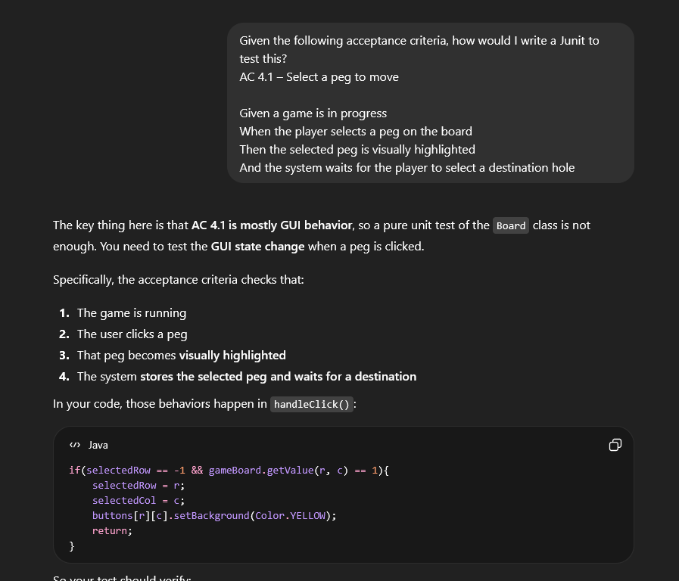
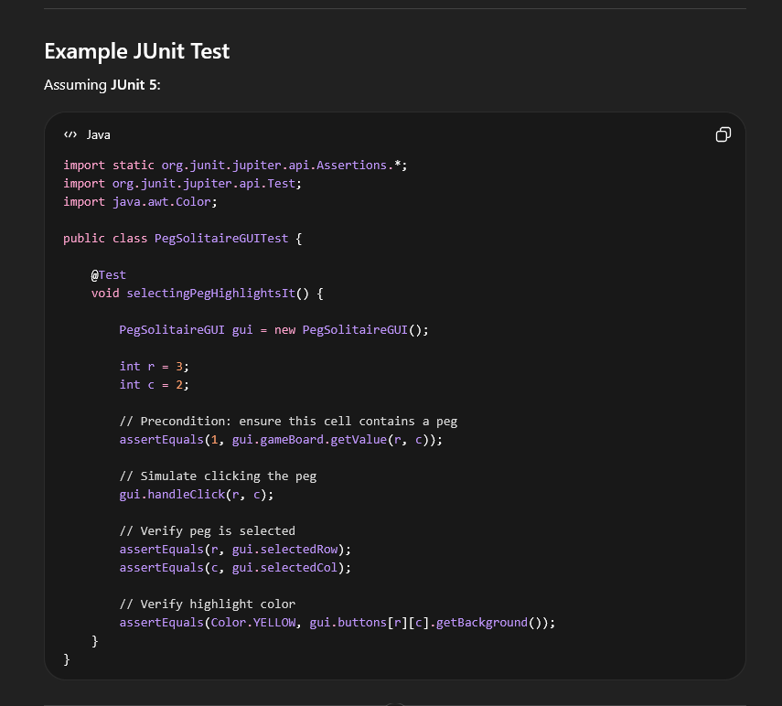
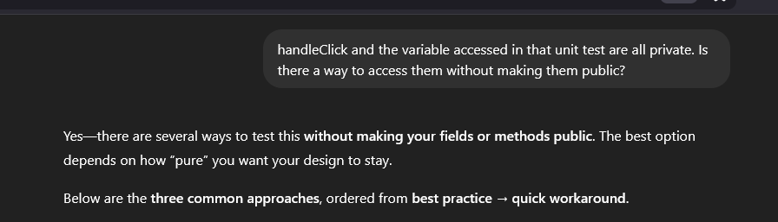
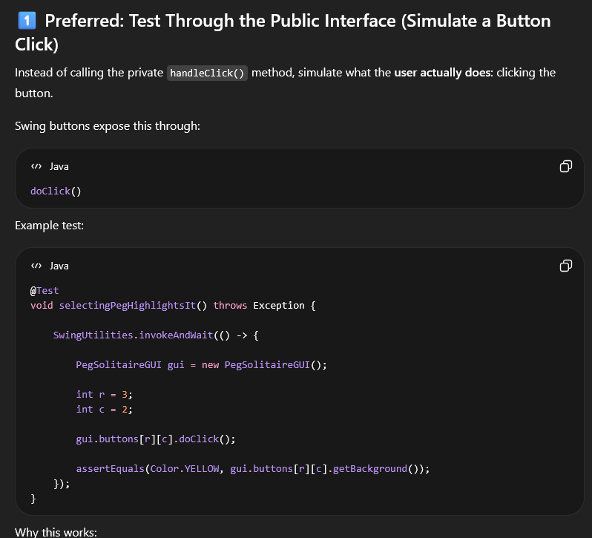
I used this second output, and included the checks for selected Row and Col from the first output.
Test 2-
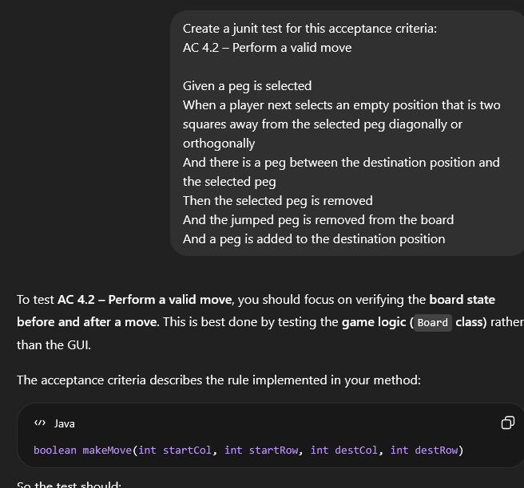
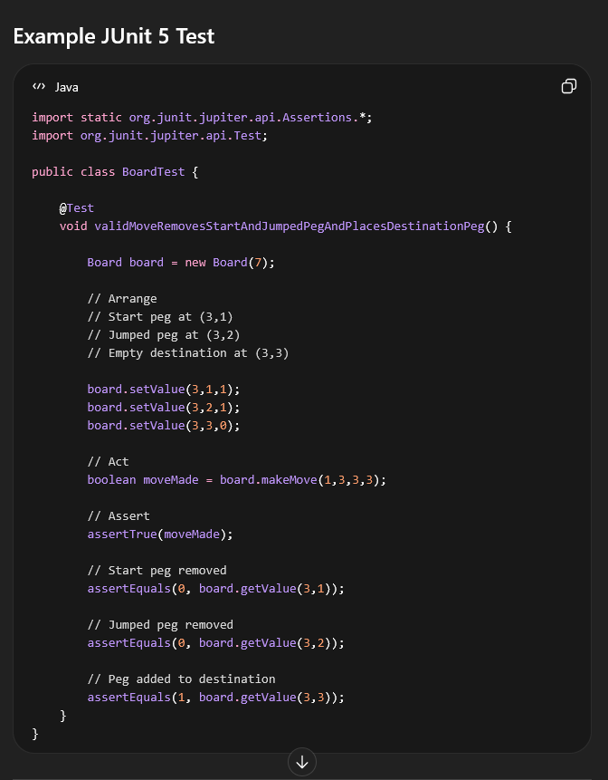
Board has no function setValue, but the test condition requires just the basic initial board state, so the constructor satisfies what the setValue function was meant to do. Removed those function calls and shortened the test function name. Otherwise this is a valid move and valid check of the completion of the move.

