Github:
https://github.com/davidboatright-hub/CS449Projec-t

- User Stories (3 points)
- User Story Template: As a <role>, I want <goal> [so that <benefit>]
ID | User Story Name | User Story Description | Priority | Estimated Effort (hours)
1 | Choose a board size |  | High | 3
  As a player, I need to be able to choose the board size before starting a game so that I can play with my preferred level of difficulty.
2 | Choose the board type | As a player, I need to be able to choose the board type before starting a game so that I can play my preferred version of Solitaire. | High | 3
3 | Start a new game of  the chosen board  size and type | As a player, I want to start a new game using my selected board size and board type so that I can begin playing Solitaire with my chosen configuration. | High | 4
4 | Make a move in a game | As a player, I need to be able to select a peg and jump over an adjacent peg into an empty hole in order to make a move  and remove pegs | High | 6
5 | A game is over | As a player, I need to know if the game is over each time I make a valid move | High | 4

II. Acceptance Criteria (AC) (12 points): Add/delete rows as needed.

1. Choose a board size
AC ID | Description | Status (completed,  toDo, inProgress)
1.1 | AC 1.1 – Display available board sizes in dropdown  Given the game application is launched  When the main screen is displayed  Then a dropdown menu labeled “Board Size” is visible  And the dropdown contains only the supported board sizes of 5, 7 and 9. | toDo
1.2 | AC 1.2 – Select a board size from dropdown  Given the game application has started  When the player selects a board size from the dropdown list  Then the selected value is shown as the current selection  And the system stores the selected board size for future game initialization | toDo
1.3 | AC 1.3 – Default board size is preselected  Given the game application is launched  When the board size dropdown is displayed  Then the default board size of 7 is preselected in the dropdown | toDo

2. Choose the board type

AC ID | Description | Status (completed,  toDo, inProgress)
2.1 | AC 2.1 – Display available board types in dropdown  Given the game application is launched  When the main screen is displayed  Then a dropdown menu labeled “Board Type” is visible  And the dropdown contains the options “English,” “Hexagon,” and “Diamond” | toDo
2.2 | AC 2.2 – Select a board type from dropdown  Given the game application has started  When the player selects a board type from the dropdown list  Then the selected board type is displayed as the current selection  And the system stores the selected board type for initializing a new game | toDo
2.3 | AC 2.3 – Default board type is preselected  Given the game application is launched  When the board type dropdown is displayed  Then a default board type of English is preselected | toDo

- Start a new game of the chosen board size and type

AC ID | Description | Status (completed,  toDo, inProgress)
3.1 | AC 3.1 – Start new game initializes board correctly  Given the player has selected a board size and board type  When the player clicks the “New Game” button  Then a new game board is displayed  And the board matches the selected size and type | toDo
3.2 | AC 3.2 – Initial board configuration is valid  Given a new game has started  When the board is displayed  Then the center hole on the board is left empty  And all other valid board positions contain pegs | toDo
3.3 | AC 3.3 – Previous game state is cleared  Given a game is currently in progress  When the player clicks the “New Game” button  Then the current board state is cleared  And a new board is initialized according to the selected size and type | toDo

- Make a move in a game
AC ID | Description | Status (completed,  toDo, inProgress)
4.1 | AC 4.1 – Select a peg to move  Given a game is in progress  When the player selects a peg on the board  Then the selected peg is visually highlighted  And the system waits for the player to select a destination hole | toDo
4.2 | AC 4.2 – Perform a valid move  Given a peg is selected  When a player next selects an empty position that is two squares away from the selected peg diagonally or orthogonally  And there is a peg between the destination position and the selected peg  Then the selected peg is removed  And the jumped peg is removed from the board  And a peg is added to the destination position | toDo
4.3 | AC 4.3 – Reject an invalid move  Given a peg is selected  When a player next selects an empty position that is two squares away from the selected peg  And there is not a peg between the destination position and the selected peg  Then the selected peg is unselected  And no change is made to the board | toDo
4.4 | AC 4.4 – Reject Invalid jump distance  Given a peg is selected  When the player selects a space that is less than or greater than 2 spaces away from the selected peg  Then the selected peg is unselected  And no change is made to the board. | toDo

- A game is over
AC ID | Description | Status (completed,  toDo, inProgress)
5.1 | AC 5.1 – Detect no remaining valid moves  Given a game is in progress  When a player makes a move that results in a board with no more valid moves remaining  Then the game is over | toDo
5.2 | AC 5.2 – Display game-over message  Given the system has detected that no valid moves remain  When the board is evaluated  Then a “Game Over” message is displayed to the player | toDo
5.3 | AC 5.3 – Display performance rating  Given the game is over  When the number of remaining pegs is calculated  Then the system displays a rating based on the number of pegs left | toDo
5.4 | AC 5.4 – Prevent further moves after game over  Given the game is over  When the player attempts to select a peg  Then the system prevents the selection  And the board state remains unchanged | toDo

Screenshots:
I used the free version of ChatGPT. For all of the user stories, ChatGPT used the word want, which doesn’t really fit because a player doesn’t just want to be able to play a move, they need to be able to. I have reworded all of the GPT generated user stories to use need instead of want.
US 1-
Here is the output from chatgpt
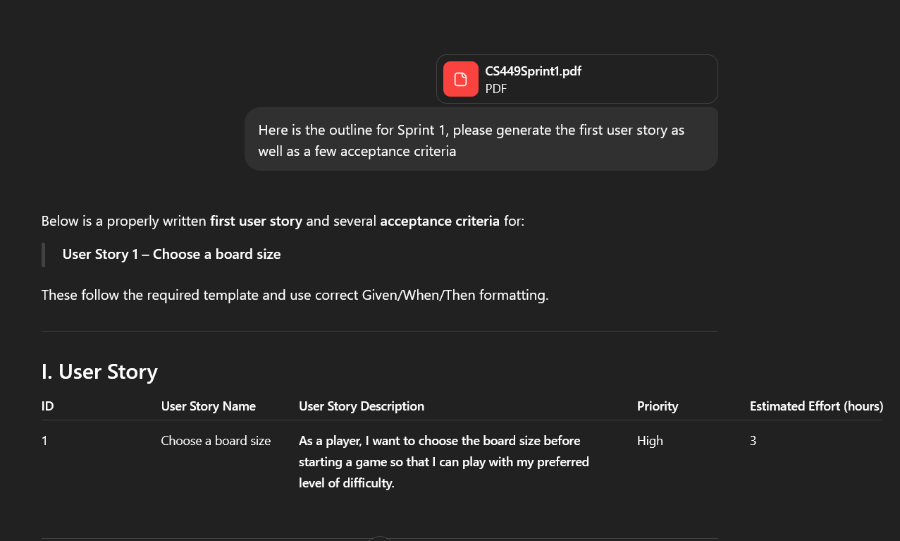
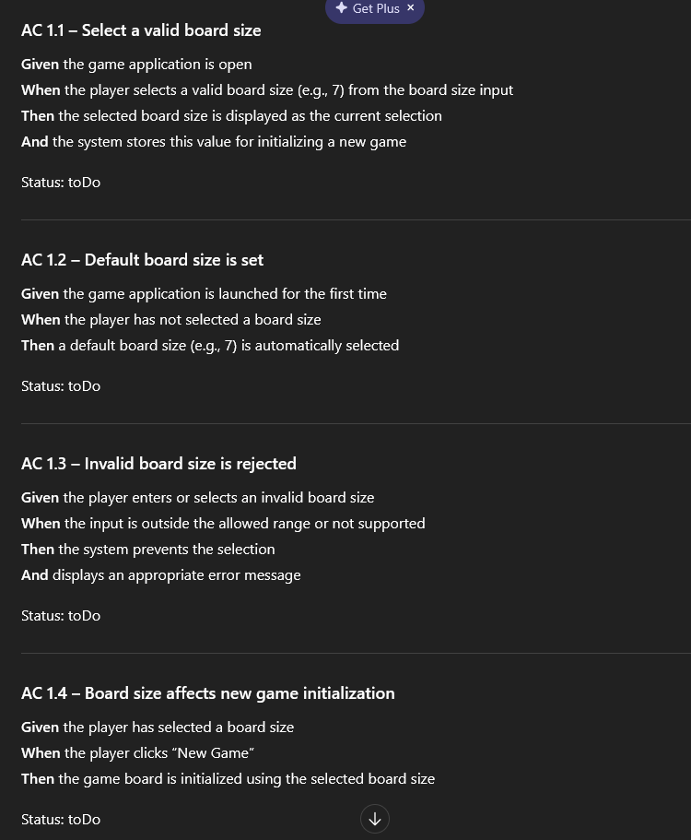
I’ve decided that utilizing a drop down menu for the size selection will allow the user to quickly know what board sizes are supported and avoid invalid selections. This should hopefully reduce the need to check for valid input as well. Here is the revised prompt.
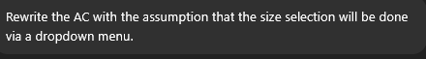
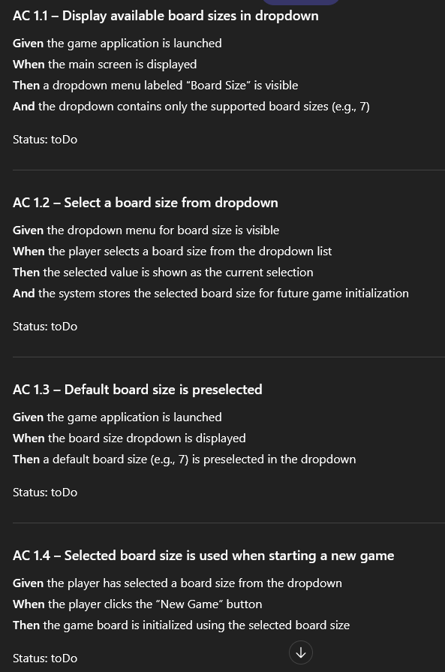
There doesn't seem to be much to fix here. I am going to change the AC to explicitly state the default size and available options. I am going to leave out AC 1.4, since something similar will be written for one of the ACs in user story 3.

US 2-
Made a slight typo in the prompt, but chatgpt gave the needed response anyway.
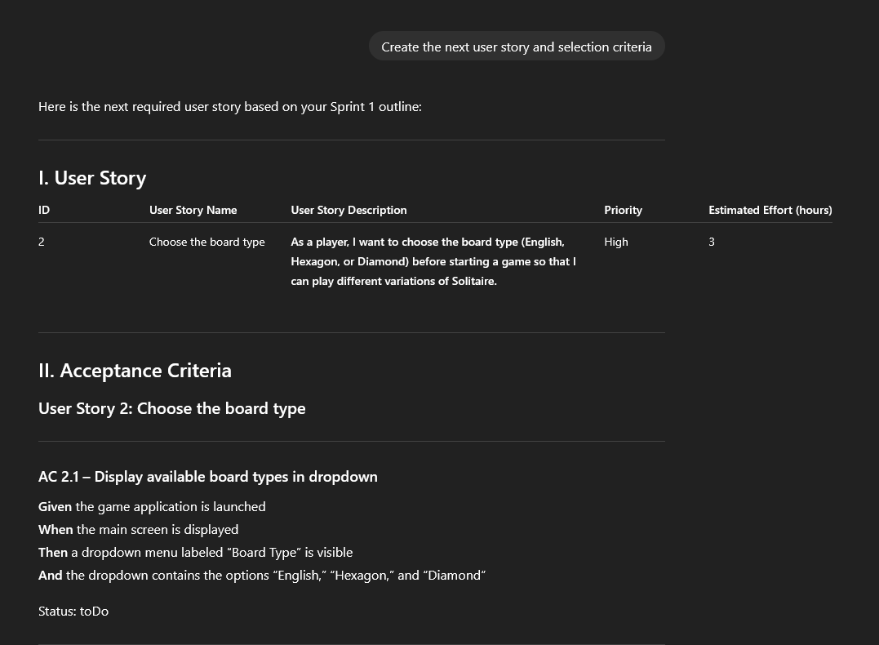

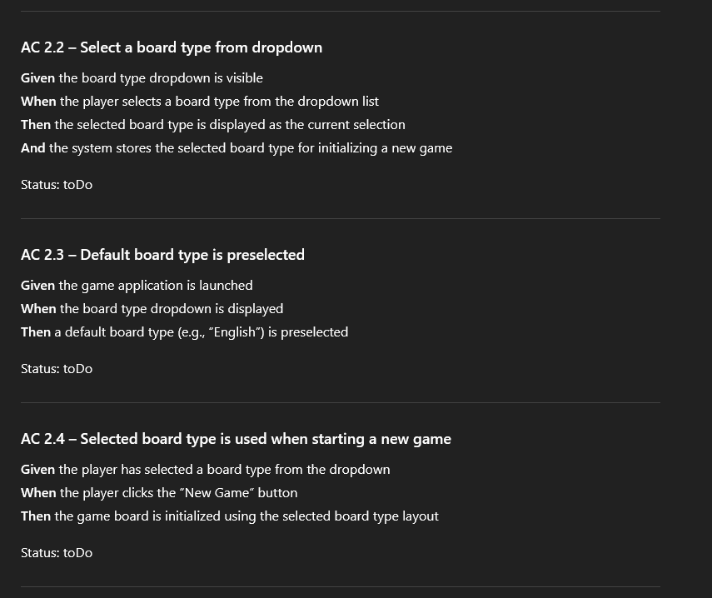
Little to change here as well. I rewrote the user story to be a bit less wordy. I removed the types listed in the story and changed the wording a little. I don’t think the original story is incorrect, but I changed it to suit me better. ChatGPT assumed the type selection would also be a drop down, and I like the idea, so I will be leaving it as a drop down. I will explicitly state the default board type in 2.3. I will also leave out 2.4 for the same reason as 1.4.

US 3-
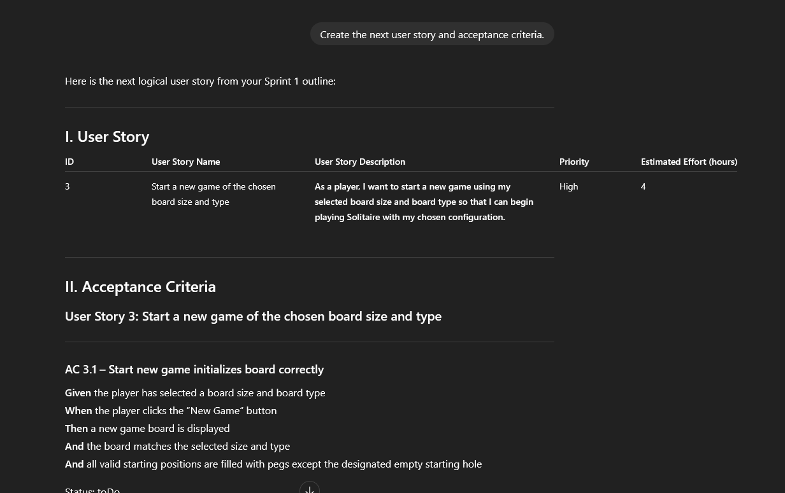
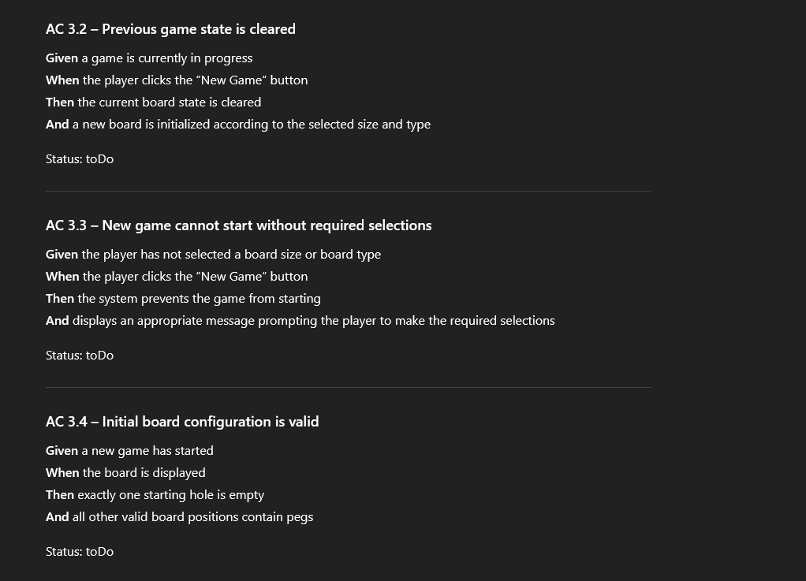
Since there will be default values for the size and type, unless selecting new game empties these fields, there will never be an instance where size and type are not selected. As such, 3.3 likely wont be necessary. The second And section in 3.1 is redundant given 3.4. In order to keep tests small and focused on specific potential issues, I will be removing that second AND in 3.1 and keeping 3.4. I will also be rewriting 3.4 so that it mentions the starting hole is the center hole. 3.4 will also be moved up in the list next to 3.1 since they cover similar topics.

US 4-
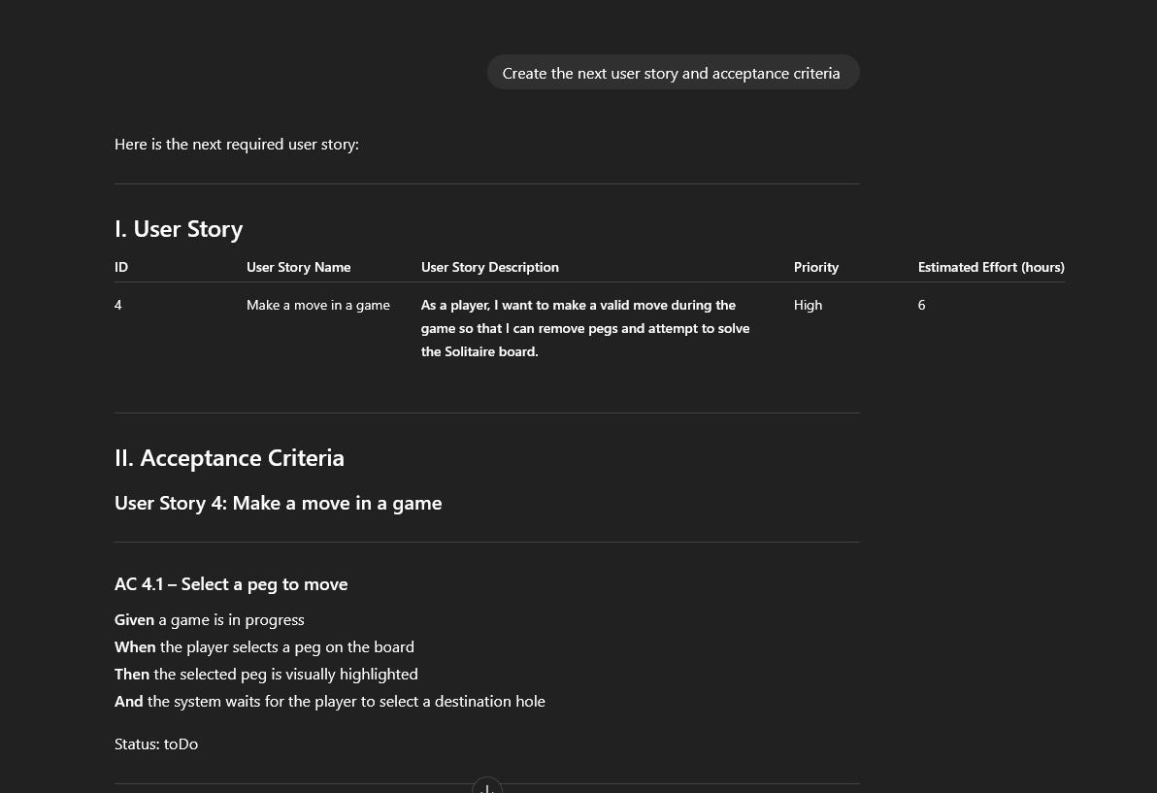
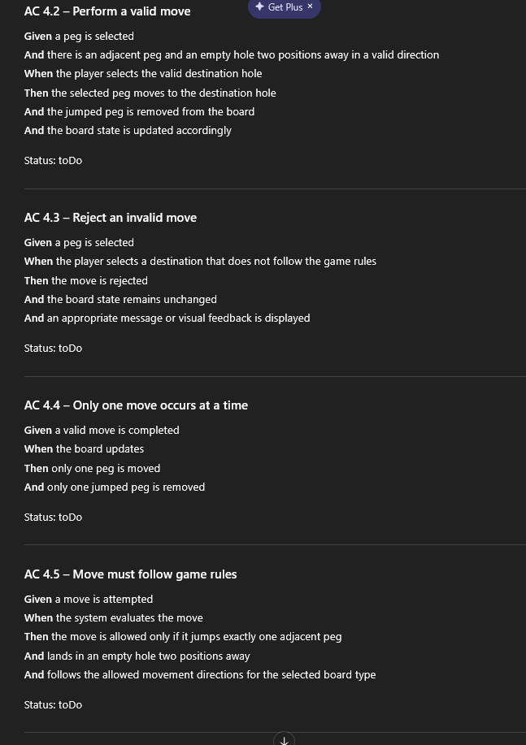
I am going to rewrite the story so that it is a bit simpler and closer to what is in the tic-tac-toe case study. I rewrote 4.2 to be a bit more explicit in what makes a valid move and to make the Then section closer to what would be happening in the code. 4.3 was split into two different negative scenario ACs which explicitly detail two different invalid move types. 4.4 and 4.5 seemed redundant and unnecessary given that earlier ACs list the criteria for valid moves and the removal of pegs, so they were left out.
US 5-
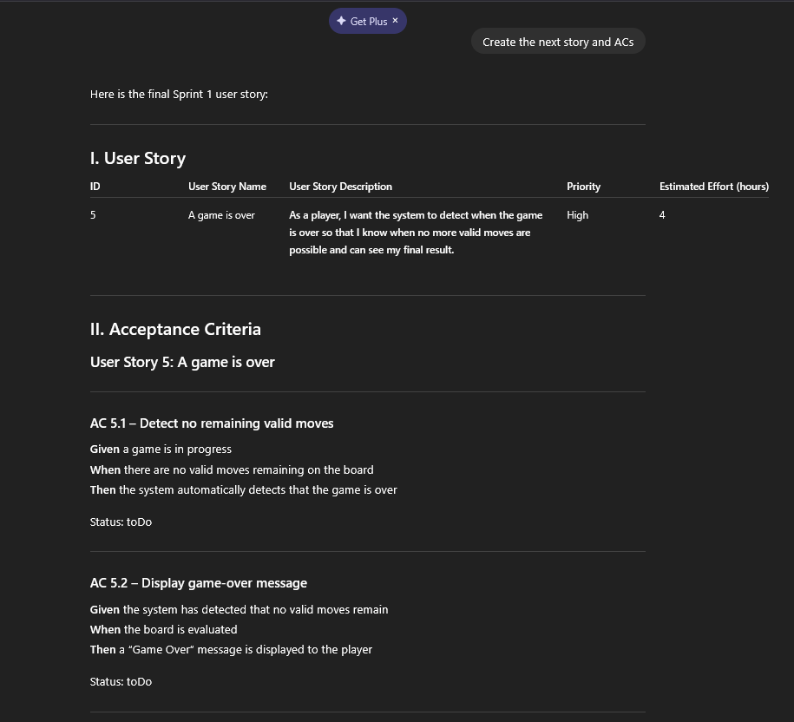
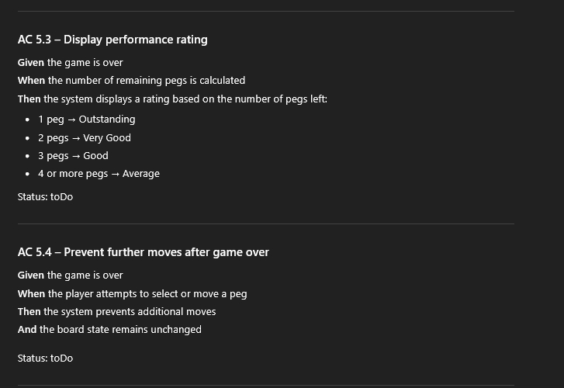
The story is unnecessarily verbose, so it will be replaced. The final story from the tic-tac-toe case study is very close to what is needed here, so I will be using something similar. I rewrote 5.1 to be closer to something like AC 4.1 from the tac-tac-toe case study. I removed the specific scores from 5.3 as I don’t feel they are needed quite yet. I changed the When and Then sections of 5.4 to an implementation that I prefer.

