Part 1-
OOP Language | Java
GUI Library | Swing
IDE | Apache NetBeans
xUnit Framework | JUnit
Programming Style Guide | https://google.github.io/styleguide/javaguide.html
Project Hosting Site | github
Other Decisions | N/A

Part 2-
The documentation on Junit that I used was:
https://docs.junit.org/6.0.2/overview.html
I created a very simple program called Minus, that implements a flawed subtraction class. MinusTest is the test file for the Minus class and contains two tests. One test should pass, the other should fail.
Minus test code:
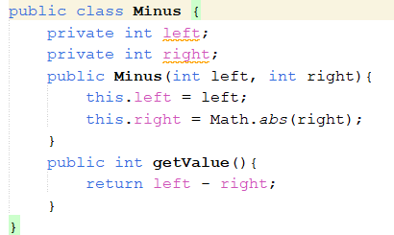
MinusTest sourcecode:
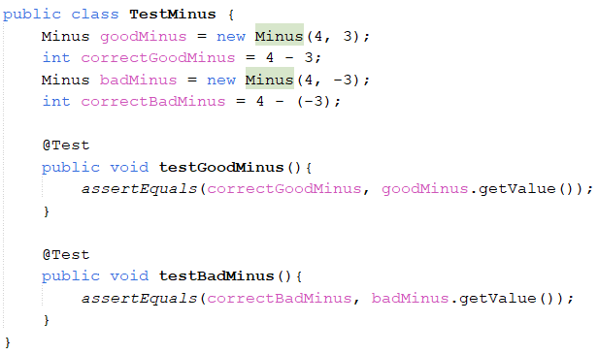
Test output screenshot:
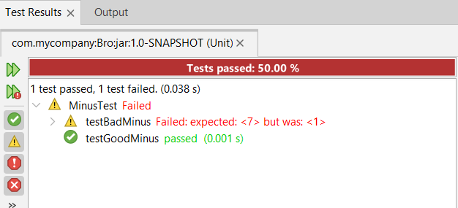
Sourcecode path (in github):
Program that will be tested:
CS449Projec-t/FinalSprint0/src/main/java/com/mycompany/finalsprint0/Minus.java
Tests:
CS449Projec-t/FinalSprint0/src/test/java/MinusTest.java
Part 3-
The Netbeans IDE features a robust GUI creation toolkit using the Swing library, which I used to implement this GUI program. For full disclosure: I designed and created the GUI using the toolkit in Netbeans, and the Java source code was generated automatically by the IDE. The tutorial I used for this process:
https://docs.oracle.com/javase/tutorial/uiswing/learn/index.html
The source code for the GUI is quite long, so it will not be copied here. If you wish to view it, please use the filepath at the bottom of this section to locate it on github. The filepath is also on the github readme.
The program in operation:

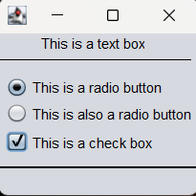
SourceCode Path (in github):
GUI:
CS449Projec-t/FinalSprint0/src/main/java/com/mycompany/finalsprint0/TestGui.java

