GitHub Link:
https://github.com/davidboatright-hub/CS449Projec-t/tree/main
- Demonstration
Panopto Link: https://umsystem.hosted.panopto.com/Panopto/Pages/Viewer.aspx?id=baa66efc-6de1-49d7-b879-b41f0013dfad
2. Summary of Source Code:
Source code file name | Production or test code? | # lines of code
Board.java | Production | 156
PegSolitaireGui.java | Production | 283
Game | Production | 43
ManualGame | Production | 18
AutomatedGame | Production | 41
TestGameLogic | Test | 325
TestAutoGame | Test | 114

3. Production Code vs User stories/Acceptance Criteria
1. Choose a board size and type
AC ID / Desc | Class Name(s) | Method Name(s) | Status (completed,  toDo, inProgress) | Notes (optional)
AC 1.1 – Display available board sizes in dropdown  Given the game application is launched  When the main screen is displayed  Then a dropdown menu labeled “Board Size” is visible  And the dropdown contains only the supported board sizes of 5, 7 and 9. | PegSolitaireGUI | PegSolitaireGUI | Completed
AC 1.2 – Select a board size from dropdown  Given the game application has started  When the player selects a board size from the dropdown list  Then the selected value is shown as the current selection  And the system stores the selected board size for future game initialization | PegSolitaireGUI | PegSolitaireGUI | Completed
AC 1.3 – Default board size is preselected  Given the game application is launched  When the board size dropdown is displayed  Then the default board size of 7 is preselected in the dropdown | PegSolitaireGUI | PegSolitaireGUI | Completed
AC 1.4 – Display available board types in dropdown  Given the game application is launched  When the main screen is displayed  Then a dropdown menu labeled “Board Type” is visible  And the dropdown contains the options “English” and “Hexagon” | PegSolitaireGUI | PegSolitaireGUI | Completed
AC 1.5 – Select a board type from dropdown  Given the game application has started  When the player selects a board type from the dropdown list  Then the selected board type is displayed as the current selection  And the system stores the selected board type for initializing a new game | PegSolitaireGUI | PegSolitaireGUI | Completed
AC 1.6 – Default board type is preselected  Given the game application is launched  When the board type dropdown is displayed  Then a default board type of English is preselected | PegSolitaireGUI | PegSolitaireGUI | Completed

2. Choose the game mode of a chosen board (manual/automated)

AC ID / Desc | Class Name(s) | Method Name(s) | Status (completed,  toDo, inProgress) | Notes (optional)
AC 2.1 – Display available game modes in dropdown  Given the game application is launched  When the main screen is displayed  Then a dropdown menu labeled “Game Mode” is visible  And the dropdown contains the options “Manual” and “Automated” | PegSolitaireGUI | PegSolitaireGUI | Completed
AC 2.2 – Selecting a game mode  Given the game application has started  When the player selects a game mode from the dropdown list  Then the selected game mode is displayed as the current selection  And the system stores the selected game mode for initializing a new game | PegSolitaireGUI | PegSolitaireGUI | Completed
AC 2.3 – Manual is the default state  Given the game Application is launched  When the game mode dropdown is displayed  Then a default game mode of Manual is preselected | PegSolitaireGUI | PegSolitaireGUI | Completed

- Start a new game of the chosen board size and type

AC ID / Desc | Class Name(s) | Method Name(s) | Status (completed,  toDo, inProgress) | Notes (optional)
AC 3.1 – Start new game initializes board correctly  Given the player has selected a board size and board type  When the player clicks the “New Game” button  Then a new game board is displayed  And the board matches the selected size and type | Board  PegSoliaireGUI | Board-handles board class  PegSolitaireGUI- Initializes a new board | Completed
AC 3.2 – Initial board configuration is valid  Given a new game has started  When the board is displayed  Then the center hole on the board is left empty  And all other valid board positions contain pegs | Board | Board | Completed
AC 3.3 – Previous game state is cleared  Given a game is currently in progress  When the player clicks the “New Game” button  Then the current board state is cleared  And a new board is initialized according to the selected size and type | Board | Board | Completed

- Make a move in a Manual game
AC ID / Desc | Class Name(s) | Method Name(s) | Status (completed,  toDo, inProgress) | Notes
AC 4.1 – Select a peg to move  Given a game is in progress  When the player selects a peg on the board  Then the selected peg is visually highlighted  And the system waits for the player to select a destination hole | PegSolitaireGUI | handleClick | Completed
AC 4.2 – Perform a valid move  Given a peg is selected  When a player next selects an empty position that is two squares away from the selected peg diagonally or orthogonally  And there is a peg between the destination position and the selected peg  Then the selected peg is removed  And the jumped peg is removed from the board  And a peg is added to the destination position | PegSolitaireGUI  Board | handleClick  makeMove | Completed
AC 4.3 – Reject an invalid move  Given a peg is selected  When a player next selects an empty position that is two squares away from the selected peg  And there is not a peg between the destination position and the selected peg  Then the selected peg is unselected  And no change is made to the board | Board | isValidMove | Completed
AC 4.4 – Reject Invalid jump distance  Given a peg is selected  When the player selects a space that is less than or greater than 2 spaces away from the selected peg  Then the selected peg is unselected  And no change is made to the board. | Board | isValidMove | Completed

- A manual game is over
AC ID / Desc | Class Name(s) | Method Name(s) | Status (completed,  toDo, inProgress) | Notes
AC 5.1 – Detect no remaining valid moves  Given a game is in progress  When a player makes a move that results in a board with no more valid moves remaining  Then the game is over | Board | isGameOver | Completed
AC 5.2 – Display game-over message  Given the system has detected that no valid moves remain  When the board is evaluated  Then a “Game Over” message is displayed to the player | PegSolitaireGUI | endGame | Completed
AC 5.3 – Display performance rating  Given the game is over  When the number of remaining pegs is calculated  Then the system displays a rating based on the number of pegs left | PegSolitaireGUI | endGame | Completed
AC 5.4 – Prevent further moves after game over  Given the game is over  When the player attempts to select a peg  Then the system prevents the selection  And the board state remains unchanged | PegSolitaireGUI | endGame | Completed

6. Make a move in an automated game
AC ID / Desc | Class Name(s) | Method Name(s) | Status (completed,  toDo, inProgress) | Notes (optional)
AC 6.1 – The computer makes a move  Given a game is in progress  When the system completes a move  Then the board should be changed  And the number of pegs should decrease | AutomatedGame | playTurn | Completed

7. An automated game is over
AC ID / Desc | Class Name(s) | Method Name(s) | Status (completed,  toDo, inProgress) | Notes (optional)
AC 7.1 – Detect no remaining valid moves  Given a game is in progress  When the system makes a move that results in a board with no more valid moves remaining  Then the game is over | PegSolitaireGUI | runAutoGame | Completed

8. Randomize the state of the board during a manual game
AC ID / Desc | Class Name(s) | Method Name(s) | Status (completed,  toDo, inProgress) | Notes (optional)
AC 8.1 – Randomize changes at least one peg  Given a game in progress  When the board is randomized  Then at least one cell on the board should change  And all cells should still contain valid values | Board | Randomize | Completed

4.1 Automated tests directly corresponding to the acceptance criteria of the above user stories
1. Choose a board size and type
Acceptance Criteria ID | Class Names of the Test Code | Method Names of Test Code | Status (Pass/Fail/In  Progress)
1.1 | TestGameLogic | testSizeDropdown | Pass
1.2 | TestGameLogic | testSelectSize | Pass
1.3 | TestGameLogic | testDefaultSize | Pass
1.4 | TestGameLogic | testTypeDropdown | Pass
1.5 | TestGameLogic | testSelectType | Pass
1.6 | TestGameLogic | testDefaultType | Pass

2. Choose the game mode of a chosen board (manual/automated)
Acceptance Criteria ID | Class Names of the Test Code | Method Names of Test Code | Status (Pass/Fail/In  Progress)
2.1 | TestGameLogic | testModeDropdown | Pass
2.2 | TestGameLogic | testSelectMode | Pass
2.3 | TestGameLogic | testDefaultMode | Pass

3. Start a new game of the chosen board size and type

Acceptance Criteria ID | Class Names of the Test Code | Method Names of Test Code | Status (Pass/Fail/In  Progress)
3.1 | TestGameLogic | test7EngBoard | Pass
3.2 | TestGameLogic | test7EngBoard | Pass
3.3 | TestGameLogic | test7EngBoard | Pass

4. Make a move in a manual game

Acceptance Criteria ID | Class Names of the Test Code | Method Names of Test Code | Status (Pass/Fail/In  Progress)
4.1 | testGameLogic | selectingPegHighlightsIt | Pass
4.2 | testGameLogic | testJumpPeg | Pass
4.3 | testGameLogic | testFailJump | Pass
4.4 | testGameLogic | testLongJump | Pass

- A manual game is over
Acceptance Criteria ID | Class Names of the Test Code | Method Names of Test Code | Status (Pass/Fail/In  Progress)
5.1 | testGameLogic | testEndingGame | Pass
5.2 | testGameLogic | testGameOverMsg | Pass
5.3 | testGameLogic | testGameOverMsg | Pass
5.4 | testGameLogic | testGameOverNoClick | Pass

6. Make a move in an automated game
Acceptance Criteria ID | Class Names of the Test Code | Method Names of Test Code | Status (Pass/Fail/In  Progress)
6.1 | TestAutoGame | testAutomatedGameMakesMove | Pass

7. An automated game is over
Acceptance Criteria ID | Class Names of the Test Code | Method Names of Test Code | Status (Pass/Fail/In  Progress)
7.1 | TestAutoGame | testAutomatedGameIsOver | Pass

8. Randomize the state of the board during a manual game
Acceptance Criteria ID | Class Names of the Test Code | Method Names of Test Code | Status (Pass/Fail/In  Progress)
8.1 | TestAutoGame | testRandomizeManualGameBoard | Pass

5.1
Describe how the class hierarchy in your design deals with the common and different
requirements of the Manual Game and the Automated Game.
In my design, each game is handled by the Game class, and the children of that class. In the sprint 2 production code, there were only two classes: Board and PegSolitaireGUI. The GUI separated the user from the actual game logic implementation in Board. The new class Game adds a new layer to this, and Game acts as an intermediary between the GUI and Board. The bulk of the work is still handled by PegSolitiareGUI and Board, Game just determines whether the control is in the hands of the GUI (player) or the computer. Game also acts as an intermediary when the GUI needs information from Board.
The class called Game is actually an abstract class, which is implemented by its two children ManualGame and AutomatedGame. Game contains the Constructor, and the abstract method playTurn. Game also contains many Getter type methods that allow Game to act as a layer between the GUI and Board. Since both children need a gameboard, and the board does not need to be different regardless of if the game is manual or automated, each child class just uses the parent’s constructor. playTurn needs different implementation in each child, so this method in Game is abstract and needs to be implemented in each child. The remaining non abstract methods are almost all getters and dependent on Board, not on type of game so these are defined in Game, not its children.
PegSolitaireGUI already fully implements a manual game, so ManualGame for the most part just hands control back to the GUI. Because of this, ManualGame is very thin, and contains no unique methods. ManualGame only implements the abstract methods defined in Game. The constructor just passes in the board that was made in PegSolitareGUI. playTurn does nothing because the GUI already handles the input of moves and Board handles the making of moves. The only real function of ManualGame is to hide Board’s implementation from PegSolitaireGUI.
Automated game is the more unique class, as it needs a special implementation of playTurn in order for the game to play itself. playMove in this class implements a very simple algorithm where the system looks for the first valid move, starting from the top left corner of the board, and makes that move. This is repeated until no more valid moves remain, as determined by the isGameOver method in Board. The loop that runs until the game is over is contained in PegSolitaireGUI so that the GUI can be updated after each move is made.
The abstract parent class
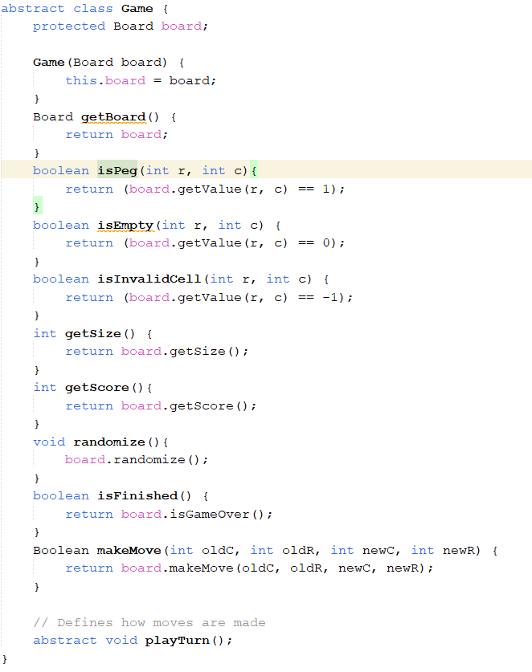
The manual game class
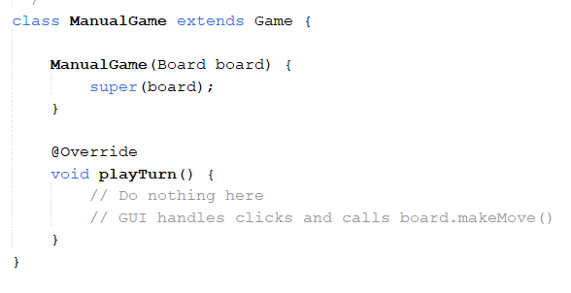
The automated class
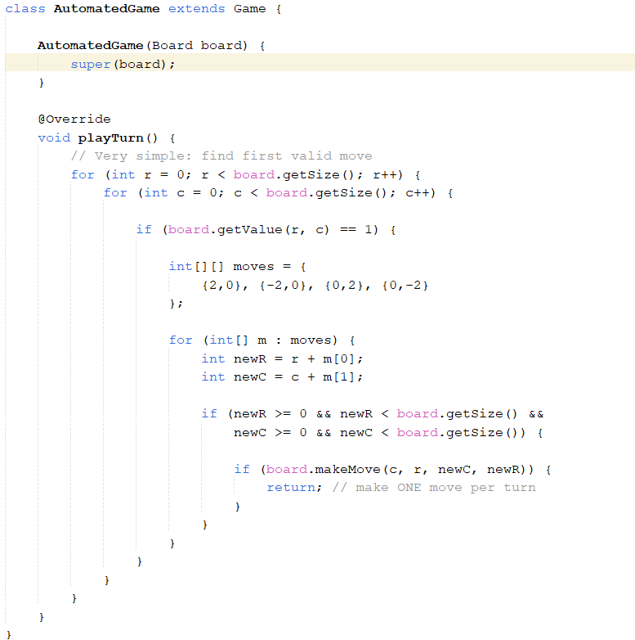

5.2
Demonstrate how you use LLM (ChatGPT or other) to analyze how well your code adheres to the design principles discussed in class - modularity, cohesion, coupling, and encapsulation – using the definitions provided in class. Provide screenshots of your interactions with the LLM, showing the prompts used and the responses received.
Interpret the LLM’s feedback, refine your prompts if needed to obtain more relevant responses, and discuss any changes made to your code based on the analysis. Explain how these refinements improve adherence to the design principles.
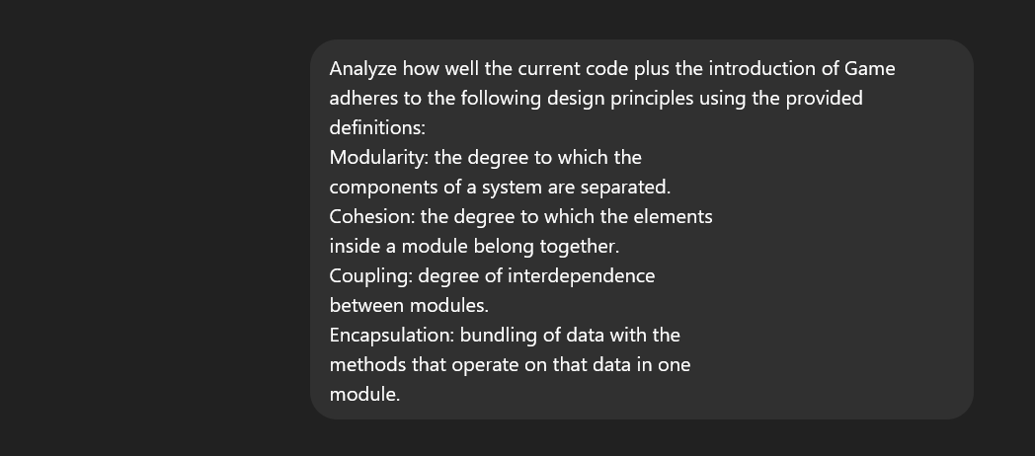
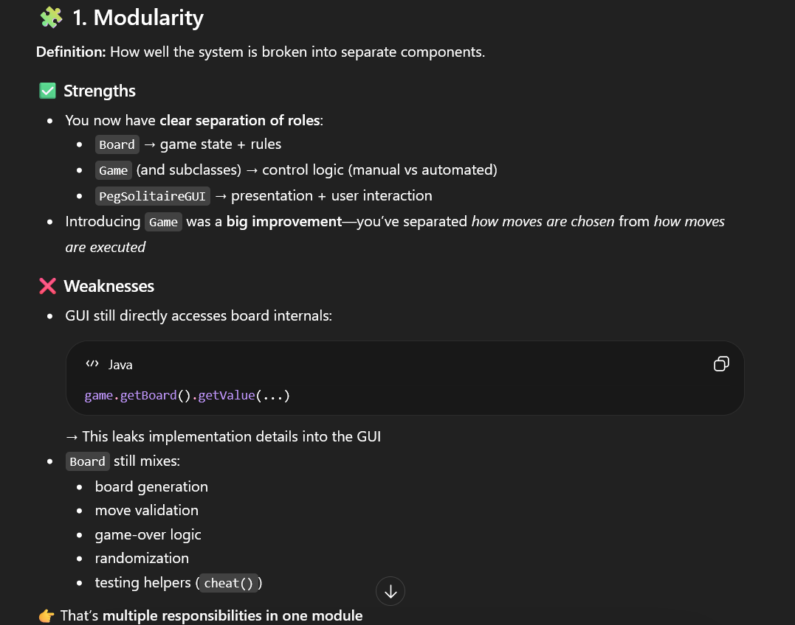
ChatGPT may be a bit confused here, as the first part of the weakness section seems to be more a weakness of encapsulation. The second part however is quite relevant. Board and PegSolitaireGUI are quite large and do quite a lot. One possible solution for Board would be to split Board into a class that stores the Board, a class that makes a board, a class that handles board interaction etc. Board is not unreasonably long, and splitting it like this leads to many small <50 line classes, which could become hard to review and understand as tracing the flow of the program becomes more difficult. By splitting up these classes, I believe encapsulation would suffer as related methods and data would be split. I don’t believe the modularity is so bad that a radical change needs to be made, so I wont change the code for this part.
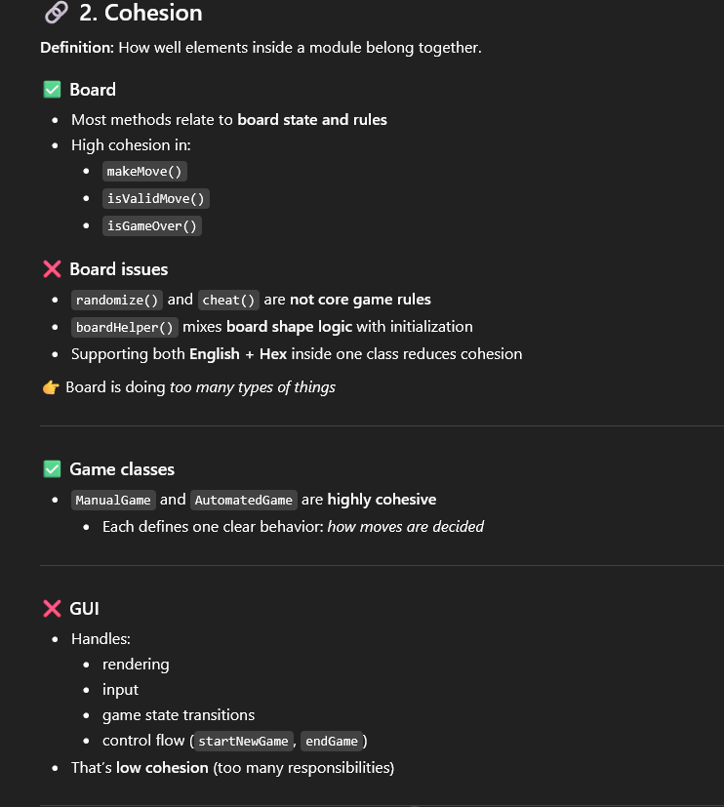
The criticism for cohesion is roughly in the same vein as modularity. Each class does too much and should be split. My response is the same as above: the classes are not big or incohesive enough to necessitate these extensive changes. The exception to this is the cheat function in Board, which is a testing helper function and clearly does not belong there. This logic will be moved to the TestGameLogic class.
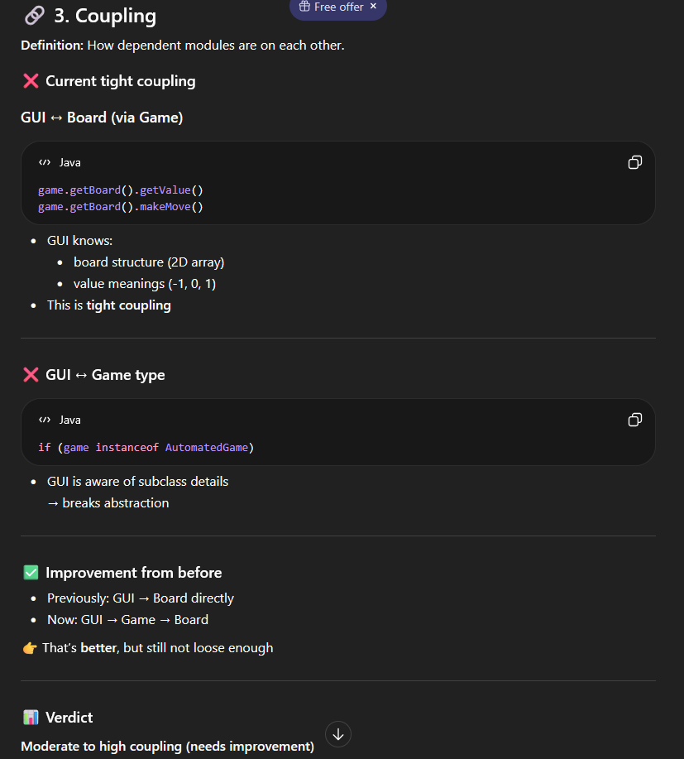
Coupling is one of the worst design principle weaknesses in this program. There were many instances of the GUI calling Board functions via the getBoard function, which can be interpreted as not only a coupling failure, but also an encapsulation failure. Many getter methods were added to the Game class (as these methods wont differ between a manual and automated game). Another big issue is that the GUI utilized game logic in things like Update Board(). For instance, when checking if a cell was a peg, it was checking if the value stored was 1. This exposes game logic and makes the GUI dependent on this exact implementation. This is rectified with the methods isPeg, isEmpty, and isInvalidCell. These methods return Booleans and take a row and a column as ints. The GUI is now slightly more protected against game logic implementation changes.
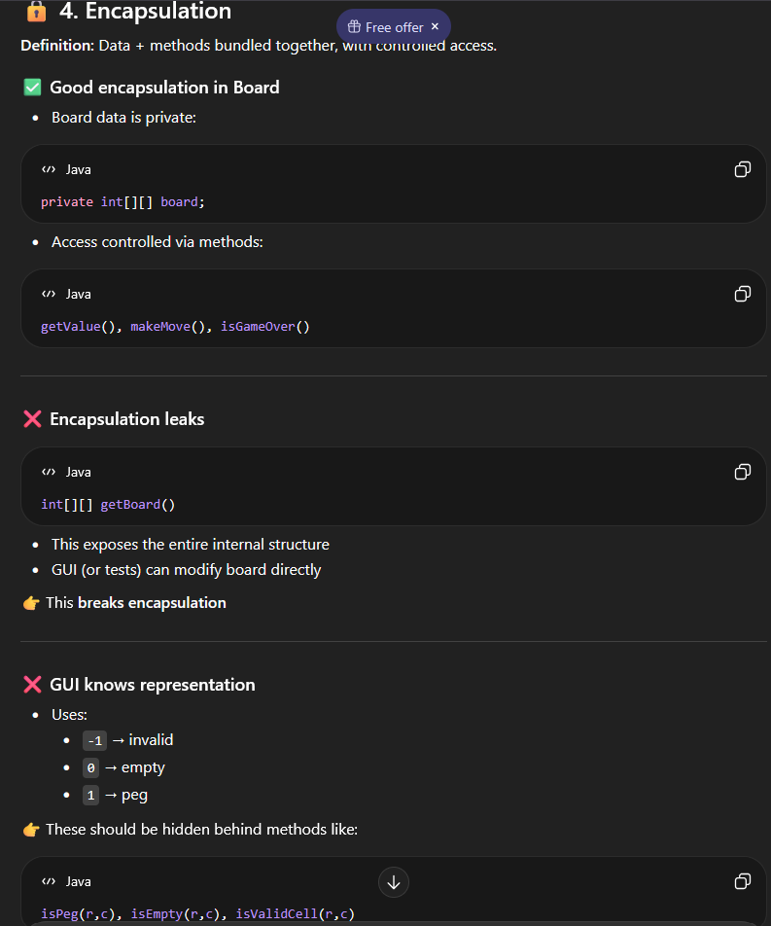
As stated in the cohesion section, the getBoard method is no longer used. The new methods added to Game now extends Game to be an actual layer between the GUI and Board. The GUI is now less aware of the inner workings of Board, and only communicates with Board via Game. Board and PegSolitaireGUI are now more neatly contained and less aware of the inner workings of each other, increasing encapsulation.
Below are some of the suggested improvements from ChatGPT. I implemented the first and second suggestion.
