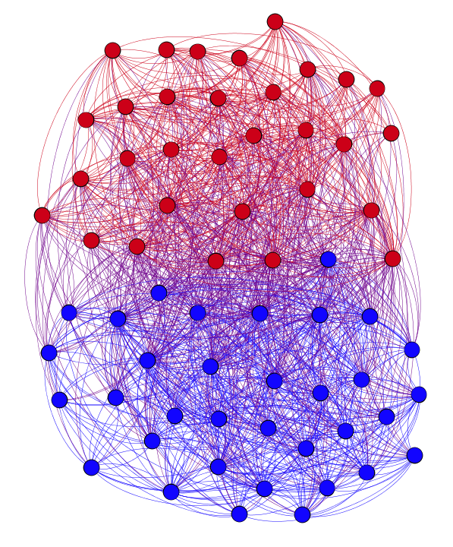
US SENATORS

RT = [('ImmigrationGOP', 11), ('SenateMajLdr', 10), ('SenJohnMcCain', 5), ('SenSanders', 4), ('EnergyDems', 3), ('GOPHELP', 2), ('reviewjournal', 2), ('NatWICAssoc', 2), ('JPFreire', 2), ('rareliberty', 2)]

Mentions= [('POTUS', 19), ('SenateMajLdr', 17), ('SenJohnBarrasso', 15), ('SenatorCantwell', 14), ('lisamurkowski', 12), ('ImmigrationGOP', 11), ('SenatorCardin', 11), ('ErnestMoniz', 10), ('CPAC', 10), ('ENERGY', 9)]

Hashtags= [('SCOTUS', 61), ('DoYourJob', 42), ('SASC', 20), ('CARA', 16), ('idpol', 14), ('StopTheSham', 14), ('veterans', 12), ('CPAC2016', 12), ('mtpol', 11), ('NoHearingsNoVotes', 11)]
Irish TDs
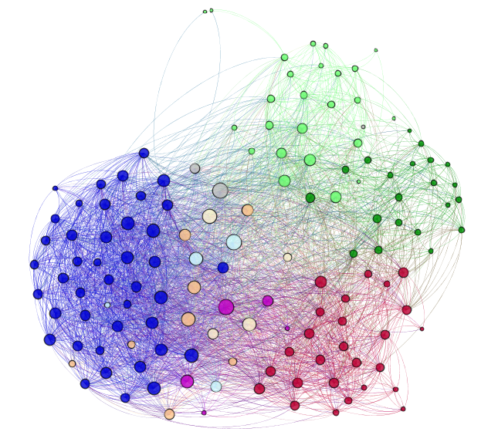

RT = [('FineGael', 84), ('fiannafailparty', 56), ('DubLoony', 32), ('eirenewsnetwork', 28), ('kclr96fm', 20), ('EndaKennyTD', 20), ('RTEdubNORTHWEST', 16), ('sinnfeinireland', 16), ('Tfitzgeraldcork', 16), ('Fingalcoco', 16)]

Mentions = [('FineGael', 192), ('fiannafailparty', 124), ('labour', 96), ('FineGaelMayo', 68), ('EricByrneTD', 56), ('RichardbrutonTD', 52), ('EndaKennyTD', 52), ('JoanCollinsTD', 52), ('PadraigMacL', 48), ('sinnfeinireland', 44)]

Hashtags = [('GE16', 624), ('ge16', 136), ('IBackJohnOMahonyTD', 36), ('NAMA', 36), ('LP16', 36), ('Wexford', 32), ('Waterford', 28), ('GE2016', 28), ('dubw', 28), ('AllianzLeagues', 24)]

40 Members of Congress

