INTERNATIONAL SALES DEPARTMENT

Export Management Guide

Berkeley Nucleonics Corporation
2955 Kerner Blvd.
San Rafael, CA 94901
Phone 415-453-9955 • Fax 415-453-9956

Print Date: 01/01/2023 - Printed copies are uncontrolled. Contact Company President for latest revision.
Table of Contents

CHAPTER 1
BNC Export Policy Statement 3

CHAPTER 2
Understanding the EAR 4

License Requirements and Exceptions 6

CHAPTER 3
Personnel Responsible for BNC EMS 7

CHAPTER 4
Record Keeping 9

CHAPTER 5
Screening 11

CHAPTER 6
Government Guidance 14

BIS Consultation 16

CHAPTER 7
Export Regulation Compliance Training 17

Internal Review of BNC’s EMS 19

APPENDICES

Introduction 20

ECCN Control Lists 20

Diversion Risk Red Flag Indicators 21

Discussion Points 23

ECCN Classifications 25

EU-100 End Use Statement 26

EU-100 End Use Statement (China) 28

Documentation Revisions 30

Employee Acknowledgement & Notes 31

BNC Specific Concerned Parties List 32
CHAPTER 1
BNC Export Policy Statement
Goal: To maximize export sales while ensuring compliance with U.S export laws and regulations.

Berkeley Nucleonics is a leading supplier of electronic test instruments and has exported instrumentation worldwide since 1964. BNC is committed to maintaining an export management system that ensures compliance with export control requirements in daily operations. This Export Management Guide is meant to be a vehicle to capture the details of the US export laws as they apply specifically to our company, our products and our customers.



BNC is committed to ongoing compliance with all Export Administration Regulations.

Adherence to Export Administration Regulations (EAR) is a top priority at Berkeley Nucleonics. BNC is committed to providing all the resources necessary to ensure ongoing EAR compliance. BNC conducts periodic discussion groups, third party audits, and export training seminars to continually improve export compliance processes. Resulting lessons learned are incorporated into this handbook to further enhance BNC’s capacity to comply with the export regulations. Careful employee review and subsequent feedback are essential to the usefulness of this handbook. It is imperative that no order be processed without complete confidence that the procedures and guidelines set forth in this handbook are met. In cases where there is any amount of uncertainty, the situation should be conveyed promptly to the company president.
Please be aware that failure to adhere to the export regulations within the Berkeley Nucleonics operation is grounds for termination of employment. Additionally, civil and criminal penalties are imposed by the Department of Commerce for failure to comply with the EAR. Thank you for your pledge to do your part to ensure BNC’s compliance with all Export Administration Regulations.

FIGURE 1.1 Berkeley Nucleonics has exported instrumentation worldwide since 1964.
CHAPTER 2

Understanding the EAR
The principal statute that governs United States export controls pertinent to BNC is the Export Administration Act (EAA) of 1979, as amended, which controls "dual-use" items and is administered by the U.S. Department of Commerce. Dual use items have both commercial and military applications.

The regulations issued under EAA are known as Export Administration Regulations, or simply EAR. The intent of the EAA and EAR is to protect important U.S. national security and foreign policy concerns.
The Department of Commerce, Bureau of Industry and Security (BIS) is the primary licensing agency for dual use exports. Of those exports and reexports subject to EAR, a relatively small percentage requires the submission of a license application to the Department of Commerce.

Five facts determine obligations under the Export Administration Regulations (EAR). Please know them.

License requirements are dependent upon an item’s technical characteristics, the destination, the end-use, and the end-user, and other activities of the end-user.
The following five facts determine obligations under the EAR: 1.) What is the item to be exported or re-exported; 2.) Where is it going; 3.) Who will receive it; 4.) What will they do with it; and, 5.) What other activities are they involved in?
As stated in the BNC Export Policy Statement, it is extremely important that all BNC personnel involved in export order fulfillment have an understanding of obligations under the EAR. The BIS maintains programs to monitor, prevent and investigate dual-use export control violations. Failure to comply with EAR regulations can result in severe penalties to corporations and individuals.

License Requirements and Exceptions
The U.S. Department of Commerce maintains a Commerce Control List (CCL), which provides detailed specifications about dual-use items requiring some type of export license. In many cases, items on the CCL will only require a license if going to a particular country. Yet some products, even if shipped to a friendly nation, will require a license due to the high risk of diversion to an unfriendly destination or because of the controversial nature of the product. The end-use and the end-user can also trigger a restriction. The CCL is periodically updated to decontrol broadly available items and to focus controls on critical technologies and on key items in which the targeted countries are deficient.
A “License Exception” is an authorization allowing export or reexport, under stated conditions, items subject to the EAR that would otherwise require a license. By using any of the License Exceptions, you are certifying that the terms, provisions, and conditions for the use of the License Exception described in the EAR have been met. All export shipments, including repairs, warranty repairs and demos must comply with the EAR.

CHAPTER 3

Personnel Responsible for Export Management

All Berkeley Nucleonics employees involved in any way with export fulfillment are expected to be knowledgeable about export regulations.
However, to ensure that all compliance related functions, duties and responsibilities are clearly identified and assigned, and to identify who to confer with in the event of an individual’s absence, a system of responsible persons with regard to export management is in place at BNC:

Berkeley Nucleonics designates ‘A’, ‘B’ and ‘C’ classifications to employees with respect to export compliance. Each classification carries the following responsibilities and authorities:

A: Employee is familiar with all aspects of the export administration regulations and the company's Export Management System (EMS). Is authorized to approve a shipment for export/re-export. Is authorized to cancel or hold up a shipment pending clarification. Participates in workshops, seminars and discussion groups and is authorized to revise the EMS handbook as needed. 'A' classification is the ONLY classification that can add a new customer to the Berkeley Nucleonics 'Approved Customer List'.
B: Employee is required to familiarize themselves with all aspects of the export administration regulations and the company's EMS system. A 'B' classification is NOT authorized to approve a shipment for export/re-export. However, a 'B' is authorized to cancel or hold up a shipment pending clarification. ‘B’ employees participate in workshops, seminars and discussion groups and in the revision process of the EMS handbook as needed.
C: Employee is required to review the distribution package included in this workbook. Employee is encouraged to contact management or the president of the company with concerns about export compliance. Employee is required to know the penalties imposed for failure to comply.
A current list of employee classifications is as follows:
'A' - Level
David Brown - President - david.brown@berkeleynucleonics.com
John Reynolds - VP of Operations - john.reynolds@berkeleynucleonics.com
'B' – Level
'C' - Level
All employees not listed above

CHAPTER 4

Record Keeping

A complete and accurate record of all export control documents pertaining to all exports must be retained by Berkeley Nucleonics and made available for inspection as required by EAR.
Administrative records are all documents related to the verification and classification of the customer purchases and requests, as well as all records used to establish ECCN and other control numbers. Administrative records pertinent to Berkeley Nucleonics include (but are not limited to):

- Export Control Classification Number (ECCN) listing
- Denied Persons List
- Blank End User Statements (Format, Date)
- Phone / Fax / Email Logs of BIS correspondence
- Entity List
- Ten General Prohibitions
- Special Nationals List
- State Department Denied Parties
- Export Management System Handbook and past revisions

Additionally, the following published guidelines are to be accessible:
- Federal Register
- Federal Register Bulletin updates
- BIS Part 736 – “The Ten General Prohibitions”
- BIS 744
- Dept of Treasury and State Regulations

Transactional Records are all documents generated in the daily operations of the company with respect to export and re-export of instrumentation. The following transactional documentation is to be kept for all export shipments, including warranty repairs and calibrations.
- EU 100 End Use Statement
- Export Compliance Checklist
- Commercial Invoices
- Shipper's Export Declarations (SED)
- Air Waybills / Bills of Lading
- Customer Correspondence / Quotations / etc.
- Customer Purchase Order
- Proof of Payment (if not under warranty)

The Export Administration Regulations require that these documents be kept for a minimum of five (5) years. Additionally, record retention rules as defined by existing Berkeley Nucleonics corporate policies are to be followed. In cases where retention limits are not identical, both regulations must be adhered to. (i.e., invoices are kept in the paid file for a minimum of seven (7) years)

Any uncertainty in record retention should be directed to the company president for review and disposition. Record retention is to be on-site at Berkeley Nucleonics and readily available to all persons involved in export compliance.
CHAPTER 5

Screening

Be sure to document export-processing decisions with up-to-date information from authoritative BIS sources.

'Screens' are separate items that need to be reviewed prior to processing an order. The following is a list of the screens that are applicable to Berkeley Nucleonics. If there are any uncertainties with regard to a particular screen, flag that item for further discussion. DO NOT approve any screen result if uncertain of your decision. Be sure to support decisions based on screens with current documentation or web-printouts.
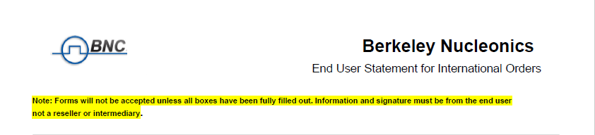
Furthermore, if a request for technical information, pricing or a formal quotation is received from a foreign entity, end-user details are to be requested when responding with price, delivery or product details.
Entity List – The Department of Commerce maintains export controls to limit the proliferation of chemical or biological weapons, nuclear weapons or explosive devices and missile systems. Certain entities are subject to license requirements for specified items under part 744 of the EAR.
Always verify that your end-user is not on the current Entity List as part of the export acceptance/refusal process. The Entity List is revised and updated on a periodic basis by adding new and amended notifications and deleting notifications no longer in effect. A current Entity List can be found at: http://www.BIS.doc.gov/Entities/
Denied Persons List - Verify your end-user is not on the Denied Person’s List (DPL). The current DPL can be found at: http://www.BIS.doc.gov/DPL/Default.shtm
Check the names of the ordering party’s firm and principals as well as the name of the end-user against the latest DPL.
Apply BIS “Know Your Customer Guidance” – Use the BIS “Know Your Customer Guidance” sheet found in the Appendix to help determine when an export license should be applied for and whether to perform further end-user checks even for shipments
that otherwise qualify for a license exception. If the prospective customer shows any of the types of suspicious characteristics set forth in the applicable “red flag indicators,” follow-up inquiries should be initiated to determine if there are legitimate explanations.
Diversion Risk– Section 736.2(b) (4-10) of the EAR states that firms may not export or reexport an item under No License Required (NLR) or a License Exception if they have “knowledge” that the customer will re-export or transfer that item without the appropriate authorization from the U.S. Government. The Diversion Risk Screen is designed to help exporters avoid a violation of this and other sections of the EAR.
Always endeavor to verify that the customer is not purchasing the product for resale/re-shipment to a 3rd party that is in violation of the Export Administration Regulations. See the Diversion Risk Red Flag Indicators List in the Appendix of this guide to assess the presence or absence of these indicators. Diversion of U.S. exports to Cuba, Iran, North Korea, Sudan and Syria is strictly prohibited under the EAR. Iraq and Libya are governed by special regulations put in effect in 2004 and 2005 respectively.
When any of the factors contained in the Red Flag Indicators List have been identified and follow-up inquiries have not satisfactorily resolved doubts, the BIS must be contacted before the export in question can proceed. If there appears to be any indication of a diversion risk for any reason, refer the transaction to the Company President for resolution.
Highly Sensitive Countries - Exports to certain countries are typically subject to BNC applying for an export license. In some cases, when a working relationship with the end user exists or a local representative is well versed in the EAR, a license application may not be required. Highly Sensitive Countries include - India, Pakistan, Russia, China, Belarus, Ukraine and Hong Kong.

End Use Screen - Sensitive Nuclear – Sec. 744.2 of EAR Regulations - While the ECCN numbers of Berkeley Nucleonics nuclear products are generally not controlled for Nuclear Proliferation, some agencies worldwide are listed as Sensitive Nuclear agencies. Verify that the customer in question is not on the current list of sensitive end users on the BIS website, or obtain clarification from the BIS counselor by phone or via email correspondence.
End-Use Screen - Missile / Biological / Chemical - Sec. 744.3 of EAR Regulations Verify that there is no indication that either the applicant for purchase of Berkeley Nucleonics instrumentation or any end-user is involved directly or indirectly in the design, development, production or use of missiles. Also verify that applicants and end-users are not involved in chemical or biological weapons research or production prior to approving this screen. Use information obtained from the BNC End-User Application (EU-100) to assist in completing these screening processes.
Additional Checklists - Review the Red Flag Indicators included in the Appendix 2 section of this document to the order you are processing. Document your concerns, and forward all related details to the Company President.
If there are any uncertainties in the order approval process, the screens mentioned above, or the application and validity of the customer, contact the BIS Office of Exporter Services for additional information.
CHAPTER 6

Government Guidance
The following 3 offices are available to assist Berkeley Nucleonics in the approval/refusal process of any order or foreign inquiry.

U.S. Department of Commerce -
Outreach and Education Services
1401 Constitution Ave, NW, Washington DC 20230
Ph: 202-482-4811 Fax: 202-482-2927
Western Regional Office -
2302 Martin Street Ste 330, Irvine, CA 92612
Ph: 949-660-0144 Fax: 949-660-9347
Western Regional Office -
160 W Santa Clara Street, Suite 725, San Jose, CA 95113
Ph: 408-998-8806, Fax: 408-998-8677
Following the review of the order or inquiry, update the Export Compliance Spreadsheet or Foreign Shipment Customer Logs in Nutshell and on the Berkeley Nucleonics servers. File all supporting documentation along with the customer order for both acceptance and refusal determinations. Approvals can be delivered to the bookkeeping person for order entry and processing. Refusals are to be notified using the standard refusal template and filed accordingly.
During order processing, an approval from an 'A' Classified Employee must be obtained. A shipment may not be processed until the 'Pending' status has been updated to 'Approved for Export'. Delay in this approval process is expected and delivery schedules to customers should be communicated accordingly.
Automated Export System – The following office is available for AES support – 800-549-0595 or email at askaes@census.gov

BIS Consultation
If questions arise regarding the propriety of any BNC export transaction, the Bureau of Industry and Security (BIS) is available to assist in the resolution of such issues.
If assistance is needed in determining the appropriateness of specific end-users or end-uses for exports, BIS’s Office of Exporter Services can be contacted at 949-660-0144
If at any time you suspect that questionable, unauthorized, or illegal activities may have taken place, or that the customer is asking you to participate in such activities, you should notify the company President and contact the BIS’s local Export Enforcement Field Office at 408-291-4212.
Any employee with concerns about the export compliance of the Corporation, or is not comfortable with the interpretations or decisions of the management of the Corporation, is encouraged to seek clarification from the BIS office.

CHAPTER 7

Export Regulation Compliance Training
The EAR is updated regularly to address the changes in the global economy. The types of controls that apply to Berkeley Nucleonics often vary in scope and complexity. Therefore, an ongoing training and review process has been established to ensure that the Berkeley Nucleonics EMS Guide meets the current economic conditions and remains compliant with all pertinent BIS regulations.

BNC schedules periodic recorded Export management meetings to review processes, educate employees, and offer a forum for open communication.



The corporation has committed to holding periodic workshops that will include “real-world” examples, employee discussions and idea sharing, review of existing practices and review of updates to BIS Regulations. This workshop will typically be held on-site at Berkeley Nucleonics. Special guests, the corporate export attorney, manufacturer's representatives, shipping company representatives or other industry contacts may be invited to participate where applicable. In addition, BNC has scheduled an annual Export Management Meeting to review export processes, educate critical employees and offer a forum for feedback and process improvement of all export issues.
All employees with any involvement in export/re-export, in addition to all 'A' and 'B' classified personnel, will be required to participate in the training workshops. A summary of the training workshop and any unresolved issues will be prepared and integrated in the EMS guide and export operation procedures.
The BIS Video Training Room is also an available resource for additional training on the EAR - https://www.bis.doc.gov/index.php/online-training-room. Videos cover topics such as “Classifying Your Item”, “License Applications”, and “Deemed Exports”.
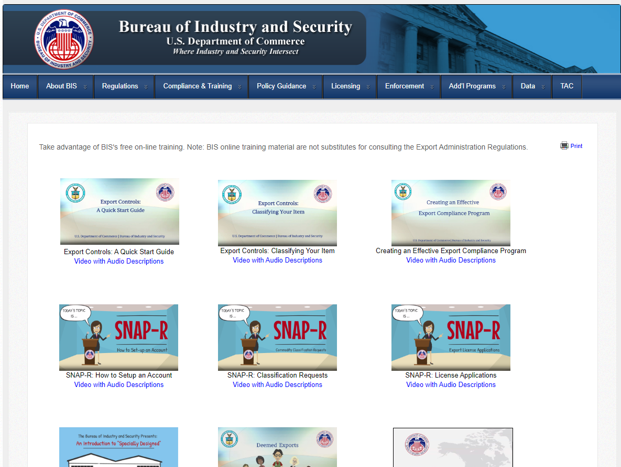

Internal Review of BNC’s EMS

Prior to the annual Export Management Meeting, BNC will undertake an internal review of the Export Management System to ensure compliance with EAR. During the course of these internal system reviews a representative sample of BNC export documents will
be inspected to confirm that they are being properly maintained. Documents that will be analyzed will include purchase orders, commercial invoices, Shipper’s Export Documents (SED), Air Waybills and general export correspondence. In addition, spot checks may be conducted to verify accuracy of export management processes and validity of procedures. These spot checks and reviews will be documented.

Appendix

The following authentication resources are intended to aid in determining the proper resolution of export and re-export issues. They will be updated continually. Final disposition of any shipment should only be made after all uncertainties have been addressed and resolved.
This section will be used to compile export-related information relevant to Berkeley Nucleonics and will be updated periodically to ensure the company is compliant with all export regulations. Company specific information does not exist on the BIS website, and therefore all persons involved in export / re-export need to review this handbook and keep a current copy of the handbook and appendix available at all times.
APPENDIX 1

ECCN classifications and Schedule B numbers are now found in Appendix 4 under the heading ECCN-100. An online version is also found at on the company server at S:\Administration\Export_Compliance\ECCN_classifications.xls
ECCN Control List
The ECCN Numbers for Berkeley Nucleonics instrumentation are controlled for Anti-Terrorism (AT) and Nuclear Nonproliferation (NP). Countries that are prohibited from receiving exports from the U.S. due to sanctions are Cuba, Iran, North Korea, Sudan and Syria. Any inquiry from these countries should not be responded to. Exports to these countries are strictly prohibited under EAR. Shipments to Iraq and Libya require special review by the BIS, and by Berkeley Nucleonics Compliance Personnel. Any such shipments are allowed only after full documentation by the end user has been reviewed and full disclosure to the BIS is accepted.
APPENDIX 2
Diversion Risk Screen – Red Flag Indicators
The following is a list of “red flag” indicators provided by the BIS to assist in the Diversion Risk Screen element of Export Management Systems. When any of the following factors have been identified, do not proceed with the export. Refer the transaction to the Company President.

- The customer or purchasing agent is reluctant to offer information about the end use (or end-user) of a product.
- The product’s capabilities do not fit the buyer’s line of business; for example, a small bakery places an order for several sophisticated lasers.
- The product ordered is incompatible with the technical level of the country to which the product is being shipped. For example, semiconductor-manufacturing equipment would be of little use in a country without an electronics industry.
- The customer has little or no business background. An example of this is when financial information is unavailable from normal commercial sources and corporate principals unknown by trade sources.
- The customer is willing to pay cash for a very expensive item when the terms of the sale call for financing.
- The customer is unfamiliar with the product performance characteristics but still wants the product.
- Routine installation, training or maintenance services are declined by the customer.
- Delivery dates are vague, or deliveries are planned for out of the way destinations.
- A freight-forwarding firm is listed as the product’s final destination.
- The shipping route is abnormal for the product and destination.
- Packing is not standard and inconsistent with usual methods.
- When questioned, the buyer is evasive or unclear about whether the purchased product is for domestic use, export, or reexport.
- Customer uses only “P.O. Box” address or has facilities that appear inappropriate for the items ordered.
- Customers’ order is for parts known to be inappropriate, for which the customer appears to have no legitimate need (e.g. there is no indication of prior authorized shipment of the system for which parts are sought).
- Customer is known to have, or is suspected of having, unauthorized dealings with embargoed customers.
Additional Berkeley Nucleonics ‘red flag’ indicators:
- Customer has no website or website is marginal with limited useful data in determining the type of organization
- Customer relies on domains typically associated with personal email accounts (email domains such as @gmail.com, @hotmail.com or @yahoo.com).
- Customer has no history in BNCs CRM System (Nutshell)
- Customer has been flagged in Nutshell with Export Concerns
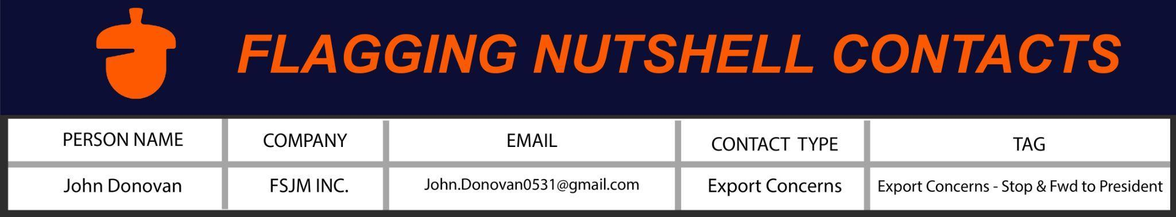
* Reminder - use the Tags Function in Nutshell with the Tag shown above on all concerned parties.
APPENDIX 3

Topic Areas for Additional Consideration

The following is a list of meeting discussion points and possible revision considerations to the current version of the Berkeley Nucleonics EMG.
- New Product Review: A review of new products is required for proper ECCN classification. Dept of Commerce determinations are stored electronically and hard copy with the company President.
- Incident Reports: Unusual activity such as attempts by international resellers to divert shipments is discussed during company export compliance meetings. Immediate disposition of an event, with documentation in the Company Archive, is enacted by the Compliance Manager and Company President. Additional procedures are in place to develop an ongoing knowledgebase. The company CRM is used to track nefarious activity and as a warning to future sales/operations personnel.
- International Travel: As part of Berkeley Nucleonics’ ‘Know Your Customer’ compliance, some international travel includes customer verification, end use verification, and qualification of international distributors’ understanding and capacity to address the EAR.
- Export Shipment Review Session: The Company President, Compliance Manager and additional employees as needed, conduct a periodic review of exports from BNC. This internal audit is designed to identify and address possible problems, complexity or burden, thereby increasing corporate compliance.
- Export Compliance Meeting: The Company holds periodic Export Compliance meetings. The meetings are recorded and mandatory for the entire company. A variety of topics are addressed in addition to recent case examples. A review of the EMG is also included in the meeting.
- Reseller Agreements: International representatives typically do not stock Berkeley Nucleonics equipment. In the rare case where this makes business sense, a written acceptance is required that the reseller will adhere to the US Dept of Commerce Bureau of Industry and Security EAR. Additionally, end use statements are required for each shipment performed by the international representative. International representatives are required to provide written understanding of the EAR and confirm full compliance with the EAR.
- Online Training: The BIS offers an introductory suite of training modules on it’s website which gives new employees an overview of the EAR.

APPENDIX 4- ECCN-100

Model# | ECCN | Schedule B / HTS | Reason for Control
507 | 3A992 | 8543.20.0000 | AT-1
625 / 625A / 630 / 632 | 3A999 | 8543.20.0000 | AT-1, AT-2
645 | 3A999 | 8543.20.0000 | AT-1, AT-2
725 | 3A999 | 8543.20.0000 | AT-1, AT-2
745 / 745T | 3A999 | 8543.20.0000 | AT-1, AT-2
1105 | 3A992 | 9030.39.0100 | AT-1
1201 | 3A992 | 9030.31.0000 | AT-1
6040 | 3A999 | 8543.20.0000 | AT-1, AT-2
7300 | 3A992 | 9030.40.0000 | AT-1
1302CA | 3A292 | 9030.20.10000 | NP-2, AT-1
505 / 555 / 565 / 575 / 577 | 3A999 | 8543.20.0000 | AT-1, AT-2
588 / 588-OEM | 3A999 | 8543.20.0000 | AT-1, AT-2
835 / 835-M | 3A992 | 8543.20.0000 | AT-1
845 / 845M / 845M-X | 3A002 | 8543.20.0000 | NS-2, AT-1
907 / 951 / 955 | 1A999 | 9030.10.0000 | AT-1, AT-2
AP-3 | 3A992 | 8543.20.0000 | AT-1
BH-1 | 3A992 | 8543.20.0000 | AT-1
DB-2 | 3A992 | 8543.20.0000 | AT-1
FTD10000 / 1150 | 3A002 | 9030.40.0000 | NS-2, AT-1
GFT-1004 (594) | 3A999 | 8543.20.0000 | AT-1, AT-2
GFT-3001 | 3A991 | 8543.20.0000 | AT-1
MCA2500R | 1A999 | 9030.10.0000 | AT-1, AT-2
PB-5 | 3A999 | 8543.20.0000 | AT-1, AT-2
Polimaster PRD's | 1A999 | 9030.10.0000 | AT-1, AT-2
SAM 935 / 940 / 945 / RD-120 | 1A999 | 9030.10.0000 | AT-1, AT-2
TB-4 | 3A992 | 8543.20.0000 | AT-1
APPENDIX 5
FORM EU-100

Berkeley Nucleonics Corporation

END USE STATEMENT
NOTE: ALL INFORMATION REQUESTED IS FOR THE ACTUAL END USER ONLY. DO NOT PROVIDE ANY INFORMATION ON AN INTERMEDIARY OR A REPRESENTATIVE ON THIS FORM. END USE STATEMENTS WILL NOT BE ACCEPTED UNLESS COMPLETED IN FULL INCLUDING SIGNATURE, DATE AND TITLE OF PERSON COMPLETING THIS FORM.
Purchase Order #:
Company/Facility Name:
Which Department:
Specific End User (First and Last Name):
Complete Address of Facility:
Address:
Phone Number:
Fax Number:
Email:
Company Website:
End Use:
The specific application of the equipment is as follows. Please describe in detail and use an additional sheet of paper if necessary.

Does this site contain a nuclear reactor? ☐Yes ☐ No
Does this site contain special nuclear material? ☐Yes ☐ No
(See page 2 for definition of special nuclear material)

Please advise if this facility is directly or indirectly involved in the development or stockpiling of any of the following. Indicate yes if this facility is involved in these facilities; indicate no if this facility is not involved in these activities:

Chemical Weapons ☐Yes ☐ No Biological Weapons ☐Yes ☐ No
Nuclear Weapons ☐Yes ☐ No Missile Production ☐Yes ☐ No

Signature: __________________________________________
Date:
Title:

BNC End Use Statement FORM EU-100 Page 2
Definitions:
Special Nuclear Material –
- Plutonium, uranium-233, uranium enriched in the isotope 233 or in the isotope 235, and any other material that the Commission, pursuant to the provisions of section 51 of the Act, determines to be special material, but does not include source material; or
- Any material artificially enriched by any of the foregoing but does not include source material.

Source Material –
(1) Uranium or thorium or any combination of uranium and thorium in any physical or chemical form; or
(2) Ores that contain, by weight, one twentieth of 1 percent (0.05%), or more, of uranium, thorium, or any combination of uranium and thorium. Source material does not include special nuclear material.

APPENDIX 6
FORM EU-100C
Berkeley Nucleonics Corporation

END USE STATEMENT
NOTE: ALL INFORMATION REQUESTED IS FOR THE ACTUAL END USER ONLY. DO NOT PROVIDE ANY INFORMATION ON AN INTERMEDIARY OR A REPRESENTATIVE ON THIS FORM. END USE STATEMENTS WILL NOT BE ACCEPTED UNLESS COMPLETED IN FULL INCLUDING SIGNATURE, DATE AND TITLE OF PERSON COMPLETING THIS FORM.
Purchase Order #:
Company/Facility Name:
Which Department:
Specific End User (First and Last Name):
Complete Address of Facility:
Address:
Phone Number:
Fax Number:
Email:
Company Website:
End Use:
Specific application of the equipment is __________________________________________________
Please describe in detail and use an additional sheet of paper if necessary.

Non Military End Use:
Is this equipment going to be used for the Chinese Military ☐Yes ☐ No

Does this site contain a nuclear reactor? ☐Yes ☐ No
Does this site contain special nuclear material? ☐Yes ☐ No
(See page 2 for definition of special nuclear material)
Please advise if this facility is directly or indirectly involved in the development or stockpiling of any of the following. Indicate yes if this facility is involved in these facilities; indicate no if this facility is not involved in these activities:

Chemical Weapons ☐Yes ☐ No Biological Weapons ☐Yes ☐ No
Nuclear Weapons ☐Yes ☐ No Missile Production ☐Yes ☐ No
Signature: __________________________________________
Date:
Title:

BNC End Use Statement FORM EU-100C Page 2

Definitions:
Special Nuclear Material –
- Plutonium, uranium-233, uranium enriched in the isotope 233 or in the isotope 235, and any other material that the Commission, pursuant to the provisions of section 51 of the Act, determines to be special material, but does not include source material; or
- Any material artificially enriched by any of the foregoing but does not include source material.

Source Material –
(1) Uranium or thorium or any combination of uranium and thorium in any physical or chemical form; or
(2) Ores that contain, by weight, one twentieth of 1 percent (0.05%), or more, of uranium, thorium, or any combination of uranium and thorium. Source material does not include special nuclear material.

APPENDIX 7

Revision Log to BNC EMG

The following is a list revisions to the BNC Export Management Guide, and items under consideration for further updates.
1987 – 2000 – See procedure guide binder, Export Compliance, US Dept of Commerce BXA
April 1, 2001 – Export Management Guide, include entity list screen, red flag indicators, updates to contact information for BXA, ECL (internal export control log)
January 1, 2004 – Version Update, Commerce Dept name change to BIS, employee classifications, additional screens, EU-100 forms, electronic license submissions
March 1, 2008 – Version Update; employee classifications, expanded list of documents under control, updates to Iraq and Libya, online training modules, retention guidelines
April 7, 2009—Version Update. ECCN and Schedule B numbers may now be found in Appendix 5 under the heading ECCN-100.
January 13, 2015—Version Update. Appendix 5 ECCN update, added Appendix, 6-8.
June 22, 2020 - Version Update - Adjustment of Employee Classifications, Reynolds is ‘A’
Sept 15, 2022 - Compliance meetings now recorded, required viewing for all current and new hires
October 8, 2022 - Version Update - Updated BIS links, Added BIS video training room, added reference to Nutshell for long term firewall, updated BIS field office contact
APPENDIX 8

Employee Acknowledgment
After review of this handbook and appendix, Revision December 28, 2022, please sign and date this page. Please make a photocopy of the Corporation's Export Compliance Records. This is to verify that you received a copy of the handbook and have reviewed it. Please bring this handbook to all Export Compliance meetings. Please address any questions or concerns to the Company President immediately.
Please Print Name: _______________________ Date: ________________
Signed: __________________________________ Title: ______________________
Employee notes:
_____________________________________________________________________________

_____________________________________________________________________________

_____________________________________________________________________________

_____________________________________________________________________________

_____________________________________________________________________________

_____________________________________________________________________________

_____________________________________________________________________________

_____________________________________________________________________________
APPENDIX 8
BNC Specific “Do Not Respond” List
(Note: Not a comprehensive list. Use Nutshell CRM for further reference)
Date | Company | Contact | Country | Notes
11/14/13 | HMT Services
12/27/19 | Andleeb Associates | Tahir Baig | PAK | Diversion Risk
10/30/20 |  | Domo Slamet | IDN
09/01/22 | MHZ Electronics | Finklestein | CA,USA | Past Violations selling on Ebay

