Offline crime may go back to pre-COVID levels, cyber won’t: Interrupted time-series analysis in Northern Ireland

Contributions should be fewer than 5,000 words, not including references, endnotes, figures or tables.

Ideas

Interrupted time series analysis + counterfactuals: https://ds4ps.org/pe4ps-textbook/docs/p-020-time-series.html#the-counterfactual

Focus in Northern Ireland

# Authors

# Corresponding author

# Acknowledgements

# Abstract

# Keywords

Coronavirus; Fraud; Counterfactuals; Temporal; Routine activities; Cyber-enabled

# Introduction

The COVID-19 pandemic and the associated stay-at-home orders imposed by national and regional governments to prevent the spread of the virus caused unprecedented changes in the everyday lives of millions worldwide. Due to the quick spread and high mortality of the virus (on 24th June 2021, the World Health Organization has recorded more than 179 million cases and almost 4 million deaths), many countries established and enforced lockdown and social distancing measures to control the virus, which had severe short- and medium-term effects on multiple social domains, including psychological wellbeing (Krendl and Perry, 2021; Rajkumar, 2020), inequality (Abedi et al., 2021; Czymara et al., 2021), the subsistence of small and medium businesses (Bartik et al., 2020) and crime rates (Nivette et al., 2021).

Many researchers and public organisations observed important decreases in some types of violent and property crime immediately after the first national and regional lockdowns in the United States (Abrams, 2021; Ashby, 2020; Mohler et al., 2020), the United Kingdom (Halford et al., 2020), Australia (Payne et al., 2021) and many other countries (Nivette et al., 2021). Simultaneously, others indicated that while street crimes decreased during the first months of the pandemic, other offences that occur in physical and digital places less affected by lockdown mobility restriction, such as domestic violence (Piquero et al., 2021), cyber-enabled fraud (Kemp et al., 2021), online hate speech (Stechemesser et al., 2020) and cyber-dependent crime (Buil-Gil et al., 2020), increased. After the first months of COVID pandemic, researchers noted that rates of traditional, offline crime started to bounce back to pre-COVID levels (Langton et al., 2021; Nix and Richards, 2021), but there is a lack of research about the medium-term impact, and the potential long-term impact, of stay-at-home order on cybercrime. More importantly, crime research has yet to understand whether the peak in cyber-enabled and cyber-dependent crime seen immediately after the first lockdown orders returns to pre-COVID levels after the ease of stay-at-home restrictions or remains well above pre-pandemic trends, thus indicating a potential long-term upward trend in cybercrime. This research analyses changes in crime, including both offline and online crime, in Northern Ireland during COVID-19 up until May 2021, and investigates the short- and medium-term impact of lockdown restrictions on crime.

The timeline of the COVID-19 pandemic in Northern Ireland was similar to that of other parts of the UK and Europe. The first case was detected in the town of Antrim on February 27th 2020, and the number of cases rose steeply throughout March. In order to control the spread of the virus, the UK Government announced the first COVID national lockdown on March 23rd, which came into force three days later on March 26th. All non-essential social and business activity was restricted for weeks, and non-essential shops, schools and universities, businesses, pubs and other venues were closed. The first lockdown was gradually eased during June and July 2020. Due to the steep rise in COVID infections during late September and early October 2020, the Northern Ireland Government announced a second lockdown on October 14th 2020, which officially began on October 16th and was mostly lifted by the second week of December. This second lockdown involved the closure of schools, universities and the hospitality sector, but it was less strict than the first national lockdown and did not involve a stay-at-home order as such. A third lockdown was announced on December 17th to begin on December 26th, and mobility restrictions were hardened on the 8th January 2021, when a stay-at-home order came into force due to the spread of a new variant of the virus. This last lockdown meant that people were only allowed to leave home for medical reasons, to buy food, exercise and work that cannot be done from home. Stay-at-home orders were progressively lifted during March and April 2021, following the increase in the proportions of persons vaccinated against COVID.

Aims of paper

Distribution of paper

# Rapid social changes and crime: The COVID-19 case

Changes in mobility

Changes in street crime

Changes in cyber

Increase in romance fraud suffered by young people in the UK (Buil-Gil and Zeng, 2021)

Reduction in successful deliveries of drugs bought in cryptomarkets (Bergeron et al., 2020)

# The present study

# Methodology

## Data

Data recorded and published by the Police Service of Northern Ireland between April 2015 and May 2021 in the crime open data portal (<https://www.psni.police.uk/inside-psni/Statistics/police-recorded-crime-statistics/>). Historical crime data can also be downloaded from the online portal of Open Data Northern Ireland (<https://www.opendatani.gov.uk/dataset/police-recorded-crime-in-northern-ireland>).

## Analytical approach

Interrupted time series analysis and counterfactuals

represents time in months, , and correspond to the first, second and third lockdowns, respectively, and , and are the number of months since the first, second and third lockdowns, respectively.

Counterfactual predicted from

With few examples (e.g., Fei et al., 2020; Humphreys et al., 2013; Martin et al., 2018; Steinbach et al., 2015), this approach has not been widely applied in crime research.

The analysis has been conducted in R software (R Core Team, 2021), and all data and codes are available from a Github repository ().

# Results

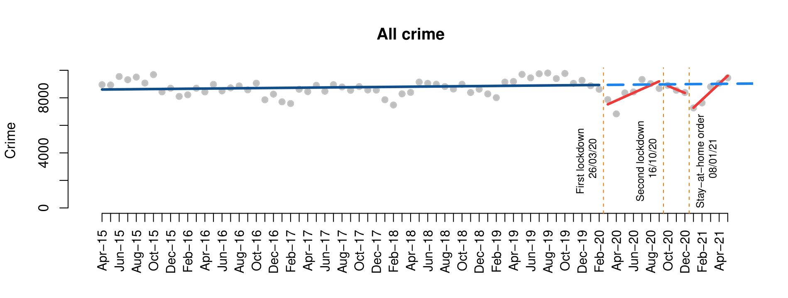

***Figure 1.*** *Interrupted time series analysis of all crime*

## Violent and sexual crime

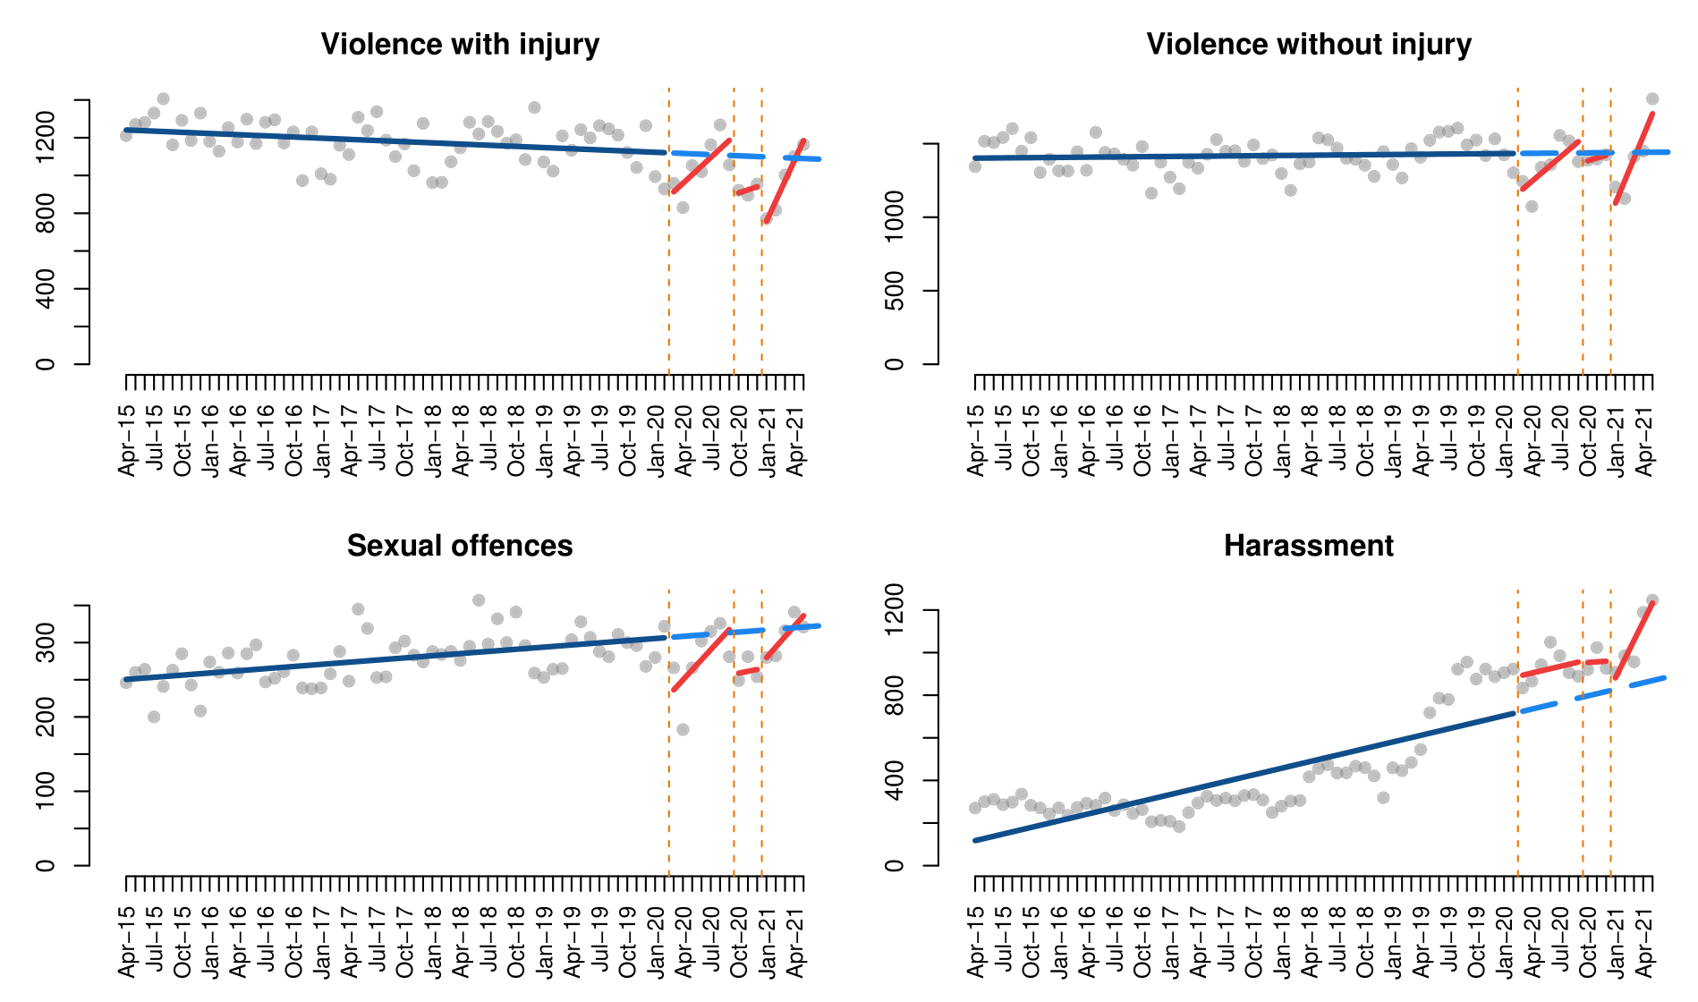

***Figure 2.*** *Interrupted time series analysis of violent and sexual crimes*

***Table 1.*** *Interrupted time series models of violent and sexual crimes*

|  |  |  |  |  |
| --- | --- | --- | --- | --- |
|  | Violence with injury | Violence without injury | Sexual offences | Harassment |
| (Intercept) | 1243.3*** | 1401.2*** | 249.5*** | 107.0** |
| Time | -2.1* | 0.5 | 1.0*** | 10.3*** |
| First lockdown | -253.5** | -297.1** | -83.7** | 169.3 |
| Time since first lockdown | 47.7* | 53.4* | 12.6* | -0.0 |
| Second lockdown | -215.5 | -73.0 | -56.9 | 164.3 |
| Time since second lockdown | 18.6 | 18.5 | 1.5 | -7.3 |
| Third lockdown | -450.0*** | -496.3*** | -50.4 | -24.2 |
| Time since third lockdown | 109.1** | 151.8*** | 13.13 | 77.7+ |
| Adjusted R2 | 0.42 | 0.24 | 0.28 | 0.82 |

***p-value<0.001, **p-value<0.01, *p-value<0.05, +p-value<0.1

## Drug crimes, damage and public order

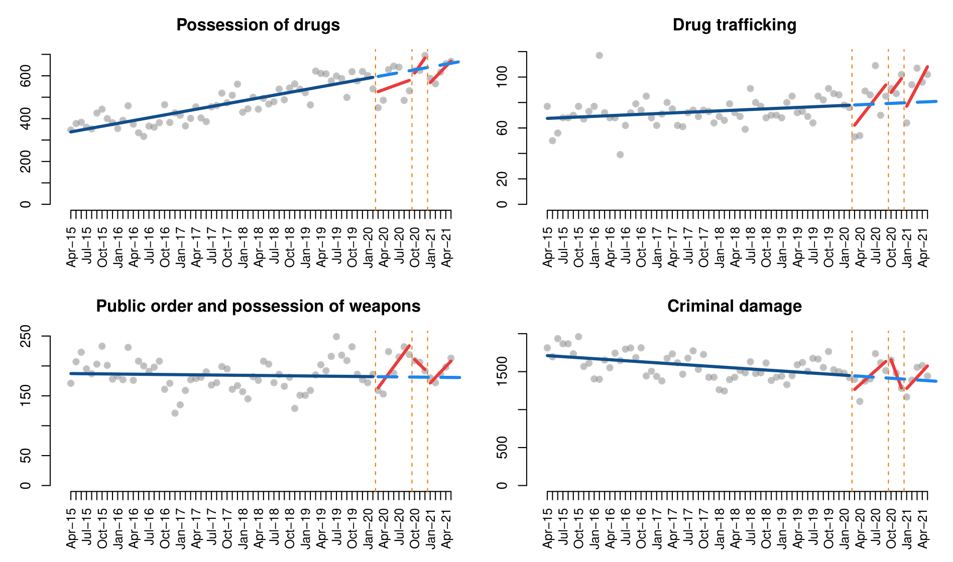

***Figure 3.*** *Interrupted time series analysis of drug crimes, damage and public order*

***Table 2.*** *Interrupted time series models of drug crimes, damage and public order*

|  |  |  |  |  |
| --- | --- | --- | --- | --- |
|  | Possession of drugs | Drug trafficking | Public order and possession of weapons | Criminal damage |
| (Intercept) | 333.8*** | 67.4*** | 187.3*** | 1715.9*** |
| Time | 4.4*** | 0.2* | -0.1 | -4.5*** |
| First lockdown | -75.5+ | -21.0* | -30.5 | -245.2+ |
| Time since first lockdown | 4.4 | 5.1* | 11.8* | 66.1* |
| Second lockdown | -46.4 | 3.2 | 37.8 | 426.3+ |
| Time since second lockdown | 31.1 | 5.3 | -8.4 | -181.5+ |
| Third lockdown | -93.7+ | -10.5 | -19.0 | -200.1 |
| Time since third lockdown | 20.7 | 7.6* | 9.3 | 78.8+ |
| Adjusted R2 | 0.76 | 0.29 | 0.05 | 0.28 |

***p-value<0.001, **p-value<0.01, *p-value<0.05, +p-value<0.1

## Burglary

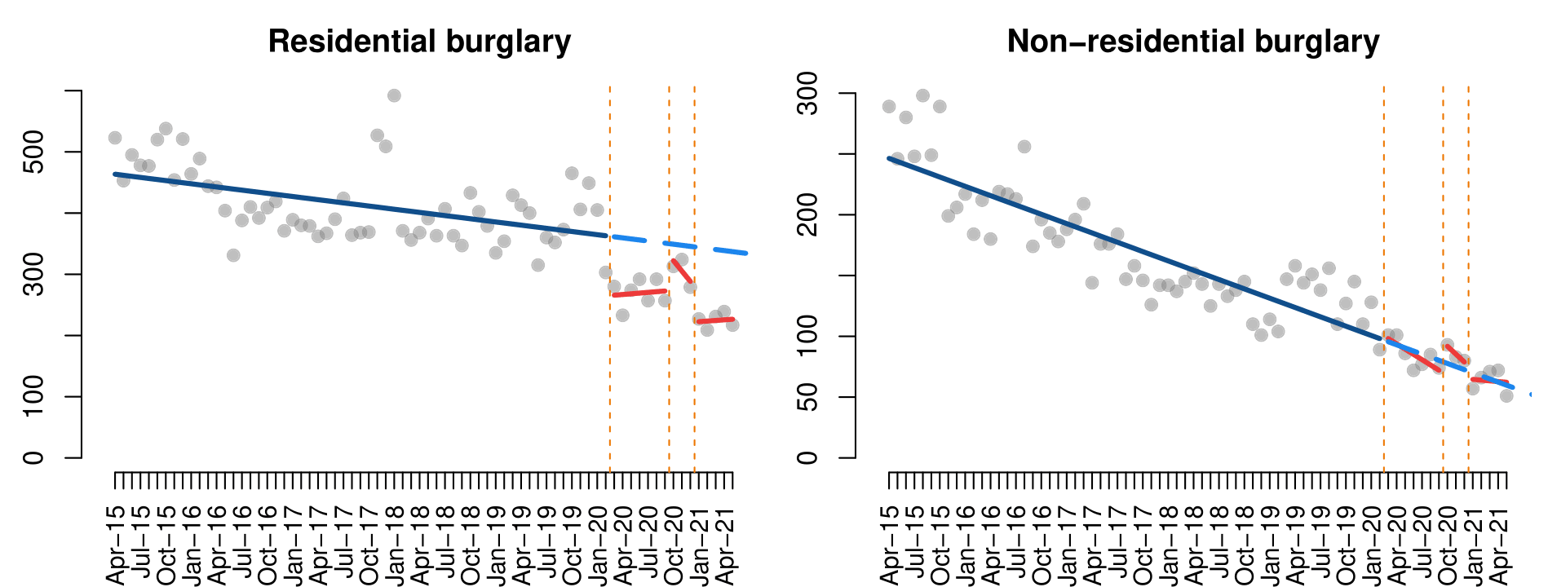

***Figure 4.*** *Interrupted time series analysis of burglary*

***Table 3.*** *Interrupted time series models of burglary*

|  |  |  |
| --- | --- | --- |
|  | Residential burglary | Non-residential burglary |
| (Intercept) | 465.2*** | 248.9*** |
| Time | -1.7*** | -2.6*** |
| First lockdown | -98.3* | 4.4 |
| Time since first lockdown | 2.9 | -1.8 |
| Second lockdown | -11.5 | 18.1 |
| Time since second lockdown | -15.3 | -3.9 |
| Third lockdown | -124.1* | -7.4 |
| Time since third lockdown | 2.7 | 2.0 |
| Adjusted R2 | 0.62 | 0.83 |

***p-value<0.001, **p-value<0.01, *p-value<0.05, +p-value<0.1

## Theft and robbery

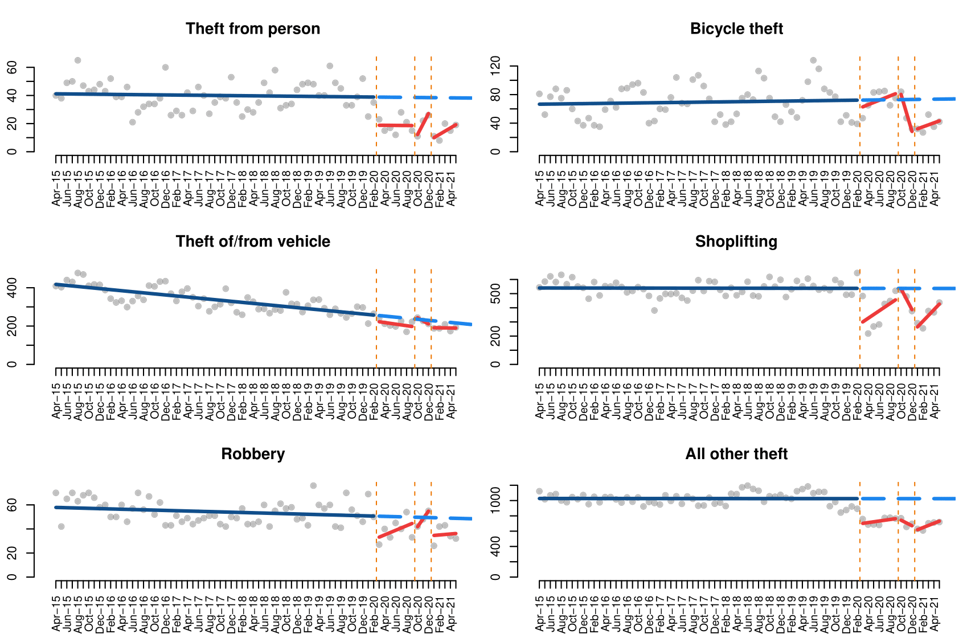

***Figure 5.*** *Interrupted time series analysis of theft and robbery*

***Table 4.*** *Interrupted time series models of theft and robbery*

|  |  |  |  |  |  |  |
| --- | --- | --- | --- | --- | --- | --- |
|  | Theft from person | Bicycle theft | Theft of/ from vehicle | Shoplifting | Robbery | All other theft |
| (Intercept) | 41.2*** | 66.5*** | 420.3*** | 540.0*** | 58.0*** | 1026.8*** |
| Time | -0.0 | 0.1 | -2.7*** | -0.0 | -0.1+ | -0.0 |
| First lockdown | -20.0* | -12.5 | -30.9 | -263.6*** | -19.4* | -333.9*** |
| Time since first lockdown | 0.0 | 3.0 | -1.3 | 26.1* | 2.0 | 10.3 |
| Second lockdown | -33.9* | 33.5 | 22.1 | 71.7 | -14.5 | -245.0* |
| Time since second lockdown | 7.5 | -26.1 | -13.7 | -74.0+ | 6.6 | -36.5 |
| Third lockdown | -30.8** | -44.0+ | -38.3 | -312.7*** | -15.3 | -434.7*** |
| Time since third lockdown | 2.3 | 2.7 | 2.4 | 40.5* | 0.5 | 28.2 |
| Adjusted R2 | 0.46 | 0.09 | 0.76 | 0.57 | 0.31 | 0.74 |

***p-value<0.001, **p-value<0.01, *p-value<0.05, +p-value<0.1

## Fraud and cybercrime

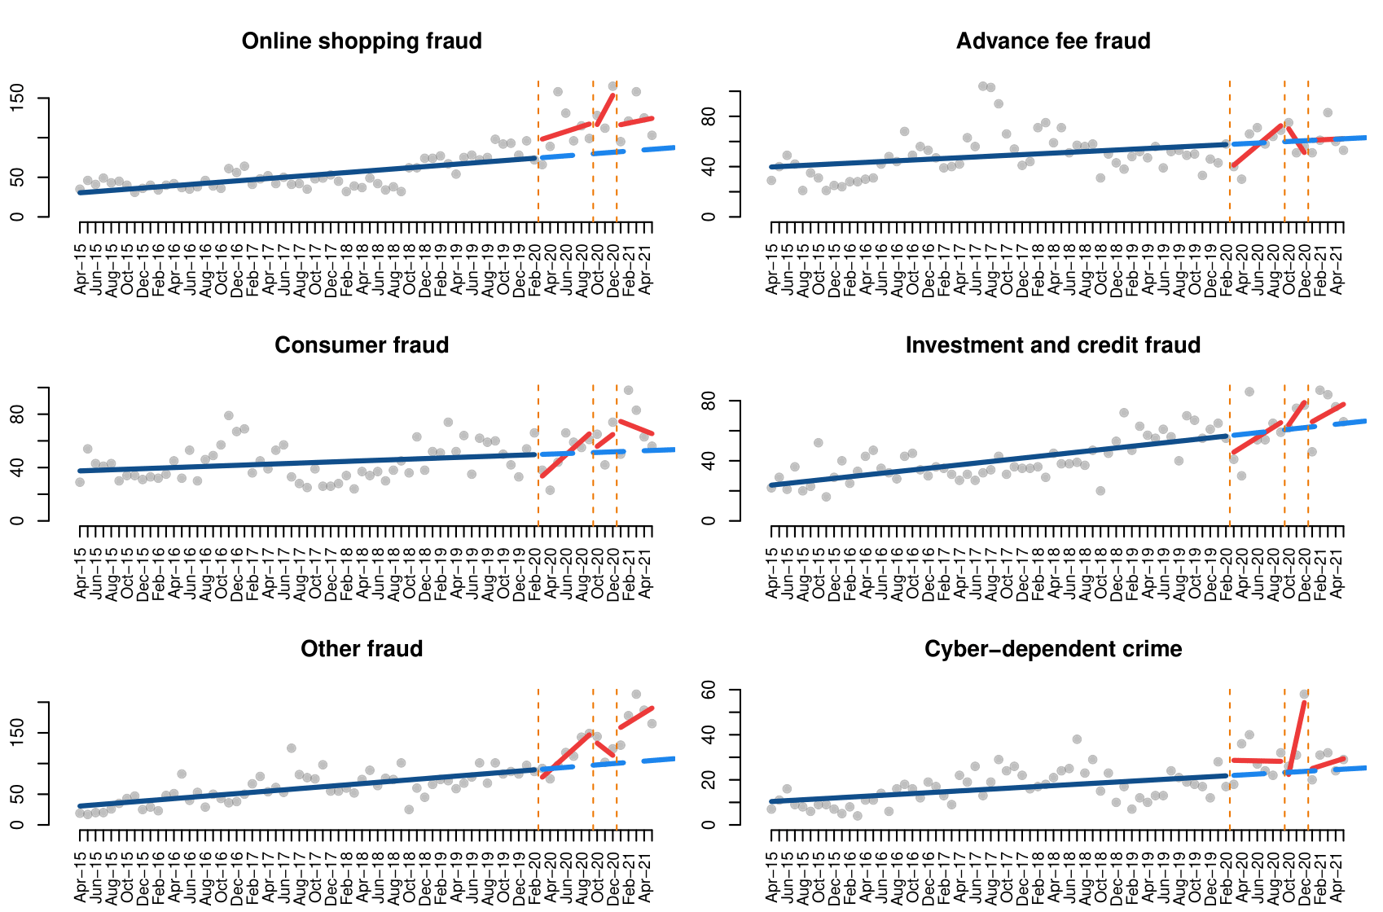

***Figure 6.*** *Interrupted time series analysis of fraud and cybercrime*

***Table 5.*** *Interrupted time series model of fraud and cybercrime*

|  |  |  |  |  |  |  |
| --- | --- | --- | --- | --- | --- | --- |
|  | Online shopping fraud | Advance fee fraud | Consumer fraud | Investment and credit fraud | Other fraud | Cyber-dependent crime |
| (Intercept) | 29.7*** | 39.4*** | 37.3*** | 23.2*** | 29.6*** | 10.2*** |
| Time | 0.8*** | 0.3* | 0.2+ | 0.6*** | 1.0*** | 0.2*** |
| First lockdown | 21.0 | -21.7 | -21.4+ | -14.0 | -23.4 | 6.9 |
| Time since first lockdown | 2.4 | 4.9 | 5.1+ | 2.7 | 10.5** | -0.3 |
| Second lockdown | 18.7 | 20.0 | 0.2 | -4.0 | 46.5 | -16.8 |
| Time since second lockdown | 17.7 | -9.8 | 4.3 | 6.9 | -11.0 | 15.8** |
| Third lockdown | 32.8+ | 0.1 | 25.1 | 1.0 | 51.0* | 0.2 |
| Time since third lockdown | 1.2 | -0.0 | -2.5 | 2.3 | 6.9 | 0.9 |
| Adjusted R2 | 0.76 | 0.10 | 0.23 | 0.59 | 0.79 | 0.52 |

***p-value<0.001, **p-value<0.01, *p-value<0.05, +p-value<0.1

# Discussion and conclusions

# References

Abedi, V., Olulana, O., Avula, V., Chaudhary, D., Khan, A., Shahjouei, S., Li, J., and Zand, R. (2021). Racial, economic, and health inequality and COVID-19 infection in the United States. *Journal of Racial and Ethnic Health Disparities*, 8, 732-742. <https://doi.org/10.1007/s40615-020-00833-4>

Abrams, D. S. (2021). COVID and crime: An early empirical look. *Journal of Public Economics*, 194, 104344. <https://doi.org/10.1016/j.jpubeco.2020.104344>

Ashby, M. P. J. (2020). Initial evidence on the relationship between the coronavirus pandemic and crime in the United States. *Crime Science*, 9, 6. <https://doi.org/10.1186/s40163-020-00117-6>

Bartik, A. W., Bertrand, M., Cullen, Z., Glaeser, E. L., Luca, M., and Stanton, C. (2020). The impact of COVID-19 on small business outcomes and expectations. *Proceedings of the National Academy of Sciences of the United States of America*, 117(30) 17656-17666. <https://doi.org/10.1073/pnas.2006991117>

Bergeron, A., Décary-Hétu, D., and Giommoni, L. (2020). Preliminary findings of the impact of COVID-19 on drugs crypto markets. *International Journal of Drug Policy*, 83, 102870. <https://doi.org/10.1016/j.drugpo.2020.102870>

Buil-Gil, D., Miró-Llinares, F., Moneva, A., Kemp, S., and Díaz-Castaño, N. (2021). Cybercrime and shifts in opportunities during COVID-19: A preliminary analysis in the UK. *European Societies*, 23(sup1), S47-S59. <https://doi.org/10.1080/14616696.2020.1804973>

Buil-Gil, D., and Zeng, Y. (2021). Meeting you was a fake: Investigating the increase in romance fraud during COVID-19. *Journal of Financial Crime*. <https://doi.org/10.1108/JFC-02-2021-0042>

Czymara, C. S., Langenkamp, A., and Cano, T. (2021). Cause for concerns: gender inequality in experiencing the COVID-19 lockdown in Germany. *European Societies*, 23(sup1), S68-S81. <https://doi.org/10.1080/14616696.2020.1808692>

Fei, G., Li, X., Sun, Q., Qian, Y., Stallones, L., Xiang, H., and Zhang, X. (2020). Effectiveness of implementing the criminal administrative punishment law of drunk driving in China: An interrupted time series analysis, 2004-2017. *Accident Analysis & Prevention*, 144, 105670. <https://doi.org/10.1016/j.aap.2020.105670>

Halford, E., Dixon, A., Farrell, G., Malleson, N., and Tilley, N. (2020). Crime and coronavirus: Social distancing, lockdown, and the mobility elasticity of crime. *Crime Science*, 9, 11. <https://doi.org/10.1186/s40163-020-00121-w>

Humphreys, D. K., Eisner, M. P., and Wiebe, D. J. (2013). Evaluating the impact of flexible alcohol trading hours on violence: An interrupted time series analysis. *PLoS ONE*, 8(2), e55581. <https://doi.org/10.1371/journal.pone.0055581>

Kemp, S., Buil-Gil, D., Moneva, A., Miró-Llinares, F., and Díaz-Castaño, N. (2021). Empty streets, busy internet: A time-series analysis of cybercrime and fraud trends during COVID-19. *Journal of Contemporary Criminal Justice*. <https://doi.org/10.1177/10439862211027986>

Krendl, A. C., and Perry, B. L. (2021). The impact of sheltering in place during the COVID-19 pandemic on older adults’ social and mental well-being. *The Journals of Gerontology: Series B*, 76(2), e53-e58. <https://doi.org/10.1093/geronb/gbaa110>

Langton, S., Dixon, A., and Farrell, G. (2021). Six months in: pandemic crime trends in England and Wales. *Crime Science*, 10, 6. <https://doi.org/10.1186/s40163-021-00142-z>

Martin, J., Cunliffe, J., Décary-Hétu, D., and Aldridge, J. (2018). Effect of restricting the legal supply of prescription opioids on buying through online illicit marketplaces: Interrupted time series analysis. *The BMJ*, 361, k2270. <http://doi.org/10.1136/bmj.k2270>

Mohler, G., Bertozzi, A. L., Carter, J., Short, M. B., Sledge, D., Tita, G. E., Uchida, C. D., and Brantingham, P. J. (2020). Impact of social distancing during COVID-19 pandemic on crime in Los Angeles and Indianapolis. *Journal of Criminal Justice*, 68, 101692. <https://doi.org/10.1016/j.jcrimjus.2020.101692>

Nivette, A. E., Zahnow, R., Aguilar, R., Ahven, A., Amram, S., Ariel, B., Arosemena Burbano, M. J., Astolfi, R., Baier, D., Bark, H., Beijers, J. E. H., Bergman, M., Breetzke, G., Concha-Eastman, I. A., Curtis-Ham, S., Davenport, R., Díaz, C., Fleitas, D., Gerell, M., Jang, K., Kääriäinen, J., Lappi-Seppälä, T., Lim, W., Loureiro Revilla, R., Mazerolle, L., Meško, G., Pereda, N., Peres, M. F. T., Poblete-Cazenave, R., Rose, S., Svensson, R., Trajtenberg, N., van der Lippe, T., Veldkamp, J., Vilalta Perdomo, C. J., and Eisner, M. P. (2021). A global analysis of the impact of COVID-19 stay-at-home restrictions on crime. *Nature Human Behaviour*. <https://doi.org/10.1038/s41562-021-01139-z>

Nix, J., and Richards, T. N. (2021). *The immediate and long-term effects of COVID-19 stay-at-home orders on domestic violence calls for service across six U.S. jurisdictions*. *Police Practice and Research*, 22(4), 1443-1451. <https://doi.org/10.1080/15614263.2021.1883018>

Payne, J. L., Morgan, A., and Piquero, A. R. (2021). Exploring regional variability in the short-term impact of COVID-19 on property crime in Queensland, Australia. *Crime Science*, 10, 7. <https://doi.org/10.1186/s40163-020-00136-3>

Piquero, A. R., Jennings, W. G., Jemison, E., Kaukinen, C., and Knaul, F. M. (2021). Domestic violence during the COVID-19 pandemic - Evidence from a systematic review and meta-analysis. *Journal of Criminal Justice*, 74, 101806. <https://doi.org/10.1016/j.jcrimjus.2021.101806>

R Core Team (2020). *R: A language and environment for statistical computing*. Vienna: R Foundation for Statistical Computing. <https://www.R-project.org/>.

Rajkumar, R. P. (2020). COVID-19 and mental health: A review of the existing literature. *Asian Journal of Psychiatry*, 52, 102066. <https://doi.org/10.1016/j.ajp.2020.102066>

Stechemesser, A., Wenz, L., and Levermann, A. (2020). Corona crisis fuels racially profiled hate in social media networks. *EClinicalMedicine*, 23, 100372. <https://doi.org/10.1016/j.eclinm.2020.100372>

Steinbach, R., Perkins, C., Tompson, L., Johnson, S., Armstrong, B., Green, J., Grundy, C., Wilkinson, P., and Edwards, P. (2015). The effect of reduced street lighting on road casualties and crime in England and Wales: Controlled interrupted time series analysis. *Journal of Epidemiology and Community Health*, 69(11), 1118-1124. <http://doi.org/10.1136/jech-2015-206012>