Offline crime bounces back to pre-COVID levels, cyber stays high: Interrupted time-series analysis in Northern Ireland

# Authors

David Buil-Gil1, Yongyu Zeng1 and Steven Kemp1,2

1Department of Criminology, University of Manchester, UK

2Department of Law, Pompeu Fabra University, Spain

# Corresponding author

David Buil-Gil. G18 Humanities Bridgeford Street Building, School of Social Sciences, University of Manchester, Oxford Road, M15 6FH, Manchester. Email: [david.builgil@manchester.ac.uk](mailto:david.builgil@manchester.ac.uk)

# Funding

This work is supported by the Research Collaboration Fund for Research Staff of the University of Manchester.

# Author contributions

All three authors contributed to the original idea and the development of the article. The data handling and analysis was conducted by the first author.

# Availability of data and materials

All data and analytical codes are available from a Github repository (anonymised repository for blind review: <https://anonymous.4open.science/r/covid_crime_NI-Anonymise/>).

# Competing interests

The authors declare that they have no competing interests.

# Abstract

Guideline does not specify wordcount

# Keywords

Coronavirus; Fraud; Counterfactuals; Temporal; Routine activities; Cyber-enabled

Offline crime returns to pre-COVID levels, cyber doesn’t: Interrupted time-series analysis in Northern Ireland

# Abstract

Guideline does not specify wordcount

# 1. Introduction

The COVID-19 pandemic and the first stay-at-home orders imposed by national and regional governments were linked to notable decreases in some types of violent and property crime in the United States (Abrams, 2021; Ashby, 2020; Mohler et al., 2020), the United Kingdom (Halford et al., 2020), Australia (Payne et al., 2021) and other countries (Nivette et al., 2021). Simultaneously, research observed increases in other offences that occur in physical and digital places less affected by lockdown mobility restrictions, such as domestic violence (Piquero et al., 2021), cyber-enabled fraud (Kemp et al., 2021), online hate speech (Stechemesser et al., 2020) and some forms of hacking (Buil-Gil et al., 2021).

After the first few months of the COVID-19 pandemic, researchers noted that rates of traditional, offline crime began to bounce back to pre-COVID levels (Balmori de la Miyar et al., 2021; Langton et al., 2021; Nix and Richards, 2021), and some violent offences even surpassed crime rates seen before the pandemic (Kim and Phillips, 2021). Nonetheless, there is a lack of research on the medium- and long-term impact of multiple lockdown orders on cyber-enabled and cyber-dependent crime. More importantly, crime research has yet to understand whether the peak rates in cybercrime seen immediately after the first lockdown orders returned to pre-COVID levels after the easing of stay-at-home restrictions, or whether cybercrime rates remained above pre-pandemic trends, thus indicating a potential long-term post-pandemic accelerated upward trend in cybercrime. Furthermore, there have been few attempts to compare online and offline crime in the same dataset, thereby limiting comparisons of trends between these crime types.

In this study, we analyse changes in crime, including offline and online crime, in Northern Ireland during COVID-19, and investigate the short- and medium-term impact of the three COVID-19 lockdowns on crime. We analyse the effect of multiple lockdowns on crime trends using interrupted time series (ITS) analysis based on segmented linear regressions and counterfactuals (McDowall et al., 2019).

# 2. COVID-19 and changes in everyday life in Northern Ireland

The timeline of the COVID-19 pandemic in Northern Ireland was similar to other parts of the UK. The first case of COVID-19 was detected on February 27th 2020, and the number of cases rose steeply throughout March. In order to control the spread of the virus, the UK Government announced the first national lockdown on March 23rd, which came into force three days later, on March 26th. The stay-at-home order meant all non-essential social and business activities were restricted for weeks, and non-essential shops, schools, universities, businesses, pubs and other venues were closed. These measures had enormous effects on mobility trends, as can be seen in Figure 1, with almost immediate reductions in mobility in places dedicated to retail and recreation, grocery and pharmacy, transit stations and workplaces, and marked increases in mobility in residential areas. The first lockdown was gradually eased during June and July 2020.

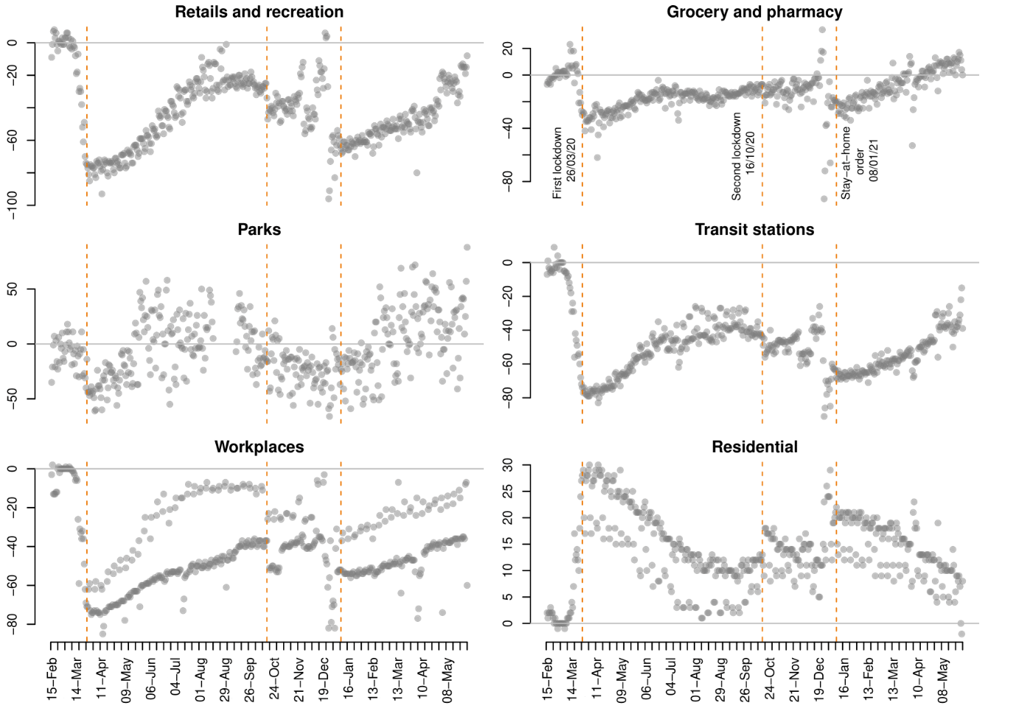

***Figure 1.*** *Percent change from baseline in mobility indicators in Belfast (February 15th 2020 to May 31st 2021). Source: Google COVID-19 Community Mobility Reports (*[*https://www.google.com/covid19/mobility/index.html?hl=en*](https://www.google.com/covid19/mobility/index.html?hl=en)*)*

Due to the steep rise in COVID-19 infections during late September and early October 2020, the Northern Ireland Government announced a second lockdown on October 14th, which officially began on October 16th. This second lockdown involved the closure of schools, universities and the hospitality sector, but it did not involve a stay-at-home order as such and the social distancing restrictions were less strict than in the first national lockdown. Although the measures associated with the second lockdown contributed to immediate changes in mobility (see Figure 1), the extent of these changes was very small compared to the first lockdown. Further restrictions, mostly related to the closure of cafes, hospitality, non-essential shops and gyms, were introduced on November 27th. The second lockdown was mostly lifted by the second week of December.

Just a few days later, however, on December 17th, a third lockdown was announced, which began on December 26th. Entertainment and hospitality businesses and non-essential shops were closed, and a maximum of three household were allowed to meet over Christmas. Some mobility restrictions were later tightened on 8th January 2021, when a stay-at-home order came into force due to the spread of a new variant of the virus. People were only allowed to leave home for medical reasons, to buy food, exercise and go to work only when work could not be done from home. As can be seen in Figure 1, some of these measures had a similar impact on mobility as the first lockdown (some of the extreme changes in mobility seen during the last days of December are due to Christmas shopping and celebrations). Stay-at-home orders were progressively lifted during March and April 2021, and mobility trends progressively returned to the pre-COVID baseline.

All these unprecedented changes in routine activities brought about by the COVID-19 lockdowns are expected to have short- and medium-term impacts on crime in Northern Ireland, as seen in other parts of the world (Nivette et al., 2021). We will analyse changes in crime after the first lockdown (March 23rd 2020), second lockdown (October 16th 2020) and the stay-at-home order of the third lockdown (January 8th 2021).

# 3. Rapid social changes and crime: The COVID-19 case

Crime is dependent on illicit opportunity structures which vary according to changes in everyday routine activities. By the end of the 1970s, Cohen and Felson (1979) observed that property and violent crime was growing in the United Stated due to series of social changes that increased the availability of suitable targets and reduced the ability of people to serve as guardians of these targets. Cohen and Felson (1979) proposed the Routine Activity Approach of crime, which argues that crime increases when (and where) there are more opportunities for offenders to converge with suitable targets in the absence of capable guardians. Since then, this approach has been applied to explain the effect of natural disasters on crime (Leitner et al., 2011), the impact of rapid economic and political changes on crime (Piatkowska et al., 2016), and changes in crime during large sports events (Kalist and Lee, 2014), amongst many other examples. However, no event in recent history has affected everyday routine activities as much as COVID-19 and the associated lockdown measures.

After the first COVID-19 lockdown was announced in many countries in March 2020, several researchers noted immediate changes in crime. Mohler et al. (2020) observed that burglary and robbery reports decreased after the first stay-at-home order in Los Angeles than Indianapolis. Also using Los Angeles crime data, Campedelli et al. (2020) observed a significant decrease in robbery, shoplifting, theft and battery during March and April 2020, but no significant changes were seen for burglary, homicide, vehicle theft or assault. Ashby (2020) analysed crime data in sixteen large US cities between January and May 2020 and noted a reduction in residential burglary and motor vehicle theft in some cities after the first stay-at-home orders. There was little variation in non-residential burglary and serious assault. In the UK, Halford et al. (2020) analysed changes in crime in Lancashire during March 2020, and noted that, by the week of March 23rd, there was a large decrease in shoplifting, theft, theft from vehicle, domestic abuse, assault and residential and non-residential burglary. Changes in recorded crime were also found in Sweden (Gerell et al., 2020), Mexico (Estévez-Soto, 2021), China (Borrion et al., 2020) and Australia (Payne et al., 2021). Nivette et al. (2021) recorded crime data from 27 cities across 23 countries and concluded that stay-at-home orders contributed to a considerable global drop in urban crime.

Some researchers noted, however, that while many types of offline crime were decreasing, there were signs that the changes in routine activities brought about by the first lockdown had increased opportunities for online crime. Using data about cyber-enabled fraud and cyber-dependent crime recorded by Action Fraud, the UK National Fraud and Cybercrime Reporting Centre, between May 2019 and May 2020, Buil-Gil et al. (2021) observed significant increases in some forms of hacking and online shopping fraud after the first stay-at-home order. Lallie et al. (2021) documented cyber-attacks reported globally and observed an increase in cybersecurity incidents such as phishing, malware and cyber-enabled fraud after February 2020. Kemp et al. (2021) analysed reports of fraud and cybercrime made to Action Fraud UK and observed a large increase in cyber-dependent crime (i.e., hacking, denial of service attacks and malware), online shopping fraud and dating fraud after the first COVID-19 lockdown, while those forms of fraud associated with offline events, such as doorstep fraud and ticket fraud, decreased. As argued by these researchers, the first stay-at-home orders contributed to an immediate spike in internet use for entertainment, teleworking, socialising, shopping, and meeting new people, thus increasing the amount of valuable crime targets in online environments. Other forms of crime enabled by the internet also increased, for example, Stechemesser et al. (2020) recorded Tweets with anti-Chinese racist content and observed a spike in online hate speech during March 2020.

All this body of literature contributes to understanding the effect of pandemic-induced, large-scale, rapid social changes on offline and online crime. However, crime research is not only interested in the short-term impact of the COVID-19 lockdown on crime, but it also aims to understand the effect of stay-at-home orders on medium- and long-term crime trends. Langton et al. (2021) showed that, after the first COVID-19 lockdown in the UK, crime started to bounce back to pre-COVID levels. Similar results were found by Balmori de la Miyar et al. (2021) using data recorded in Mexico. Nix and Richards (2021) observed that domestic violence calls for police services in the US returned to pre-COVID levels when lockdown restrictions were lifted.

Existing research appears to indicate that the quick changes in offline crime seen immediately after the first COVID-19 lockdown were temporary, and crime trends progressively returned to pre-COVID levels after social distancing restrictions were relaxed. Nonetheless, while some of the changes in offline routine activities brought about by stay-at-home orders may indeed be temporary (e.g., bars and restaurants reopen, employees return to work from the office, sport events and concerts are organised, travelling is allowed), some of the changes in online everyday practices may not be restricted to the pandemic and may have long-term effects on cybercrime. Online shopping is a clear example, since internet sales were well above pre-COVID levels even after May 2021 (Office for National Statistics, 2021). There is also an expected long-term post-pandemic upward use of online gaming, social media, teleworking, online food delivery, online conference platforms and online dating (Nurse et al., 2021; Ofcom, 2021). Thus, it is plausible that the upward trend seen in cybercrime since March 2020 may not return to levels recorded before the pandemic.

# 4. Methodology

## 4.1 Data

In this article we analyse data recorded by the Police Service of Northern Ireland between April 2015 and May 2021. Crime data was accessed from the crime open data portal[1]. To our knowledge, the Police Service of Northern Ireland is the only UK police force that publishes open access crime data for both offline and online offences, thus allowing us to analyse the impact of the first, second and third COVID-19 lockdowns on both crime types. We analyse the following types of crime aggregated in months: (a) violence and sexual crime, (b) drug crimes, damage and public order, (c) burglary, (d) theft and (e) fraud and cybercrime[2].

Thus, we analyse a variety of crimes that could be affected in different ways by the mobility restrictions of the three lockdowns. For example, opportunities for violent offences and theft are found mostly in ‘public places’ and thus were likely to decrease during stay-at-home orders and return to normal levels after each lockdown (Balmori de la Miyar et al., 2021). While residential burglary opportunities were likely to decrease during lockdown due to the increase of ‘capable guardians’ at home, this may not be the case for non-residential burglaries (Felson et al., 2020). Some fraud types are clearly cyber-enabled, such as online shopping fraud, and thus opportunities were likely to grow with increased internet use both during and after lockdown, while other fraud categories may include both offline and online incidents (for example, investment and advance free fraud can be enabled by the internet in some cases but not always). Cyber-dependent crimes can only take place online.

## 4.2 Analytical approach

In order to analyse the immediate effect of each COVID-19 lockdown on crime, but also the medium-term changes in crime after each lockdown, we utilise ITS analysis based on segmented linear regressions (McDowall et al., 2019). The ITS segmented linear model used here is given by:

$$Y= β_{0}+β_{1}T+β_{2}D_{1}+β_{3}P_{1}+β_{4}D_{2}+β_{5}P_{2}+β_{6}D_{3}+β_{7}P_{3}+e$$

where $Y$ is the value of crime in a given month, $T$ represents time (in months) from 1 to 74, $D_{1}$, $D_{2}$ and $D_{3}$ correspond to the first, second and third lockdowns, respectively, and $P_{1}$, $P_{2}$ and $P_{3}$ is the time (months) passed since the first, second and third lockdowns, respectively. In order to compare the observed crime trends with the expected changes in crime if COVID-19 had not happened, we calculate the ‘counterfactuals’ (i.e., the linear trend that crime would have followed if lockdown restriction had not taken place). We predict the ‘counterfactuals’ from:

$$Y= β_{0}+β_{1}T+e$$

Aside from a few exceptions (e.g., Humphreys et al., 2013; Steinbach et al., 2015), this approach has rarely been applied in crime research, but its application is widespread in epidemiology, economics and other fields.

While this a simple approach that enables us to obtain direct results to achieve our aims, it is not free of limitations. One of the main assumptions of the ordinary least squares (OLS) estimation used here is that error terms are independent from one another, but this may be highly problematic in time-series analysis when the score of $Y$ (crime value) at one point in time is correlated with the scores at another points (i.e., there may be ‘serial autocorrelation’). Moreover, the segmented linear regression does not account for the seasonality that define the trends of some crime types, and thus our coefficient estimates may be affected by seasonal patterns beyond stay-at-home orders (e.g., the second lockdown began in October 2020, after summer, when crime could decrease due to seasonal crime variation). In order to account for both these threats to the validity of our results, we also estimate multivariate linear regressions with Auto Regressive Integrated Moving Average (ARIMA) errors as a sensitivity check[3]. The results of the models with ARIMA errors are presented in the Appendix, showing remarkably similar results to that of the ITS analysis, but we also note a few important differences that will be described in detail in the next section. The analysis has been conducted in R software (R Core Team, 2021).

# 5. Results

This section presents the results of the ITS analysis. The results of the multivariate ARIMA errors are presented in the Appendix as a sensitivity check.

Overall, as shown in Figure 2, recorded crime suffered a marked decrease after the first and third lockdowns in Northern Ireland, while the effect of the second lockdown was less evident. Crime rates progressively returned to pre-COVID levels after the first and third lockdown. However, as described in the literature review, this is likely to mask substantial differences between crime types, and may be related to seasonal patterns that are more evident among some offences than others.

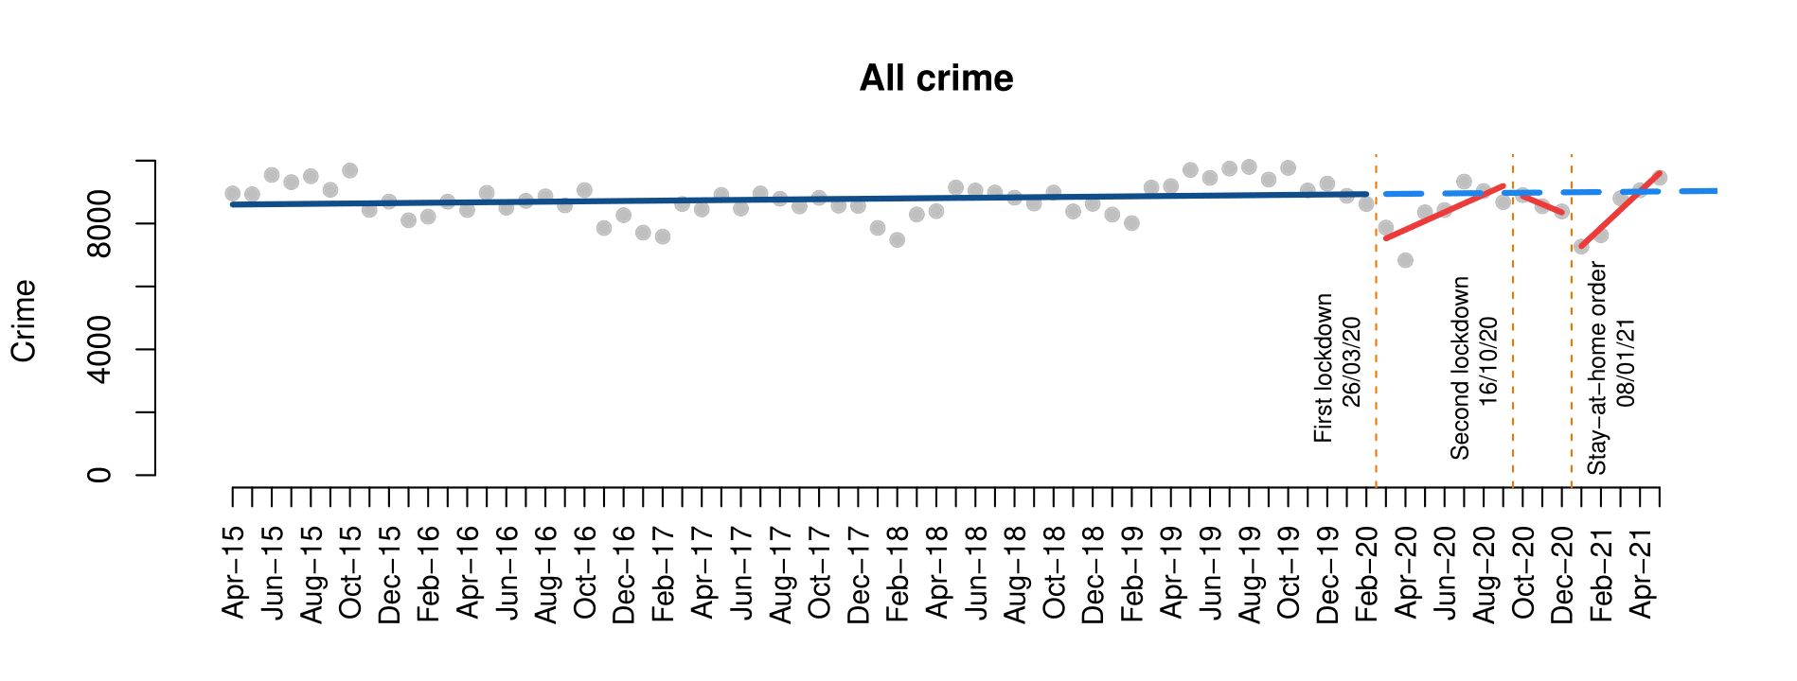

***Figure 2.*** *Interrupted time series analysis of all crime*

## 5.1 Violence and sexual crime

The results of the ITS analysis of violence and sexual offences show that recorded crime levels decreased immediately after each COVID-19 lockdown, and then rapidly returned to pre-COVID levels (Figure 3). The results of the ITS models, presented in Table 1, further reinforce this finding, showing that: (a) the immediate decrease in crime resulting from the first lockdown was statistically significant in all four cases; (b) the gradual increase in crime after the first lockdown is statistically significant in the case of violence with and without injury and sex crime, but not robbery; and (c) violent crime with and without injury significantly decreased immediately after the third lockdown, and returned to pre-COVID levels during the following months as lockdown restrictions were lifted. The results of the multivariate models with ARIMA errors show similar results (see Appendix), but they also find that, in the case of robbery, the effects of the second lockdown (negative), time since second lockdown (positive), and third lockdown (negative) on crime are statistically significant.

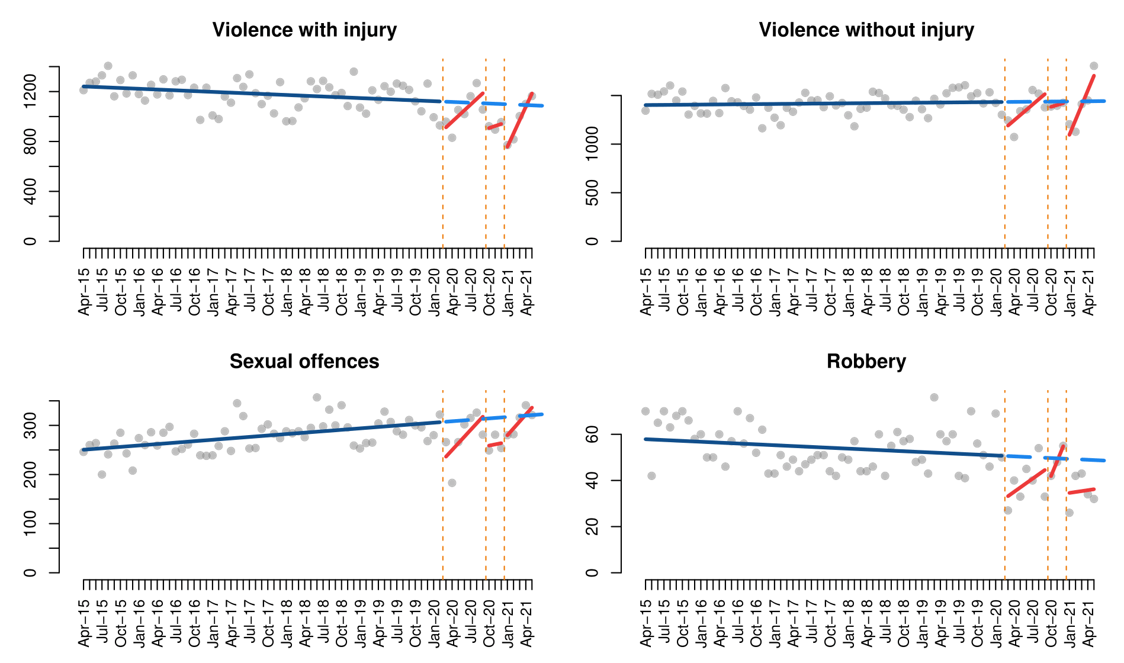

***Figure 3.*** *Interrupted time series analysis of violent and sexual crimes*

***Table 1.*** *Interrupted time series models of violent and sexual crimes*

|  |  |  |  |  |
| --- | --- | --- | --- | --- |
|  | Violence with injury | Violence without injury | Sexual offences | Robbery |
| (Intercept) | 1243.3*** | 1401.2*** | 249.5*** | 58.0*** |
| Time | -2.1* | 0.5 | 1.0*** | -0.1+ |
| First lockdown | -253.5** | -297.1** | -83.7** | -19.4* |
| Time since first lockdown | 47.7* | 53.4* | 12.6* | 2.0 |
| Second lockdown | -215.5 | -73.0 | -56.9 | -14.5 |
| Time since second lockdown | 18.6 | 18.5 | 1.5 | 6.6 |
| Third lockdown | -450.0*** | -496.3*** | -50.4 | -15.3 |
| Time since third lockdown | 109.1** | 151.8*** | 13.13 | 0.5 |
| Adjusted R2 | 0.42 | 0.24 | 0.28 | 0.32 |

***p-value<0.001, **p-value<0.01, *p-value<0.05, +p-value<0.1

## 5.2 Drug crimes, damage and public order

Recorded drug-related crimes and public order/criminal damage offences show notably different trends. One the one hand, drug crimes levels decreased immediately after each COVID-19 lockdown and progressively returned to pre-COVID levels during the following months. On the other hand, ITS analysis of public order and criminal damage shows that crime decreased immediately after the first and third lockdowns, and then returned to the overall linear trendline, but the observed effect of the second lockdown was different to those seen above, showing a decrease in crime after October 2020. This can be seen both in Figure 4 and Table 2. However, as can be observed in Figure 4, the trends of public order and criminal damage during the pandemic follow remarkably similar patterns to pre-COVID trends, with increases during summer and lower levels in winter. Thus, caution is necessary when attempting to establish links between COVID-19 lockdowns and crime, since changes in crime may simply be driven by crime seasonality. It should also be highlighted that drug trafficking offences are clearly larger during COVID-19 than before.

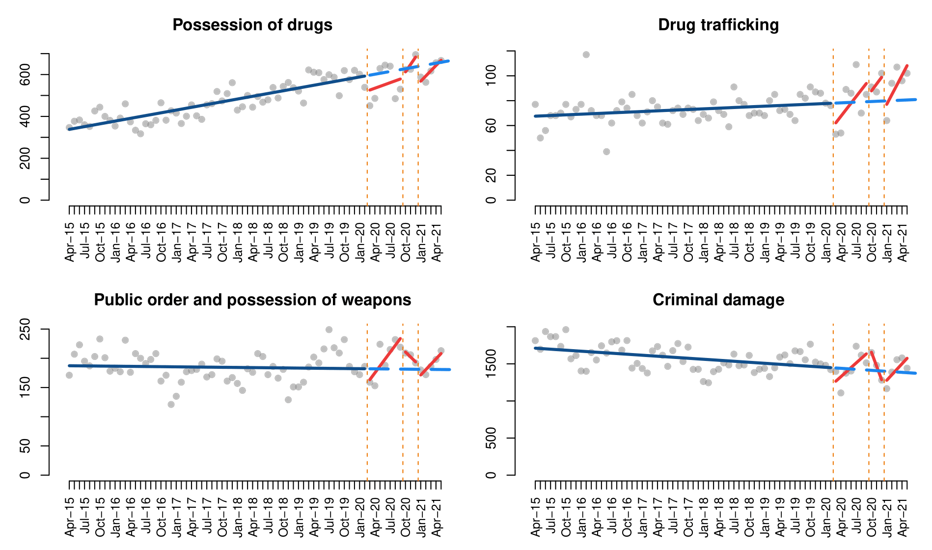

***Figure 4.*** *Interrupted time series analysis of drug crimes, damage and public order*

***Table 2.*** *Interrupted time series models of drug crimes, damage and public order*

|  |  |  |  |  |
| --- | --- | --- | --- | --- |
|  | Possession of drugs | Drug trafficking | Public order and possession of weapons | Criminal damage |
| (Intercept) | 333.8*** | 67.4*** | 187.3*** | 1715.9*** |
| Time | 4.4*** | 0.2* | -0.1 | -4.5*** |
| First lockdown | -75.5+ | -21.0* | -30.5 | -245.2+ |
| Time since first lockdown | 4.4 | 5.1* | 11.8* | 66.1* |
| Second lockdown | -46.4 | 3.2 | 37.8 | 426.3+ |
| Time since second lockdown | 31.1 | 5.3 | -8.4 | -181.5+ |
| Third lockdown | -93.7+ | -10.5 | -19.0 | -200.1 |
| Time since third lockdown | 20.7 | 7.6* | 9.3 | 78.8+ |
| Adjusted R2 | 0.76 | 0.29 | 0.06 | 0.28 |

***p-value<0.001, **p-value<0.01, *p-value<0.05, +p-value<0.1

The results of the segmented linear models (Table 2) are very similar to the multivariate ARIMA error regressions (Appendix), but there are some notable differences regarding the statistical significance of some temporal variables. For instance, the ARIMA error model shows that the negative effect of the first lockdown on crime was also statistically significant in the case of public order and possession of weapon offences, the effect of time since the second and third lockdowns is also significant in the case of possession of drug crimes (while the negative effect of the third lockdown on possession of drugs may not be significant), and the negative effect of the third lockdown on criminal damage is statistically significant.

## 5.3 Burglary

There was a clear difference between the effect of COVID-19 on burglary trends when the crime occurred in residential dwellings in comparison to non-residential buildings. While residential burglary decreased after March 2020 and remained well below pre-COVID levels from then, non-residential burglary was not affected in any significant way by the COVID-19 lockdowns (Figure 5). In the case of residential burglary, the segmented linear model results indicate that crime decreased immediately after the first and third lockdowns, and these changes were statistically significant (Table 3), but the ARIMA error model indicates that only the effect of the first lockdown was statistically significant (Appendix).

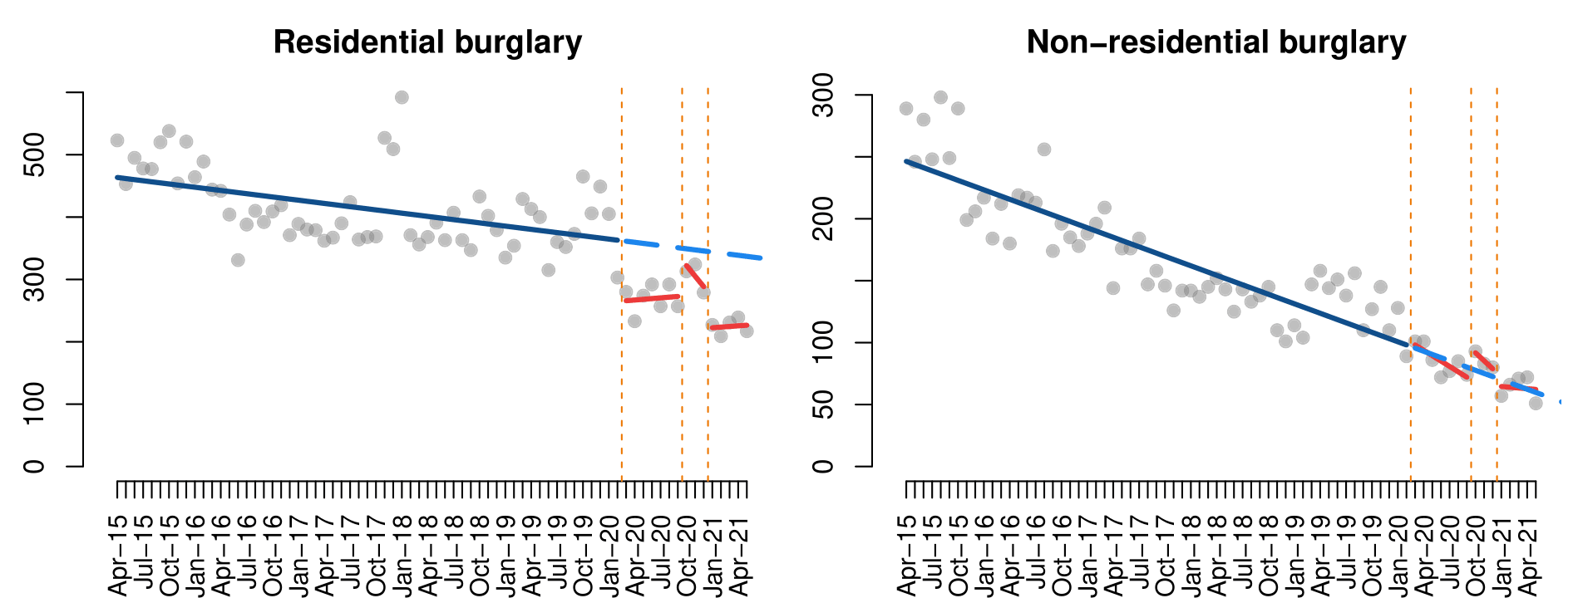

***Figure 5.*** *Interrupted time series analysis of burglary*

***Table 3.*** *Interrupted time series models of burglary*

|  |  |  |
| --- | --- | --- |
|  | Residential burglary | Non-residential burglary |
| (Intercept) | 465.2*** | 248.9*** |
| Time | -1.7*** | -2.6*** |
| First lockdown | -98.3* | 4.4 |
| Time since first lockdown | 2.9 | -1.8 |
| Second lockdown | -11.5 | 18.1 |
| Time since second lockdown | -15.3 | -3.9 |
| Third lockdown | -124.1* | -7.4 |
| Time since third lockdown | 2.7 | 2.0 |
| Adjusted R2 | 0.63 | 0.84 |

***p-value<0.001, **p-value<0.01, *p-value<0.05, +p-value<0.1

## 5.4 Theft

As can be seen in Figure 6, there are important differences across the four types of theft analysed. First, reports of theft from persons decreased immediately after each COVID-19 lockdown, and then started to return to progressively pre-COVID levels after lockdown restrictions were lifted in each case. While the ITS model in Table 4 indicates that the drops in crime observed after each lockdown were statistically significant, the results of the ARIMA error model show that these changes may not be statistically significant (Appendix). Second, changes in bicycle theft during the pandemic appear to follow pre-COVID seasonal patterns, with large increases during summer and fewer crimes recorded in winter. However, the decrease in bicycle theft seen immediately after the third lockdown provoked the lowest level registered since April 2015, and as such this decrease is statistically significant both in the segmented linear model (Table 4) and the ARIMA error model (Appendix). Third, the trend of theft of/from vehicle during the pandemic follows the steady decreasing trend seen before COVID-19, and none of the changes observed since March 2020 are statistically significant (the ARIMA error model shows that the decrease in crime after the third lockdown may be statistically significant). And fourth, we observe that shoplifting experienced a substantial decrease after the first and third lockdowns, but subsequently started to bounce back to pre-COVID levels. Model results also show that, in this case, there was a decrease in crime records instead of an increase during the months following the second lockdown, and this does not appear to be attributed to pre-COVID seasonal trends. All these changes are statistically significant both in the ITS and ARIMA error models.

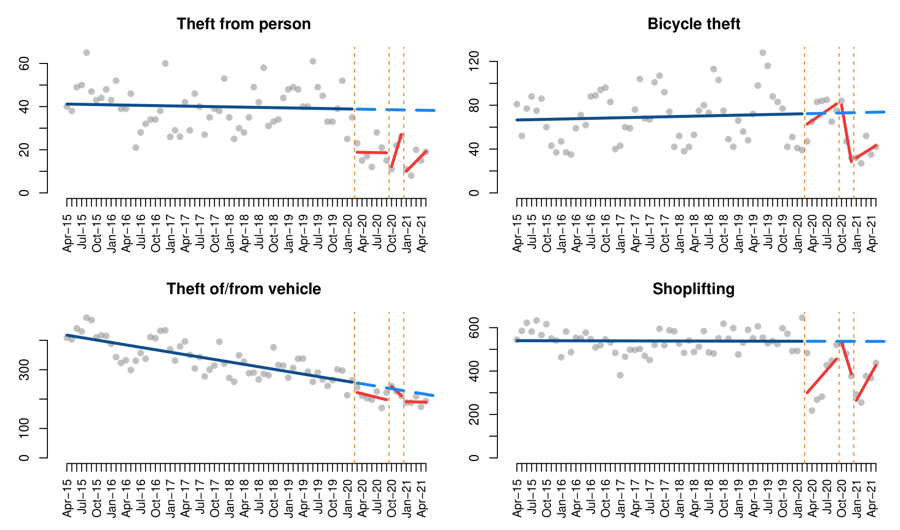

***Figure 6.*** *Interrupted time series analysis of theft and robbery*

***Table 4.*** *Interrupted time series models of theft and robbery*

|  |  |  |  |  |
| --- | --- | --- | --- | --- |
|  | Theft from person | Bicycle theft | Theft of/ from vehicle | Shoplifting |
| (Intercept) | 41.2*** | 66.5*** | 420.3*** | 540.0*** |
| Time | -0.0 | 0.1 | -2.7*** | -0.0 |
| First lockdown | -20.0* | -12.5 | -30.9 | -263.6*** |
| Time since first lockdown | 0.0 | 3.0 | -1.3 | 26.1* |
| Second lockdown | -33.9* | 33.5 | 22.1 | 71.7 |
| Time since second lockdown | 7.5 | -26.1 | -13.7 | -74.0+ |
| Third lockdown | -30.8** | -44.0+ | -38.3 | -312.7*** |
| Time since third lockdown | 2.3 | 2.7 | 2.4 | 40.5* |
| Adjusted R2 | 0.47 | 0.09 | 0.76 | 0.57 |

***p-value<0.001, **p-value<0.01, *p-value<0.05, +p-value<0.1

## 5.5 Fraud and cybercrime

We also analyse changes in fraud and cybercrime during COVID-19. At first glance, in Figure 7, we observe a striking increase in recorded crime across all types of fraud, cyber-enabled or not, and cyber-dependent crime from March 2020. In all cases there is also a steady increase since 2015, which is observed in the statistically significant effect of time on crime trends in the ITS model results (Table 5). There are, however, important differences across crime types.

In the case of investment and advance fee fraud, which can be cyber-enabled in some cases but not others, recorded crime decreased immediately after the first lockdown, but there was an increase immediately after the second and third lockdown orders. While none of these associations is statistically significant according to the results of the segmented linear model (Table 5), the results of the ARIMA error model (Appendix) find a statistically significant negative effect immediately after the first lockdown, and a positive effect in the period since the first lockdown and immediately after the second. Regarding consumer fraud offline, the results of the ITS model show that the only temporal variable that may be statistically significant in explaining crime trends is the time since the first lockdown (Table 5), with a slight increase in crime during the months following March 2020. However, this is not reflected in the results of the ARIMA error model (Appendix), which shows that the negative effect of the first lockdown, time since second lockdown and third lockdown on offline consumer fraud are statistically significant. In the case of consumer fraud online, we see a steep increase in crime records during the COVID-19 pandemic, and while the results of the ITS model (Table 5) show that the only statistically significant temporal variable was the immediate effect of the third lockdown, the multivariate ARIMA error model show that the period since the first lockdown and the second lockdown were also likely to have statistically significant positive effects on online consumer fraud. The ARIMA error model results also show that the first lockdown had a negative effect on recorded online consumer fraud. Regarding other frauds, which may be cyber-enabled or committed fully offline, we observe that the first lockdown may have provoked a decrease in crime which was then followed by an increase, though this is not observed in the results of the ARIMA error model. However, the ARIMA error model shows that other frauds increased significantly from the third lockdown. Finally, with regards to cyber-dependent crime, we also see large peaks in crime records during COVID-19, but the only variables with statistically significant effects are the time since the second lockdown, according to the ITS model (Table 5), or the time since the second lockdown and the first lockdown, according to the ARIMA error model (Appendix).

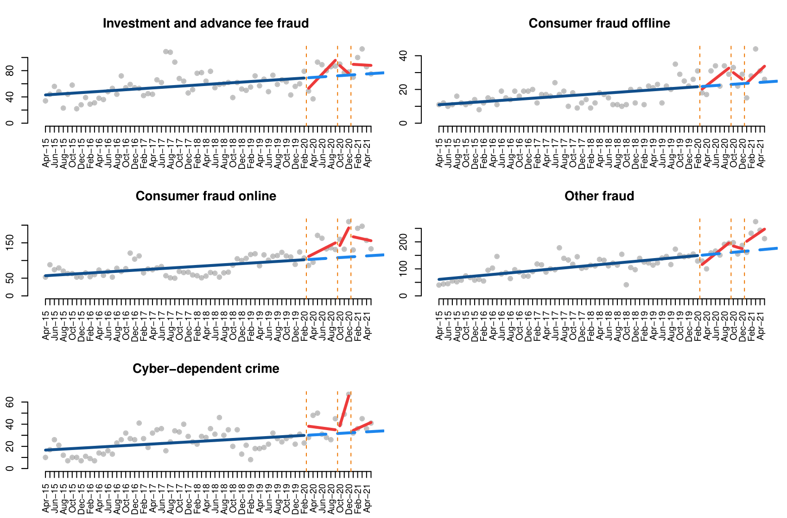

***Figure 7.*** *Interrupted time series analysis of fraud and cybercrime*

***Table 5.*** *Interrupted time series model of fraud and cybercrime*

|  |  |  |  |  |  |
| --- | --- | --- | --- | --- | --- |
|  | Investment and advance fee fraud | Consumer fraud offline | Consumer fraud online | Other fraud | Cyber-dependent crime |
| (Intercept) | 42.6*** | 10.8*** | 56.2*** | 59.5*** | 16.4*** |
| Time | 0.4*** | 0.2*** | 0.8*** | 1.5*** | 0.2** |
| First lockdown | -22.8 | -3.5 | 3.0 | -46.5* | 8.8 |
| Time since first lockdown | 6.7* | 1.9+ | 5.6 | 11.8* | -0.8 |
| Second lockdown | 21.8 | 9.1 | 9.8 | 29.8 | -6.5 |
| Time since second lockdown | -6.4 | -2.2 | 24.2 | -6.5 | 13.2** |
| Third lockdown | 16.7 | -2.1 | 60.1* | 26.3 | 0.4 |
| Time since third lockdown | -0.8 | 2.3 | -3.6 | 7.9 | 1.6 |
| Adjusted R2 | 0.36 | 0.49 | 0.67 | 0.74 | 0.45 |

***p-value<0.001, **p-value<0.01, *p-value<0.05, +p-value<0.1

# 6. Discussion and conclusions

The COVID-19 pandemic and first lockdown orders led to rapid changes in everyday routine activities, which had direct effects on opportunities for crime (Nivette et al., 2021). Immediately after the first stay-at-home orders came into force in many countries in March 2020, many researchers noted that various forms of property and violent crime suffered a notable decrease due to the reduced opportunities for offenders to converge with targets in physical settings (Abrams, 2021; Ashby, 2020). Simultaneously, others highlighted that some forms of cyber-enabled and cyber-dependent crime increased due the growth in internet use for work and leisure (Kemp et al., 2021; Lallie et al., 2021). After the first months of pandemic, some of the social distancing restrictions were relaxed and rates of offline crime began to bounce back to pre-COVID trends (Balmori de la Miyar et al., 2021; Langton et al., 2021), but there is a gap in research about the mid-term effect of multiple lockdowns on online crime, and few previous studies have compared online and offline crime using the same dataset. To fill these gaps, the present paper analysed crime data recorded in Northern Ireland between April 2015 and May 2021 to analyse the short-, medium- and potential long-term effects of each lockdown on various forms of offline and online crime.

We identified that not all crime types were affected in the same way by the lockdown restrictions. Firstly, recorded violence, drug crimes and theft from persons experienced immediate drops when each of the three lockdowns came into force, and crime then returned to pre-COVID levels after lockdown orders were relaxed. These offences take place primarily in physical places that experienced decreases in mobility during each lockdown, and thus the opportunities for offenders to converge with suitable targets decreased with lockdown restrictions, and crime then returned to normal trends when social distancing measures were eased. Interestingly, while most forms of violent crime appeared to return to the same levels seen before the pandemic, drug trafficking not only bounced back to pre-COVID levels, but post-pandemic rates were well above those seen before the pandemic. Similar results were found in a study that analysed drug seizures over time in the United States (Palamar et al., 2021), and Langton et al. (2021) observed a peak in drug crime in England and Wales in May 2020, though a similar increase in drug crime was not observed in other countries (Balmori de la Miyar et al., 2021). It is still unclear whether recorded drug trafficking increased as a result of growth in police activity, as drug trafficking could become more visible with less people walking the streets, or whether this reflects actual changes in the supply and demand of drugs. Contrarily, while recorded theft from persons decreased with each lockdown and then increased slightly, crime levels were still below pre-COVID levels in May 2021. Could this be because people who become involved in crime returned to the streets quickly after lockdown restrictions were lifted, but those not involved in crime did not leave the home as often as before COVID-19? That would explain why violent crime, in which two persons may mutually become involved in the incident, quickly returned to pre-COVID levels, while theft from persons, in which a crime target is needed, did not return to crime levels seen before the pandemic. That would also explain why residential burglary remained well below pre-COVID levels even in May 2021, due to the continued overall increase in the time spent by residents (capable guardians) at home. Further research is needed to identify changes in offender and victim activities.

Secondly, some of the crime types with the most obvious seasonal patterns, including public order and possession of weapons, criminal damage, and bicycle theft, all of which tend to show much higher rates during summer, show a very similar seasonal variation during the pandemic. Crime records decreased with the first lockdown (March 2020) and increased during summer, after the second lockdown (October 2020) crime started to decrease during autumn and reached minimum levels with the stay-at-home order of the third lockdown in winter (January 2021), and after winter crime records began to increase again. Given the close correspondence between the traditional seasonal patterns in crime and the lockdown periods, it becomes difficult to fully comprehend the extent to which changes in crime are due to a continuation of pre-COVID crime seasonality or lockdown restrictions. Our model results provide some support to the hypothesis that social distancing orders significantly affected crime trends in these cases, and thus we can expect that changes in crime are due to the combined effect of lockdown restrictions and seasonal variation. This is particularly evident in the case of bicycle theft, with a large, unusual decrease when the stay-at-home order of the third lockdown came into place. The trend in shoplifting is unique and markedly different from all other offline crimes, with crime records suffering a very large drop immediately after both stay-at-home orders and progressively returning to pre-COVID levels during the following months, but with lower levels recorded by the end of the second lockdown (December) than when the second lockdown came into place in October. This is likely to be the result of the stricter restrictions in place by the end of November, when cafes, hospitality and non-essential shops were closed.

And thirdly, we observe that most forms of fraud and cybercrime rose rapidly during the early months of COVID-19 and continued growing up until May 2021. With the exception of drug trafficking, none of the traditional, offline crimes analysed above experienced clear increases during the pandemic, and thus fraud and cybercrime represent an exception to the overly simplistic view that crime decreased during COVID-19. The other crime type which also likely saw increases during the pandemic was domestic violence (Piquero et al., 2021), though some researchers note that it quickly returned to pre-COVID levels when lockdown restrictions were eased (Nix and Richards, 2021). Our data did not allow us to explore trends in domestic violence. In the case of fraud and cybercrime, there were notable differences across crime types. While consumer fraud online, cyber-dependent crime and other fraud records experienced notable growth from the first lockdown up until May 2021, a similar increase was not as clear in the case of consumer fraud offline, which decreased after some of the COVID-19 lockdowns. Investment and advance fee frauds, which can be cyber-enabled or not, appear to have decreased when the first lockdown came into place and possibly increased after that. It is possible, if not probable, that those forms of fraud that are enabled by digital technologies rose substantially during the pandemic (Buil-Gil et al., 2021), while non-cyber-enabled fraud suffered little variation (Kemp et al., 2021). Moreover, we do not see any indication of cyber-enabled and cyber-dependent crime returning to pre-COVID trends. While our data only allow analysis of changes in crime up until May 2021, it will be important to study cybercrime trends during late 2021 and early 2022 to explore the possibility of a long-term increase in digital offences, which is of clear relevance for policy, practice and academic debate. As some have noted, the increase in online gaming, teleworking, meetings, online shopping and online dating may extend beyond COVID-19 (Nurse et al., 2021; Ofcom, 2021), thus creating new crime opportunities and accelerating the long-term upward trend in online crime.

Our study also identified that not all COVID-19 lockdowns in Northern Ireland had the same effect on crime. The first lockdown, which was defined by a stay-at-home order and restrictions over all non-essential social and business activity, had an overall negative effect on most types of street crimes, due to a reduction in opportunities for the physical convergence between offenders and suitable targets. Similarly, the stay-at-home order of the third lockdown, in January 2021, also had evident effects on mobility and crime opportunities. In contrast, the effect on crime trends of the second lockdown, which involved the closure of schools, universities and the hospitality sector but not a stay-at-home order, was less evident and non-significant in many cases.

While the findings presented in this article are first-of-its-kind and contribute to the criminological literature about the short-, mid- and long-term effects of rapid social changes on crime (offline and online), these are not free of limitations. The main threat to the validity of our findings is related to the use of police-recorded crime statistics as a primary source of data. Police-recorded crime data are known to be severely affected by measurement error arising from underreporting and underrecording, and it is yet unknown the extent to which the COVID-19 pandemic not only affected crime but also the measurement properties of crime statistics (Wallace et al., 2021). This may be particularly problematic in the case of cybercrime, given the low reporting rates that define these offences (van de Weijer et al., 2019). Future research is needed to explore if crime reporting and recording practices changed during COVID-19, thus illuminating the extent to which research using police-recorded crime data to study changes in crime may be affected by measurement error.

# References

Abrams, D. S. (2021). COVID and crime: An early empirical look. *Journal of Public Economics*, 194, 104344. <https://doi.org/10.1016/j.jpubeco.2020.104344>

Ashby, M. P. J. (2020). Initial evidence on the relationship between the coronavirus pandemic and crime in the United States. *Crime Science*, 9, 6. <https://doi.org/10.1186/s40163-020-00117-6>

Balmori de la Miyar, J. R., Hoehn-Velasco, L., and Silverio-Murillo, A. (2021). The U-shaped crime recovery during COVID-19: Evidence from national crime rates in Mexico. *Crime Science*, 10, 14. <https://doi.org/10.1186/s40163-021-00147-8>

Borrion, H., Kurland, J., Tilley, N., and Chen, P. (2020). Measuring the resilience of criminogenic ecosystems to global disruption: A case-study of COVID-19 in China. *PLoS ONE*, 15(10), e0240077. <https://doi.org/10.1371/journal.pone.0240077>

Buil-Gil, D., Miró-Llinares, F., Moneva, A., Kemp, S., and Díaz-Castaño, N. (2021). Cybercrime and shifts in opportunities during COVID-19: A preliminary analysis in the UK. *European Societies*, 23(sup1), S47-S59. <https://doi.org/10.1080/14616696.2020.1804973>

Campedelli, G. M., Aziani, A., and Favarin, S. (2020a). Exploring the immediate effects of COVID-19 containment policies on crime: An empirical analysis of the short-term aftermath in Los Angeles. *American Journal of Criminal Justice*. <https://doi.org/10.1007/s12103-020-09578-6>

Campedelli, G. M., Favarin, S., Aziani, A., and Piquero, A. R. (2020b). Disentangling community-level changes in crime trends during the COVID-19 pandemic in Chicago. *Crime Science*, 9, 21. <https://doi.org/10.1186/s40163-020-00131-8>

Cohen, L. E., and Felson, M. (1979). Social change and crime rate trends: A routine activity approach. *American Sociological Review*, 44, 588-608. <https://doi.org/10.2307/2094589>

Estévez-Soto, P. R. (2021). Crime and COVID-19: Effect of changes in routine activities in Mexico City. *Crime Science*, 10, 15. <https://doi.org/10.1186/s40163-021-00151-y>

Felson, M., Jiang, S., and Xu, Y. (2020). Routine activity effects of the Covid-19 pandemic on burglary in Detroit, March, 2020. *Crime Science*, 9, 10. <https://doi.org/10.1186/s40163-020-00120-x>

Gerell, M., Kardell, J., and Kindgren, J. (2020). Minor covid-19 association with crime in Sweden. *Crime Science*, 9, 19. <https://doi.org/10.1186/s40163-020-00128-3>

Halford, E., Dixon, A., Farrell, G., Malleson, N., and Tilley, N. (2020). Crime and coronavirus: Social distancing, lockdown, and the mobility elasticity of crime. *Crime Science*, 9, 11. <https://doi.org/10.1186/s40163-020-00121-w>

Humphreys, D. K., Eisner, M. P., and Wiebe, D. J. (2013). Evaluating the impact of flexible alcohol trading hours on violence: An interrupted time series analysis. *PLoS ONE*, 8(2), e55581. <https://doi.org/10.1371/journal.pone.0055581>

Hyndman, R. J., and Khandakar, Y. (2008). Automatic time series forecasting: The forecast package for R. *Journal of Statistical Software*, 26(3), 1-22. <https://doi.org/10.18637/jss.v027.i03>

Kalist, D. E., and Lee, D. Y. (2016). The National Football League: Does crime increase on game day? *Journal of Sports Economics*, 17(8), 863-882. <https://doi.org/10.1177/1527002514554953>

Kemp, S., Buil-Gil, D., Moneva, A., Miró-Llinares, F., and Díaz-Castaño, N. (2021). Empty streets, busy internet: A time-series analysis of cybercrime and fraud trends during COVID-19. *Journal of Contemporary Criminal Justice*. <https://doi.org/10.1177/10439862211027986>

Kim, D., and Phillips, S. W. (2021). When COVID-19 and guns meet: A rise in shootings. *Journal of Criminal Justice*, 73, 101783. <https://doi.org/10.1016/j.jcrimjus.2021.101783>

Lallie, H. S., Shepherd, L. A., Nurse, J. R. C., Erola, A., Epiphaniou, G., Maple, C., and Ballekens, X. (2021). Cyber security in the age of COVID-19: A timeline and analysis of cyber-crime and cyber-attacks during the pandemic. *Computers & Security*, 105, 102248. <https://doi.org/10.1016/j.cose.2021.102248>

Langton, S., Dixon, A., and Farrell, G. (2021a). Six months in: pandemic crime trends in England and Wales. *Crime Science*, 10, 6. <https://doi.org/10.1186/s40163-021-00142-z>

Leitner, M., Barnett, M., Kent, J., and Barnett, T. (2011). The impact of hurricane Katrina on reported crimes in Louisiana: A spatial and temporal analysis. *The Professional Geographer*, 63(2), 224-261. <https://doi.org/10.1080/00330124.2010.547156>

Mohler, G., Bertozzi, A. L., Carter, J., Short, M. B., Sledge, D., Tita, G. E., Uchida, C. D., and Brantingham, P. J. (2020). Impact of social distancing during COVID-19 pandemic on crime in Los Angeles and Indianapolis. *Journal of Criminal Justice*, 68, 101692. <https://doi.org/10.1016/j.jcrimjus.2020.101692>

Nivette, A. E., Zahnow, R., Aguilar, R., Ahven, A., Amram, S., Ariel, B., Arosemena Burbano, M. J., Astolfi, R., Baier, D., Bark, H., Beijers, J. E. H., Bergman, M., Breetzke, G., Concha-Eastman, I. A., Curtis-Ham, S., Davenport, R., Díaz, C., Fleitas, D., Gerell, M., Jang, K., Kääriäinen, J., Lappi-Seppälä, T., Lim, W., Loureiro Revilla, R., Mazerolle, L., Meško, G., Pereda, N., Peres, M. F. T., Poblete-Cazenave, R., Rose, S., Svensson, R., Trajtenberg, N., van der Lippe, T., Veldkamp, J., Vilalta Perdomo, C. J., and Eisner, M. P. (2021). A global analysis of the impact of COVID-19 stay-at-home restrictions on crime. *Nature Human Behaviour*. <https://doi.org/10.1038/s41562-021-01139-z>

Nix, J., and Richards, T. N. (2021). *The immediate and long-term effects of COVID-19 stay-at-home orders on domestic violence calls for service across six U.S. jurisdictions*. *Police Practice and Research*, 22(4), 1443-1451. <https://doi.org/10.1080/15614263.2021.1883018>

Nurse, J. R., Williams, N., Collins, E., Panteli, N., Blythe, J., and Koppelman, B. (2021). Remote working pre- and post-COVID-19: An analysis of new threats and risks to security and privacy. In C. Stephanidis, M. Antona and S. Ntoa (Eds.), *HCI International 2021 – Posters* (pp. 583-590). Cham: Springer. <https://doi.org/10.1007/978-3-030-78645-8_74>

Ofcom (2021). *Online nation. 2021 report*. Retrieved from: <https://www.ofcom.org.uk/__data/assets/pdf_file/0013/220414/online-nation-2021-report.pdf>

Office for National Statistics (2021). *Dataset: Retail Sales Index time series*. Retrieved from: <https://www.ons.gov.uk/businessindustryandtrade/retailindustry/datasets/retailsales>

Palamar, J. J., Le, A., Carr, T. H., and Cottler, L. B. (2021). Shifts in drug seizures in the United States during the COVID-19 pandemic. *Drug and Alcohol Dependence*, 221(1), 108580. <https://doi.org/10.1016/j.drugalcdep.2021.108580>

Payne, J. L., Morgan, A., and Piquero, A. R. (2021). Exploring regional variability in the short-term impact of COVID-19 on property crime in Queensland, Australia. *Crime Science*, 10, 7. <https://doi.org/10.1186/s40163-020-00136-3>

Piatkowska, S. J., Messner, S. F., and Raffalovich, L. E. (2016). The impact of accession to the European Union on homicide rates in Eastern Europe. *European Sociological Review*, 32(1), 151-161. <https://doi.org/10.1093/esr/jcv086>

Piquero, A. R., Jennings, W. G., Jemison, E., Kaukinen, C., and Knaul, F. M. (2021). Domestic violence during the COVID-19 pandemic - Evidence from a systematic review and meta-analysis. *Journal of Criminal Justice*, 74, 101806. <https://doi.org/10.1016/j.jcrimjus.2021.101806>

R Core Team (2021). *R: A language and environment for statistical computing*. Vienna: R Foundation for Statistical Computing. <https://www.R-project.org/>.

Stechemesser, A., Wenz, L., and Levermann, A. (2020). Corona crisis fuels racially profiled hate in social media networks. *EClinicalMedicine*, 23, 100372. <https://doi.org/10.1016/j.eclinm.2020.100372>

Steinbach, R., Perkins, C., Tompson, L., Johnson, S., Armstrong, B., Green, J., Grundy, C., Wilkinson, P., and Edwards, P. (2015). The effect of reduced street lighting on road casualties and crime in England and Wales: Controlled interrupted time series analysis. *Journal of Epidemiology and Community Health*, 69(11), 1118-1124. <http://doi.org/10.1136/jech-2015-206012>

van de Weijer, S. G. A, Leukfeldt, R., and Bernasco, W. (2019). Determinants of reporting cybercrime: A comparison between identity theft, consumer fraud, and hacking. *European Journal of Criminology*, 16(4), 486-508. <https://doi.org/10.1177/1477370818773610>

Wallace, D., Walker, J., Nelson, J., Towers, S., Eason, J., and Grubesic, T. H. (2021). The 2020 coronavirus pandemic and its corresponding data boon: Issues with pandemic-related data from criminal justice organizations. *Journal of Contemporary Criminal Justice*. https://doi.org/10.1177/10439862211027993

# Appendix

***Table A1.*** *Multivariate linear regressions with ARIMA errors (coefficients and 95% Confidence Intervals)*

|  |  |  |  |  |  |  |
| --- | --- | --- | --- | --- | --- | --- |
|  | Violence with injury | Violence without injury | Sexual offences | Robbery | Possession of drugs | Drug trafficking |
| First lockdown | **-113.8** [-225.1, -2.5] | **-157.2** [-255.0, -59.4] | **-77.0** [-113.4, -40.7] | **-28.2** [-38.4, -18.0] | **-53.3** [-103.0, -3.5] | **-30.2** [-44.4, -16.1] |
| Time since first lockdown | **41.9** [9.8, 73.9] | **24.9** [3.2, 46.6] | 7.4 [-3.8, 18.6] | 1.9 [-1.0, 4.9] | 9.1 [-1.8, 20.1] | **5.2** [0.9, 9.5] |
| Second lockdown | -134.5 [-368.3, 99.2] | -53.1 [-183.7, 77.5] | -68.8 [-149.5, 12.0] | **-22.5** [-44.2, -0.8] | -17.6 [-105.5, 70.2] | 8.6 [-22.5, 39.7] |
| Time since second lockdown | 40.4 [-23.6, 104.5] | 27.4 [-25.8, 80.6] | 4.6 [-14.6, 25.8] | **7.0** [1.1, 12.9] | **40.5** [5.4, 75.5] | 4.1 [-4.2, 12.4] |
| Third lockdown | **-321.2** [-578.9, -63.4] | **-453.0** [-578.6, -327.4] | -54.4 [-145.0, 36.3] | **-24.6** [-48.6, -0.6] | -12.0 [-86.7, 62.7] | -14.2 [-49.1, 20.6] |
| Time since third lockdown | **106.5** [65.8, 147.1] | **152.8** [117.2, 188.3] | 13.3 [-0.8, 27.3] | 0.5 [-3.3, 4.2] | **21.9** [4.9, 38.8] | **8.0** [2.6, 13.4] |
| Model components | (1, 1, 0) | (0, 0, 2) | (1, 1, 0) | (1, 1, 0) | (1, 1, 2) | (1, 1, 0) |

|  |  |  |  |  |  |  |
| --- | --- | --- | --- | --- | --- | --- |
|  | Public order and possession of weapons | Criminal damage | Residential burglary | Non-residential burglary | Theft from person | Bicycle theft |
| First lockdown | **-40.6** [-67.4, -13.9] | **-241.2** [-397.3, -85.1] | **-67.3** [-123.6, -11.0] | 12.1 [-11.0, 35.2] | -14.5 [-28.9, 0.0] | -4.8 [-24.0, 14.4] |
| Time since first lockdown | 17.2 [-4.2, 38.6] | **52.8** [16.2, 89.4] | 0.2 [-16.6, 17.0] | 8.0 [-10.7, 26.8] | 0.4 [-13.2, 14.1] | 2.0 [-2.5, 6.5] |
| Second lockdown | 60.0 [-83.9, 203.9] | **369.4** [93.2, 645.7] | 2.4 [-119.4, 124.2] | 84.1 [-41.8, 210.1] | -27.4 [-117.7, 63.0] | **41.9** [11.1, 72.7] |
| Time since second lockdown | 7.2 [-23.4, 37.7] | **-186.0** [-277.8, -94.3] | -15.0 [-47.1, 17.0] | 2.6 [-24.1, 29.3] | 13.1 [-8.0, 34.2] | **-27.5** [-40.5, -14.5] |
| Third lockdown | 50.8 [-163.7, 265.2] | **-295.4** [-570.2, -20.6] | -109.4 [-246.0, 27.1] | 65.5 [-122.4, 253.3] | -7.7 [-143.2, 127.9] | **-40.9** [-68.6, -13.3] |
| Time since third lockdown | 17.0 [-19.4, 53.4] | **73.5** [23.9, 123.2] | 0.4 [-20.7, 21.4] | 14.2 [-17.8, 46.1] | 9.8 [-21.7, 41.4] | 3.3 [-4.4, 11.0] |
| Model components | (2, 2, 0) | (0, 1, 1) | (1, 1, 0) | (2, 2, 0) | (4, 3, 0) | (1, 0, 1) |

|  |  |  |  |  |  |  |  |
| --- | --- | --- | --- | --- | --- | --- | --- |
|  | Theft of/ from vehicle | Shoplifting | Investment and advance fee fraud | Consumer fraud offline | Consumer fraud online | Other fraud | Cyber-dependent crime |
| First lockdown | -34.0 [-74.8, 6.8] | **-265.5** [-308.7, -222.3] | **-22.5** [-40.3, -6.7] | **-24.2** [-31.7, -16.7] | **-127.2** [-151.8, -102.6] | -6.4 [-39.5, 26.7] | **11.4** [3.6, 19.3] |
| Time since first lockdown | -4.3 [-13.8, 51.] | **12.6** [2.6, 22.7] | **7.8** [4.2, 11.4] | -6.1 [-14.6, 2.3] | **60.0** [30.5, 89.4] | 21.6 [-15.8, 58.9] | -0.1 [-1.9, 1.7] |
| Second lockdown | -19.1 [87.9, 49.8] | 90.6 [-17.0, 198.2] | **33.5** [7.7, 59.5] | -53.3 [-108.4, 1.8] | **313.6** [120.7, 506.5] | 85.9 [-161.3, 333.2] | -0.6 [-14.4, 13.2] |
| Time since second lockdown | -13.1 [-37.5, 11.4] | **-103.6** [-142.4, -64.7] | -4.9 [-15.1, 5.3] | **-28.2** [-45.2, -11.2] | -3.8 [-59.4, 51.8] | 10.2 [-41.4, 61.8] | **13.5** [8.5, 18.6] |
| Third lockdown | **-80.5** [-145.2, -15.8] | **-407.3** [-501.0, -313.7] | 19.8 [-2.8, 42.5] | **-158.4** [-248.0, -68.8] | 204.7 [-112.1, 521.5] | 5.3 [-338.9, 349.6] | 6.5 [-6.4, 19.5] |
| Time since third lockdown | 0.7 [-13.2, 14.6] | **36.2** [16.5, 55.9] | 0.6 [-5.0, 6.1 | -19.1 [-49.5, 11.2] | 7.3 [-79.8, 94.4] | **100.5** [14.9, 189.0] | 1.8 [-0.7, 4.4] |
| Model components | (1, 1, 1) | (1, 2, 8) | (1, 1, 1) | (4, 5, 0) | (4, 5, 0) | (5, 4, 0) | (0, 1, 1) |

1. Crime data in Northern Ireland can be accessed from the open data portal (<https://www.psni.police.uk/inside-psni/Statistics/police-recorded-crime-statistics/>) and the Open Data Northern Ireland portal (<https://www.opendatani.gov.uk/dataset/police-recorded-crime-in-northern-ireland>).
2. The first group includes violence with and without injury, sexual offences, and robbery. The second group includes possession of drugs, drug trafficking, public order and possession of weapons, and criminal damage (e.g., arson, forced entry into a property, graffiti). The third group includes residential and non-residential burglary. The fourth group includes theft from person, bicycle theft, theft of/from vehicle, and shoplifting. And the fifth group includes investment and advance fee fraud (when victims are asked to make upfront payments for goods, services, schemes or products that do not materialise; for example, fraud recovery scams, inheritance fraud, lender loan fraud, ‘419’ frauds, rental frauds, Ppyramid schemes, pension scams or boiler room fraud), consumer fraud offline (for example, doorstep fraud and consumer non-investment fraud), consumer fraud online (for example, online shopping fraud, computer software service fraud and consumer phone fraud), other types of fraud (for example, fraud by abuse of trust, corporate employee fraud, credit card fraud, charity fraud, false accounting or business trading fraud), and cyber-enabled dependent crime (crimes that can only take place online, such as hacking, denial of service attacks and computer viruses).
3. We apply a variation of the Hyndman-Khandakar algorithm (Hyndman and Khandakar, 2008) to select the multivariate ARIMA error model with the best goodness-of-fit for each crime type. This algorithm seeks a data-driven selection of the components $p$ (order of the auto regressive model), $d$ (order of differencing) and $q$ (order of moving average), and $P$, $D$ and $Q$ (the seasonal components), of the model, thus finding the model that adjust best to the data in each case. We evaluated the models selected using the Durbin-Watson and Ljung-Box tests to assess the autocorrelation of the residuals, and the KPSS test to assess the stationarity of fitted values. In some cases, the components of the model were adjusted manually to ensure that model assumptions were met.