

**E-PROJECT SEM 4**



**Instructor :** Nguyễn Ngọc Anh

**Group members :** Trần Thuận

Phan Ngọc Lâm

Huỳnh Viết Thông

**Danang 2020**

**TABLE OF CONTENTS**

1. Acknowledgement…………………………………………………………………. 3
2. Problem Introduction………………..…………………………………………… 4
3. Requirements Specification……………………………………………………. 5
   1. Customer Requirements Specification…………………………… 5
   2. Software and Hardware Requirements………………………….. 6
4. Analysis and Design………………………………………………………………… 7
   1. Use Case Diagram………………………………………………………….. 8
   2. Entity Relationship Diagram…………………………………………… 8
      1. Database Design…………………………………………… 8
      2. ER Diagram…………………………………………………. 13
5. Interface Design……………………………………………………………………. 14
6. Requirement Checklist………………………………………………………….. 26

**ACKNOWLEGEMENT**

We would like to acknowledge all those who have given us moral support and helped in making the project a success.

We wish to express our gratitude to eProject Team at Head Office who guided and helped us.

Thanks to our teachers Nguyễn Ngọc Anh who guided us during the Project.

Also, we would like to express our gratitude to all the staff members of our center for not only providing us an opportunity to work with them on this project, but also for their support and encouragement throughout the process.

**PROBLEM INTRODUCTION**

In Vietnam, a typical developing country, travelling on land is still the most popular means of people transportation, accounts for over 90% of total passenger transportation all over the country (according to government statistics in 2017). Because of the huge demand, buying tickets for coaches the traditional way can be uneasy and time consuming. As eCommerce is gaining popularity dramatically, the need for coach companies to have their own booking application also increase. Our project aims to build a booking mobile application for a coach company, providing the customer with user-friendly interfaces and well-thought functions. An administrative website will also be a convenient tool for admins to administrate and make modifications where needed as fast and simple as possible.

**REQUIREMENTS SPECIFICATION**

**Customer requirements specification:**

The Application is to be created based on the following requirements:

* Customers can see the available seats for each trips and each day.
* The seats arrangement is displayed visually to help customer choose their seats easier.
* Information of each trip is public to help customers to be more informed.
* Booking and paying process flow is fluent.
* Administration is easy and can be adapted quickly.
* Easy to make changes and modifications.

**Software and hardware requirements:**

**Hardware:**

* Minimum Android 5(Lollipop) or iOs 10.1
* Minimum of 500Mb of Ram

**Software:**

* SPRING TOOL SUITE 4
* SPRING BOOT
* REACT NATIVE
* Web API

**ANALYSIS AND DESIGN**

USE CASE DIAGRAM**:**

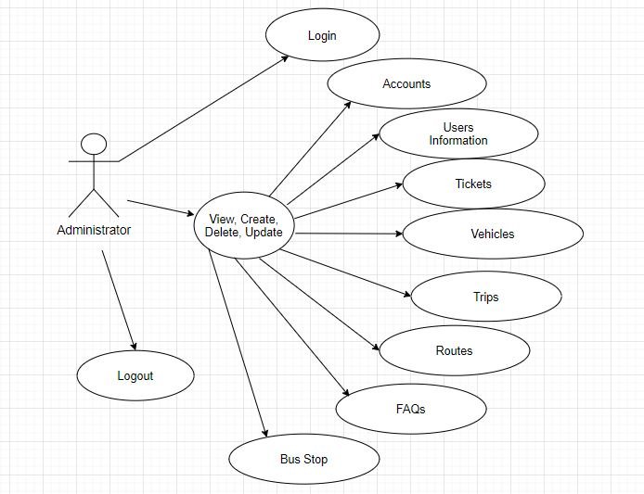

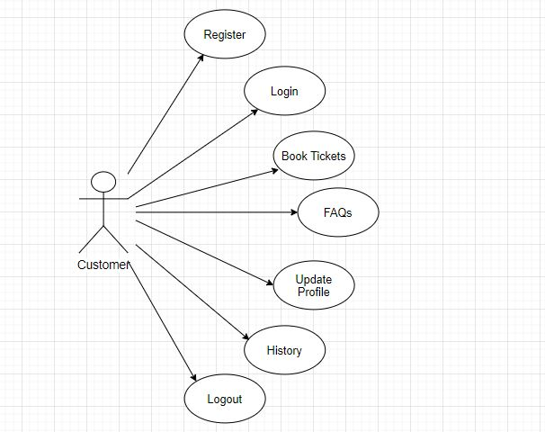

ENTITY RELATIONSHIP DIAGRAM**:**

* Database design
  + Table name: BusStop

|  |  |  |
| --- | --- | --- |
| **Field Name** | **Data Type** | **Key** |
| Id | int | Primary |
| Name | nvarchar | Not Null |
| CityId | Int | Not Null |

* + Table name: Cities

|  |  |  |
| --- | --- | --- |
| **Field Name** | **Data Type** | **Key** |
| Id | int | Primary |
| Name | nvarchar | Not Null |

* + Table name: Routes

|  |  |  |
| --- | --- | --- |
| **Field Name** | **Data Type** | **Key** |
| Id | int | Primary |
| Start | int | Not Null |
| Destination | int | Not Null |
| Distance | decimal | Not Null |
| Price | money | Not Null |

* + Table name: RouteTime

|  |  |  |
| --- | --- | --- |
| **Field Name** | **Data Type** | **Key** |
| Id | int | Primary |
| RouteId | Int | Not Null |
| Time | varchar | Not Null |

* + Table name: Trip

|  |  |  |
| --- | --- | --- |
| **Field Name** | **Data Type** | **Key** |
| Id | int | Primary |
| RouteId | int | Not Null |
| DateStart | datetime | Not Null |
| VehicleId | int | Not Null |
| Status | varchar | Not Null |

* + Table name: TripCloseTimes

|  |  |  |
| --- | --- | --- |
| **Field Name** | **Data Type** | **Key** |
| Id | int | Primary |
| RouteId | int | Not Null |
| CloseDate | datetime | Not Null |
| Description | nvarchar | Allow Null |

* + Table name: Vehicles

|  |  |  |
| --- | --- | --- |
| **Field Name** | **Data Type** | **Key** |
| Id | int | Primary |
| TotalSeat | int | Not Null |
| SeatType | nvarchar | Not Null |
| LiscensePlates | varchar | Not Null |
| Model | nvarchar | Not Null |
| VehicleNumber | varchar | Not Null |
| RouteTimeId | int | Not Null |
| Description | nvarchar | Allow Null |

* + Table name: FAQs

|  |  |  |
| --- | --- | --- |
| **Field Name** | **Data Type** | **Key** |
| Id | int | Primary |
| Name | Nvarchar | Allow Null |
| FContent | Nvarchar | Allow Null |

* + Table name: Tickets

|  |  |  |
| --- | --- | --- |
| **Field Name** | **Data Type** | **Key** |
| Id | int | Primary |
| TicketNumber | varchar | Not Null |
| Price | int | Not Null |
| DateStart | datetime | Not Null |
| CreatedDate | datetime | Not Null |
| Seat | varchar | Not Null |
| VehicleId | int | Not Null |
| Status | Varchar | Not Null |
| RouteId | Int | Not Null |
| Note | Nvarchar | Allow Null |
| RouteTimeId | Int | Not Null |
| OTP | Varchar | Allow Null |
| BusStopId | Int | Not Null |
|  |  |  |

* + Table name: Accounts

|  |  |  |
| --- | --- | --- |
| **Field Name** | **Data Type** | **Key** |
| Id | int | Primary |
| Username | varchar | Not Null |
| Password | varchar | Not Null |
| CreatedDate | datetime | Not Null |
| Status | varchar | Not Null |
| EmpId | int | Allow Null |
| DivisionId | int | Not Null |
| CusId | Int | Allow Null |
| VerifyCode | varchar | Not Null |

* + Table name: Divisions

|  |  |  |
| --- | --- | --- |
| **Field Name** | **Data Type** | **Key** |
| Id | int | Primary |
| Name | nvarchar | Not Null |
| Type | varchar | Not Null |
| DivisionLevel | tinyint | Not Null |

* + Table name: EmployeesInformation

|  |  |  |
| --- | --- | --- |
| **Field Name** | **Data Type** | **Key** |
| Id | int | Primary |
| Name | nvarchar | Not Null |
| DivisionId | int | Not Null |
| Address | nvarchar | Not Null |
| Status | bit | Not Null |
| IdCard | varchar | Not Null |
| Birthday | date | Not Null |
| VehicleId | int | Not Null |
| Gender | nvarchar | Not Null |
| PhoneNumber | varchar | Not Null |
| Email | nvarchar | Not Null |
| CreatedDate | Datetime | Not Null |
|  |  |  |

* + Table name: CustomersInformation

|  |  |  |
| --- | --- | --- |
| **Field Name** | **Data Type** | **Key** |
| Id | int | Primary |
| FullName | nvarchar | Not Null |
| Address | nvarchar | Allow Null |
| IdCard | varchar | Allow Null |
| Birthday | date | Not Null |
| Gender | nvarchar | Not Null |
| PhoneNumber | varchar | Not Null |
| Email | nvarchar | Not Null |
| CreatedDate | datetime | Not Null |

* E-R Diagram

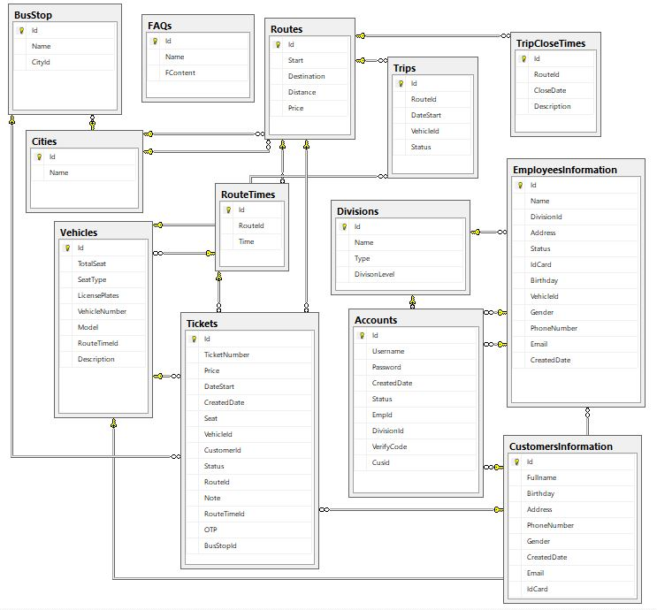

**INTERFACE DESIGN**

Customer App Screen

1. **Login Screen**

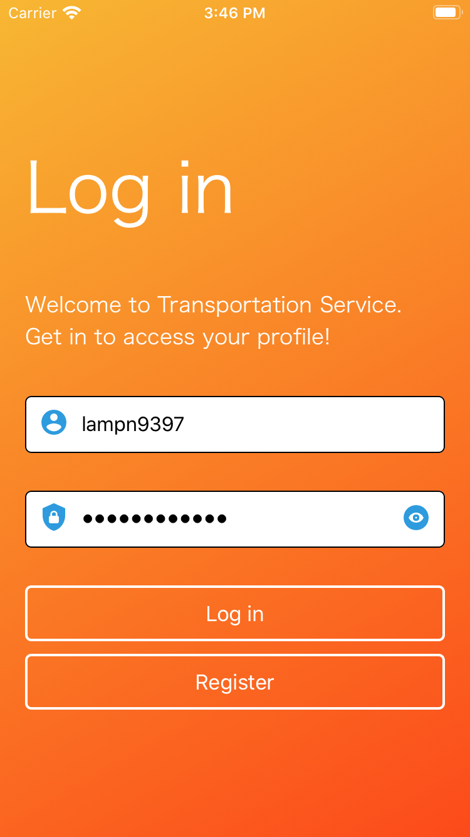

1. Register Screen

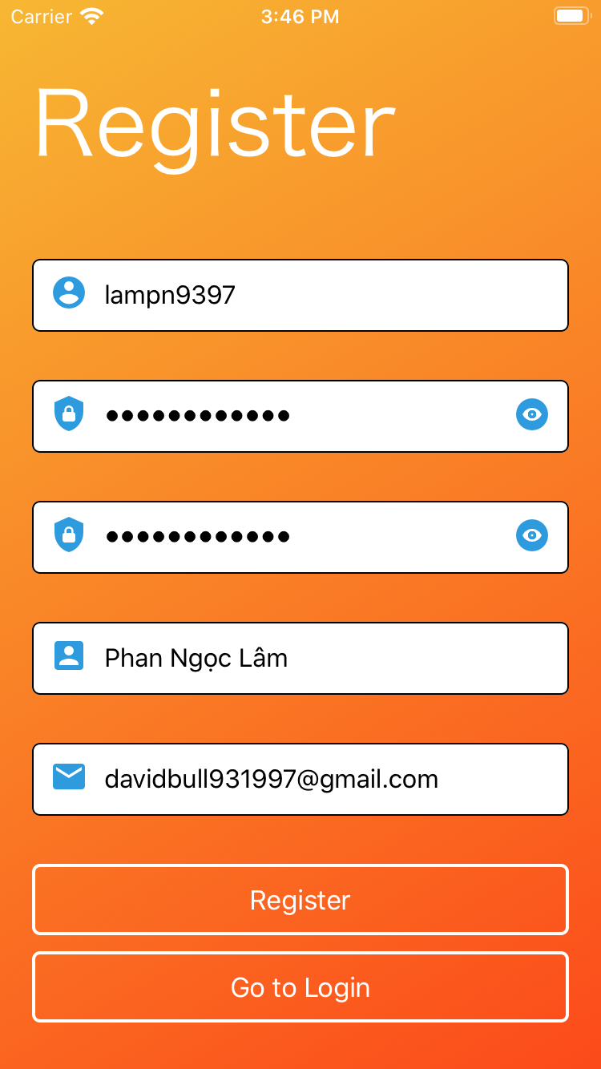

1. Ticket Booking Screen

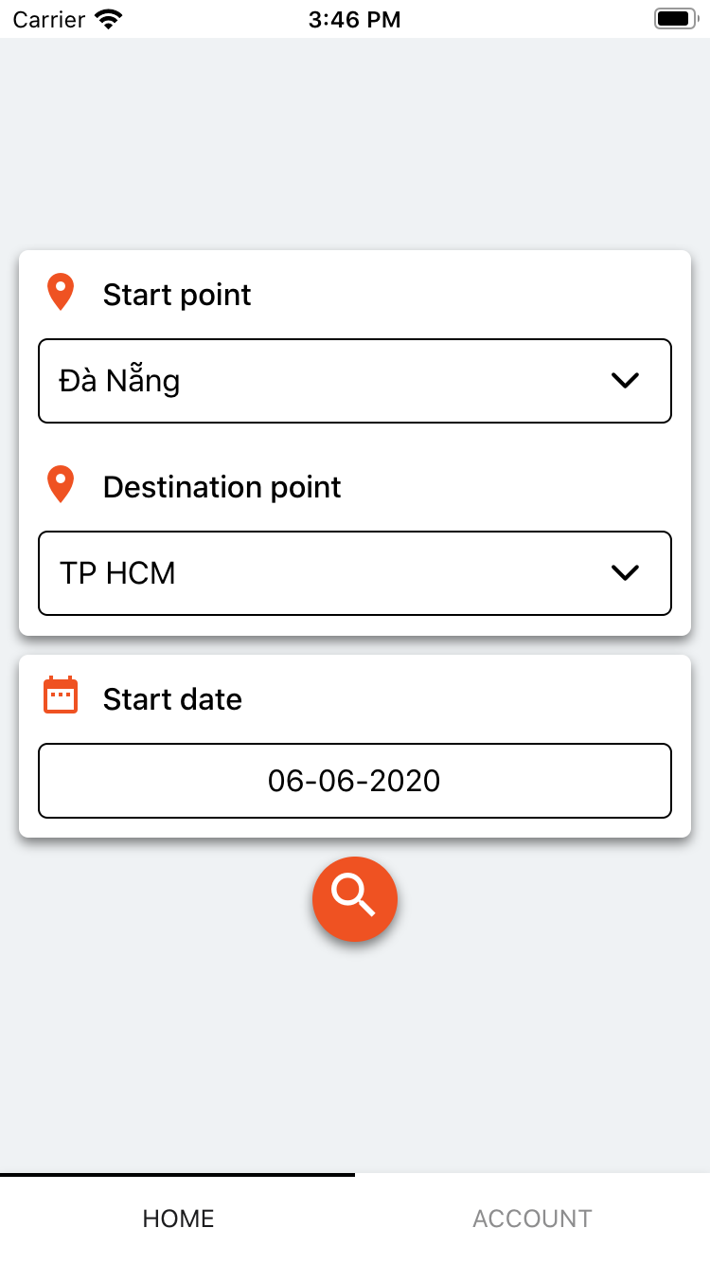

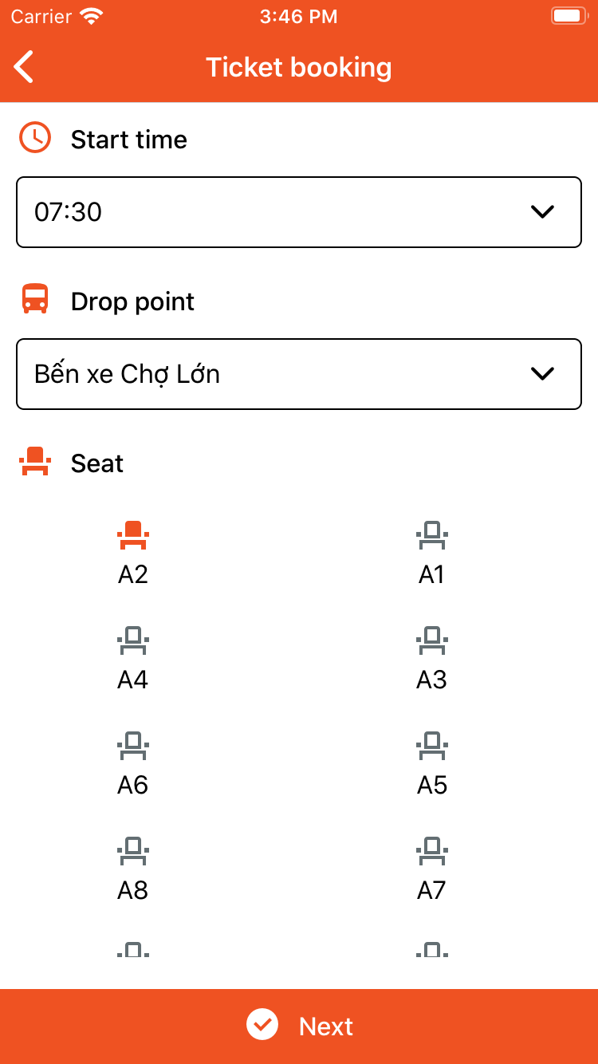

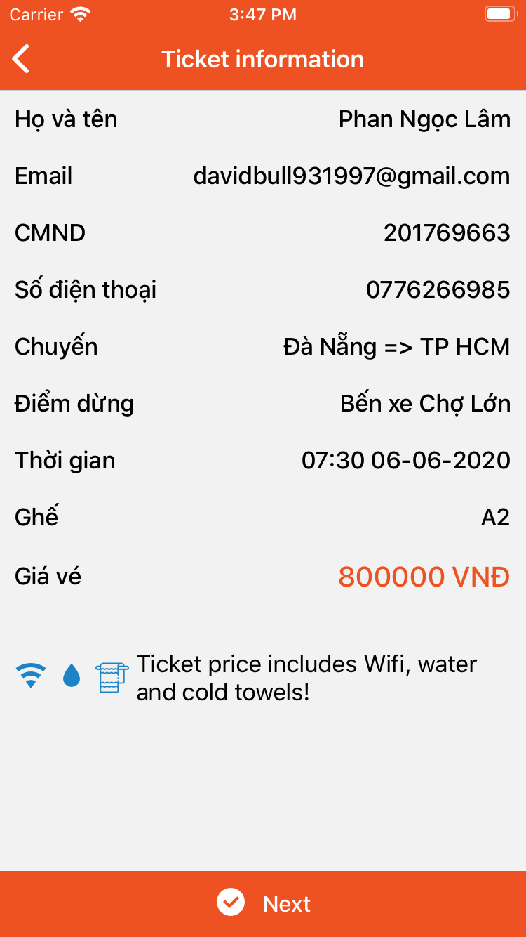

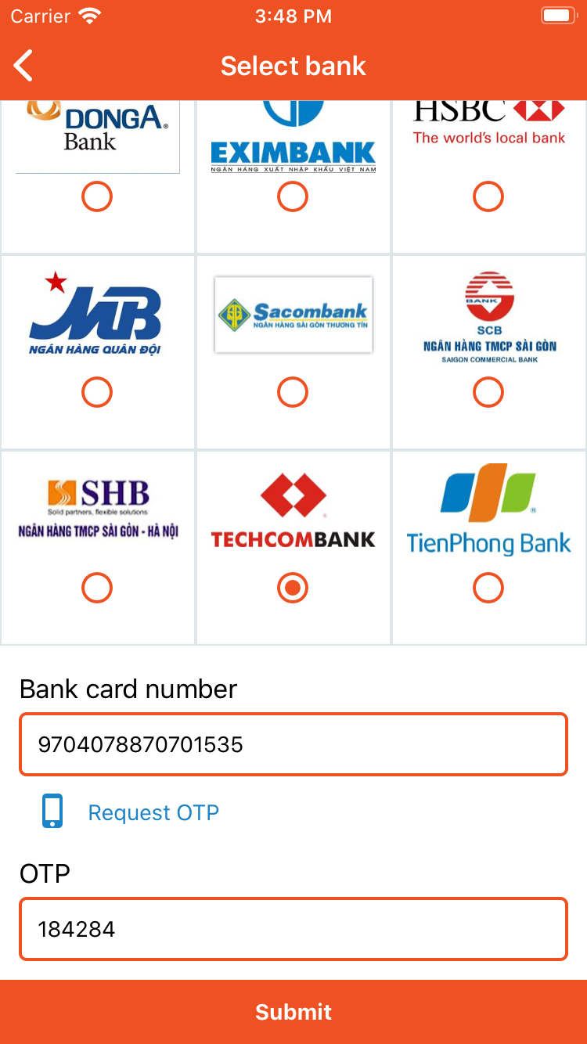

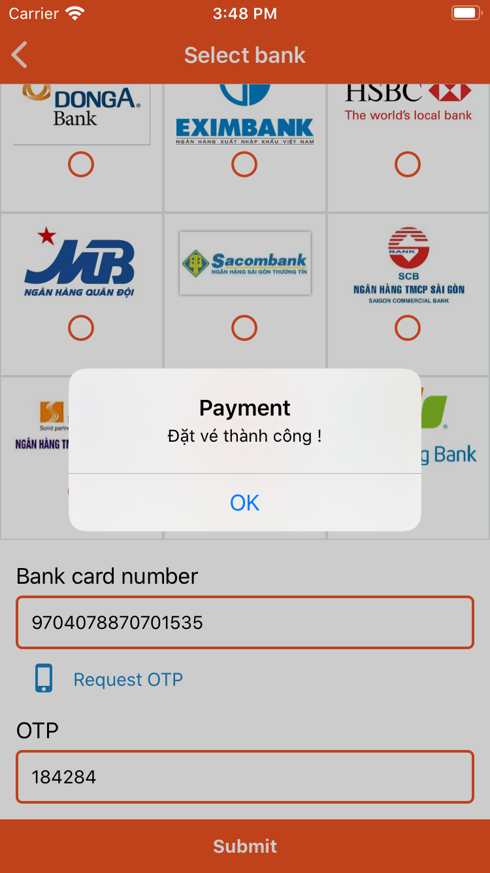

1. Account Screen

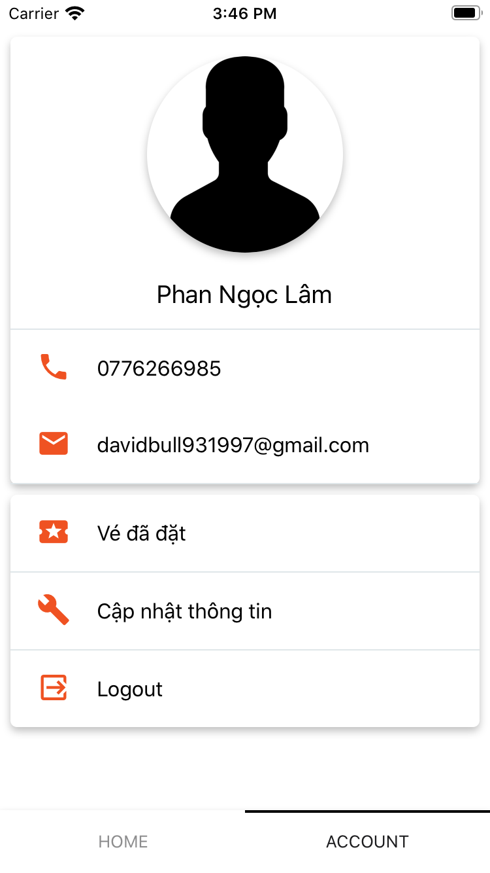

1. Tickets Booking History Screen

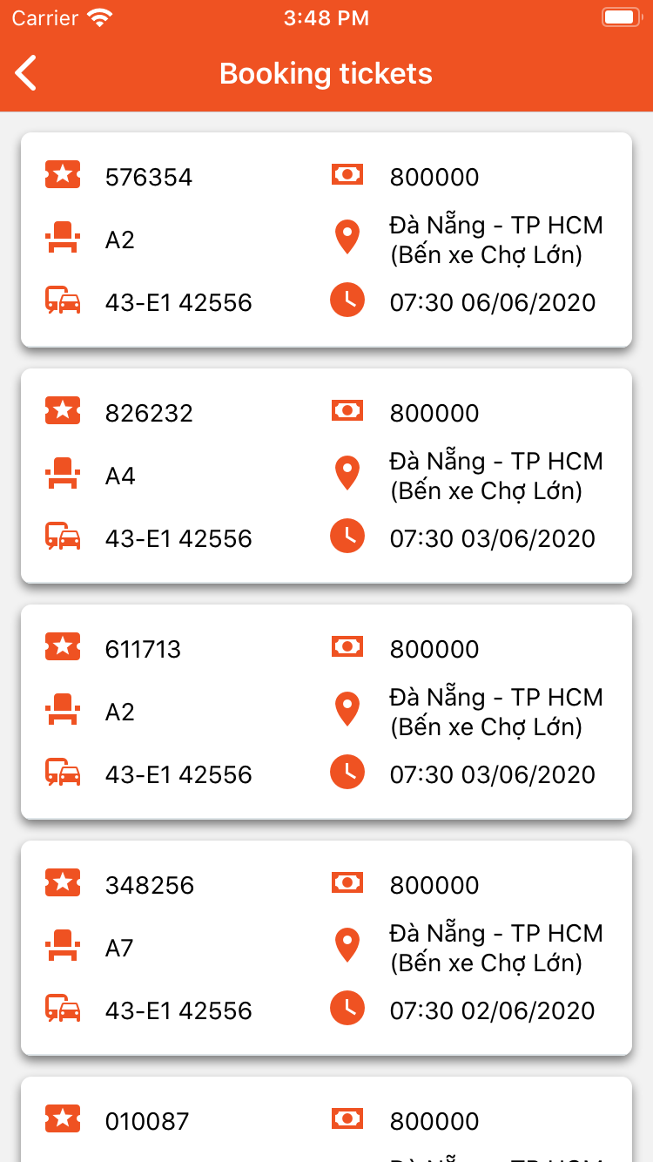

1. Ticket Detail Screen

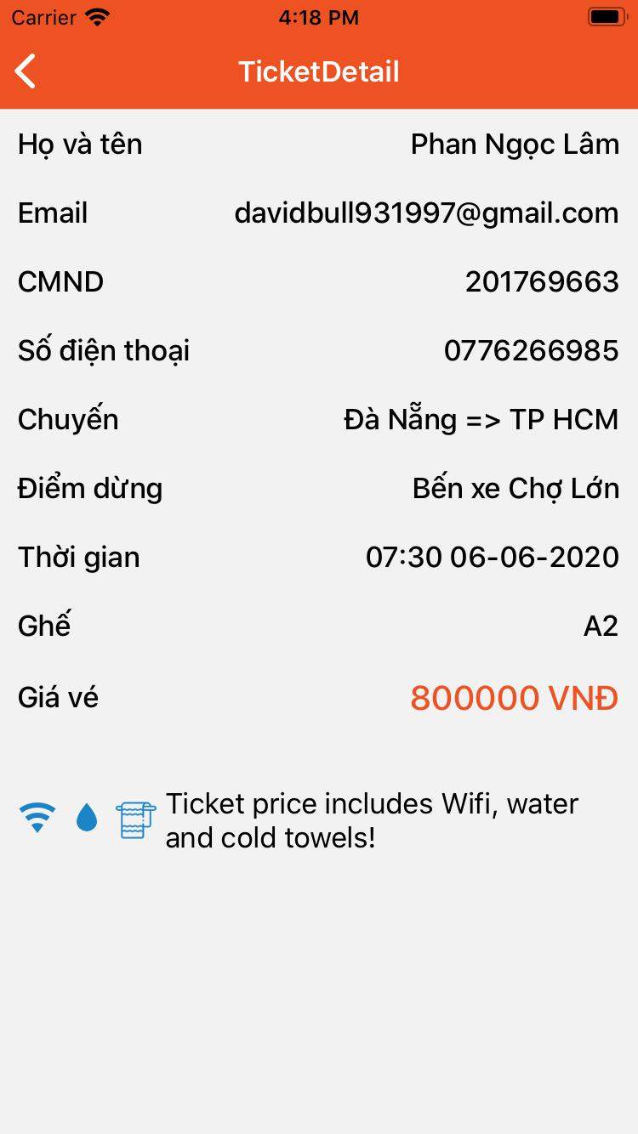

1. FAQs Screen

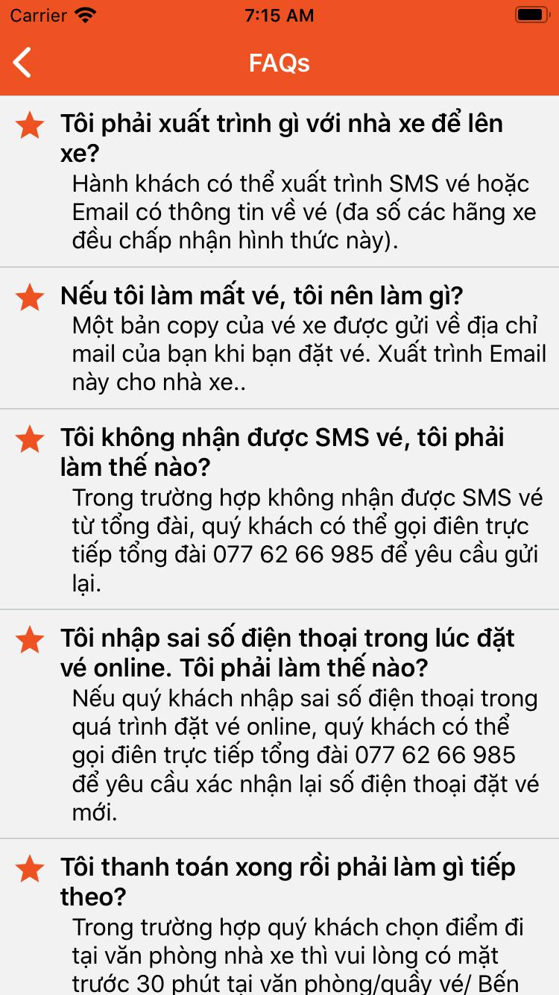

Admin Website Screen

1. Login Screen

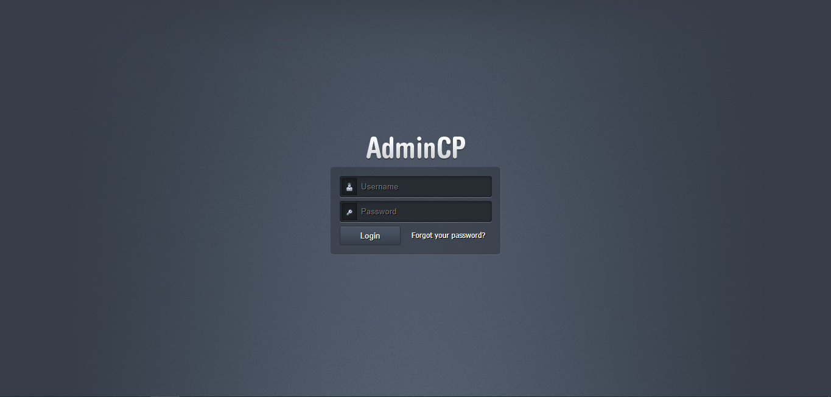

1. Dashboard Screen

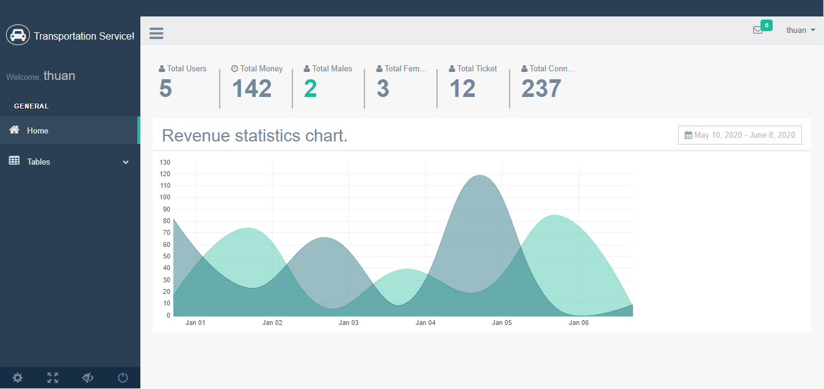

**REQUIREMENT CHECKLIST**

|  |  |  |
| --- | --- | --- |
| **NO** | **REQUIREMENT** | **STATUS** |
| 1 | Customers can see the available seats for each trip and each day. | Completed |
| 2 | The seats arrangement is displayed visually to help customer choose their seats easier. | Completed |
| 3 | Information of each trip is public to help customers to be more informed. | Completed |
| 4 | Booking and paying process flow is fluent. | Completed |
| 5 | Administration is easy and can be adapted quickly. | Completed |