Container Styles
- responsive:

- fixed-width (max-width changes at each breakpoint):
  - .container
  - class=”container”
- fluid-width (100% wide):
  - .container-fluid
  - class="container-fluid"

Breakpoints

extra small ( xs )
// Extra small devices (portrait phones, less than 544px)
// No media query since this is the default in Bootstrap

small ( sm )
// Small devices (landscape phones, 544px and up)
@media (min-width: 544px) { ... }

medium ( md )
// Medium devices (tablets, 768px and up)
@media (min-width: 768px) { ... }

large ( lg )
// Large devices (desktops, 992px and up)
@media (min-width: 992px) { ... }

extra large ( xl )
// Extra large devices (large desktops, 1200px and up)
@media (min-width: 1200px) { ... }

Grid System

Based on 12 column layout with multiple tiers – One for each breakpoint using predefined CSS classes.
There are 3 major components: containers, rows and columns
- Rows are horizontally grouped so columns line up properly
- Content should always be placed within columns, and only may be immediate children of rows.
- Column classes indicate the number of columns to use (out of 12) per row.
  - So if we wanted 3 equal columns we would use .col-sm-4
- Column widths are percentages so they are fluid in the parent element, and automatically have padding.

Responsive Breakpoints

- extra small ( xs )
- small ( sm )
- medium (md )
- large ( lg )
- extra large ( xl )
Breakpoints are all based on minimum widths – They apply to that tier as well as all the tiers larger than it.
- Eg) .col-sm-4 applies to all small,medium,large and extra large screened devices.

 | Extra small <544px | Small ≥544px | Medium ≥768px | Large ≥992px | Extra large ≥1200px
Grid behavior | Horizontal at all times | Collapsed to start, horizontal above breakpoints
Container width | None (auto) | 576px | 720px | 940px | 1140px
Class prefix | .col-xs- | .col-sm- | .col-md- | .col-lg- | .col-xl-
# of columns | 12
Gutter width | 1.875rem / 30px (15px on each side of a column)
Nestable | Yes
Offsets | Yes
Column ordering | Yes

Using Grid Classes to code for multiple sized devices

<div class="row">
<div class="col-xs-6 col-sm-3">.col-xs-6 .col-sm-3</div>
<div class="col-xs-6 col-sm-3">.col-xs-6 .col-sm-3</div>

<!-- Add the extra clearfix for only the required viewport -->
<div class="clearfix hidden-sm-up"></div>

<div class="col-xs-6 col-sm-3">.col-xs-6 .col-sm-3</div>
<div class="col-xs-6 col-sm-3">.col-xs-6 .col-sm-3</div>
</div>

Responsive Column Resets

With 4 tiers of grids available, there will be times when columns don’t clear right at certain breakpoints because one is taller than the other. To fix this issue, use a combination of a .clearfix class and responsive utility classes to hide

 | Extra small devicesPortrait phones (<544px) | Small devicesLandscape phones (≥544px - <768px) | Medium devicesTablets (≥768px - <992px) | Large devicesDesktops (≥992px - <1200px) | Extra large devicesDesktops (≥1200px)
.hidden-xs-down | Hidden | Visible | Visible | Visible | Visible
.hidden-sm-down | Hidden | Hidden | Visible | Visible | Visible
.hidden-md-down | Hidden | Hidden | Hidden | Visible | Visible
.hidden-lg-down | Hidden | Hidden | Hidden | Hidden | Visible
.hidden-xl-down | Hidden | Hidden | Hidden | Hidden | Hidden
.hidden-xs-up | Hidden | Hidden | Hidden | Hidden | Hidden
.hidden-sm-up | Visible | Hidden | Hidden | Hidden | Hidden
.hidden-md-up | Visible | Visible | Hidden | Hidden | Hidden
.hidden-lg-up | Visible | Visible | Visible | Hidden | Hidden
.hidden-xl-up | Visible | Visible | Visible | Visible | Hidden

Offsetting Columns

Columns can be moved to the right using the offset classes
- .offset-md-* Where * is the number of columns to the right
- eg) .offset-md-4 moves that column 4 columns over on md or larger devices

Nested Columns

- Columns can be nested (IE have another 12 columns within another column group) by creating another row within the column …

<div class="row">
<div class="col-sm-9">
Level 1: .col-sm-9
<div class="row">
<div class="col-xs-8 col-sm-6">
Level 2: .col-xs-8 .col-sm-6
</div>
<div class="col-xs-4 col-sm-6">
Level 2: .col-xs-4 .col-sm-6
</div>
</div>
</div>
</div>

Column Ordering

Columns can be reordered using push and pull modifier classes.

.col-md-3 .pull-md-9 | .col-md-9 .push-md-3

<div class="row">
<div class="col-md-9 push-md-3">.col-md-9 .push-md-3</div>
<div class="col-md-3 pull-md-9">.col-md-3 .pull-md-9</div>
</div>

* Columns have swapped positions using pull/push classes

Built-in Content Styles

FONTS:

Font size is set to: font-size: 16px in <html> and set to font-size: 1rem in <body> to allow easy responsive type scaling via media queries.

Bootstrap 4 comes with a built-in font stack …

$font-family-sans-serif:

// Safari for OS X and iOS (San Francisco)
-apple-system,

// Chrome for OS X (San Francisco)
BlinkMacSystemFont,

// Windows
"Segoe UI",

// Android
"Roboto",

// Linux
"Oxygen", // KDE

"Ubuntu",
"Cantarell", // GNOME

// Firefox OS [R.I.P.]
"Fira Sans",

// Older Android
"Droid Sans",

// Basic web fallback
"Helvetica Neue", Arial, sans-serif !default;

The font-family is applied to the <body> and inherited throughout.

TABLES

In-built table styling is triggered by adding the .table class to any <table> element. Custom style variations can then be shown using modifier classes …

Standard table formatting …

<table class="table">
<thead>
<tr>
<th>#</th>
<th>First Name</th>
<th>Last Name</th>
<th>Username</th>
</tr>
</thead>
<tbody>
<tr>
<th scope="row">1</th>
<td>Mark</td>
<td>Otto</td>
<td>@mdo</td>
</tr>
… etc …

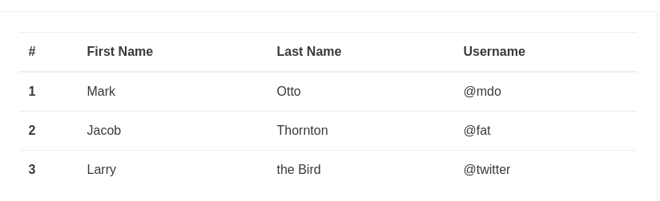

Colours can be Inversed using the .table-inverse modifier class …

<table class="table table-inverse">

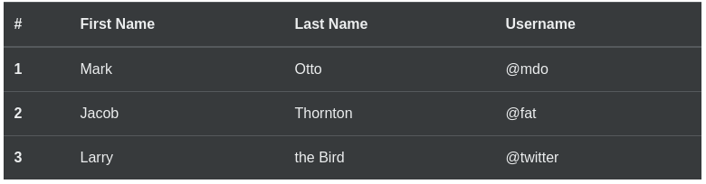

The table head element ( <thead> ) can be styled using the .thead-default and .thead-inverse modifier classes …

<table class="table">
<thead class="thead-default">
<tr>

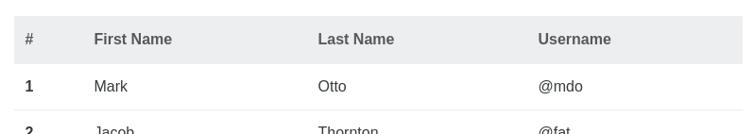

<table class="table">
<thead class="thead-inverse">

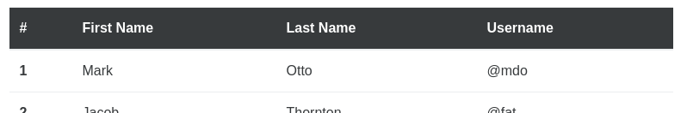

Zebra stripping (Where odd/even rows are coloured differently) can be automatically added to table rows by adding the .table-striped class modifier to the <table> element …

<table class="table table-striped">
<thead>
<tr>
<th>#</th>
<th>First Name</th>
<th>Last Name</th>

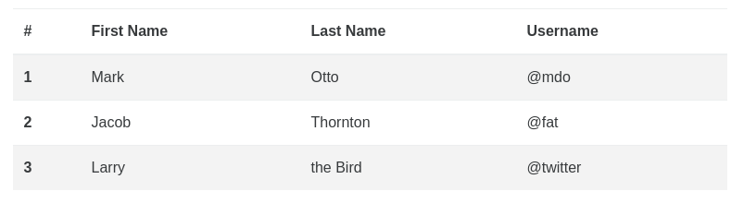
… or combined with the .table-inverse to create a inverse zebra stripe …

<table class="table table-striped table-inverse">
<thead>
<tr>
<th>#</th>

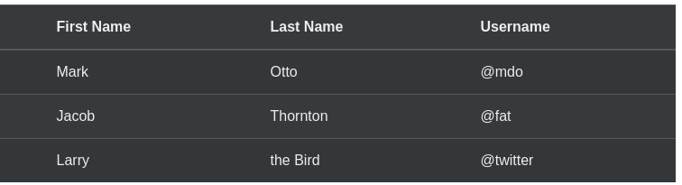

To have borders on all sides of the table cells, use the .table-bordered class modifier in the <table> element

<table class="table table-bordered">
<thead>
<tr>
<th>#</th>
<th>First Name</th>

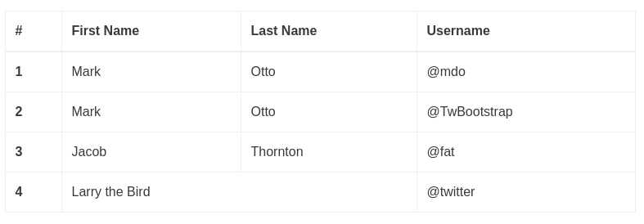
… or inverted …

<table class="table table-bordered table-inverse">
<thead>
<tr>
<th>#</th>

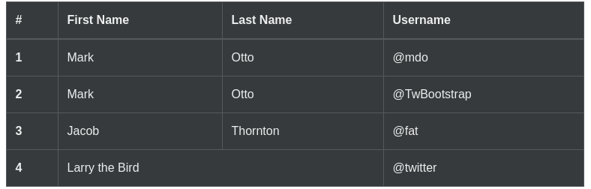

We can also set that we want rows within the <tbody> to highlight on hover by using the .table-hover class in th <table> element

<table class="table table-hover">
<thead>
<tr>
<th>#</th>
<th>First Name</th>
<th>Last Name</th>
<th>Username</th>
</tr>
</thead>
<tbody>
<tr>
<th scope="row">1</th>
<td>Mark</td>
… etc …

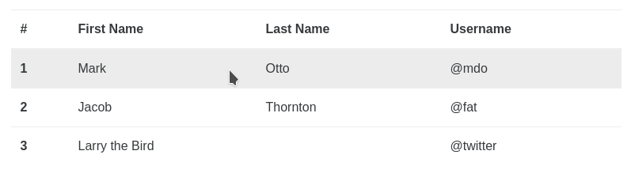
Tables can also be made more compact using .table-sm to halve the cell padding

<table class="table table-sm">
<thead>
<tr>
<th>#</th>
<th>First Name</th>
<th>Last Name</th>
<th>Username</th>
</tr>
</thead>
<tbody>
<tr>
<th scope="row">1</th>
<td>Mark</td>
… etc …

Contextual classes may also be used …

.table-active Applies the hover color to a particular row or cell
.table-success Indicates a successful or positive action
.table-info Indicates a neutral informative change or action
.table-warning Indicates a warning that might need attention
.table-danger Indicates a dangerous or potentially negative action

<!-- On rows -->
<tr class="table-active">...</tr>
<tr class="table-success">...</tr>
<tr class="table-info">...</tr>
<tr class="table-warning">...</tr>
<tr class="table-danger">...</tr>

<!-- On cells (`td` or `th`) -->
<tr>
<td class="table-active">...</td>
<td class="table-success">...</td>
<td class="table-info">...</td>
<td class="table-warning">...</td>
<td class="table-danger">...</td>
</tr>

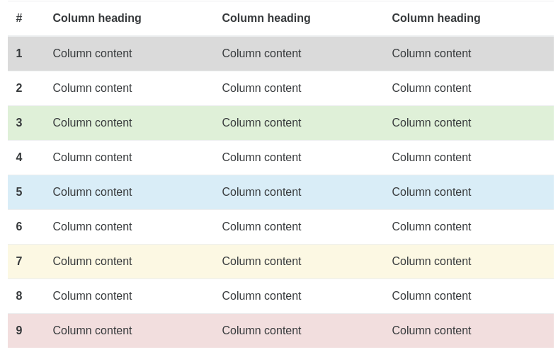

https://hackerthemes.com/bootstrap-cheatsheet/

