**Project 2 Proposal**

David Chao

Chris Elliott

Sebastian Munoz

Using the CPS (Current Population Survey) dataset provided by Federal Reserve of Kansas City, we will determine if there is any correlation between employment levels with education, age or the State one lives in. In particular we are more interested in (1) Whether or not higher education means lower unemployment, (2) Whether or not age plays a factor in unemployment, and (3) Whether or not certain States have significant unemployment rates. This dataset will encompass October 2018 through October 2019.

**Dataset:**

<https://cps.kansascityfed.org/cps>

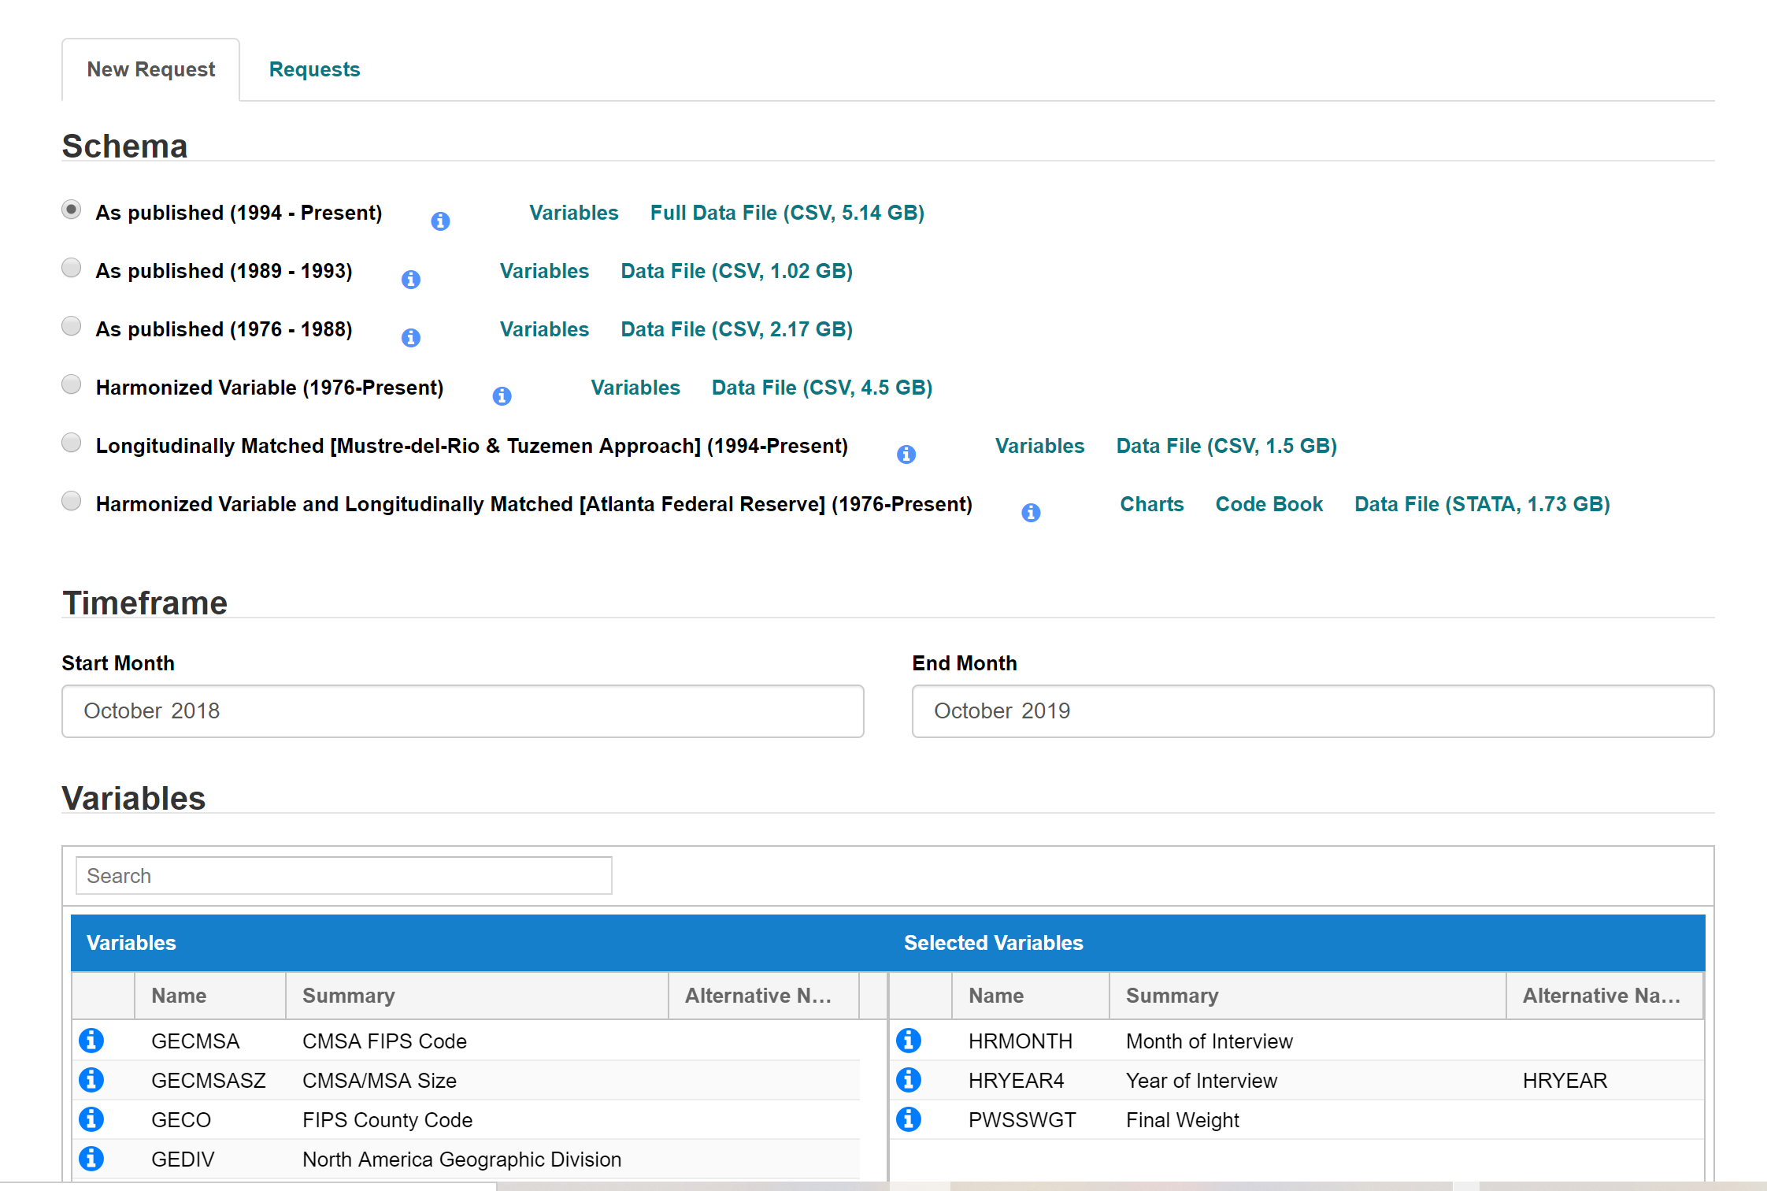

We will ETL data to a database (PostgreSQL) by using Pgadmin, and then use Jupiter Notebook to build basic HTML pages that describe what we think we will get before doing the analysis vs what the data will be presented after the analysis. The presentation will have charts comprised using DS3 and SVG and run Flask to render the data visualization. The web page will be interactive for users to click on to see different chart results.