**1. List the following details of each employee: employee number, last name, first name, gender, and salary.**

SELECT employees.emp_no, employees.last_name, employees.first_name, employees.gender, salaries.salary FROM employees JOIN salaries ON employees.emp_no = salaries.emp_no;

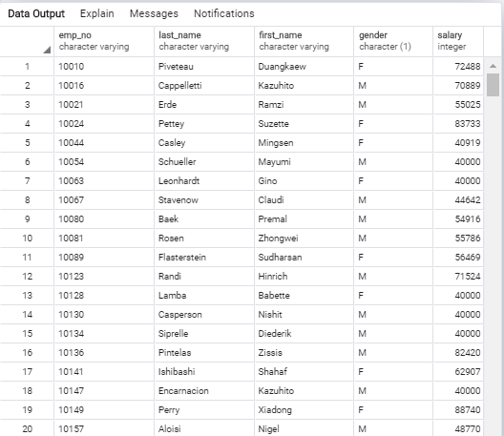

SELECT count(*) FROM employees JOIN salaries ON employees.emp_no = salaries.emp_no;The total number of employees: 300024

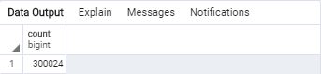

**2. List employees who were hired in 1986.**

SELECT first_name, last_name, hire_date FROM employees WHERE hire_date BETWEEN '1986-01-01' AND '1986-12-31' order by hire_date desc;

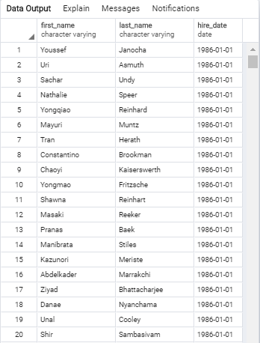 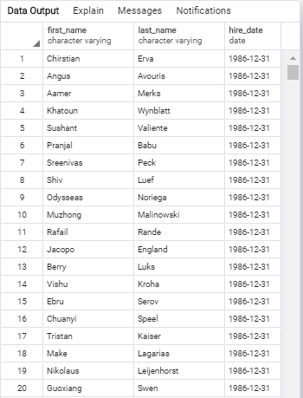

SELECT count(*) FROM employees WHERE hire_date BETWEEN '1986-01-01' AND '1987-01-01';

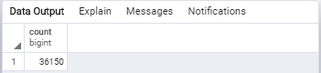

**3. List the manager of each department with the following information: department number, department name, the manager's employee number, last name, first name, and start and end employment dates.**

SELECT departments.dept_no, departments.dept_name, dept_manager.emp_no, employees.last_name, employees.first_name, dept_manager.from_date, dept_manager.to_date FROM departments JOIN dept_manager ON departments.dept_no = dept_manager.dept_no JOIN employees ON dept_manager.emp_no = employees.emp_no;

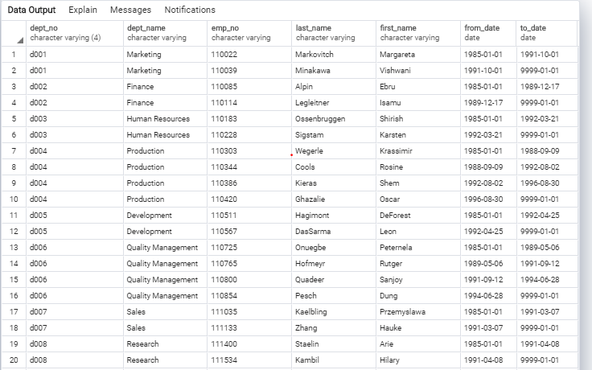

SELECT count(*) FROM departments JOIN dept_manager ON departments.dept_no = dept_manager.dept_no JOIN employees ON dept_manager.emp_no = employees.emp_no;

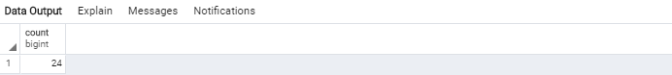

**4. List the department of each employee with the following information: employee number, last name, first name, and department name.**

SELECT dept_emp.emp_no, employees.last_name, employees.first_name, departments.dept_name FROM dept_emp JOIN employees ON dept_emp.emp_no = employees.emp_no JOIN departments ON dept_emp.dept_no = departments.dept_no;

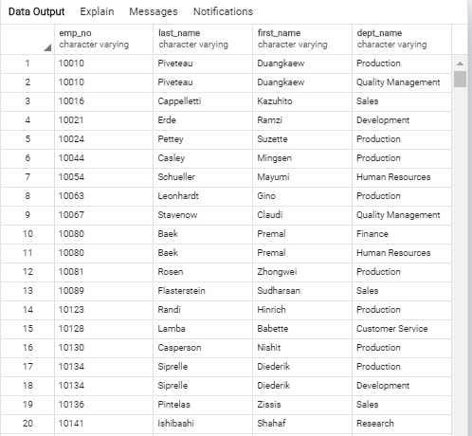

SELECT count(*) FROM dept_emp JOIN employees ON dept_emp.emp_no = employees.emp_no JOIN departments ON dept_emp.dept_no = departments.dept_no;

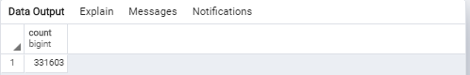

**5. List all employees whose first name is "Hercules" and last names begin with "B."**

SELECT first_name, last_name FROM employees WHERE first_name = 'Hercules' AND last_name LIKE 'B%';

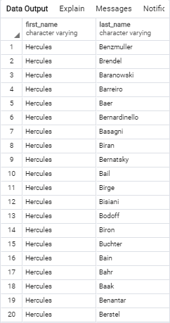

SELECT count(*) FROM employees WHERE first_name = 'Hercules' AND last_name LIKE 'B%';

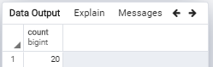

**6. List all employees in the Sales department, including their employee number, last name, first name, and department name.**

SELECT dept_emp.emp_no, employees.last_name, employees.first_name, departments.dept_name FROM dept_emp JOIN employees ON dept_emp.emp_no = employees.emp_no JOIN departments ON dept_emp.dept_no = departments.dept_no WHERE departments.dept_name = 'Sales';

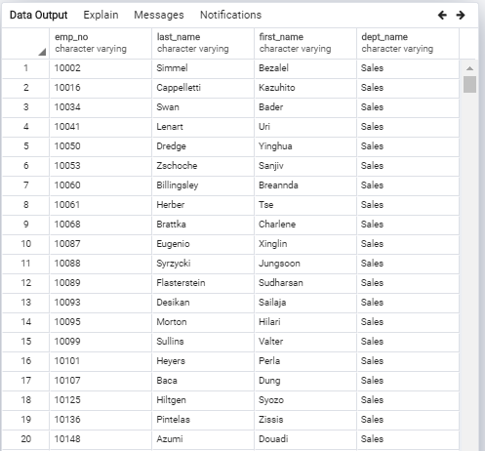

SELECT count(*) FROM dept_emp JOIN employees ON dept_emp.emp_no = employees.emp_no JOIN departments ON dept_emp.dept_no = departments.dept_no WHERE departments.dept_name = 'Sales';

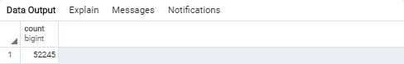

**7. List all employees in the Sales and Development departments, including their employee number, last name, first name, and department name.**

SELECT dept_emp.emp_no, employees.last_name, employees.first_name, departments.dept_name FROM dept_emp JOIN employees ON dept_emp.emp_no = employees.emp_no JOIN departments ON dept_emp.dept_no = departments.dept_no WHERE departments.dept_name = 'Sales' OR departments.dept_name = 'Development';

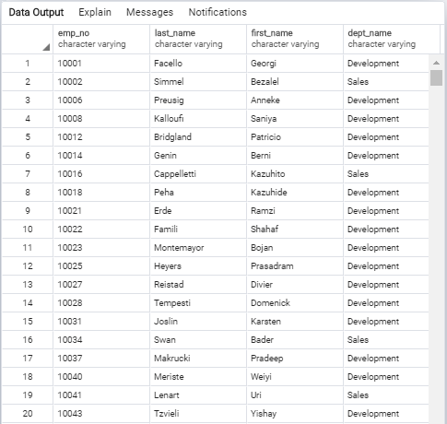

SELECT count(*) FROM dept_emp JOIN employees ON dept_emp.emp_no = employees.emp_no JOIN departments ON dept_emp.dept_no = departments.dept_no WHERE departments.dept_name = 'Sales' OR departments.dept_name = 'Development';

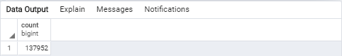

**8. In descending order, list the frequency count of employee last names, i.e., how many employees share each last name.**

SELECT last_name, COUNT(last_name) AS "frequency FROM employees GROUP BY last_name ORDER BY COUNT(last_name) DESC;

