AG1082A - Project Planning and Reporting
Dissertation

SSAO vs Ambient Occlusion Maps

David Clarke
BSc (Hons) Computer Game Applications Development
2010

Technical Supervisor: Grant Clarke

University of Abertay Dundee
Institute of Arts, Media and Computer Games
Table of Contents

- Table of contents
- Table of images
- Introduction
- Literature review
- Methodology
- Results and discussion
- Conclusions and recommendations
- Future work
- Bibliography
- Glossary
- Appendix

Table of Images

- Illustration 1: Ambient Occlusion........Page 1
Introduction

Three dimensional computers graphics at heart are an approximation of geometry. To accurately render 3D geometry, some form of lighting model would be required, to give the illusion of depth on a rasterised 2D image. The most accurate lighting model would be ray tracing. Where every ray of light interacts with every vertex in the scene, and is measured against the materials of the object to accurately recreate the colour of the object at that point. This method would automatically (with no extra set up) render any shadows and differences in ambient light shading correctly. The downside is that this technique is very computationally expensive, and often takes large amounts of powerful computers a lot of time to calculate even a scene.
As an alternative, lighting models that offer real time simulations of light were created to offer a solution to this problem. The downside to these methods is that they sacrifice quality for speed. This has led to research for accurate real time lighting methods being furthered into the modern day. Companies such as Nvidia and Crytek have long since been developing techniques to recreate accurate lighting within 3D scenes, and one such technique that has been developed is known as Ambient Occlusion (AO).
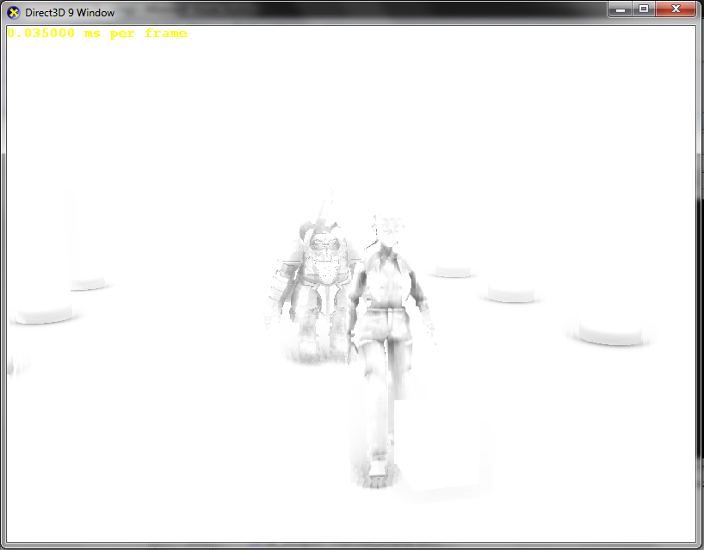Illustration 1: Ambient Occlusion
Ambient occlusion is the method of recreating the way ambient light behaves between two surfaces that sit at an acute angle to each other. Should an object or point on a 3D model be occluded, less light should be reaching the object in comparison to a point that is not occluded at all. This method should display the occluded point of a model as darker than those non-occluded points.
Ambient occlusion at its purest, similar to ray tracing, is an expensive calculation. Again, similar to ray tracing, alternative methods that can be calculated quickly and/or used in real time have been developed to fill the void left behind. Two such methods are Screen Space Ambient Occlusion (SSAO) and ambient occlusion maps which can be generated in a 3D modelling package.
SSAO can calculate ambient occlusion in real time, and apply the result of the calculation to the scene directly, as the game is running. This has the advantage of being adaptable and being dynamic. SSAO can calculate occlusion for moving geometry, animated models and static models at the same time. This ensures that the occlusion on a scene is always correct as it is not dependant on what geometry is in the scene. Instead it requires information about the scene as a rasterised image, which should alleviate it of a speed deficit should more geometry be added to the scene. The downside of SSAO is that it is an approximation and one that may not offer the most accurate results, depending on how many iterations the algorithm can perform per pixel per frame.
The alternative is to use ambient occlusion maps. Ambient occlusion maps are textures, that can be applied to models in the same was as regular texture. Often they are simply combined with the models own texture to give the illusion of occlusion. These maps are generated from within a 3D modelling package and are often generated at the same time as a model is being created. The advantage of using AO maps in a real time game scenario is that there is no calculation required by the game application itself. The game renders the objects using the AO maps in the same way that it would render textures onto a surface. This saves a lot of processing time for applications, and is useful for applications that are already processor intensive, such as computer games.
The disadvantage of ambient occlusion maps is that they cannot be changed after they have been generated. This means that for animated models, there are certain times in the animation where the occlusion on that model can be incorrect. This can also be seen if an object falls onto a surface. Without dynamic ambient occlusion, the surface would not appear to be occluded by this new object and this may break the illusion.
Whilst these two techniques each offer their advantages and disadvantages, both could potentially compliment each other. SSAO could be used to handle the dynamic, animated objects, whilst ambient occlusion maps can be used to give static models in a scene occlusion. This could potentially cut down on the calculations performed by the SSAO algorithm and save processing time, whilst still giving the full effect of ambient occlusion on the entire scene by rendering the AO maps on static models.
SSAO however is a real-time implementation of the standard ambient occlusion model. It could prove to be sufficiently fast and accurate for calculating ambient occlusion for the entire scene without the use of AO maps to ease the strain and save time on the calculation.
Literature Review
Ambient occlusion is the process of darkening certain areas within a 3D scene depending on how much light can and cannot reach that point in space. There are differing techniques of using ambient occlusion within a real-time game scenario. One of which calculates the ambient occlusion in real-time whilst the game is running. This technique is referred to as Screen Space Ambient Occlusion, or SSAO for short. The other method is to calculate the ambient occlusion from within a 3D modelling packages and apply it to 3D models as part of a texture.
The literature is far more in depth regarding SSAO as this is implemented by programmers as part of a rendering pipeline. This process is often performed once and then adjusted and maintained throughout the course of a games development as it automatically encompasses any geometry that is added to a scene. Pre-calculating ambient occlusion is usually a task performed by artists and the occlusion itself needs to be calculated for each model that they create. This can be a time consuming process.
The disadvantage of calculating ambient occlusion in real-time is that the calculation itself can take time and on lower end computing hardware may not be possible. This can be resolved by using pre-calculated occlusion, however this technique doesn’t offer the same dynamic properties of SSAO.
SSAO
SSAO has been documented in many presentations, tutorials and papers and is regarded as the most effective real-time ambient occlusion method. The technique was invented by Crytek and since has been documented in many different forms by many others including Nvidia and Blizzard Entertainment.
Nvidia discusses the setup for their SSAO technique. They mention that they form a depth buffer which contains depth information for the scenes geometry. The position of a point in the scene can then be reconstructed from it’s position within the texture and the depth information sampled from the texture. This information is then used in the ambient occlusion calculation.
A seperate technique featured on Gamedev.net suggests storing the XYZ positional data directly the RGB colour values of the texture. This is mentioned as offering an easier method of accessing the same data as Nvidia’s depth reconstruction from within the SSAO shader. This method doesn’t require reconstructing the position of the pixel and can just grab that information from a point on the texture. Depending on the hardware however it is recognised that this method may indeed be slower than reconstructing this data using depth information. However this requires another render pass separate from drawing normals and depth. Using depth can cut down on a render pass as this will allow the user to store the value of the geometries normals and depth in the standard RGBA values of a texture.
This however is only one component of the whole SSAO technique. SSAO spans several render passes. These can vary with each implementation however the general consensus uses the first pass to draw screen space normals and depth information to a texture. This is then passed into an SSAO algorithm which uses the information to compare depth of the current pixel and the depth of a pixel that is currently being sampled by the algorithm.
Blizzard calculate their occlusion factor by “sampling the depth of neighboring pixels in screen space.” (Blizzard Entertainment, 2008). This allows the occlusion to be scaled so that nearer samples occlude any given point more so than samples that are farther away. Where as the algorithm by José María Méndez for GameDev.net utilises the dot product between samples and the occluded point to scale the occlusion factor. The reasoning behind this is that “points directly above the occludee contribute more than points near it.” (Gamedev.net, 2010).
Various sources are all agreed with what to do with the occlusion factor once it has been calculated. Most simply multiply it per pixel by the colour value for each pixel in the scene. It is also widely acknowledged that SSAO algorithms produce quite high noise results. The main recommendation for dealing with this is applying a blur to the occlusion map generated by the SSAO algorithm to smooth the results and make them appear to scale more linearly when applied to the scene.
The alternative that no SSAO algorithms discuss is increasing the number of samples taken by the algorithm. There is good reason for this, as it would slow down the calculation too much and it would lose its real time advantage. However this is a feasible alternative for pre-calculating ambient occlusion for 3D models.
There are also differences in the sampling methods used by various methods. Some methods detail their sampling methods as taking place in 3D where as some detail it as a 2D operation. Many opinions seem to suggest that either is perfectly acceptable, and that not much of a difference occurs with regards to the quality of the ambient occlusion. The difference comes when sampling in 3D, any sampling vectors must be projected into two dimensions. Sampling in 2D from the beginning allows the method to skip this step and still calculate an accurate ambient occlusion term from the 2D sampling rays.
Pre-Calculating Ambient Occlusion
This method of calculating ambient occlusion is a process that has been set out by the developers of 3D modelling packages. Depending on the modelling package of choice the process does differ, but not enough to warrant discussion among the game development community.
The discussion instead stems from the argument whether or not to take the time to perform this calculation instead of or as a compliment to SSAO. Most implementations of SSAO are intended to replace the need to calculate ambient occlusion for each model. It is a technique that's speed is not dependant on how much geometry is contained within a 3D scene and can calculate occlusion with no extra work required on behalf of the artists.
However the shortcomings of the technique often leave gaps which can be filled by artists who pre-calculate the occlusion factor for geometry within a modelling package. The downside of this method is that calculating and adjusting the occlusion is a timely process. If a mistake is made or an adjustment is required then the occlusion must be recalculated for every piece of geometry in the scene that needs to be adjusted, individually.

References

Literature Review

Nvidia Corporation, 2008. Screen Space Ambient Occlusion [online] California (Published 2008) Available at: <http://developer.download.nvidia.com/SDK/10.5/direct3d/Source/ScreenSpaceAO/doc/ScreenSpaceAO.pdf> [Accessed 9 March 2011]

Gamedev.net, 2010. A simple and practical approach to SSAO [online] (Published 2010) Available at: <http://archive.gamedev.net/reference/articles/article2753.asp> [Accessed 26 November 2010]

Blizzard Entertainment, 2008. Starcraft II Effects and Techniques (SIGGRAPH publication) [online] (Published 2008) Available at: <http://developer.amd.com/gpu_assets/S2008-Filion-McNaughton-StarCraftII.pdf> [Accessed 9 March 2011]

Blizzard Entertainment, 2008. Starcraft II Effects and Techniques (SIGGRAPH publication) [online] (Published 2008) Available at: <http://developer.amd.com/documentation/presentations/legacy/Chapter05-Filion-StarCraftII.pdf> [Accessed 26 November 2011]

Bibliography

Crytek, 2007. Finding Next Gen: CryEngine 2 (SIGGRAPH publication) [online] (Published 2007) Available at: <http://developer.amd.com/documentation/presentations/legacy/Chapter8-Mittring-Finding_NextGen_CryEngine2.pdf> [Accessed 9 March 2011]

Nvidia Corporation, 2008. Real-Time Depth Buffer Based Ambient Occlusion (GDC publication) [online] (Published 2008) Available at: <http://developer.download.nvidia.com/presentations/2008/GDC/GDC08_Ambient_Occlusion.pdf> [Accessed 9 March 2011]

Nvidia Corporation, 2008. Image-Space Horizon-Based Ambient Occlusion (SIGGRAPH publication) [online] (Published 2008) Available at: <http://developer.download.nvidia.com/presentations/2008/SIGGRAPH/HBAO_SIG08b.pdf> [Accessed 9 March 2011]

Acronyms and Abbreviations

AO: Ambient Occlusion
SSAO: Screen Space Ambient Occlusion

