# **THANK YOU FOR PURCHASING OUR ITEM , YOU REALLY HELP US TO IMPROVE AND DEVELOP NEW GAME SOURCE CODE . THANK YOU FOR YOUR SUPPORT , YOU ARE REALLY AWESOME . THANK YOU SO MUCH .**

**PLEASE READ THIS DOCUMENTATION BEFORE YOU START USING OUR GAME SOURCE , IF YOU HAVE ARE ADVANCE USER ABOUT UNITY YOU CAN SKIP THIS TUTORIAL . THIS DOCUMENTATION ONLY IF YOU FIRST USER OF UNITY**

## **Requirments :**

1. 64 BIT COMPUTER SYSTEM
2. UNITY 2018.1.6.F1 (HIGHLY RECOMMEND USING SAME VERSION OF UNITY)
3. JAVA SDK 8 VERSION ( REALLY RECOMMENDED )  
   <http://www.oracle.com/technetwork/java/javase/downloads/jdk8-downloads-2133151.html>  
   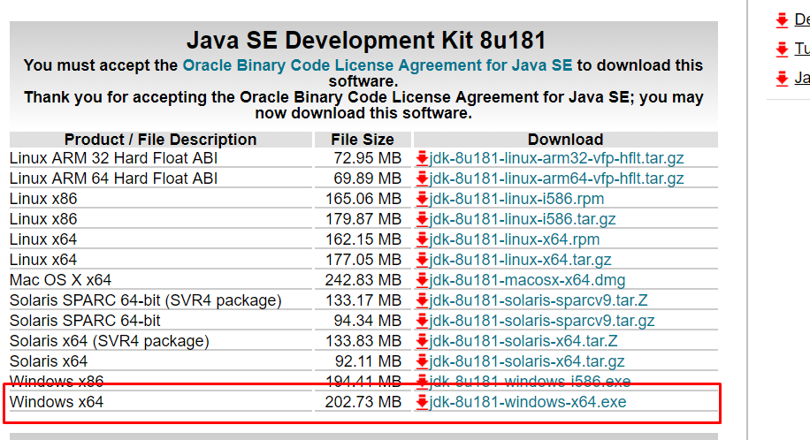
4. ANDROID SDK  
   <https://developer.android.com/studio/>   
   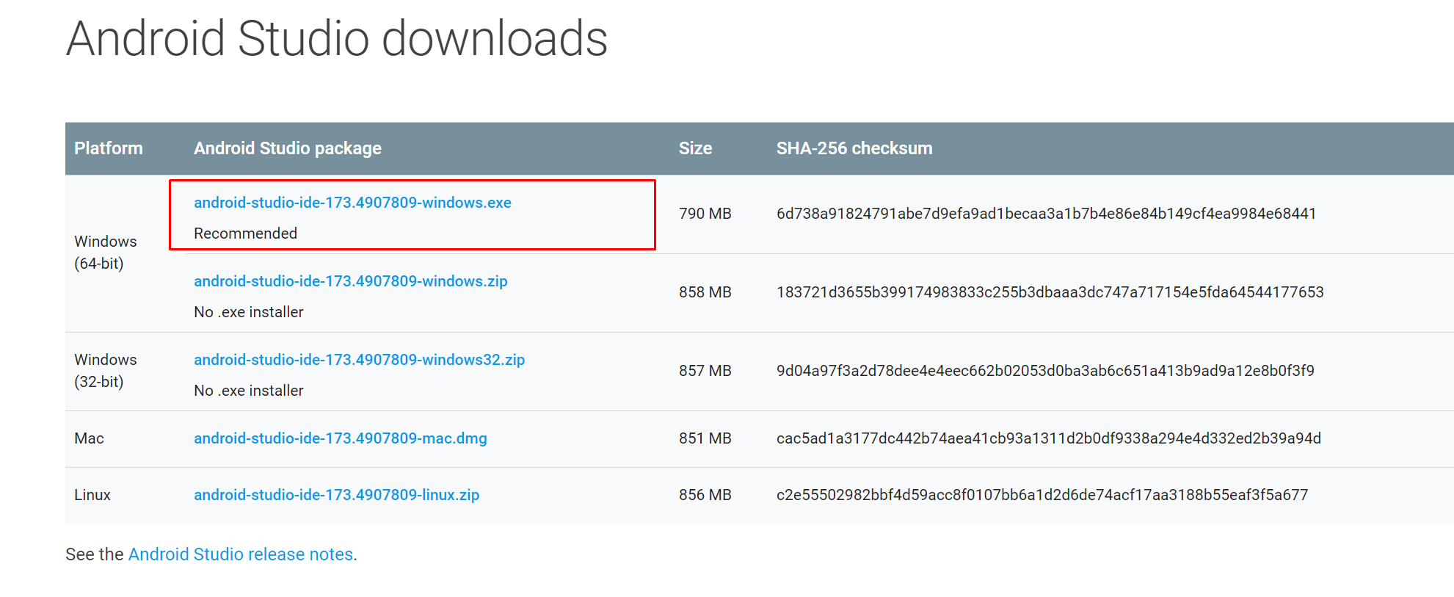
5. INTERNET CONNECTION

**YOU NEED INSTALL JAVA SDK 8 VERSION AND ANDROID STUDIO (ANDROID SDK ) FIRST . THEN YOU CAN GO TO NEXT STEP**

## 1. HOW TO SETUP UNITY

1. Go To <https://unity3d.com/get-unity/download/archive> and open on your browser
2. Then search 2018.1.6 and select your Download OS (Win) or (Mac) like this pic  
   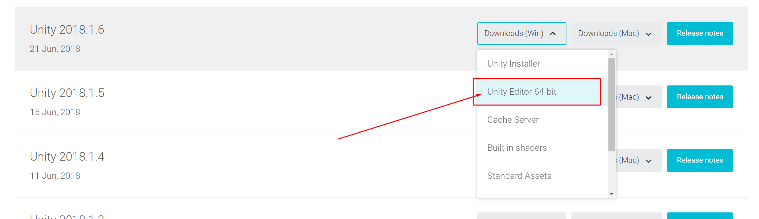
3. After finish Download file , Install Unity by click twice on UnitySetup64-2018.1.6f1.exe , then you can click **“Next”**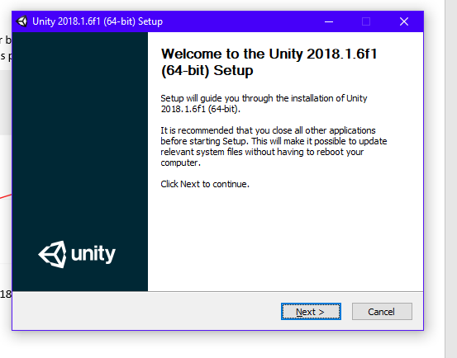

You Need Connection

1. After Finished You Can Open Your Unity . you can sign in or skip this step   
   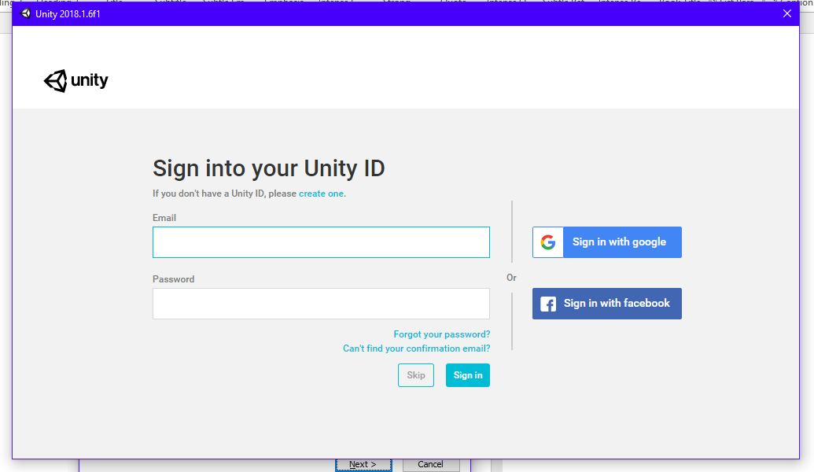
2. Click New on right side   
   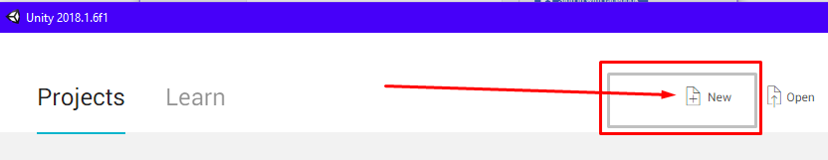
3. Then click on create project on bottom right side :   
   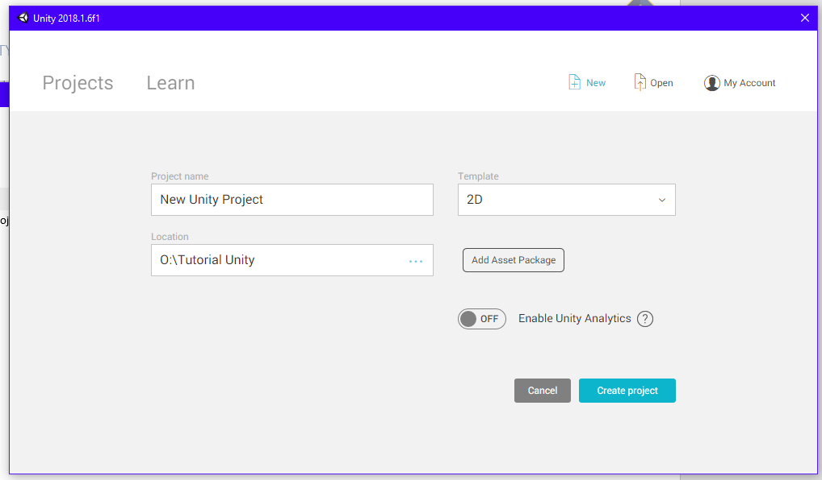
4. Click “File > Build Settings “ or you can use Keyboard Shortcut Ctrl + Shift + B  
   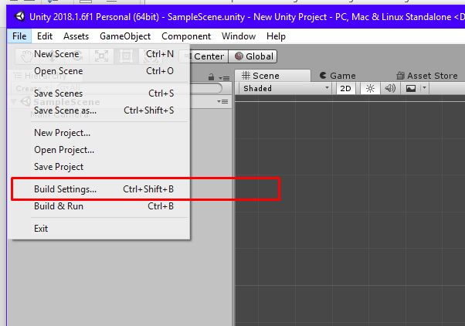
5. Then on left side , click Android and click on Open Download Page , close unity , install the module and **REOPEN your Unity**   
   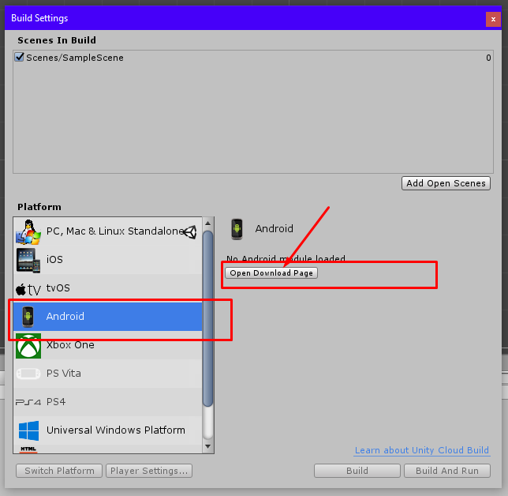
6. After Reopen Unity you need go to “Edit and click on Prefrences “   
   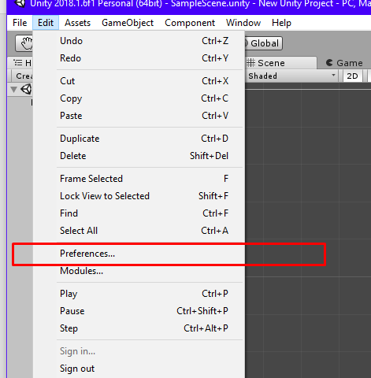
7. Then click on External Tools , and Locate your SDK and JDK Path , Example : this pic   
   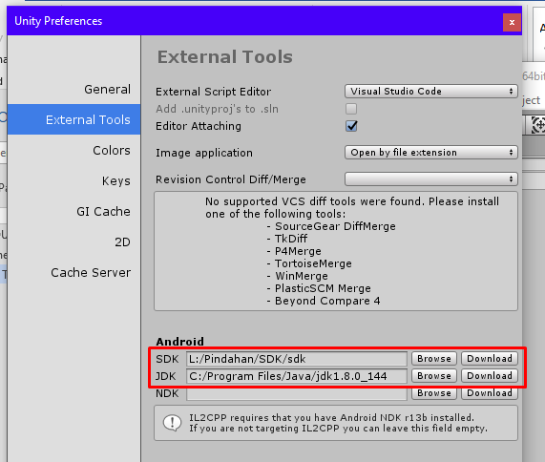  
     
   More Information :   
   SDK Path : <https://stackoverflow.com/questions/26739114/android-studio-sdk-location>  
   JDK Path : <https://stackoverflow.com/questions/4681090/how-do-i-find-where-jdk-is-installed-on-my-windows-machine>
8. Then congratulations , you have finished setup your Unity System . you can read next Documentation