User Guide

AO Admin

Version 1.0

AO UK Limited
7, Ballantrae, Stewartfield • East Kilbride • Lanarkshire • G74 4TZ Scotland
Telephone +44-1355-570 100 • Office Telephone +32-2-511 17 31
www.aouk.co.uk

Contents

Introduction
AO Admin is the browser-based editing system for the AO database and part of the AO suite of products. The AO system is a product information management and database system for the creating and editing products centrally, for use in multiple outputs.
AO Admin handles the following tasks:
- Manages users and groups
- Manages user permissions (access rights)
- Manages profiles (visibility of table fields and rows, access to named items) per group
- Manages AO Campaign database structure (Custom Fields, Picklists and Helper Selections)

Overview of Terms

BROWSER AND ACCESS
When connecting to AO, please use the following Internet browser:
- Google Chrome, latest version
Address
For the address to connect to the portal ask the IT manager or system administrator to give the server’s IP or DNS address. A typical address would look like this:
<address>:28080/portal/auth/portal/ or http://myCompanyDNS:8080/portal/auth/portal/
Note: In general, an internal IP or DNS address is used. For security reasons these addresses are not published on the Internet. This means that you can only connect to the server from within the local network.

GETTING STARTED

LOGIN PAGE
Step 1: Open your browser and type the following URL:
Step 2: You will then be presented with the Login page. Your AO System Administrator should provide your username and password.
- Username:
- Password:
Each user will have their own username and password. This is for:
- Security
- Your username identifies the type of user and functions available within the AO system
- If there are any issues within the AO system, we can more easily identify the users affected by these issues via the different usernames

FORGOTTEN PASSWORD
TO BE ADDED

DASHBOARD AND MENU

DASHBOARD
The Dashboard is the home page for AO Admin. The Dashboard is customisable by client / user and can provide a summary of Active Users, Groups or Profiles. Examples of Dashboard items can be seen below.

MENU
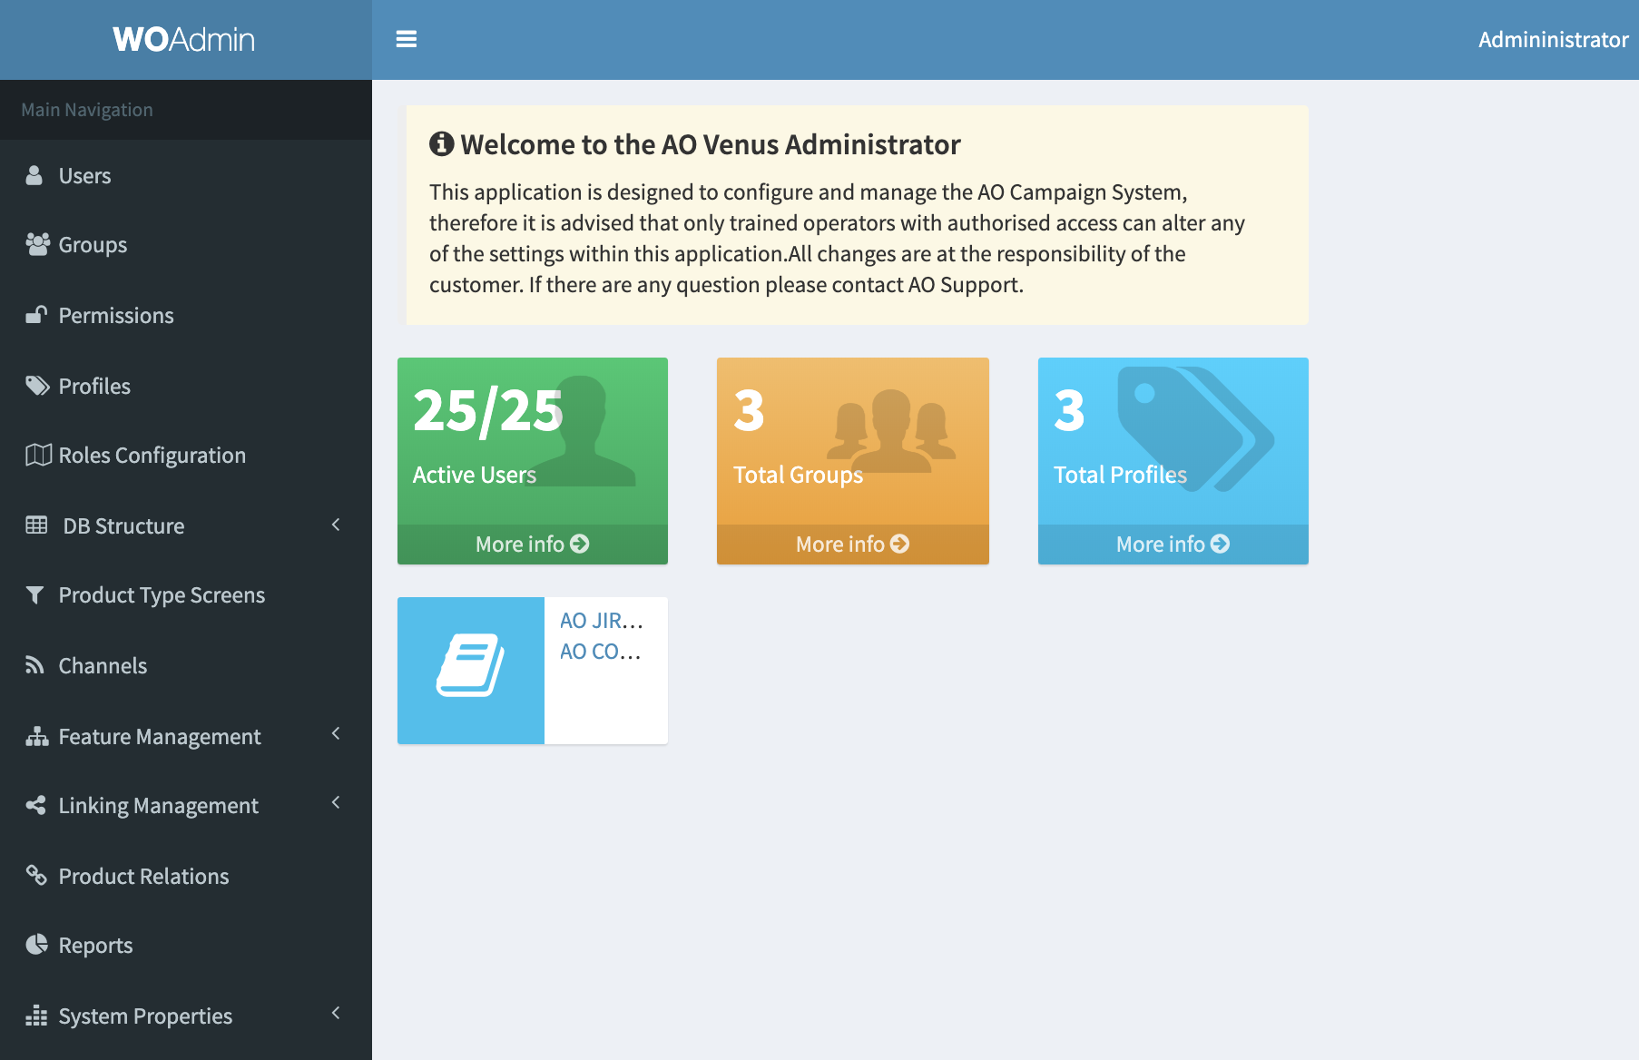
The left-hand side menu provides the following options:

USERS
When selecting Users from the left-side menu, a list of all users is presented. Here, you can create new users and edit or delete existing users.

CREATING A NEW USER
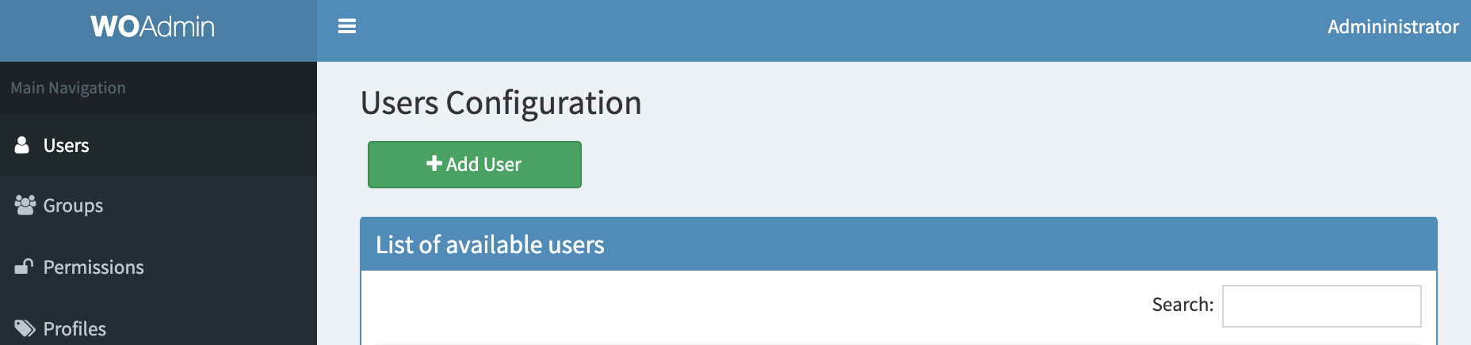
To create a new User in AO Admin, first select the Users tab on the left-hand side of the screen and select the green Add User button as shown below:

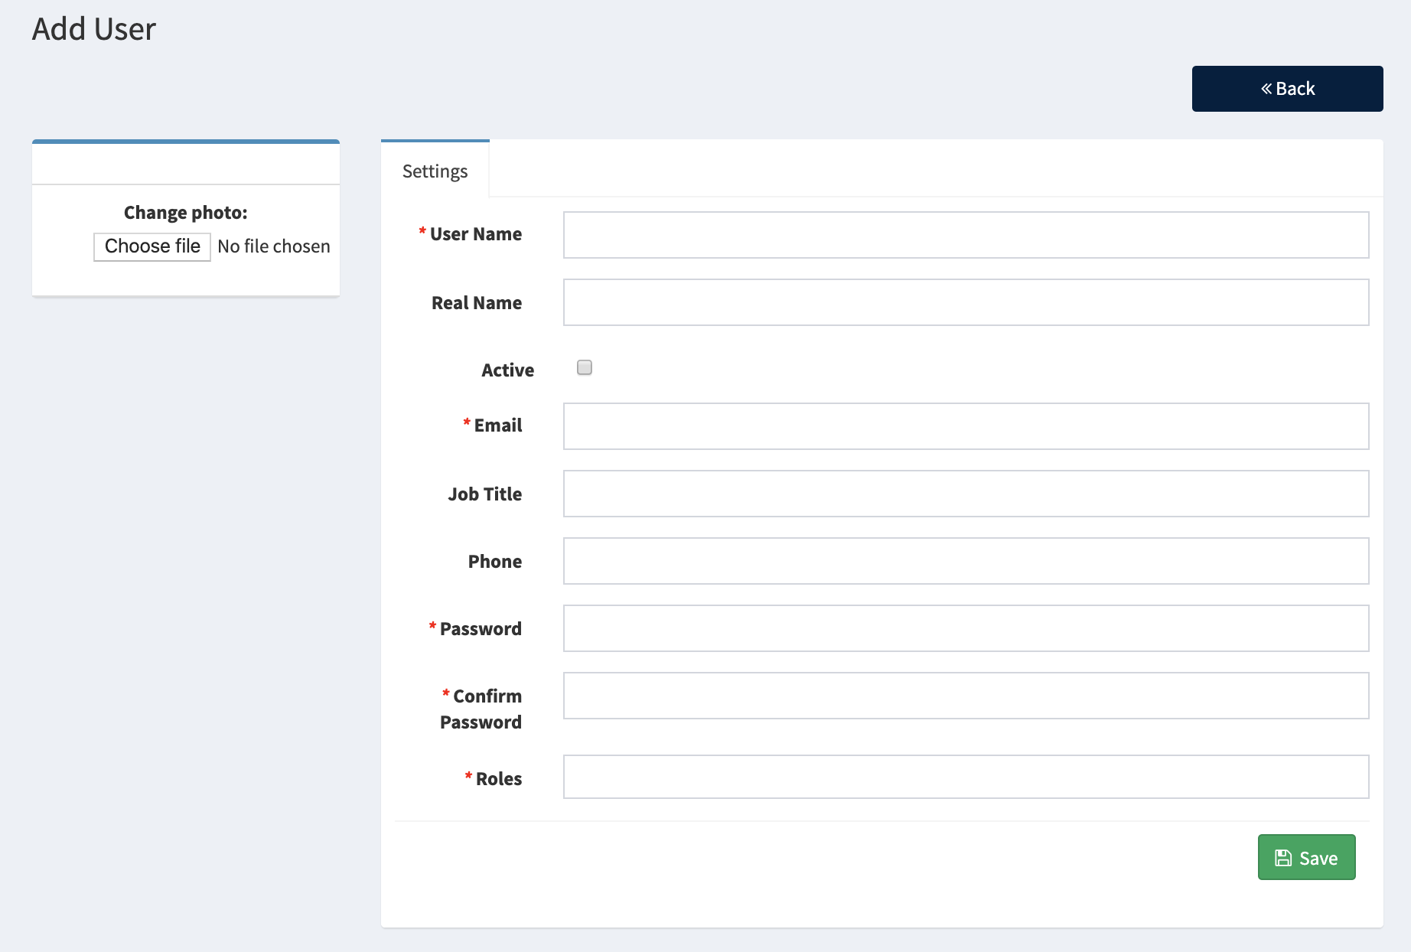
Clicking this button will show the following screen. Here you can add the required details for your new user, including adding a photo and assigning Roles (covered later in this guide). Clicking the Active button will make this new user account live on the system.

GROUPS
Within the Products section you can perform all product-related operations:
- Editing individual or multiple products
- Creating new products
- Deleting products
- Duplicating products

CREATING A NEW GROUP

PERMISSIONS

PROFILES

ROLE CONFIGURATIONS

DATABASE STRUCTURE

PRODUCT TYPES
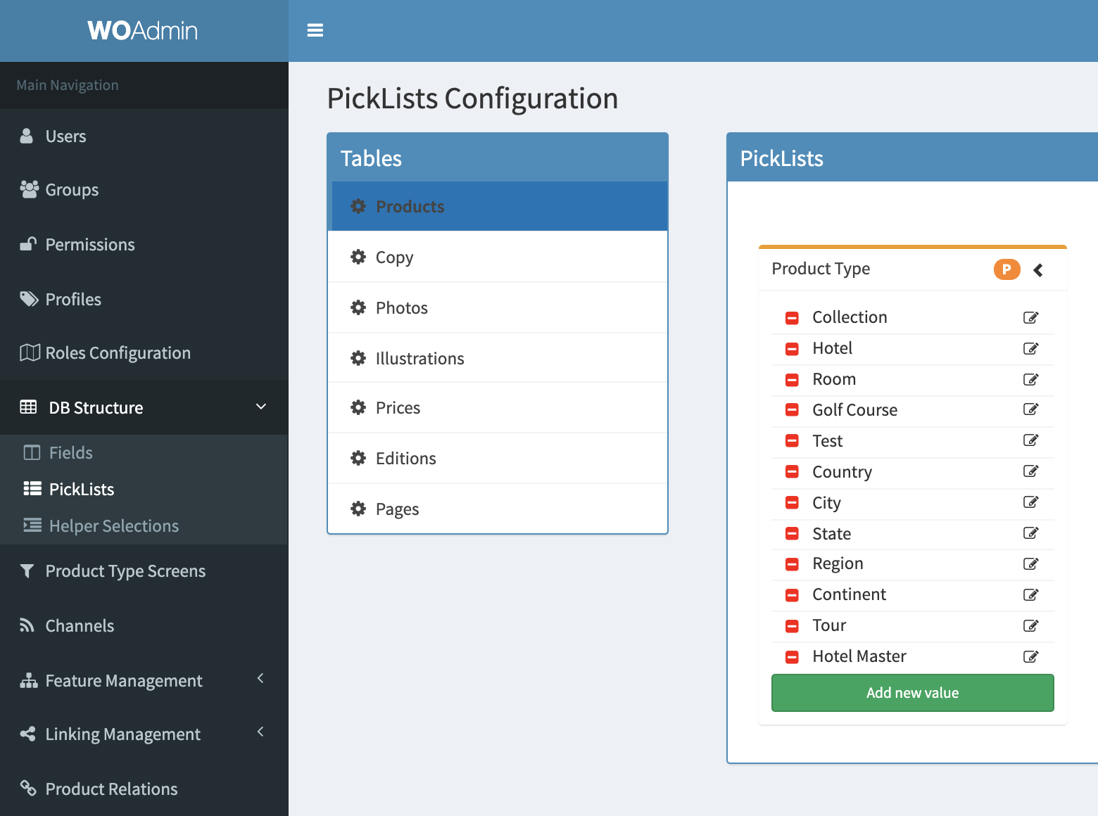
12.1 Creating a new Product Type
To create a new Product Type in AO Admin, select DB Structure from the list on the left-hand side of the screen. From this list, select Picklists and then Products.
From here, use the green, “Add new value” button, to create and name your new Product.

CHANNELS

FEATURE MANAGEMENT
Within AO Admin, Features are Sections or Templates applied to Products (expand).
14.1 Creating a new Feature section
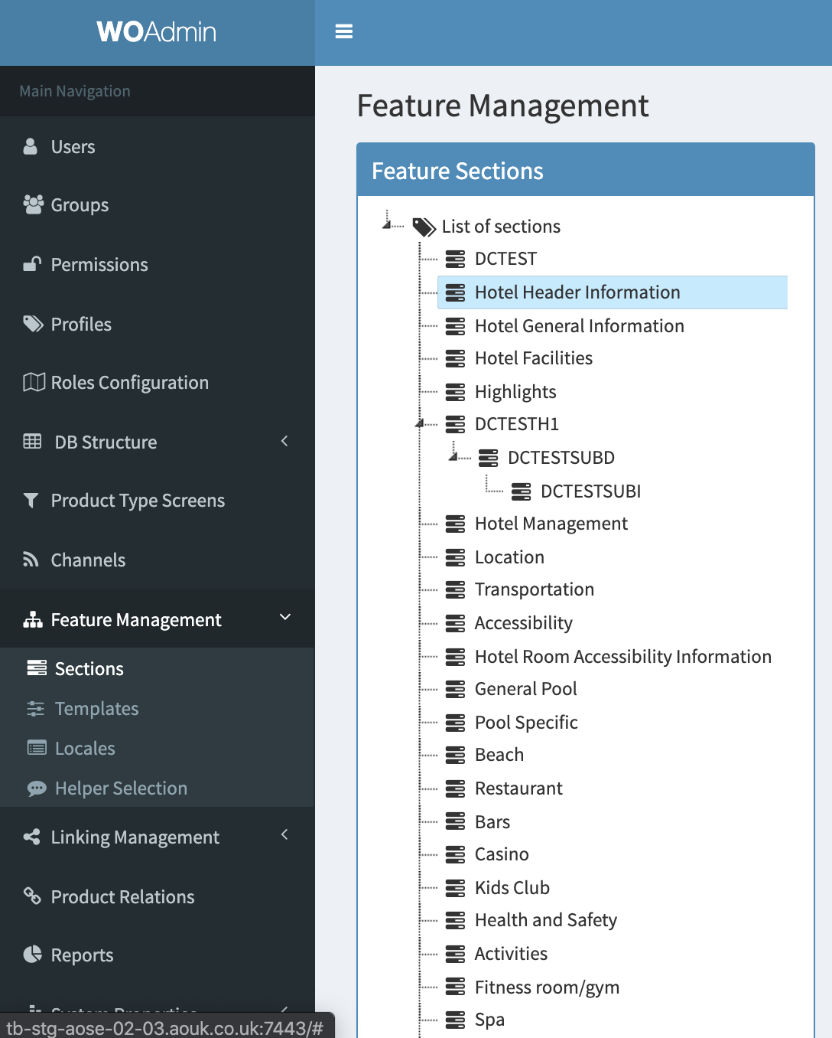
Sections are the lists of Features that can be applied to a Product Type. Sections are created first by assigning a name to the Feature then the various fields, attributes and types.
To create a new Feature Section, on the left-hand side list, select Feature Management > Sections. Right clicking on List of sections will allow you to create a new Section.

LINKING MANAGEMENT

PRODUCT RELATIONS

REPORTS

