Dartmouth College HANOVER ● NEW HAMPSHIRE ● 03755-3547

*Department of Government, 6108 Silsby Hall*

603/ 646-2544 FAX: 603/ 646-2152

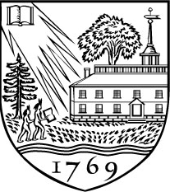

December 24, 2017

Harold D. Clarke and Geoffrey Evans

Editors, *Electoral Studies*

Dear Professors Clarke and Evans:

I am pleased to submit a manuscript, “Voting lines, equal treatment, and early voting check-in times in Florida,” to *Electoral Studies.* The manuscript is co-authored with David Cottrell and Daniel A. Smith.

In our manuscript, my co-authors and I engage the subject of voting lines. The manuscript considers two aspects of lines, the extent to which a line is a time tax imposed on the voters who must wait in it and the extent to waiting in line affects future electoral participation. Our research on lines leverages thousands of early voting check-in times from six major Florida counties.

We show that minority voters in Florida bore a greater burden of the waiting time tax in 2012---although the situation was much better in 2016. We show as well that waiting in line has a small but non-zero effect on the probability of turning out to vote in the future (the effect is approximately one percentage point). In addition, waiting in line to vote early is associated with a lower likelihood of voting early in the future. Our findings have implications for theories about equal treatment of voters as well as empirical research on election administration.

Thank you for your consideration of my manuscript, and I look forward to hearing from you in the future.

Regards,

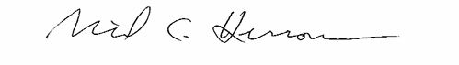

Michael C. Herron

*William Clinton Story Remsen 1943 Professor of Government*

*Chair, Program in Quantitative Social Science*