STAT 420 | Multivariate Normal Distribution | Stepanov  Dalpiaz

X = 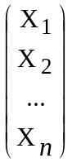 – | n-dimensional  random vector | E ( X ) = μ = 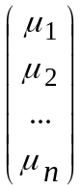

Σ = 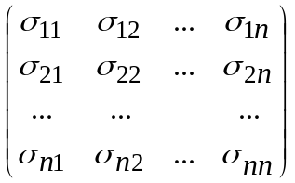 | σij = Cov ( Xi , Xj )  Σ = E [ ( X – μ ) ( X – μ )' ]  Σ – symmetric, nonnegative-definite

Multivariate Normal Distribution:

X ~ N n ( μ, Σ ) f X ( x ) = 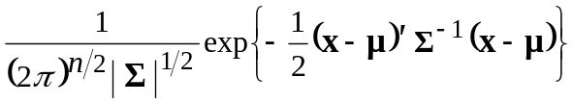

Z ~ N n ( 0, In ) f Z ( z ) = 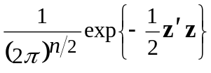 = 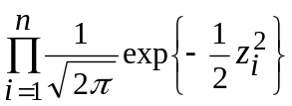

X = Σ 1/2 Z + μ

M X ( t ) = 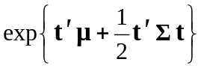 t = 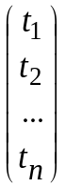 ∈ Rn

Y = A X + b A – m × n b ∈ Rm

⇒ Y ~ N m ( A μ + b, A Σ A' )
_ _ _ _ _ _ _ _ _ _ _ _ _

X = 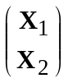 | X1 is of dimension m < n  X2 is of dimension n – m | μ = 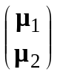 Σ = 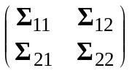

X1 | X2 ~ N m
1. Consider a random vector 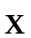 = 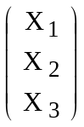 with mean E ( ) = = 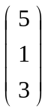
and variance-covariance matrix Cov ( ) = Σ = 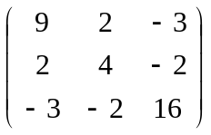.

Then Var ( X 1 ) = 9, Var ( X 2 ) = 4, Var ( X 3 ) = 16,

ρ 12 = 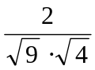 = , ρ 13 = 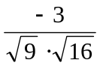 = 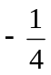, ρ 23 = 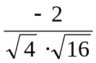 = .

Consider 2 X 1 – 3 X 2 – X 3 = 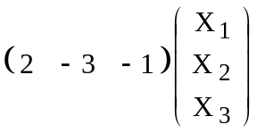.

E ( 2 X 1 – 3 X 2 – X 3 ) = 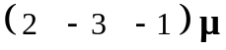 = 2 μ 1 – 3 μ 2 – μ 3 = 2 ⋅ 5 – 3 ⋅ 1 – 1 ⋅ 3 = 4.

Var ( 2 X 1 – 3 X 2 – X 3 ) = 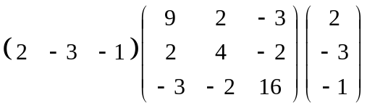
= 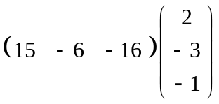 = 64.

OR

Var ( 2 X 1 – 3 X 2 – X 3 ) = 4 Var ( X 1 ) + 9 Var ( X 2 ) + Var ( X 3 )
– 12 Cov ( X 1 , X 2 ) – 4 Cov ( X 1 , X 3 ) + 6 Cov ( X 2 , X 3 )
= 36 + 36 + 16 – 24 + 12 – 12 = 64.

2. | X ~ N 3 ( μ, Σ ) μ = 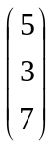 Σ = 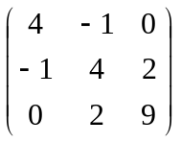

a) Find P ( X 1 > 6 ).

X1 ~ N ( 5, 4 )
P ( X1 > 6 ) = 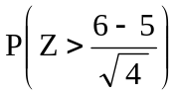 = P ( Z > 0.5 ) = 0.3085.

b) Find P ( 5 X 2 + 4 X 3 > 70 ).

E ( 5 X 2 + 4 X 3 ) = 5 ⋅ 3 + 4 ⋅ 7 = 43.

Var ( 5 X 2 + 4 X 3 ) = 25 Var ( X 2 ) + 40 Cov ( X 2 , X 3 ) + 16 Var ( X 3 )
= 25 ⋅ 4 + 40 ⋅ 2 + 16 ⋅ 9 = 324.

OR

Var ( 5 X 2 + 4 X 3 ) = 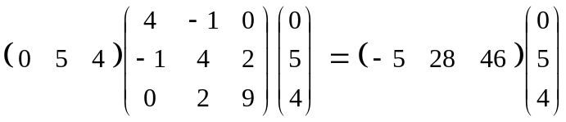 = 324.

P ( 5 X 2 + 4 X 3 > 70 ) = 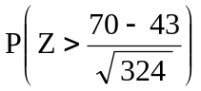 = P ( Z > 1.50 ) = 0.0668.

c) Find P ( 3 X 3 – 5 X 2 < 17 ).

E ( 3 X 3 – 5 X 2 ) = 3 ⋅ 7 – 5 ⋅ 3 = 6.

Var ( 3 X 3 – 5 X 2 ) = 9 Var ( X 3 ) – 30 Cov ( X 2 , X 3 ) + 25 Var ( X 2 )
= 9 ⋅ 9 – 30 ⋅ 2 + 25 ⋅ 4 = 121.
OR

Var ( 3 X 3 – 5 X 2 ) = 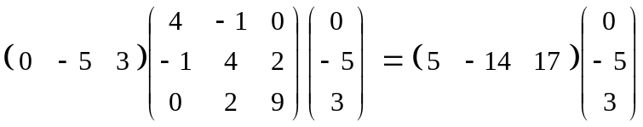 = 121.

P ( 3 X 3 – 5 X 2 < 17 ) = 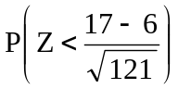 = P ( Z < 1.00 ) = 0.8413.

d) Find P ( 4 X 1 – 3 X 2 + 5 X 3 < 80 ).

E ( 4 X 1 – 3 X 2 + 5 X 3 ) = 4 μ1 – 3 μ 2 + 5 μ 3 = 4 ⋅ 5 – 3 ⋅ 3 + 5 ⋅ 7 = 46.

Var ( 4 X 1 – 3 X 2 + 5 X 3 ) = 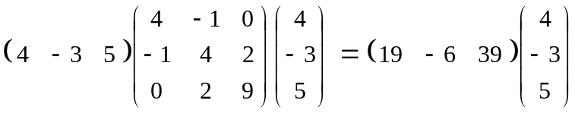
= 289.

4 X1 – 3 X2 + 5 X3 ~ N ( 46, 289 )

P ( 4 X1 – 3 X2 + 5 X3 < 80 ) = 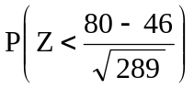 = P ( Z < 2.00 ) = 0.9772.

e)* Find P ( X1 > 8 | X2 = 1, X3 = 10 ).

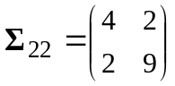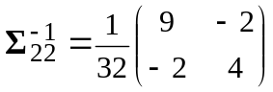

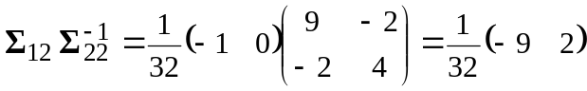

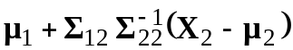 = 5 + 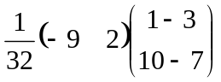 = 5.75.

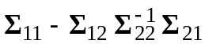 = 4 – 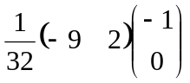 = 3.71875.

X1 | X2 = 1, X3 = 10 ~ N ( 5.75, 3.71875 )

P ( X1 > 8 | X2 = 1, X3 = 10 ) = 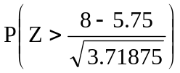 = P ( Z > 1.17 ) = 0.1210.

