Object oriented programming
Bsc Computer Science – University of London
Mid-term assignment - by David Della Rossa

Abstract
This assignment asks to create a bot as a software component integrated into the Merklerex program, able to automatically carry out trading activities, like analyzing the entries in the OrderBook, do bid and ask operations, based on the content of the wallet.
The bot should also be able to log information regarding its activity.

Implementation
Looking at the current state of the solution, I noticed that the bot to be created is basically functionally similar to the part already written, that manages the user interaction.
The similarities are that both bot and user are able to create asks and bids over the OrderBook, managing the wallet.
A user is able to look at the content of the wallet, to look at the market statistics up to that point, to submit asks and bids based on his/her evaluations.
These are exactly the same functionalities the bot has to offer.
The difference is that in one case the decision whether to ask or bid is left to the user, in the other case is taken by the software.
In the given solution, the two different aspects of coordinating the program and its components, and the user interaction, all lie within the same class.
One first step I wanted to do is to separate the two different concerns, user interaction from the business logic of keeping the program run, advancing the timeframe and coordinating the exchange of information among the various software parts of the program.
I’ve introduced a new class called CLInterpreter, which stands for Command Line Interpreter. This class displays information to the user and collects her selections through the console. It analyzes the user input and interprets that input as actions to execute over the program’s components. However, it does not directly execute those actions, instead it informs the main class MerkelMain of the actions to execute and let the MerkelMain instance to actually do the job.
This improves the cohesion, in line with the separation of concerns principle, as
the user interaction with the program is now physically separated from the actual execution of those actions, which is delegated to the MerkelMain class.
As Bot and CLInterpreter both interact the same way with MerkelMain class, I thought to segregate the common interface into a virtual class called IActor.
Another important difference is that the user wants to control the Bot somehow, which means the CLInterpreter should be able to collect and interpret user commands destined to the Bot. However I did not want to add a direct dependency of the CLInterpreter from the Bot. I’d rather want to give CLInterpreter a sort of remote control for the Bot.
To do so, I extracted that part of the Bot’s publicly accessible interface into a virtual class IBotControl. I then created another class, named BotRemoteControl which invokes actions onto the Bot via the IBotControl interface.
The BotRemoteControl instance is created by the Bot itself, calling a factory method called getRemote, which initializes the BotRemoteControl in order to be able to invoke the actual Bot’s instance methods. It is the MerkelMain class that invokes the getRemote method and receives the reference to the instance of BotRemoteControl, which it then passes to the CLInterpreter at construction.
Doing so, the CLInterpreter can execute actions onto the Bot instance, without a direct reference to it.

MerkelMain class
The purpose of this class is to instantiate and initialize all the instances needed for the program to work, exchange information and actions between these component, run the main loop and perform the main functionalities of the program. See the sequence of operations at startup here(14).

Changes made
It is basically very similar to what we developed during the course, with the following differences:
- The interaction with the user has been moved out in a separate class (CLInterpreter);
- It now owns an instance of CLInterpreter, an instance of Bot and an instance of BotRemoteControl, along with OrderBook and Wallet.
- It implements four new event handlers to attach to the four actions invoked by the IActor’s events, adopting the Observer design pattern. These actions are:
  - Enter Ask
  - Enter Bid
  - Go to next timeframe
  - Quit application
The constructor of the MerkelMain class creates instances of the other components needed, OrderBook, Wallet, Bot, BotRemoteControl, CLInterpreter. See 14.
It then attaches the events exposed by the IActor instances, Bot and CLInterpreter, to the proper event handlers.
In this implementation, Bot does not issue Quit requests or gotoNextTimeFrame requests, as these actions are left under the sole user control.
This is the point where the actors of the Observer pattern are connected: MerkelMain is the observer, Bot and CLIntepreter are the observed.
Regarding BotRemoteControl, this is not actually needed by MerkelMain, as it owns Bot and can execute actions directly on it. It is needed, though, to let CLInterpreter execute actions on Bot, without having a real dependency from it.

Addition of a Quit command
I added an additional option to the menu, Quit which, when selected, quits the program.
This is done adding a new boolean field called m_keepRunning, initialized to true.
This field is checked at every iteration of the main while loop in the init method.
When the user selects the Quit option, the CLInterpreter invokes the quitRequest_EventHandler which sets the m_keepRunning field to false, so that at the next iteration the while loop exits.

IActor interface

Motivation
Segregate the common interface between Bot and CLInterpreter.

Structure
IActor exposes two functions:
- processFrame, invoked to let the IActor instance process the new Frame. The new timeframe value is passed as input parameter;
- saleCompleted, invoked to inform the IActor instance that a sale has been completed. A reference to the sale is passed as input parameter;
and four other functions used by the observer pattern, to raise events:
- enterAsk_Event, used to inform the observer that a new ask has been created. The new ask is passed as input parameter and received by the observer which can process it;
- enterBid_Event, same as enterAsk_Event;
- gotoNextTimeFrame_Event, currently implemented only by CLInterpreter, invoked when the user selects the correspondent menu option. This tells the observer to go to the next timeframe;
- quitRequest_Event, tells the observer to quit the program.

IBotControl interface

Motivation
This interface is implemented by the Bot and exposes methods used by the BotRemoteControl class, acting as a mediator between Bot and CLInterpreter. CLInterpreter invokes them when the user selects the correspondent options.

Structure
This interface exposes four methods:
- logWallet, to tell the Bot to log the Wallet status in its log;
- logBids, to tell the Bot to log the historical of its bids in its log;
- logAsks, to tell the Bot to log the historical of its asks in its log;
- logSales, to tell the Bot to log the historical of its sales in its log;

Bot class

Motivation
The Bot is a software component able to perform trading actions autonomously.
In this implementation, the Bot is not completely automatic, meaning that the user controls, iteration by iteration, if the bot has to process the current frame.
It is also the user that manually advances to the next timeframe. This choice is made in order to have a better control on the actions performed by the bot, for analysis and debug purpose. Of course, it can easily be made completely autonomous and able to run continuously without any user intervention.

Structure
It requires a reference to the OrderBook and to the Wallet, in order to perform its analysis and take its decisions on whether to instruct new actions.

How it works
The Bot takes its decisions whether to bid or ask based on the history of average price calculated during the previous time frames.
At the very first iteration, the Bot is not able to do any bids or asks as it does not contain enough information about the prices. Analysing the prices in the first timeframe, though, it starts building its history of prices, so that at the next timeframe it can start trading.
The history of average prices is stored into an instance of a class named RollingAverageManager, explained later in this document. It basically contains the last n average prices for a product.
The main method is processFrame, which processes the timeframe passed as input parameter, through the following steps:
- Get the price average from the RollingAverageManager;
- Get the list of asks and bids for the current timeframe;
- Calculate the new price average based on the current asks and bids and add it to the RollingAverageManager;
- If the OrderBook contains asks below the average price, for a particular product, calculate the max amount of bids that can be done, based on the Wallet content, generate the bids for the same product and invoke the enterBid event;
- If the OrderBook contains bids above the average price, for a particular product, calculate the max amount of asks that can be done, based on the Wallet content, generate the asks for the same product an invoke the enterAsk event;
- Update the m_historicalAsk and m_istoricalBids collection with the asks and bids created.
When a sale is finalized, the Bot is informed via the saleCompleted method, so it can update its m_historicalSales collection.
See a flowchart of this algorithm right here(11).

BotRemoteControl class

Motivation
This is to let the CLInterpreter execute commands onto the Bot instance, without owning an instance of it.

Structure
BotRemoteControl exposes five methods to execute actions onto the Bot.
It is created invoking the getRemote factory method exposed by the Bot class. In the creation phase, the five methods of the remote are bound to the correspondent methods on the Bot, so that executing the actions on the remote means executing the same actions onto the Bot.

RollingAverageManager class

Motivation
The logic of the Bot is as follows. Calculate the average of the last n average prices and, if for the current timeframe there are asks below the average, do a bid at the average price, whereas, if there are bids above the average, do an ask at the average price.
This class is used to memorize the average prices of the last n timeframes for a product into a vector and get the average of all these average prices.
The size of the vector is initialized to 4 by default, based on the size of the current dataset. Of course, increasing the vector size, increases the number of values used to calculate the average.
Worth notice that this algorithm considers only the most recent prices for a product, giving them the same importance. A more elaborated logic might be calculating a weighted average, so to give a higher weight to the more recent prices, than the older.

Structure
This class contains a fixed-sized vector, which in turn contains a set of double values. These values are the average prices of a product collected during the last n timeframes. Every time the insert method is called, the index of the current position on the vector is moved to the next position and the new value inserted there. The pointer to the current position rolls over when the end of the array is reached, so that the vector always contains the last n prices for a product.

CLInterpreter class

Motivation
This class manages the interaction with the user, displaying information on the console and receiving the user selection. It then interprets the user selection into actions and notifies the MerkelMain of these action requests.

Structure
It is similar to the code written during the course with some differences:
- It uses the Observer design pattern to notify the observer (MerkelMain) of the user selection.
- It implements some new actions to control the Bot, such as:
  - Let Bot process current frame
  - Let Bot log the wallet
  - Let Bot log its bids
  - Let Bot log its asks
  - Let Bot log its sales

Wallet class
I noticed that creating more bids within the same timeframe, I could bid more money than actually hold in my Wallet. In order to manage this unwanted situation, I introduced a new structure in Wallet, named m_reserves, which maps each currency type with a double value. For each currency, this value represents the amount of money already used in other bids within the current timeframe. When creating a new bid, the reserveAmount function on Wallet returns the amount of that currency in the wallet, take out the reserves already asked within the same timeframe. This value is the money available for the next bid in the same timeframe. Reserves are cleared after the timeframe is over.

Changes Made
A new map called m_reserves has been introduced to manage situations where, within the same timeframe, multiple bids and asks are performed. In this case, the amount of money available for a bid takes into account other bids already done for the same currency in the same timeframe.

Requirements
- R1: Market analysis
  - R1A: Bot accesses order book:
    - Bot constructor: the Bot constructor accepts a constant reference to an instance of OrderBook. This reference is stored in the private variable m_orderBook.
    - In Bot::processFrame the OrderBook reference is accessed several times, to get the lists of asks and bids for the current timeframe. When new asks and bids are created by the bot, these are added to the OrderBook and finally processed by OrderBook::matchAsksToBids function.
  - R1B: Bot can generate predictions of future market prices
    - Bot analizes the content of OrderBook every time it processes a frame, calculates the average of the prices for each products and stores this into an instance of RollingAverageManager. There is one instance per product type, storing the averages of price for that particular product. Bot uses this data to determine the price when creating new asks and bids.
- R2: Bids, asks and sales
  - R2A: Bot can generate bids and place them in the order book
    - Bot::processFrame – Bot generates new bids when it finds asks in the OrderBook with price below its calculated average for the product.
  - R2B: Bot can generate asks and place them in the order book
    - Bot::processFrame – Bot generates new asks when it finds bids in the OrderBook with price above its calculated average for the product.
  - R2C: Bot updates wallet after successful sales
    - Bot notifies MerkelMain of new asks and bids. When a sale is finalized, the wallet is updated. This happens in Wallet::processSale.
- R3: Logging
When Bot is instantiated, it opens a file for logging. This is an instance of std::ofstream, therefore can be easily interchanged with any other type of output streams, like a std::cout. This instance of logger is accessed throught the variable m_logger owned by Bot.
  - R3A: Bot generates a log of the contents of its wallet
    - Bot logs the content of the wallet at the beginning of every processFrame call.
    - Bot::logWallet method, invoked by CLInterpreter when user selects option 8.
  - R3B: Bot generates a log of its bids and asks
    - Bot logs details of its bids and asks as soon as it creates them;
    - Bot::logBids method is invoked by CLInterpreter when user selects option 9.
    - Bot::logAsks method is invoked by CLInterpreter when user selects option 10.
  - R3C: Bot generates a log of its sales
    - Bot logs its finalized sales as soon as it is notified of them by the MerkelMain instance.
    - Bot::logSales is invoked by CLInterpreter when user selects option 11.

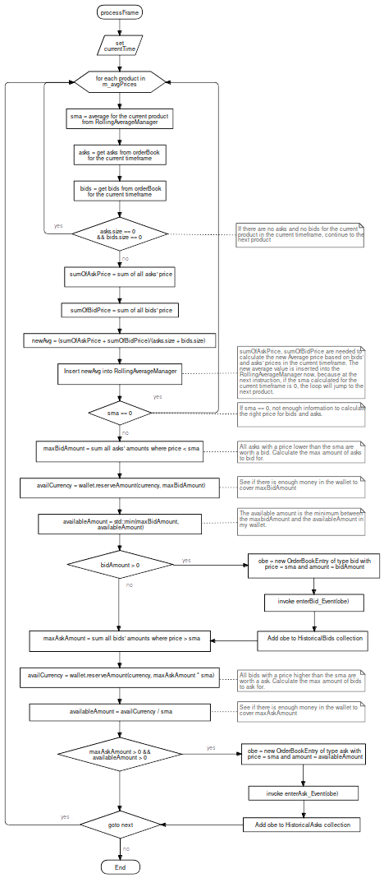
Flowchart for Bot::processFrame

Class diagram
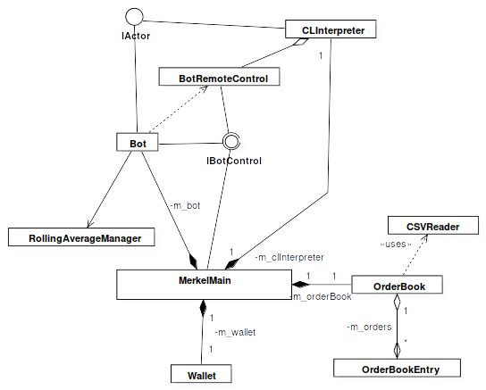

Class diagram complete
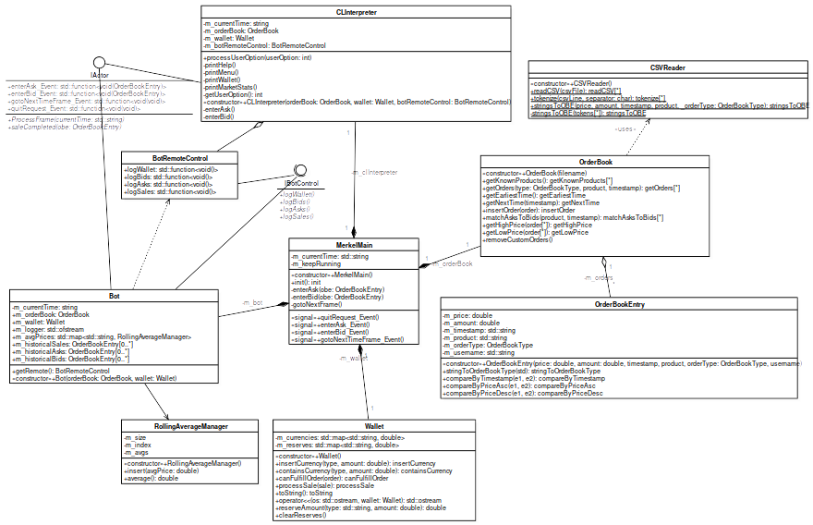

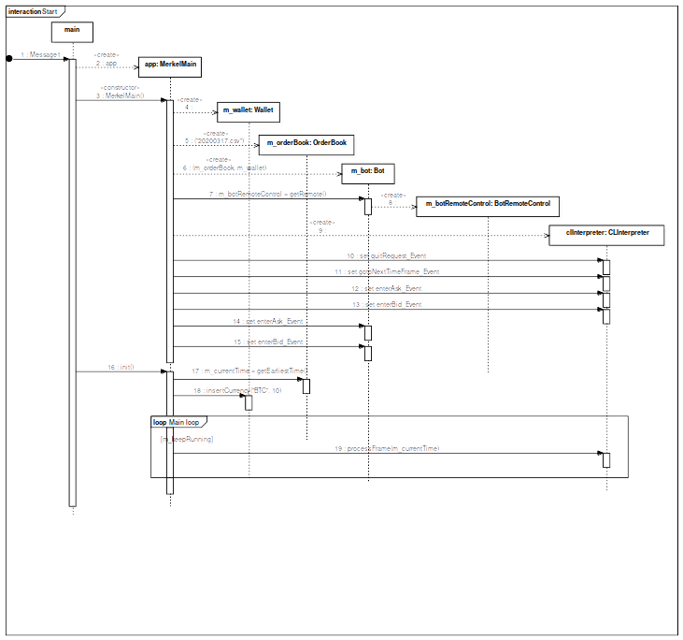
Message sequence at startup

Example of log file generated:

======================================================
Processing frame 2020/03/17 17:01:35.103526
Averages:
BTC/USDT: 5356.66
DOGE/BTC: 4.05e-07
DOGE/USDT: 0.00155102
ETH/BTC: 0.0219267
ETH/USDT: 117.397
What's in my wallet:
BTC : 2.217823
DOGE : 24691358.024691
Product: BTC/USDT: calculated price average: 5356.66
Available amount of asks below average: 0.000414064
Available currency to place bids: USDT 0; amount of BTC I can purchase: 0
Available amount of bids above average: 0
Available currency to place asks: USDT 0; amount of BTC I can get: 0
Product: DOGE/BTC: calculated price average: 4.05e-07
Available amount of asks below average: 1.82936e+08
Available currency to place bids: BTC 0; amount of DOGE I can purchase: 0
Available amount of bids above average: 0
Available currency to place asks: BTC 0; amount of DOGE I can get: 0
Product: DOGE/USDT: calculated price average: 0.00155102
Available amount of asks below average: 2.41168e+06
Available currency to place bids: USDT 0; amount of DOGE I can purchase: 0
Available amount of bids above average: 2.25262e+06
Available currency to place asks: USDT 3493.86; amount of DOGE I can get: 2.25262e+06
Ask: DOGE/USDT,0.00155102,2.25262e+06
Product: ETH/BTC: calculated price average: 0.0219267
Available amount of asks below average: 358.331
Available currency to place bids: BTC 0; amount of ETH I can purchase: 0
Available amount of bids above average: 0
Available currency to place asks: BTC 0; amount of ETH I can get: 0
Product: ETH/USDT: calculated price average: 117.397
Available amount of asks below average: 56.8923
Available currency to place bids: USDT 0; amount of ETH I can purchase: 0
Available amount of bids above average: 0
Available currency to place asks: USDT 0; amount of ETH I can get: 0
Sale completed: Asksale: BTC/USDT,5356.24,0.000414064
Sale completed: Asksale: DOGE/USDT,0.00154847,390889
Sale completed: Asksale: DOGE/USDT,0.00154847,24430.9
Sale completed: Asksale: DOGE/USDT,0.00154847,10676.6
Sale completed: Asksale: DOGE/USDT,0.00154847,657.57
Sale completed: Asksale: DOGE/USDT,0.00154847,858476
Sale completed: Asksale: DOGE/USDT,0.00154847,619.048
Sale completed: Asksale: DOGE/USDT,0.00154847,399936
Sale completed: Asksale: DOGE/USDT,0.00154847,1320.51
Sale completed: Asksale: DOGE/USDT,0.00154847,407335
Sale completed: Asksale: DOGE/USDT,0.00154847,157647
Sale completed: Asksale: DOGE/USDT,0.00154847,633.144
Sale completed: Asksale: DOGE/USDT,0.00154847,159055
Wallet content:
BTC : 2.217408
DOGE : 22279682.484649
USDT : 3736.617208
History of Bids:
Bid: DOGE/BTC,4.05e-07,2.46914e+07
History of Asks:
Ask: BTC/USDT,5356.24,0.000414064
Ask: DOGE/USDT,0.00154847,2.41168e+06
Ask: DOGE/USDT,0.00155102,2.25262e+06
History of Sells:
Bidsale: DOGE/BTC,3.1e-07,1.19057e+07
Bidsale: DOGE/BTC,3.2e-07,1.27856e+07
Asksale: BTC/USDT,5356.24,0.000414064
Asksale: DOGE/USDT,0.00154847,390889
Asksale: DOGE/USDT,0.00154847,24430.9
Asksale: DOGE/USDT,0.00154847,10676.6
Asksale: DOGE/USDT,0.00154847,657.57
Asksale: DOGE/USDT,0.00154847,858476
Asksale: DOGE/USDT,0.00154847,619.048
Asksale: DOGE/USDT,0.00154847,399936
Asksale: DOGE/USDT,0.00154847,1320.51
Asksale: DOGE/USDT,0.00154847,407335
Asksale: DOGE/USDT,0.00154847,157647
Asksale: DOGE/USDT,0.00154847,633.144
Asksale: DOGE/USDT,0.00154847,159055

End of the assignment

