ORIGIN Recommender Prototyping at 8 Feb 2026

All code on https://github.com/davidderoure/origin/

RECOMMENDER 1

Questions arising:
- How is mood represented. Based on PANAS I inityially assumed a vector of 20 numbers from 1-5. But I don't know how emojis will map to this (also how many emojis does a user select to indicate their mood)? I discussed this with a small group of "young people" and they said that emoji semantics are changing all the time and inconsistent across different groups.
- What makes a good recommendation? I naively assumed recommendations should match or improve mood but this seems to be an absolutely key design decision for ORIGIN and needs some expert advice. Also what makes a bad recommendation (e.g. the "selecting away from" aspect we discussed e.g. for trigger themes).
- How do we convey contextual information (e.g. it's black history month, or a new batch of stories is available). I've currently assumed this could be done by using free text tags to promote/boost a story.
- We could do with some sample stories and categories etc in order to test more realistically (for design I’ve assumed 10 themes, 100 stories, 1000 users). We could also do with some example user interaction data, and this is something we could generate for testing - I wonder what user model could be used for the generation (and maybe to evaluate the recommendations)

Code is in a colab notebook rec1.ipynb

RECOMMENDER 2

After our meeting on 2nd Feb which discussed the above, the updated code rec2.py also explores:

- Mood score is now just a single numeric value (1-10 scale)
- 'slider_position' introduced as event type with a position value from 0.0 to 1.0 for completely "individual" (content-based only) to completely "others" (collaborative filtering only) and default of 0.5
- “universal signals” still apply (promotional tags, novelty, theme avoidance)
- Added time based decay of events (half-life 30 days for general preferences and 14 days for mood-related events).
- Story Transition Tracking captures pairs/sequences
To test this the server app.py uses the rec2.py code and supports interaction from a browser. It includes 25 AI-generated stories. This uses the Flask web application framework and the UX is purely for testing the recommender logic.
Here is an example of the system in use
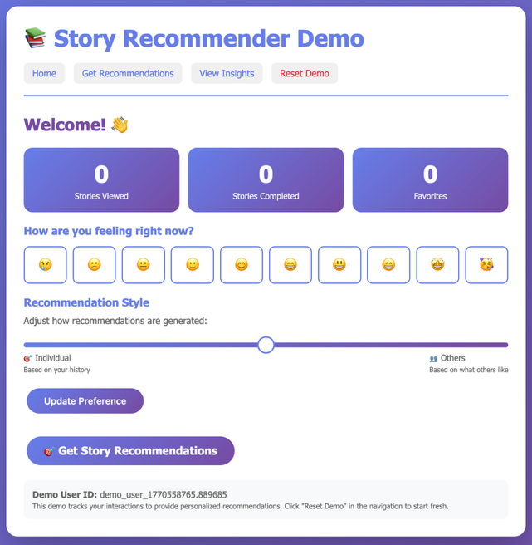 | 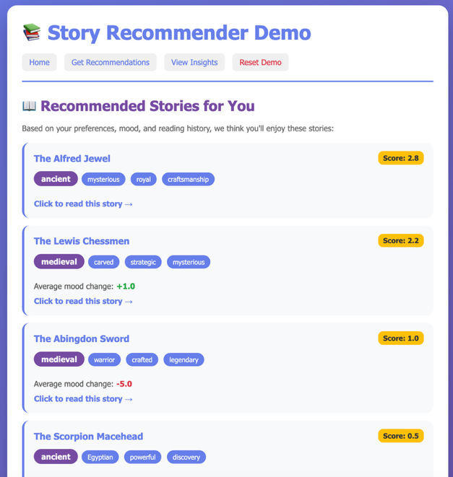
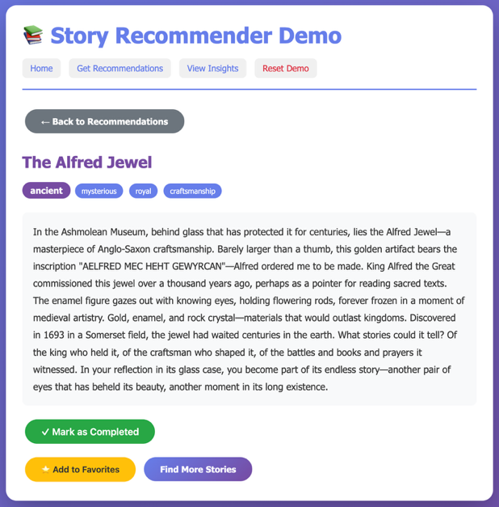 | 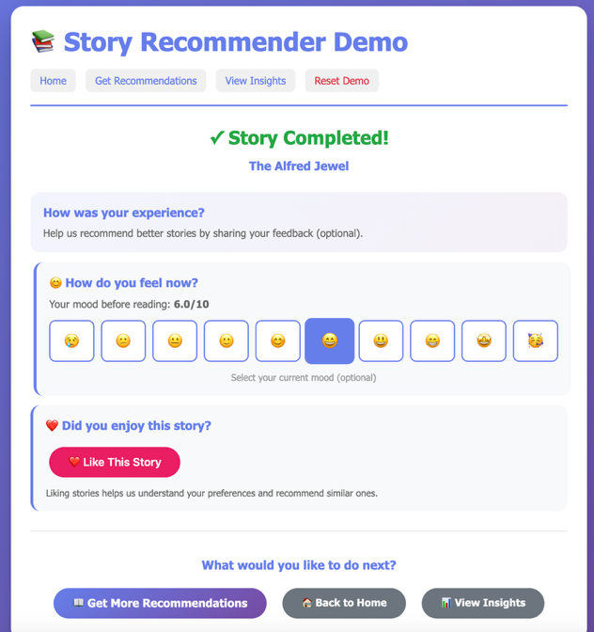
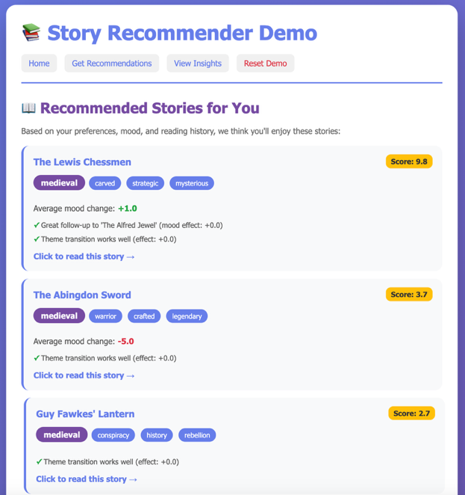 | 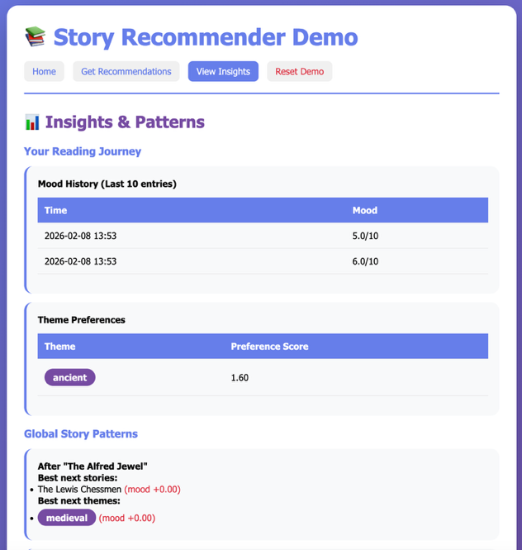
Questions arising:
- Is the single numeric score for mood sufficient?
- Do we want to have an individual-group recommendations slider?
- What do people think about having a time decay?
- What do people think about making recommendations based on story pairs/sequences?
- NB Currently not using dwell time.

ORIGIN Recommender IPC comparison

Python integration options for discussion

- Run python as a web server for development and test. Clean separation of concerns and good tooling. Server maintains state (not ideal).
- C# opens websocket to python on startup to provide a single persistent connection for callbacks to save state – then we can have fire-and-forget events, request-response, and server-initiated callbacks. But code is complicated because it has to handle connection management and message serialization/deserialization manually.
- Communicate with Python process using gRPC. Fast and bidirectional. Simpler and cleaner code and dramatically simplifies C#(?). Extra learning step (i.e. using protobuf).
- Named pipes also an option – I found this messy to debug.

After trying example code for all of these (see github), this is the comparison:

 | WebSocket (FastAPI) | gRPC | Named Pipes/Sockets
Python Server Code | Simple | Very Simple | Complex
C# Client Code | Complex | Very Simple | Complex
Maintainability | Good | Excellent | Poor
Type Safety | None (JSON) | Strong (protobuf) | None (JSON)
Debugging | Medium | Easy | Hard
Latency | ~2-10ms | ~1-5ms | ~0.1-1ms
Initial Setup | Simple | Medium (codegen) | Simple
Cross-platform | Yes | Yes | Different code

David De Roure 2026-02-08

