HTML:

<http://paletton.com/#uid=73u120kuRdcPNtbyBlFoG8BkQ3f>

/\* CSS - Cascading Style Sheet \*/

/\* Palette color codes \*/

/\* Palette URL: http://paletton.com/#uid=73u120kuRdcO+mRANj6n9aLhd5R \*/

/\* Feel free to copy&paste color codes to your application \*/

/\* As hex codes \*/

.color-primary-0 { color: #062C43 } /\* Main Primary color \*/

.color-primary-1 { color: #024A74 }

.color-primary-2 { color: #043F61 }

.color-primary-3 { color: #112937 }

.color-primary-4 { color: #0F181E }

.color-secondary-1-0 { color: #260847 } /\* Main Secondary color (1) \*/

.color-secondary-1-1 { color: #3C047B }

.color-secondary-1-2 { color: #340767 }

.color-secondary-1-3 { color: #25133A }

.color-secondary-1-4 { color: #17101F }

.color-secondary-2-0 { color: #696204 } /\* Main Secondary color (2) \*/

.color-secondary-2-1 { color: #B6A900 }

.color-secondary-2-2 { color: #988D00 }

.color-secondary-2-3 { color: #565118 }

.color-secondary-2-4 { color: #2F2D16 }

.color-complement-0 { color: #693C04 } /\* Main Complement color \*/

.color-complement-1 { color: #B66400 }

.color-complement-2 { color: #985400 }

.color-complement-3 { color: #563A18 }

.color-complement-4 { color: #2F2316 }

/\* Generated by Paletton.com © 2002-2014 \*/

/\* http://paletton.com \*/

Fonts

h1 { font-family: Tahoma, Verdana, Segoe, sans-serif; font-size: 24px; font-style: normal; font-variant: normal; font-weight: 700; line-height: 26.4px; }

h3 { font-family: Tahoma, Verdana, Segoe, sans-serif; font-size: 14px; font-style: normal; font-variant: normal; font-weight: 700; line-height: 15.4px; }

p { font-family: Tahoma, Verdana, Segoe, sans-serif; font-size: 14px; font-style: normal; font-variant: normal; font-weight: 400; line-height: 20px; }

blockquote { font-family: Tahoma, Verdana, Segoe, sans-serif; font-size: 21px; font-style: normal; font-variant: normal; font-weight: 400; line-height: 30px; }

pre { font-family: Tahoma, Verdana, Segoe, sans-serif; font-size: 13px; font-style: normal; font-variant: normal; font-weight: 400; line-height: 18.5714px; }

OLD DESIGNS

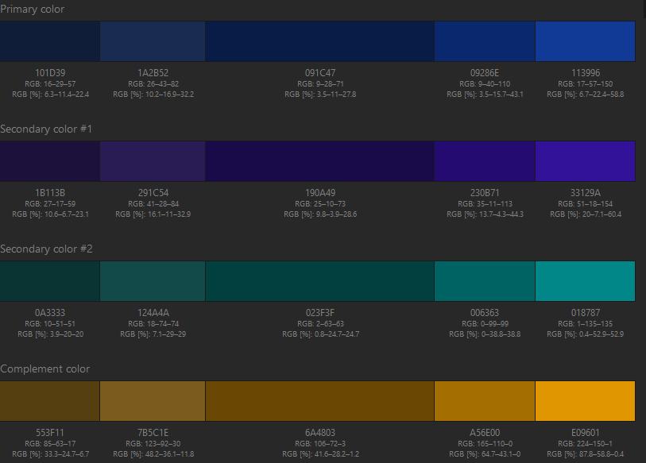

<http://paletton.com/#uid=63L0u0kuXdgpDaJohfoAXkHvOs8>

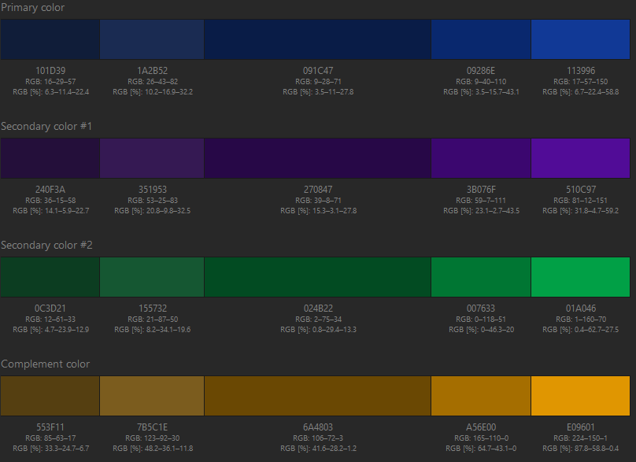 <http://paletton.com/#uid=63L0N0kuXdgpDaJohfoAXkHvOs8>

CSS /\* As hex codes \*/

m.color-primary-0 { color: #062C43 } /\* Main Primary color \*/

1.color-primary-1 { color: #0D2736 }

2.color-primary-2 { color: #16394E }

4.color-primary-3 { color: #054469 }

5.color-primary-4 { color: #095D8F }

m.color-secondary-1-0 { color: #6A5303 } /\* Main Secondary color (1) \*/

1.color-secondary-1-1 { color: #554611 }

2.color-secondary-1-2 { color: #7B661E }

4.color-secondary-1-3 { color: #A58100 }

5.color-secondary-1-4 { color: #E0AF01 }

m.color-secondary-2-0 { color: #6A0B03 } /\* Main Secondary color (2) \*/

1.color-secondary-2-1 { color: #551611 }

2.color-secondary-2-2 { color: #7B241E }

4.color-secondary-2-3 { color: #A50C00 }

5.color-secondary-2-4 { color: #E01201 }

m.color-complement-0 { color: #6A3C03 } /\* Main Complement color \*/

1.color-complement-1 { color: #553711 }

2.color-complement-2 { color: #7B511E }

4.color-complement-3 { color: #A55B00 }

5.color-complement-4 { color: #E07C01 }

Link: <https://paletton.com/#uid=43u0C0kuXdgpDaJohfoAXkHvOs8>