Does Lower Extremity Compensation Independently Inform Sagittal Deformity Correction Planning?

David D Liu, MD¹; Breton Line BS²; Feyza Achilova, BA³; Bassel G. Diebo, MD³; Virginie Lafage, PhD⁴; Renaud Lafage, MS⁴; Richard Hostin, MD⁵; Peter G. Passias, MD⁶; Eric O. Klineberg, MD⁷; Jeffrey L. Gum, MD⁸; Han Jo Kim, MD⁹; Robert K. Eastlack, MD¹⁰; Gregory M. Mundis Jr., MD¹⁰; Themistocles S. Protopsaltis, MD¹¹; Kojo D. Hamilton, MD¹²; Justin S. Smith, MD PhD¹³; Munish C. Gupta, MD⁹; Brett Rocos, MD⁶; Jeffrey P Mullin¹⁴, MD; Frank J. Schwab, MD⁴; Christopher I. Shaffrey, MD¹⁵; Stephen J. Lewis, MD¹⁶; Christopher P. Ames, MD¹⁷; Lawrence G. Lenke, MD¹⁸; Sang Hun Lee, MD¹⁹; Khaled M. Kebaish, MD¹⁹; Shay Bess, MD²; Alan H Daniels, MD³; International Spine Study Group

For submission to JNS Spine
Abstract 374/375 words
Text: 2477/4000 words
Tables and figures: 8/8
References: 24/45

Affiliations:
- Mass General Brigham, Harvard Medical School, Department of Neurosurgery, Boston, MA, USA
- Denver International Spine Center, Rocky Mountain Hospital for Children and Presbyterian St. Luke’s Medical Center, Denver, CO, USA
- Brown University School of Medicine, Department of Orthopedic Surgery, Providence, RI, USA
- Lenox Hill Hospital, Northwell Health, Department of Orthopedic Surgery, New York, NY
- Southwest Scoliosis Institute, Plano, TX, USA
- Duke University School of Medicine, Department of Orthopedic Surgery, Durham, NC, USA
- University of Texas Health, Department of Orthopedic Surgery, Houston, TX, USA
- University of Louisville School of Medicine, Louisville, KY, USA
- Hospital for Special Surgery, Department of Orthopedic Surgery, New York, NY, USA
- San Diego Center for Spinal Disorders, La Jolla, CA, USA
- New York University School of Medicine, Department of Orthopedic Surgery, New York, NY, USA
- University of Pittsburgh Medical Center, Department of Neurosurgery, Pittsburgh, PA, USA
- University of Virginia School of Medicine, Department of Neurosurgery, Charlottesville, VA, USA
- Department of Neurosurgery, Jacobs School of Medicine and Biomedical Sciences, University at Buffalo, Buffalo , New York , USA
- Duke University School of Medicine, Department of Neurosurgery, Durham, NC, USA
- University of Toronto, Department of Orthopedic Surgery, Toronto, Ontario, Canada
- University of California San Francisco School of Medicine, Department of Neurosurgery, San Francisco, CA, USA
- Columbia University Vagelos College of Physicians and Surgeons, Department of Orthopedic Surgery, NewYork-Presbyterian Och Spine Hospital, New York, NY, USA
- Johns Hopkins University School of Medicine, Department of Orthopedic Surgery, Baltimore, MD, USA

Corresponding Author:
Name:
Current Institution:
Email:

Keywords: adult spinal deformity, surgical planning, full-body radiograph, sagittal deformity, lower extremity compensation, spinal alignment
Abstract
Objective
Lower extremity compensation in adult spinal deformity (ASD) occurs as a response to sagittal malalignment. Full-body imaging measures lower limb alignment, with knee flexion (KF) as a proxy for compensation. However, full-body radiographs are not universally available, and KF is thought to be downstream of other spinopelvic parameters, especially pelvic tilt (PT). We evaluated the association of KF with the degree of deformity correction and PT to determine if it has utility in sagittal correction planning.
Methods
A retrospective analysis of a prospective multicenter adult spinal deformity database was performed for patients with full-body radiographs available at preoperative and 6-week timepoints. Several radiographic parameters, including knee flexion (KF), lumbar lordosis (LL), sagittal vertical axis (SVA), and PT were measured. Change in lordosis (∆LL) was calculated. Multivariable regression and principal components analysis (PCA) with other radiographic parameters and age were utilized to assess whether KF was independently associated with ∆LL. Subgroup of patients with pathologic (>20°) PT and for each individual surgeon were analyzed. Univariate regression of KF with the Oswestry Disability Index (ODI) and Scoliosis Research Society Questionnaire (SRS-22) and were performed.
Results
A total of 679 patients were included. Preoperative KF was strongly associated with ΔLL (r=0.48, p<0.0001). However, KF had no independent association with ∆LL after subtracting the variance from a multivariate alignment model (5 variables; r=0.056, p=0.08) and a more comprehensive PCA-based model (r=0.038, p=0.25). Conversely, in patients with satisfactory alignment (|PI-LL mismatch| < 10), there was no association between PI-LL mismatch and KF (r=0.04, p=0.30). These findings were replicated for each surgeon and found to be overall similar for SVA. There was an association between KF and pathologic PT (r=0.316, p<0.001) but not normal PT (r=0.049, p=0.37); repeating the confounder analysis for PT instead of KF did show a residual independent relationship with ∆LL (r=-0.35, p<0.001). Finally, KF was associated with ODI at all timepoints (p<0.003) and with SRS-22 preoperatively (p=0.01) and at 2 years (p<0.001).
Conclusions
After controlling for other well-known spinopelvic parameters, knee flexion (KF) was not independently associated with sagittal correction, whereas pelvic tilt (PT) was. For patients with pathologic PT, KF is collinear with PT. This suggests that lower extremity compensation may not be required specifically for sagittal alignment planning, though its overall clinical utility still warrants further investigation.
Introduction
Adult spinal deformity (ASD) is characterized by sagittal malalignment that leads to substantial disability. When surgery is indicated, planning paradigms focus on radiographic parameters that can be changed during correction, such as lumbar lordosis, thoracic kyphosis, sagittal vertical axis, and thoracolumbar pelvic angles^{1,2}. As our understanding of global spinal alignment evolves, the role of the lower extremities has been highlighted as an additional biomechanical compensation mechanism for severe deformity³. In this framework, the pelvis and lower extremities form a chain that aims to keep the trunk and head balanced over the feet⁴. After pelvic retroversion through pelvic tilt reaches its maximum range, the knee flexes in order to move the bicoxofemoral axis forward³. The active muscular contraction to maintain this position can cause significant pain and disability⁵.
Alignment from the head to the pelvis can be assessed by 36-inch lateral X-rays, but analyzing the lower limbs in the context of sagittal alignment requires specialized imaging⁶. However, full-body imaging is expensive compared to standard 36-inch films and is not routinely available at most centers⁷. One of the main value propositions of full-body imaging systems in ASD is the ability to assess lower limb compensation⁸ (Figure 1). Studies have shown that degree of lower limb compensation—with knee flexion as a proxy—is associated with disability, but that it can be confounded by other factors such as BMI, osteoarthritis^{9,10}, or patient positioning during imaging¹¹. It is not clear whether surgeons actually use this information to plan the amount of surgical correction¹².
In this study, we sought to evaluate the role of lower limb imaging in surgical planning based on alignment data from a multicenter ASD cohort with preoperative and early postoperative full body imaging available. Specifically, we investigated if preoperative knee flexion predicts the amount of lordosis correction, and whether any apparent effect persists after controlling for established radiographic parameters and age^{13,14}. We hypothesized that 1. knee flexion would be correlated with but not independently associated with the degree of surgical correction obtained; and 2. the contribution of knee flexion would be overshadowed by pelvic tilt, which is available in routine 36-inch films.
Methods
Study Design and Patient Population
This study is a retrospective analysis of a prospectively maintained multicenter database of ASD, with IRB approval at each participating site (study ClinicalTrials.gov Identifier: NCT04194138). Inclusion criteria for enrollment included age 18 years or older, and one of the following radiographic criteria of spinal deformity: maximal scoliosis ≥20°, sagittal vertical axis (SVA) ≥5cm, pelvic tilt (PT) ≥25°, and/or thoracic kyphosis (TK) ≥60°). Exclusion criteria for were spinal deformities associated with autoimmune, acute traumatic, neoplastic, neuromuscular, syndromic and/or infectious disorders.
In this analysis, patients were included if they underwent thoracolumbar fusion and had full-body imaging available preoperatively and at 6 weeks. The 6-week timepoint was chosen since it most closely reflects the immediate radiographic results of the index correction. Patients were excluded if they required revision surgery before 6 weeks or if proximal junctional kyphosis (PJK) occurred at any timepoint, in order to isolate preoperative compensation and index correction rather than secondary postoperative failure states.
Data Collection
Baseline demographic variables included age, gender, and the anonymized identity of the treating surgeon. Full-body radiographs were obtained using the EOSedge system (Alphatec). Radiographic assessment of full-body radiographs was performed centrally using dedicated and validated software¹⁵ (Spineview, SpineLab, ENSAM). Radiographic parameters included sagittal vertical axis (SVA; C2 to S1), total lumbar lordosis (LL; L1-S1 lordosis), distal lordosis (L4-S1 LL; L4-S1 lordosis), thoracic kyphosis (TK; T2-T12), T4-L1 pelvic angle (PA) mismatch, pelvic tilt (PT), and pelvic incidence (PI). Knee flexion (KF) was measured as the sagittal plane angle at the knee joint, between the axis of the femur and tibia. If the projections between the right and left limb were not superimposed, the mean axis was used.
Patient reported outcome measures (PROMs) for this study included the Scoliosis Research Society-22 Questionnaire (SRS-22) and Oswestry Disability Index (ODI), collected at the preoperative, 6-week, and 2-year timepoints.
Statistical Analysis
The primary variables of interest were KF, LL, PI-LL mismatch, and PT. Changes in KF, LL, and PI-LL mismatch were computed between the 6 week and preoperative time points. We used ∆LL and PI-LL mismatch as a proxy for surgical planning in the sagittal plane since LL is the most directly modifiable radiographic parameters by surgeons. Univariate linear regression was used to compare relationships between KF with ∆LL and PT. To determine the independent contribution of KF to ∆LL in the context of other radiographic variables, we performed two analyses to subtract shared variance: multivariate linear regression (which is more clinically interpretable and based on causative relationships) and PCA (which is more comprehensive).
For the multivariate linear regression approach, a set of radiographic parameters was chosen as covariates to regress with ∆LL based on variance inflation factors (VIFs) of each covariate. A VIF < 5 was considered satisfactory, and if the VIF >= 5 then the covariate was dropped from the model. Residuals from this model (i.e. variation in ∆LL not explained by these deformity parameters) were regressed against KF, allowing for estimation of the independent association between KF and surgical correction after accounting for shared variance with other alignment variables.
For the PCA-based approach, the dimensions of maximum variance were obtained based on eight common preoperative alignment variables: PI, LL, distal LL, SVA, PT, TK, T4-L1 PA mismatch, and age. Variables were normalized prior to PCA, and the number of retained components was determined using multiple complementary methods, including cumulative variance explained, eigenvalues >1 (Kaiser criterion), and broken-stick modeling. The retained PCA components were included as covariates in a multivariable model predicting ΔLL. Residuals from this model (ie, variation in ΔLL not explained by the PCA components) were then regressed against KF. This was repeated for ∆SVA in place of ∆LL. This was also repeated for PT in place of KF.
The above regression analyses were repeated within two clinically meaningful subgroups. First, patients were stratified based on treating surgeon identity (if >20 cases) in order to isolate the effect of individual surgeon planning. Second, patients were stratified according to PT < 20 and >=20 to determine if these effects were modified by pathologic pelvic retroversion.
Finally, univariate correlations between knee flexion with the SRS-22 and ODI were compared at baseline, 6 weeks, and 2 years. Subdomains of the SRS-22 score were also regressed against KF, with Benjamini-Hochberg correction for multiple comparisons. All statistical modeling and tests were performed using R 4.5.1 (R Foundation for Statistical Computing, Vienna, Austria), with a two-sided significance threshold of ⍺=0.05.
Results
Knee flexion and surgical planning (change in lumbar lordosis)
679 patients were included in this study, aged 61.8±15.0 years and 68.0% female. Preoperative knee flexion (KF) was found to be strongly associated with larger correction based on ∆LL (Figure 2A; r=0.48, R²=0.23, p<0.001). The multivariate regression model utilized PT, SVA, age, PI, and TK in addition to KF; LL, distal LL, and PI-LL were dropped from the variable set due to VIF > 10. After this adjustment, there was no correlation between of KF and the residual variance in ∆LL (Figure 2B; r=0.056, R²=0.001, p=0.08). The PCA-based confounder analysis also demonstrated that the independent effect of KF vanished to an even larger degree after accounting for all parameters (Figure 3B; r=0.038, R²=0.000, p=0.25).
Both of these patterns were replicated on a per-surgeon basis as well. That is, within all patients operated on by an individual surgeon, KF was strongly associated with ∆LL but had no residual relationship after accounting for other deformity parameters (Figure 4). One surgeon had an adjusted p-value of 0.024 which became insignificant after correction for multiple comparisons (Table 1).
For SVA instead of LL, there was also a strong association between preoperative KF and ∆SVA (r=-0.43, R²=0.19, p<0.001). After PCA-based confounder adjustment, a small amount of variance in ∆SVA was still explained by KF (r=0.10, R²=0.004, p=0.002). For PT instead of KF, after confounder adjustment, there was still a strong component of variance in ∆LL that was explained by PT (r=-0.35, R²=0.12, p<0.001).
Conversely, among patients with satisfactory postoperative alignment (|PI-LL mismatch| < 10°), there was no association between PI-LL mismatch with preoperative KF (r=0.04, p=0.30) or ∆KF (r=-0.01, p=0.82) (Figure 5). Among patients with satisfactory 6-week SVA < 3cm, there was no association between preoperative SVA (r=0.07, p=0.22) or ∆SVA (r=0.09, p=0.13). Similarly, within all surgeons, patients with satisfactory postoperative alignment had randomly distributed preoperative and 6-week KF (all p>0.05).
Sub-analysis of the role of normal vs pathologic pelvic tilt
Among patients with preoperative PT < 20°, KF was not correlated with pelvic tilt (r=0.049, R²=0.002, p=0.37, n=341). In contrast, among patients with preoperative PT >= 20°, KF was strongly associated with PT (r=0.316, R²=0.10, p<0.001, n=733) (Figure 6). Furthermore, among patients who had pathologic preoperative PT >= 20, there was still no independent association between KF and ∆LL after PCA-based adjustment (r=0.036, R²=0.0005, p=0.37). At 6 weeks, there was also no association between KF and normal PT (r=0.11, p=0.06) but there was a strong association between KF and pathologic PT (r=0.21, p<0.001).
Patient-reported outcome measures
There were associations between KF and ODI preoperatively, at 6 weeks, and at 2 years (p<0.003) (Table 2). There was an association between KF and SRS-22 composite score preoperatively (r=-0.078, p=0.01) and at 2 years (r=-0.259, p<0.001) but not at 6 weeks (r=-0.063, p=0.07). By SRS-22 subdomain (Benjamini-Hochberg corrected), at the preoperative timepoint activity and appearance were associated with KF (p<0.002); at 2 years, there were associations with all subdomains (p<0.004), most notably activity (r=-0.262, p<0.001) and appearance (r=-0.274, p<0.001).
Discussion
In this study, we investigated the role of LE compensation in planning sagittal correction with KF and ∆LL as proxies. After subtracting the contribution of several other radiographic deformity parameters, there was no residual independent association between KF and ∆LL and only a small association between KF and ∆SVA. Conversely, for patients with satisfactory postoperative alignment, their preoperative and 6-week KF were randomly distributed. This was true in subgroup analyses of patients treated by each individual surgeon, and in patients with pathologic pelvic tilt. Overall, these results suggest that KF is a marker of compensatory burden; the information carried by KF in planning sagittal correction is already contained within the classic radiographic parameters that surgeons use to plan correction.
This interpretation fits well within the broader conceptual literature on sagittal compensation. The modern whole-body alignment framework describes a hierarchical response to sagittal malalignment: loss of lumbar lordosis and increasing trunk inclination are first buffered by segmental spinal changes and pelvic retroversion, and then, when those mechanisms are insufficient, by lower-extremity recruitment including knee flexion and ankle adaptation Our results align with that model by showing that knee flexion rises with deformity severity and magnitude of correction, but does not appear to add independent planning information once the upstream drivers of imbalance are known.
Accordingly, we found that KF is strongly correlated with ∆LL, but that this relationship is shared with other radiographic parameters and age. Our main statistical approach was to subtract out the shared variance with both a minimal variable set and a comprehensive variable set with PCA using multiple regression. The resultant random distribution between KF and ∆LL implies that on its own, KF does not carry any predictive power on ∆LL. KF is therefore either a confounder or a mediator in the setting of radiographic parameters and their relationship with ∆LL. If it is a mediator, then it would be “upstream” and causative of other parameters such as PI, PT, and LL. However, since KF is “downstream” of other spinopelvic parameters in the biomechanical chain¹⁶, then it is a confounding random variable.
We repeated this analysis in subgroups of patients treated by an individual surgeon and reproduced the same result. This addresses the possibility that radiographic associations can appear or disappear based on averaging across heterogeneous surgical philosophies. Our results suggest that no surgeon uses KF as an independent consideration when planning degree of sagittal correction. Importantly, this does not mean that KF has no clinical utility, only that surgeons do not seem to use it when planning sagittal correction.
The presence of correlations between KF with ODI and SRS-22 at all timepoints suggest that KF does track with clinical outcomes^{17,18}, despite confounding factors such as age and osteoarthritis^{19,20}. This suggests that outside of the surgical setting, there is likely a clinical utility for KF in the pre- and post-operative setting in further phenotyping patient disability and understanding why some patients remain functionally compromised despite satisfactory alignment^{18,21,22}. Research into dynamic lower limb kinematics, for example in a motion capture setting, may reveal lower dynamic extremity compensatory mechanisms that static films miss^{23,24}.
There was a small correlation between KF and ∆SVA, but as ∆SVA is not directly modifiable during surgery, this is likely a marker of residual compensation for global malalignment rather than surgical planning²⁵. Of the radiographic parameters included in this study, KF is most conceptually linked to PT²⁶, with some studies suggesting that PT is a sufficient measure of LE compensation²⁷. Pelvic retroversion occurs before knee flexion as both work to align the head and spine over the feet. We found a strong correlation between KF and PT in the setting of pathologic PT (>=20) but not in the setting of normal PT (<20). This suggests that KF activates only after PT becomes pathologic, and when it does, they are strongly associated²⁸. Importantly, PT had residual explanatory power for ∆LL after confounder adjustment. This suggests that even when full-body films are available, surgeons do utilize PT to plan sagittal deformity correction but not KF.
This study is limited by its retrospective nature. We inferred sagittal correction through change in lordosis. A more causative study would directly ask surgeons in the preoperative setting how they utilize KF to plan sagittal correction. Further research is also required to understand KF can be used to intelligently plan sagittal correction, as there are no clear guidelines. For example, there may be patients with severe malalignment, low PT from inability to adequately retrovert the pelvis, and high KF; this population may benefit from consideration of KF independently of PT. This study also does not address the role of KF in the broader biomechanical setting, as it focuses only on sagittal deformity correction planning.
Conclusion
Spinal deformity surgeons do not appear to utilize the degree of lower extremity compensation when planning sagittal deformity correction, after accounting for other radiographic parameters. Pathologic pelvic tilt is strongly associated with lower extremity compensation, and surgeons do appear to use pelvic tilt to plan correction. Although KF may be a marker of disability in the pre- and post-operative setting, it may be a marker of downstream compensation rather than a primary target for surgical planning. This suggests that further research is required to integrate LE lower extremity compensation into surgical planning or that 36-inch films may be sufficient for adult spinal deformity surgery.
References
1. Lafage V, Schwab F, Patel A, Hawkinson N, Farcy J-P. Pelvic Tilt and Truncal Inclination: Two Key Radiographic Parameters in the Setting of Adults With Spinal Deformity. Spine. 2009;34(17):E599-E606. doi:10.1097/BRS.0b013e3181aad219
2. Lafage R, Schwab F, Elysee J, et al. Surgical Planning for Adult Spinal Deformity: Anticipated Sagittal Alignment Corrections According to the Surgical Level. Global Spine J. Oct 2022;12(8):1761-1769. doi:10.1177/2192568220988504
3. Ferrero E, Liabaud B, Challier V, et al. Role of pelvic translation and lower-extremity compensation to maintain gravity line position in spinal deformity. J Neurosurg Spine. Mar 2016;24(3):436-46. doi:10.3171/2015.5.Spine14989
4. Vaynrub M, Tishelman J, Buckland AJ, Errico TJ, Protopsaltis TS. The Ankle-Pelvic Angle (APA) and Global Lower Extremity Angle (GLA): Summary Measurements of Pelvic and Lower Extremity Compensation. Int J Spine Surg. Feb 2021;15(1):130-136. doi:10.14444/8017
5. Lafage R, Duvvuri P, Elysee J, et al. Quantifying the Contribution of Lower Limb Compensation to Upright Posture: What Happens If Adult Spinal Deformity Patients Do Not Compensate? Spine (Phila Pa 1976). Aug 1 2023;48(15):1082-1088. doi:10.1097/brs.0000000000004646
6. Jalai CM, Cruz DL, Diebo BG, et al. Full-Body Analysis of Age-Adjusted Alignment in Adult Spinal Deformity Patients and Lower-Limb Compensation. Spine (Phila Pa 1976). May 1 2017;42(9):653-661. doi:10.1097/brs.0000000000001863
7. Dietrich TJ, Pfirrmann CW, Schwab A, Pankalla K, Buck FM. Comparison of radiation dose, workflow, patient comfort and financial break-even of standard digital radiography and a novel biplanar low-dose X-ray system for upright full-length lower limb and whole spine radiography. Skeletal Radiol. Jul 2013;42(7):959-67. doi:10.1007/s00256-013-1600-0
8. Escott BG, Ravi B, Weathermon AC, et al. EOS low-dose radiography: a reliable and accurate upright assessment of lower-limb lengths. J Bone Joint Surg Am. Dec 4 2013;95(23):e1831-7. doi:10.2106/jbjs.L.00989
9. Fu P, Xu W, Xu P, Huang J, Guo JJ. Relationship between spinal imbalance and knee osteoarthritis by using full-body EOS. BMC Musculoskelet Disord. May 19 2023;24(1):402. doi:10.1186/s12891-023-06508-5
10. Balmaceno-Criss M, Lafage R, Alsoof D, et al. Impact of Hip and Knee Osteoarthritis on Full Body Sagittal Alignment and Compensation for Sagittal Spinal Deformity. Spine (Phila Pa 1976). Jun 1 2024;49(11):743-751. doi:10.1097/brs.0000000000004957
11. Marks MC, Stanford CF, Mahar AT, Newton PO. Standing lateral radiographic positioning does not represent customary standing balance. Spine (Phila Pa 1976). Jun 1 2003;28(11):1176-82. doi:10.1097/01.Brs.0000067271.00258.51
12. Lafage R, Liabaud B, Diebo BG, et al. Defining the Role of the Lower Limbs in Compensating for Sagittal Malalignment. Spine (Phila Pa 1976). Nov 15 2017;42(22):E1282-e1288. doi:10.1097/brs.0000000000002157
13. Yucekul A, Ozpinar A, Kilickan FDB, et al. Relationship between pelvic incidence-adjusted relative spinopelvic parameters, global sagittal alignment and lower extremity compensations. Eur Spine J. Oct 2023;32(10):3599-3607. doi:10.1007/s00586-023-07677-6
14. Protopsaltis TS, Soroceanu A, Tishelman JC, et al. Should Sagittal Spinal Alignment Targets for Adult Spinal Deformity Correction Depend on Pelvic Incidence and Age? Spine (Phila Pa 1976). Feb 15 2020;45(4):250-257. doi:10.1097/brs.0000000000003237
15. Rillardon L, Levassor N, Guigui P, et al. [Validation of a tool to measure pelvic and spinal parameters of sagittal balance]. Rev Chir Orthop Reparatrice Appar Mot. May 2003;89(3):218-27. Validation d'un outil de mesure des paramètres pelviens et rachidiens de l'équilibre sagittal du rachis.
16. Liu Y, Zhu W, Kong C, et al. Sagittal Femur-Pelvis Balancing Mechanism and Linear Correlation Chain in Patients With Spinal Disorders: A Radiographic Retrospective Analysis. Spine (Phila Pa 1976). Aug 1 2025;50(15):1042-1051. doi:10.1097/brs.0000000000005344
17. Yoshihara H, Hasegawa K, Okamoto M, Hatsushikano S, Watanabe K. Relationship between sagittal radiographic parameters and disability in patients with spinal disease using 3D standing analysis. Orthop Traumatol Surg Res. Nov 2018;104(7):1017-1023. doi:10.1016/j.otsr.2018.07.009
18. Passias PG, Horn SR, Frangella NJ, et al. Full-Body Analysis of Adult Spinal Deformity Patients' Age-Adjusted Alignment at 1 Year. World Neurosurg. Jun 2018;114:e775-e784. doi:10.1016/j.wneu.2018.03.079
19. Wang WJ, Liu F, Zhu YW, Sun MH, Qiu Y, Weng WJ. Sagittal alignment of the spine-pelvis-lower extremity axis in patients with severe knee osteoarthritis: A radiographic study. Bone Joint Res. May 2016;5(5):198-205. doi:10.1302/2046-3758.55.2000538
20. Kohno M, Iwamura Y, Inasaka R, et al. Influence of comorbid knee osteoarthritis on surgical outcome and sagittal spinopelvic/lower-extremity alignment in elderly patients with degenerative lumbar spondylolisthesis undergoing transforaminal lumbar interbody fusion. J Neurosurg Spine. Jun 1 2020;32(6):850-858. doi:10.3171/2019.11.Spine19978
21. Dave P, Lafage R, Smith JS, et al. Predictors of pelvic tilt normalization: a multicenter study on the impact of regional and lower-extremity compensation on pelvic alignment after complex adult spinal deformity surgery. J Neurosurg Spine. Apr 1 2024;40(4):505-512. doi:10.3171/2023.11.Spine23766
22. Williamson TK, Dave P, Mir JM, et al. Persistent Lower Extremity Compensation for Sagittal Imbalance After Surgical Correction of Complex Adult Spinal Deformity: A Radiographic Analysis of Early Impact. Oper Neurosurg. Feb 1 2024;26(2):156-164. doi:10.1227/ons.0000000000000901
23. Arima H, Yamato Y, Hasegawa T, et al. Discrepancy Between Standing Posture and Sagittal Balance During Walking in Adult Spinal Deformity Patients. Spine (Phila Pa 1976). Jan 1 2017;42(1):E25-e30. doi:10.1097/brs.0000000000001709
24. Arima H, Yamato Y, Hasegawa T, et al. Extensive Corrective Fixation Surgeries for Adult Spinal Deformity Improve Posture and Lower Extremity Kinematics During Gait. Spine (Phila Pa 1976). Oct 1 2017;42(19):1456-1463. doi:10.1097/brs.0000000000002138
25. Ha WS, Shin MH. Postoperative lower limb compensation in patient with adult spinal deformity. J Clin Neurosci. Jan 2019;59:106-111. doi:10.1016/j.jocn.2018.10.119
26. Khalife M, Lafage R, Diebo B, et al. The contribution of lower limbs to Pelvic Tilt: A baseline and postoperative full-body analysis. Gait Posture. Jan 2026;123:110013. doi:10.1016/j.gaitpost.2025.110013
27. Shimizu T, Cerpa M, Lenke LG. Understanding sagittal compensation in adult spinal deformity patients: relationship between pelvic tilt and lower-extremity position. J Neurosurg Spine. Nov 1 2021;35(5):616-623. doi:10.3171/2021.1.Spine201660
28. Mohanty S, Lai C, Greisberg G, et al. Knee flexion compensation in postoperative adult spinal deformity patients: implications for sagittal balance and clinical outcomes. Spine Deform. May 2024;12(3):785-799. doi:10.1007/s43390-024-00824-z

Figure Legends
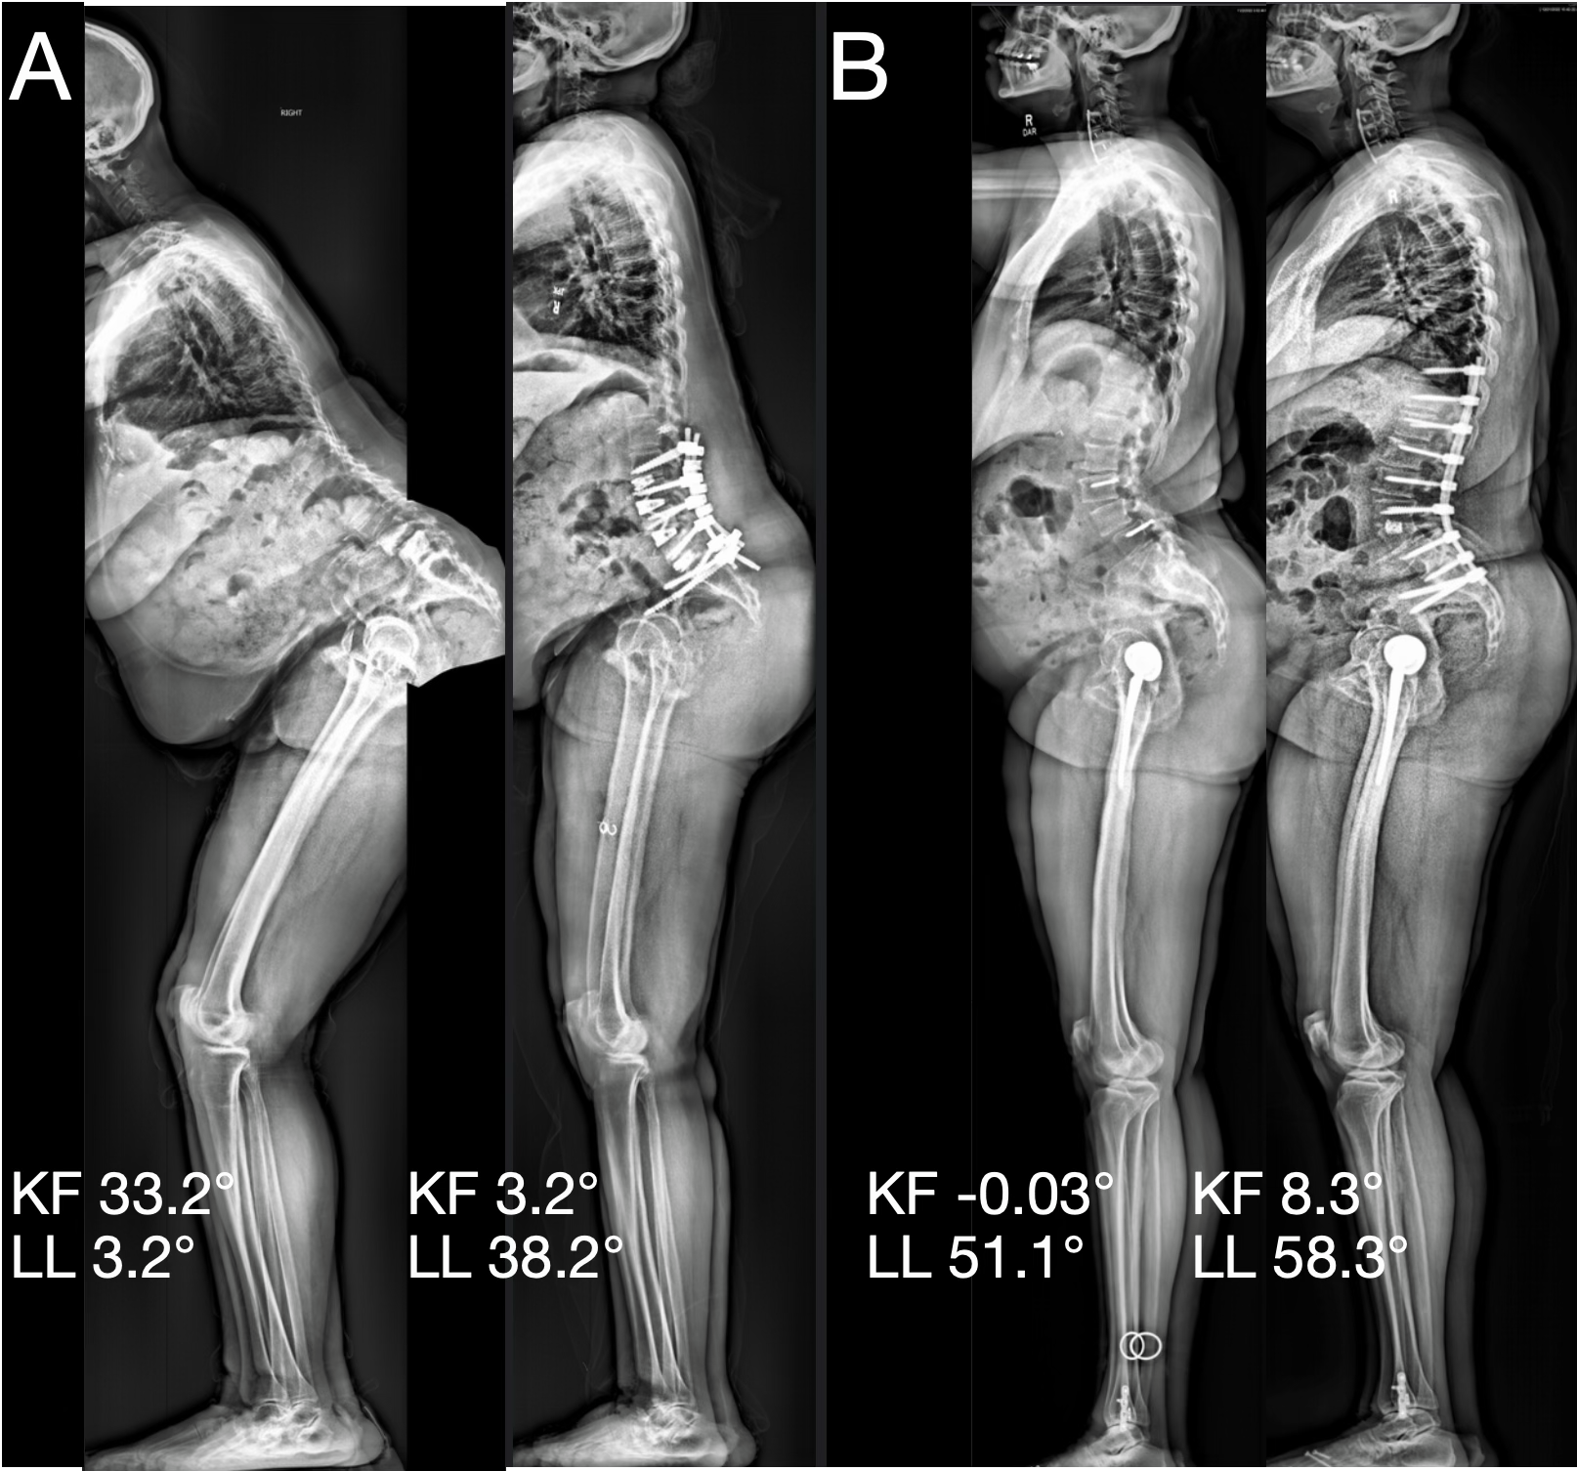
Figure 1. Examples of full-body films demonstrating differing degrees of knee flexion (KF) and lumbar lordosis (LL) preoperatively (left) and at 6 weeks (right). The patient in (A) has high knee flexion preoperatively which relaxes after correction of the deformity. The patient in (B) has an increase in knee flexion postoperatively, although the degree knee flexion remains low.
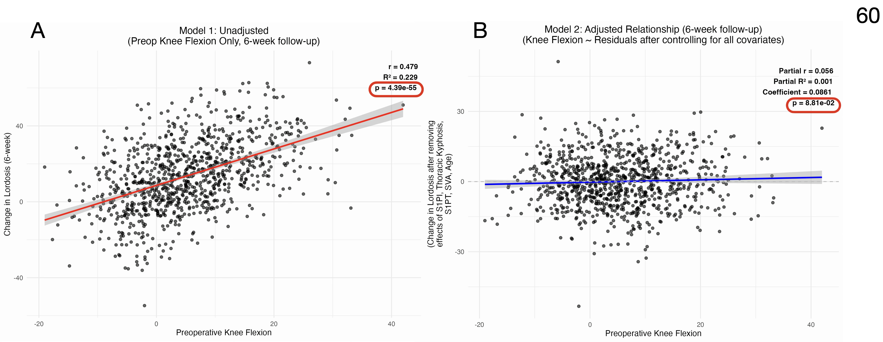
Figure 2. A. Univariate regression between preoperative knee flexion (KF) and change in lordosis (∆LL) between preoperative and 6 week timepoints. This demonstrates a strong association between KF and ∆LL. B. Univariate regression between KF and the residual variance in ∆LL after multivariate regression with several radiographic parameters. There is no independent association between KF and ∆LL.
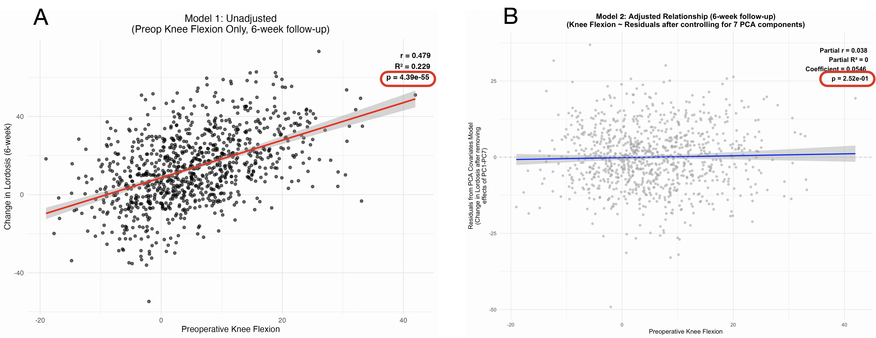
Figure 3. A. Univariate regression between preoperative knee flexion (KF) and change in lordosis (∆LL) between preoperative and 6 week timepoints. This demonstrates a strong association between KF and ∆LL. B. Univariate regression between KF and the residual variance in ∆LL after multivariate regression with seven PCA components. There is no independent association between KF and ∆LL.
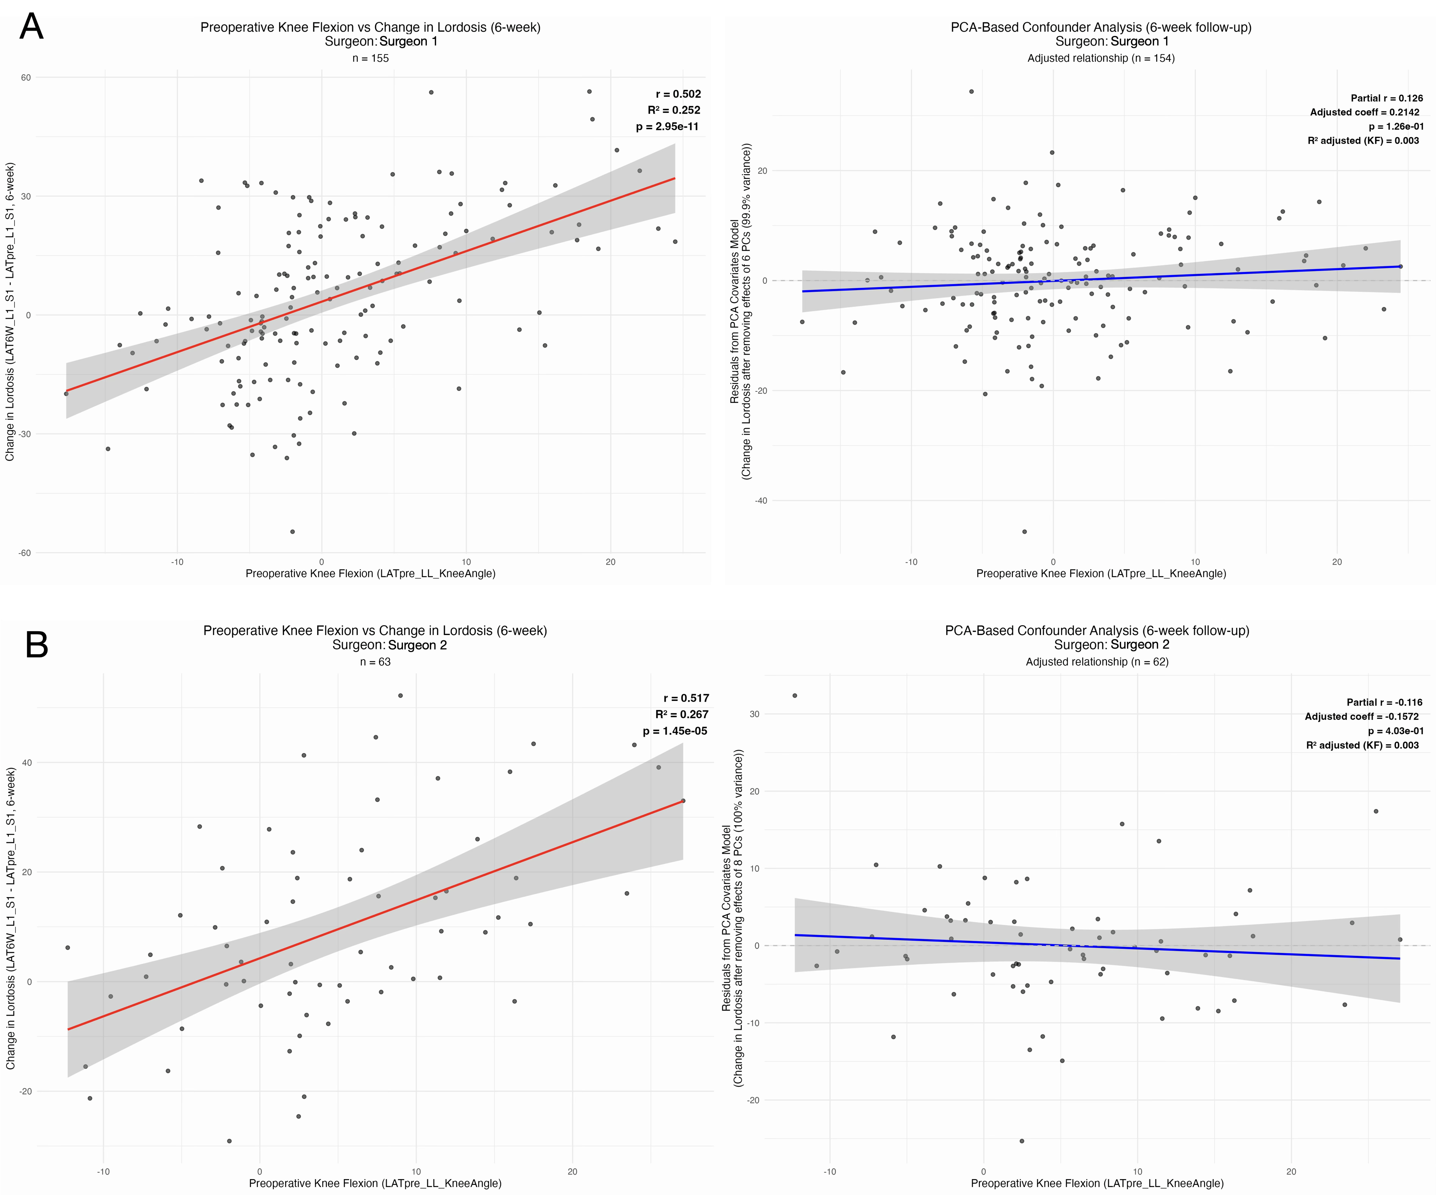
Figure 4. Examples of the same confounding subtraction analysis in Figure 3, but for two surgeons, denoted surgeon 1 (A) and surgeon 2 (B). The plots have the same distributions as the aggregate multicenter data in Figure 3, which demonstrates a consistent effect across surgeons.

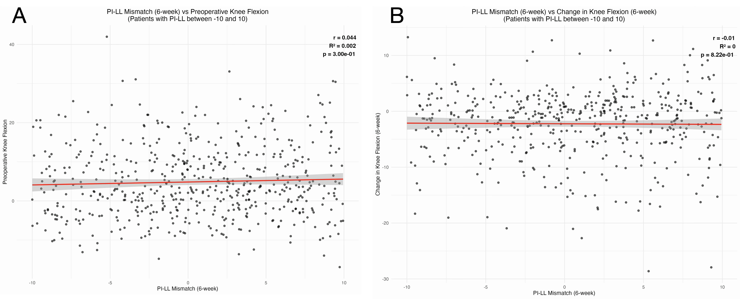
Figure 5. Among patients with satisfactory PI-LL mismatch (<10°), there was no association with knee flexion (A) or change in knee flexion (B).

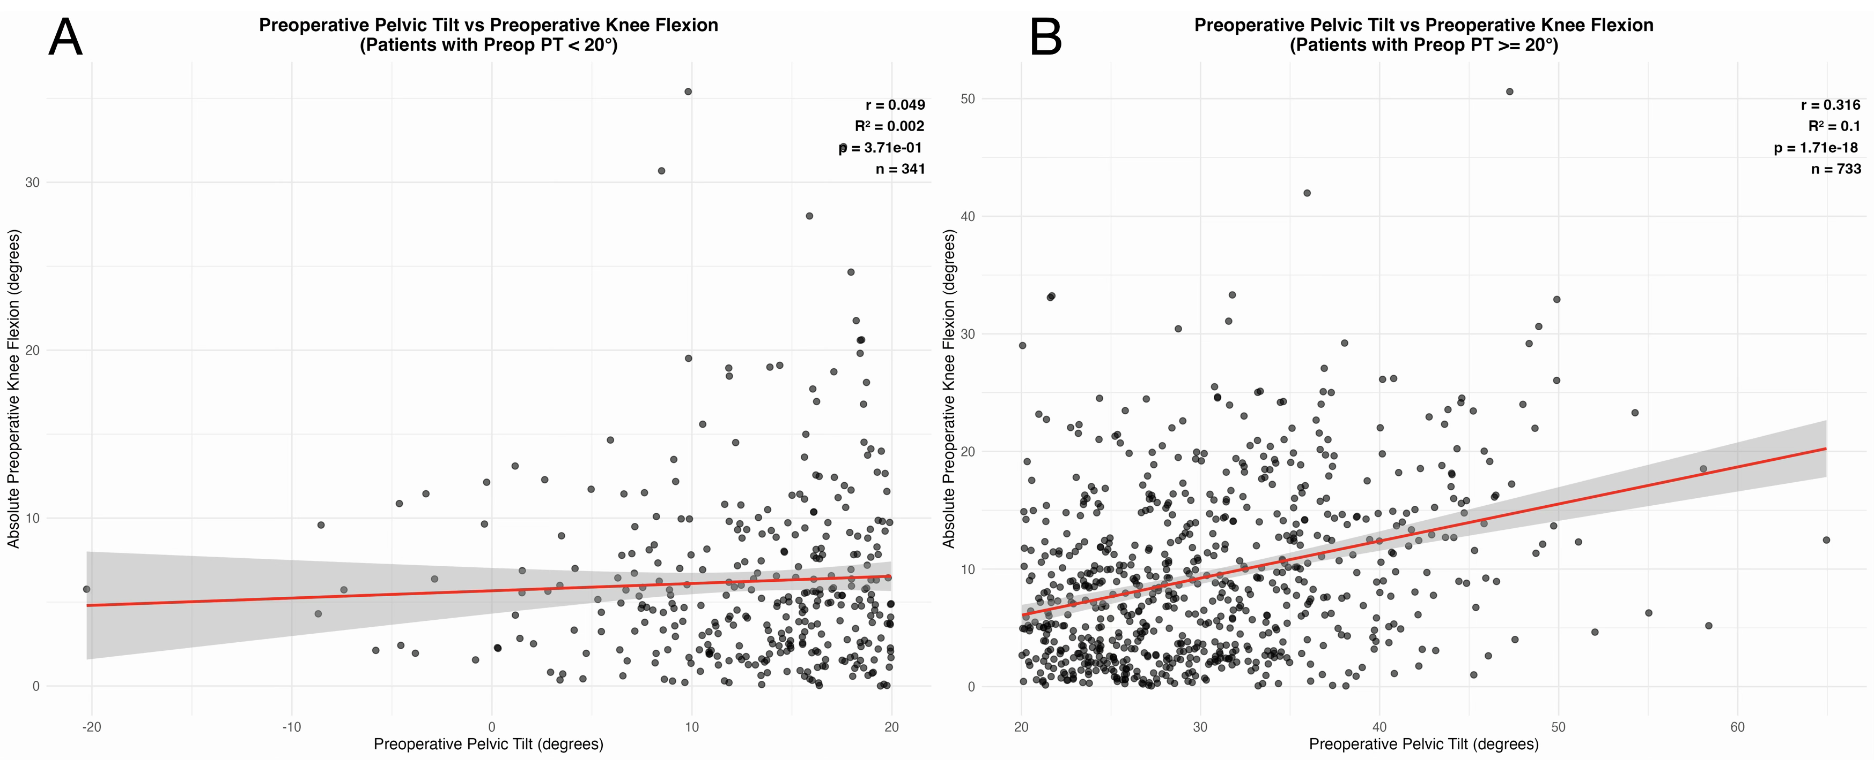
Figure 6. There was no association between preoperative pelvic tilt (PT) and knee flexion (KF) in patients with normal (<20°) PT (A), but there was a strong association between PT and KF among patients with pathologic (>= 20° PT).

Surgeon | Original p-value | Adjusted p-value (after regression with PCA) | R² adjusted
Surgeon 1 | < 0.001 | 0.422 | 0.004
Surgeon 2 | < 0.001 | 0.174 | 0.013
Surgeon 3 | < 0.001 | 0.801 | 0.001
Surgeon 4 | < 0.001 | 0.759 | 0.001
Surgeon 5 | < 0.001 | 0.626 | 0.003
Surgeon 6 | < 0.001 | 0.422 | 0.026
Surgeon 7 | 0.002 | 0.422 | 0.023
Surgeon 8 | 0.010 | 0.174 | 0.058
Surgeon 9 | 0.024 | 0.422 | 0.011
Surgeon 10 | 0.024 | 0.422 | 0.015
Surgeon 11 | 0.024 | 0.422 | 0.018
Surgeon 12 | 0.026 | 0.939 | 0.000
Surgeon 13 | 0.057 | 0.928 | 0.000
Surgeon 14 | 0.208 | 0.759 | 0.006

Table 1. p-values from the regression between knee flexion (KF) and change in lumbar lordosis (∆LL) after subtracting out the variance from principal components analysis (PCA) components. p-values are Benjamini-Hochberg corrected over the 14 surgeons.

Timepoint | Outcome | r | p-value
Preoperative | ODI | 0.144 | 0.000
 | SRS-22 total | -0.078 | 0.013
 | SRS-22 Activity | -0.121 | <0.001
 | SRS-22 Pain | -0.026 | 0.467
 | SRS-22 Appearance | -0.114 | 0.001
 | SRS-22 Mental health | -0.008 | 0.840
 | SRS-22 Satisfaction | 0.004 | 0.896
6 weeks | ODI | 0.113 | 0.001
 | SRS-22 total | -0.063 | 0.071
 | SRS-22 Activity | -0.071 | 0.062
 | SRS-22 Pain | -0.020 | 0.611
 | SRS-22 Appearance | -0.062 | 0.099
 | SRS-22 Mental health | -0.040 | 0.320
 | SRS-22 Satisfaction | -0.033 | 0.417
2 years | ODI | 0.277 | <0.001
 | SRS-22 total | -0.259 | <0.001
 | SRS-22 Activity | -0.262 | <0.001
 | SRS-22 Pain | -0.175 | 0.004
 | SRS-22 Appearance | -0.274 | <0.001
 | SRS-22 Mental health | -0.131 | 0.039
 | SRS-22 Satisfaction | -0.183 | 0.003

Table 2. Univariate linear regression of knee flexion with Oswestry Disability Index (ODI) and Scoliosis Research Society Questionnaire (SRS-22) and its subdomains; correlation coefficients (r) and p-values are presented. SRS-22 subdomain p-values are Benjamini-Hochberg corrected.

