$$h\left(∆\right):hypothenus of a triangle$$

$$i\left(∆\right):hauteur du triangle rectangle, correspondant à l^{'}axe vertical ou Y$$

$j:longueur du triangle rectangle, correspondant à l^{'}axe horizontal ou X$

$$AB:Plan AxB pour la fonction f\left(x\right)=\frac{C}{x}$$

$$XY:Plan XxY→rotation de-45° de AxB$$

$$∅:Origine des plans AB et XY simultanément, i.e. le point \left(0,0\right)$$

$$P:ensemble des points de la fonction f\left(x\right)$$

$$p:un point p tel que p∈P$$

$$C=x_{AB}\left(p\right)*y_{AB}\left(p\right)$$

$$x_{AB}\left(p\right)=\frac{C}{y_{AB}\left(p\right)}$$

$$y_{AB}\left(p\right)=\frac{C}{x_{AB}\left(p\right)}$$

$$∆_{p∅A}:Triangle rectangle formé par les points Pi,∅ et l^{'}axe A$$

$$∆_{pXA}:Triangle rectangle formé par les points Pi,X et l^{'}axe A$$

ΔpAØ

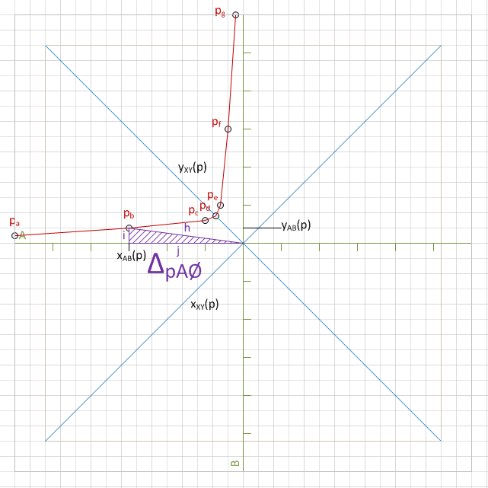 $$i\left(∆_{pA∅}\right)=y_{AB}(p)$$

$$j\left(∆_{pA∅}\right)=x_{AB}\left(p\right)$$

$$h\left(∆_{pA∅}\right)=\sqrt{{x_{AB}\left(p\right)}^{2}+{y_{AB}\left(p\right)}^{2}}$$

ΔpXX

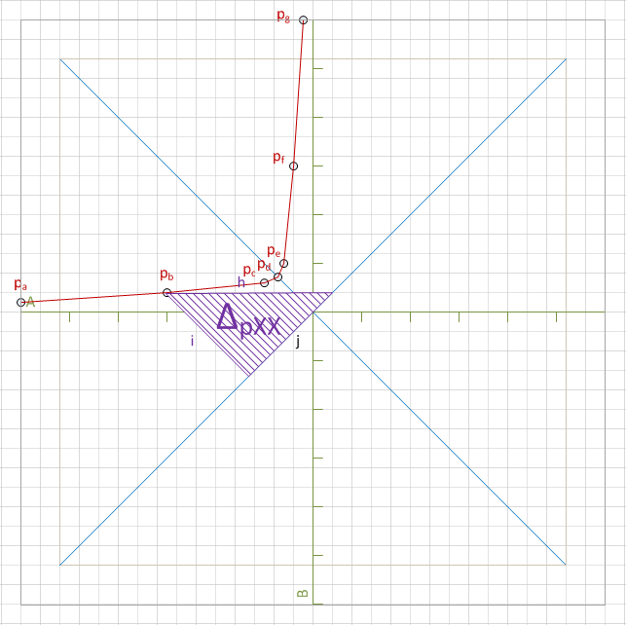

$h\left(∆_{pXX}\right)=x_{AB}\left(p\right)+y_{AB}\left(p\right)$ This is a remarkable property

$${h\left(∆_{pXX}\right)}^{2}={i\left(∆_{pXX}\right)}^{2}+{j\left(∆_{pXX}\right)}^{2}$$

$i\left(∆_{pXX}\right)= j\left(∆_{pXX}\right)$ This triangle is isosceles and rectangle, i.e. it is a semi-square

$${h\left(∆_{pXX}\right)}^{2}={2i\left(∆_{pXX}\right)}^{2}$$

$$h\left(∆_{pXX}\right)=\sqrt{{2i\left(∆_{pXX}\right)}^{2}}$$

$${i\left(∆_{pXX}\right)}^{2}=\frac{{h\left(∆_{pXX}\right)}^{2}}{2}$$

$${i\left(∆_{pXX}\right)}^{2}=\frac{{{(x}_{AB}\left(p\right)+y_{AB}\left(p\right))}^{2}}{2}$$

$$i\left(∆_{pXX}\right)=\sqrt{\frac{{{(x}_{AB}\left(p\right)+y_{AB}\left(p\right))}^{2}}{2}}$$

$i\left(∆_{pXX}\right)=y_{XY}(p)$ By definition, the height i of the triangle is the y coordinate of p in the XY plan

$y_{XY}(p)=\sqrt{\frac{{{(x}_{AB}\left(p\right)+y_{AB}\left(p\right))}^{2}}{2}}$

ΔpXØ

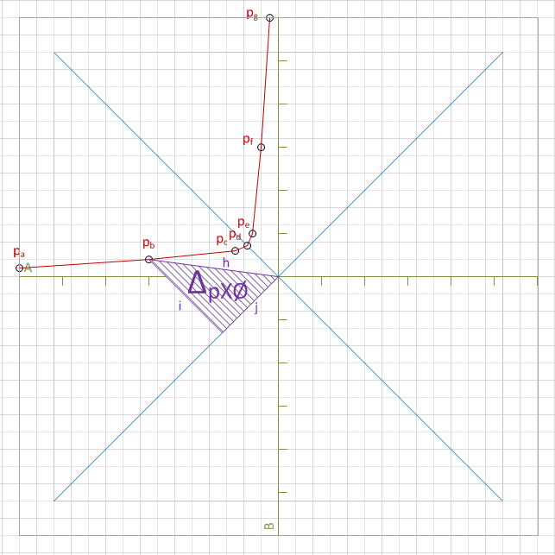

$$h\left(∆_{pX∅}\right)=h\left(∆_{pA∅}\right)$$

$$h\left(∆_{pX∅}\right)=\sqrt{{x_{AB}\left(p\right)}^{2}+{y_{AB}\left(p\right)}^{2}}$$

$$i\left(∆_{pX∅}\right)=i\left(∆_{pXX}\right)$$

$$i\left(∆_{pX∅}\right)=\sqrt{\frac{{{(x}_{AB}\left(p\right)+y_{AB}\left(p\right))}^{2}}{2}}$$

${h\left(∆_{pX∅}\right)}^{2}={i\left(∆_{pX∅}\right)}^{2}+{j\left(∆_{pX∅}\right)}^{2}$ Pythagoras

$${j\left(∆_{pX∅}\right)}^{2}={h\left(∆_{pX∅}\right)}^{2}-{i\left(∆_{pX∅}\right)}^{2}$$

$${j\left(∆_{pX∅}\right)}^{2}={\left(\sqrt{{x_{AB}\left(p\right)}^{2}+{y_{AB}\left(p\right)}^{2}}\right)}^{2}-{\left(\sqrt{\frac{{{(x}_{AB}\left(p\right)+y_{AB}\left(p\right))}^{2}}{2}}\right)}^{2}$$

$${j\left(∆_{pX∅}\right)}^{2}={x_{AB}\left(p\right)}^{2}+{y_{AB}\left(p\right)}^{2}-\frac{{{(x}_{AB}\left(p\right)+y_{AB}\left(p\right))}^{2}}{2}$$

$$j\left(∆_{pX∅}\right)=\sqrt{{x_{AB}\left(p\right)}^{2}+{y_{AB}\left(p\right)}^{2}-\frac{{{(x}_{AB}\left(p\right)+y_{AB}\left(p\right))}^{2}}{2}}$$

Now transform fAB(x) into fXY(x)