

Web Design Style Guide

AviaTalk.com

06/10/2023

David Rueda Madrid

Index

1. The brand, tone and logo 2

2. Typography 3

3. Colour palette 4

4. Icons 5

5. Image ratio 6

6. Form controls & interface elements 7

7. Bibliography 8

# The brand, tone and logo

This is the logo designed for the web, with a delta style triangle:



*Principal design of the AviaTalk.com blog*

An alternate version is also available:



*Secondary design of the AviaTalk.com blog*

And also will be a logo only version for mobile devices:



*Logo design for mobile devices*

# Typography

The principal typography for the page will be Ubuntu Light 300.

This will be mainly used in the home page, the header, footer and important buttons:

Everyone has the right to freedom of thought, conscience and religion; this right includes freedom to change his religion or belief, and freedom, either alone or in community with others and in public or private, to manifest his religion or belief in teaching, practice, worship and observance. Everyone has the right to freedom of opinion and expression; this right includes freedom to hold opinions without interference and to seek, receive and impart information and ideas through any media and regardless of frontiers. Everyone has the right to rest and leisure, including reasonable limitation of working hours and periodic holidays with pay.

The secondary typography for the page will be Open Sans Light 300.

This will be mainly used in the articles itself:

Everyone has the right to freedom of thought, conscience and religion; this right includes freedom to change his religion or belief, and freedom, either alone or in community with others and in public or private, to manifest his religion or belief in teaching, practice, worship and observance. Everyone has the right to freedom of opinion and expression; this right includes freedom to hold opinions without interference and to seek, receive and impart information and ideas through any media and regardless of frontiers. Everyone has the right to rest and leisure, including reasonable limitation of working hours and periodic holidays with pay.

# Colour palette

The colour palette will be based off the logo for the blog and here is a summary:

|  |  |  |  |
| --- | --- | --- | --- |
|  |  | **Hex code** |  |
| Primary colour |  | #B4001D | This will be used on the header & footer |
| Typography |  | #FFFFFF | The text will be in this colour to have good contrast |

|  |  |  |  |
| --- | --- | --- | --- |
| Secondary colour |  | #F7A500 | This will be used for the menu buttons and all the buttons of the webpage |
| Typography |  | #000000 | The text will be in this colour to have good contrast |

|  |  |  |  |
| --- | --- | --- | --- |
| Primary neutral colour |  | #EBEBEB | This will be used for the background colour for the webpage |
| Typography |  | #000000 | The text will be in this colour to have good contrast |

|  |  |  |  |
| --- | --- | --- | --- |
| Secondary neutral colour |  | #FFFFFF | This will be used for the background colour for inputs in forms |
| Typography |  | #000000 | The text will be in this colour to have good contrast |

This colour palette is based on the actual livery of [Asiana Airlines](https://flyasiana.com/) & was chosen by personal preference.

# Icons

The icons used will be Material Symbols by Google:

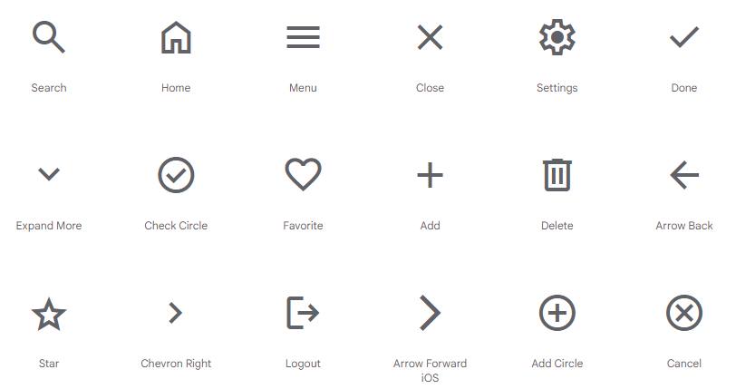

*The most used icons of Material Symbols*

# Image ratio

The image ratio that will be used will be Classic Film 3:2:

* For the desktop the size will be 600x400 like in this image:

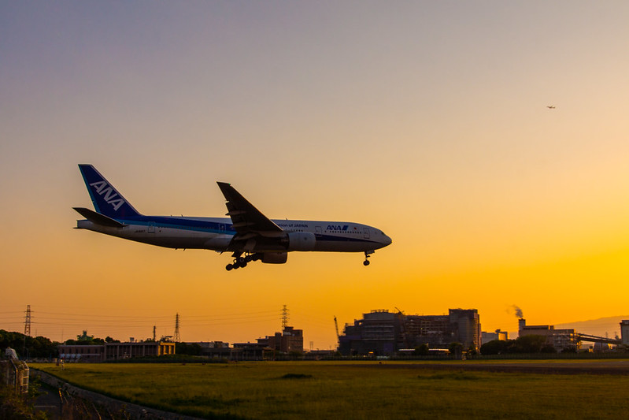

*This image of a Boeing 777-281 has the 3:2 ratio in 600x400 (actual size)*

And for mobile devices & areas with the need of smaller images, the size will be 400x267, using the same 3:2 ratio:

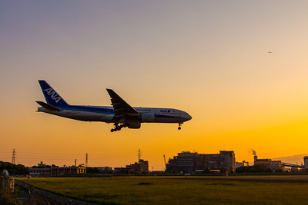

*This image of a Boeing 777-281 has the 3:2 ratio in 400x267 (actual size)*

# Form controls & interface elements

This is how the page will look like:

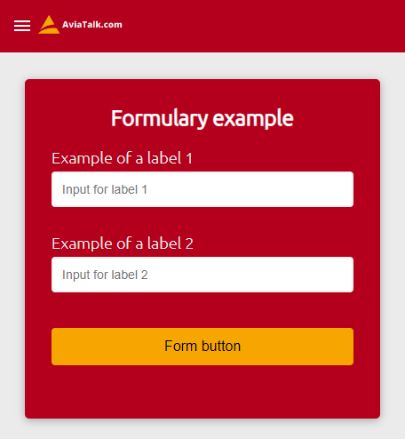

*Example of how a form looks with this web design*

# Bibliography

Logo created with logo AI:

<https://www.logoai.com/>

Ubuntu font from Google Fonts:

<https://fonts.google.com/specimen/Ubuntu?stroke=Sans+Serif>

Open Sans font from Google Fonts:

<https://fonts.google.com/specimen/Open+Sans?stroke=Sans+Serif>

Colours available with Coolors.co

<https://coolors.co/b4001d-f7a500-ebebeb-ffffff>

Material Symbols icons by Google:

<https://fonts.google.com/icons?icon.platform=web>

Image used for the image ratio (Boeing 777-281 of ANA landing at ITM – JA8197):

<https://flic.kr/p/AvxYHN>

Calculate Aspect Ratio:

<https://calculateaspectratio.com/>

Made by David Rueda Madrid