**Assignment #2: Fridge Poetry App**

**COMP 2406A**

This webpage simulates a fridge poetry app where users log in to be able to submit words they enter to a server and move the words around on a canvas. Visitors who are not logged in can see the words on the canvas being updated but cannot add new words or move existing words. Words moved around on the canvas by one user also move in real-time on all users logged on. Users can also log out when they are done with their session and their words will still appear on the screen.

**How to Use**

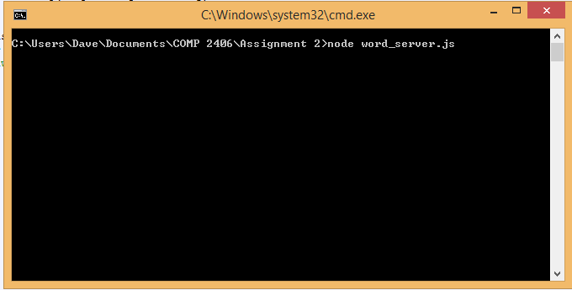

First, go to the Command Prompt, navigate to the directory containing the app’s files and type “node word_server.js” to start the server.



Enter “127.0.0.1:3000” into your browser (<http://localhost:3000/assignment2.html> can be used as an alternate URL).

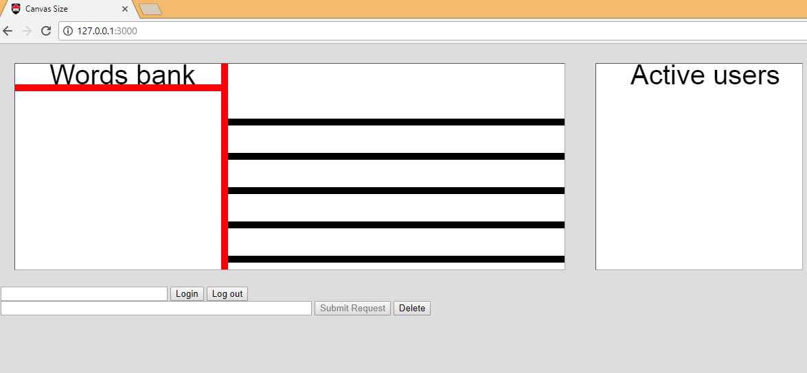

This is what the web page should look like after loading.

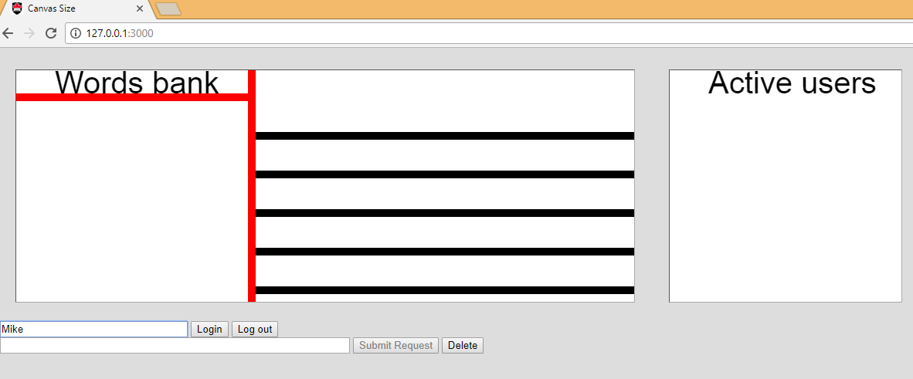

User #1 enters their name in the log in bar.

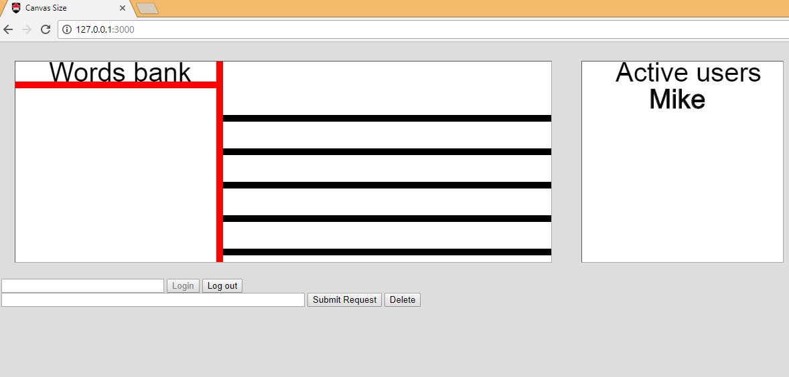

After the user has logged in, the “Submit Request” button is enabled and the “login” button is greyed out.

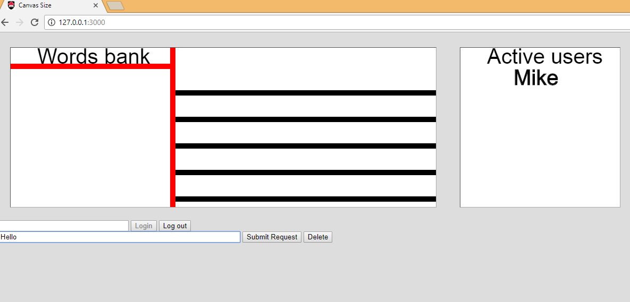

Once you have logged in, enter a word in the submission bar and press “Submit Request” to send the word to the server.

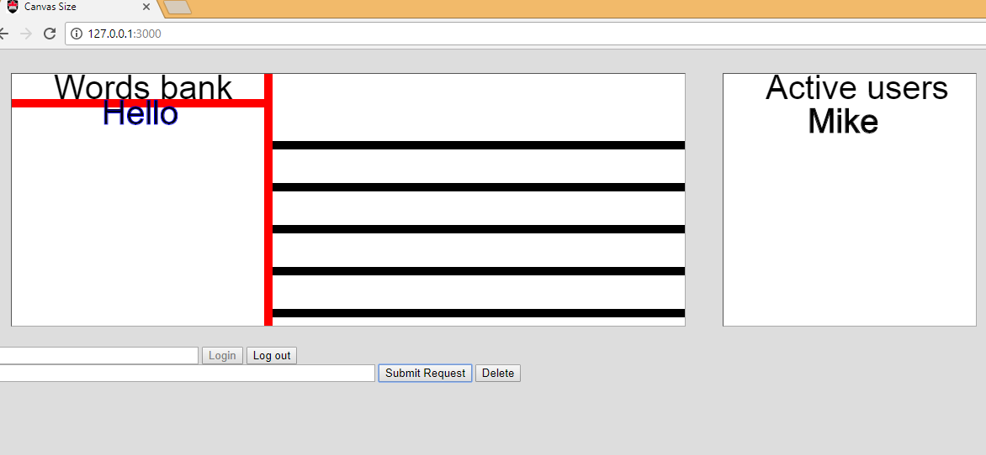

Once the word has been received by the server, it shows up on the left-hand side of the canvas known as the “Words bank”.

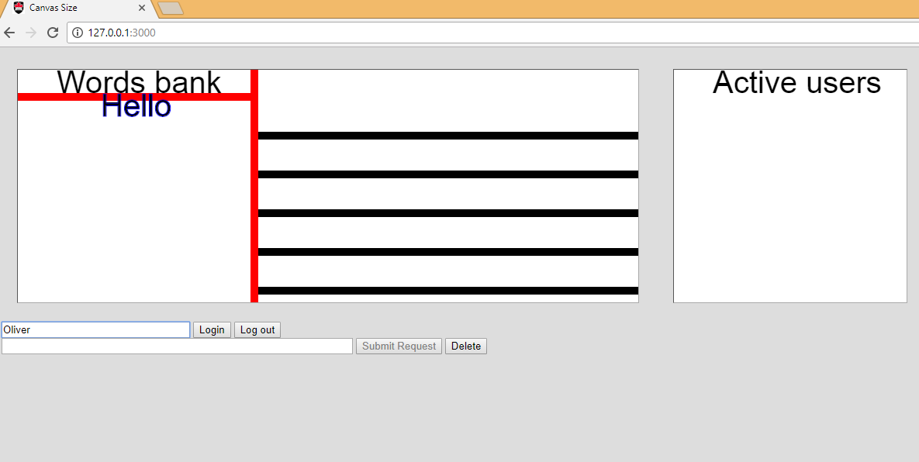

Another user can join in from their own browser window and log in to the fridge poetry server. You don’t have to log in to see the words on the “fridge” but logging in is required to move words around or add new words.

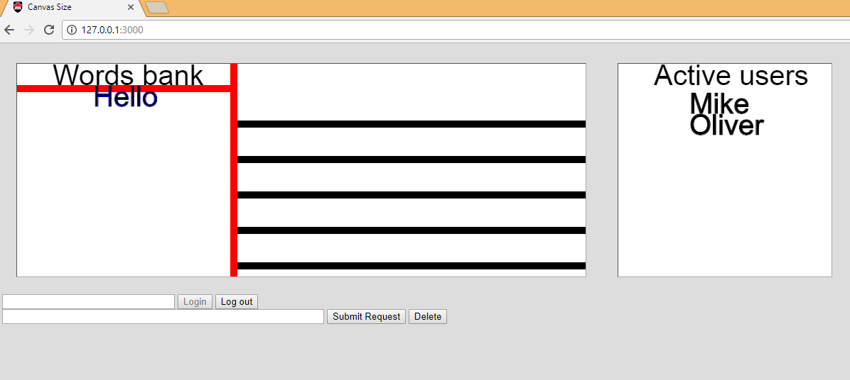

After user #2 has logged in, their screen now shows the list of users.

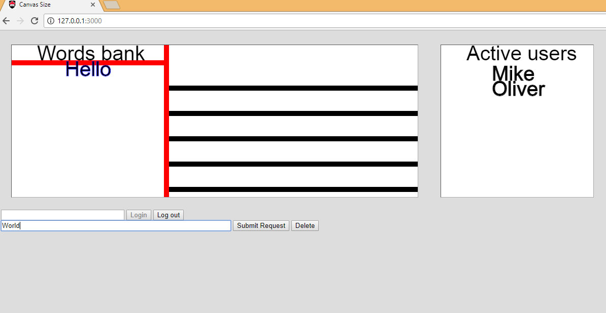

User #2 can add a word after logging in.

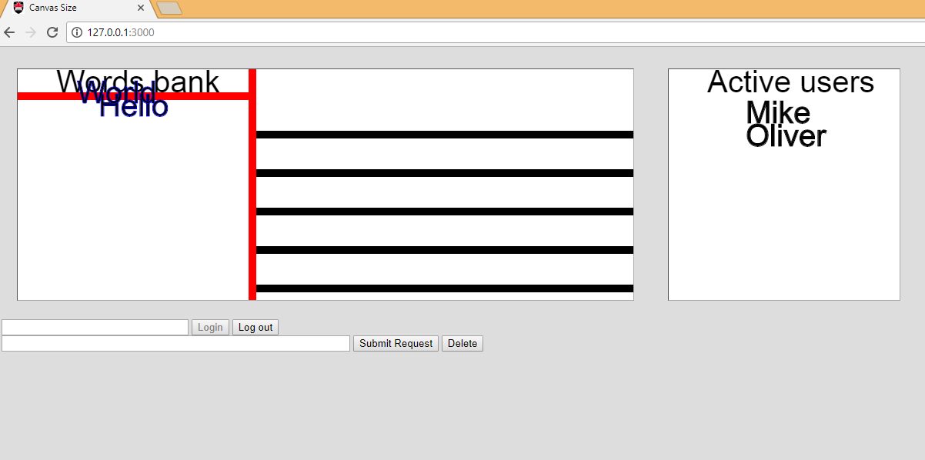

“World” now shows up in the “Words bank” of the canvas.

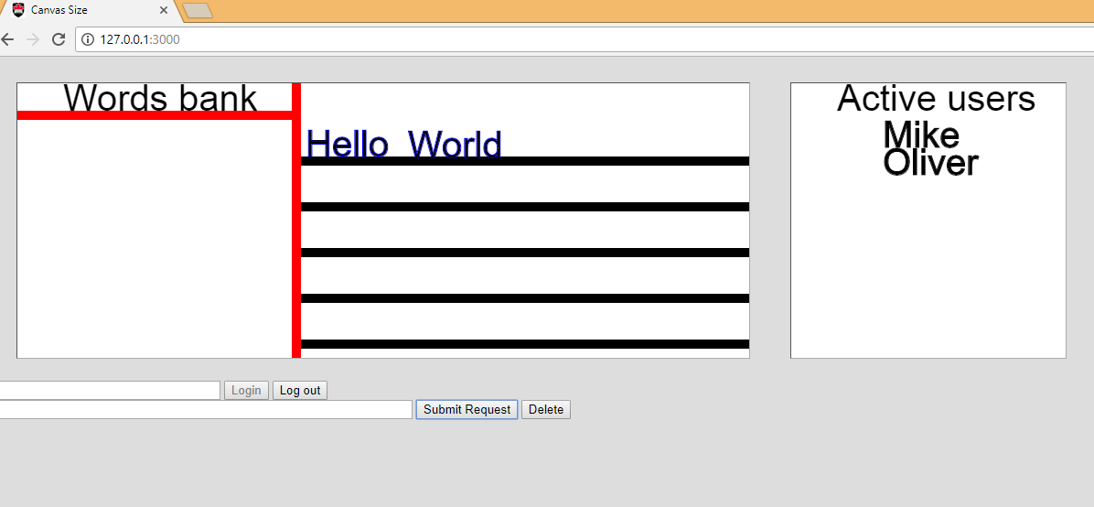

User #2 can move the words they added and also the words user #1 added.

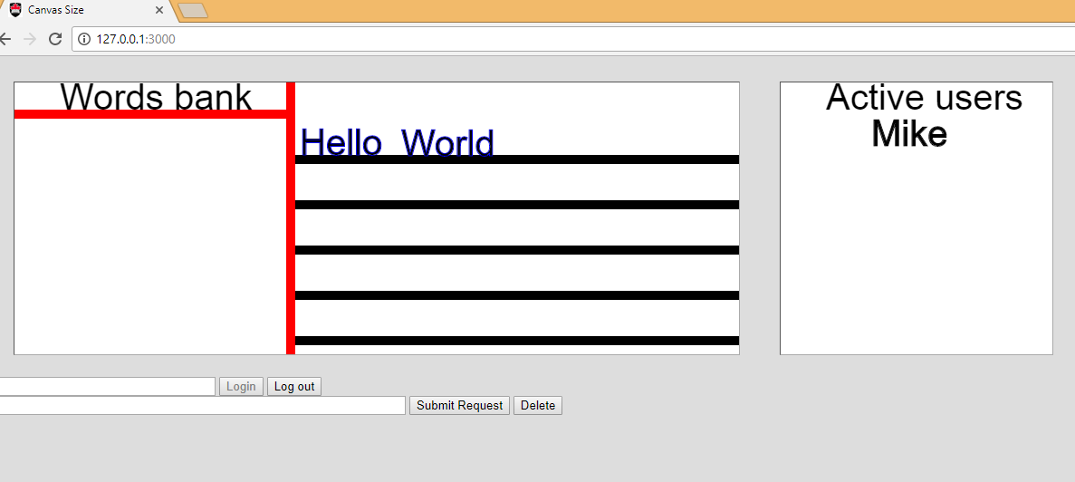

The changes to the canvas made by user #2 also show up on user #1’s canvas.

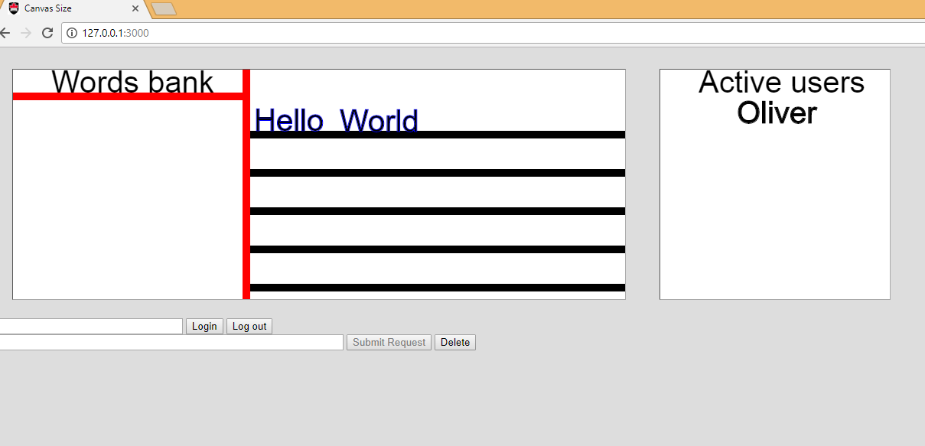

When user #1 logs out, the “Submit Request” button is greyed out and the user list is updated to only show user #2 logged in.