# Sona

Characteristic

* 3D game
* Close environment
* Third person camera
* Puzzle and Enemy
  + No fight mechanics only escape from enemies
* Platform PC
  + Multiplatform: xbox/playstation ?
* Mood
  + From dark to light, from the bottom to the top

Story

* Main story
  + Radioactive explosion 🡪 someone get super powers and a scientist want to study this incident to be able to reproduce it.
* Super powers
  1. Go through walls (Portal?)
  2. Invisibility
  3. Slow down and speed up time
* Characters
  + Young lady
    - P3
  + Boy
    - P1
    - P2
  + Player
    - P? (we have to decide which power player has)
* Environment
  + Lab on a ship
* Story
  + Player learns story reading spare documents around levels

Mechanics

* Managing characters
  + Move
  + Stop
  + Use power
* Items
  + Collect
  + Use
  + Manage Inventory
* Hide from enemies
  + E.g. AI for NPC

Random points to discuss/prove

* Cutscenes?
* Managing turn like Dragon Age so player can stop the time, give orders and then resume the time?
  + Actions at the same time

Levels

There are three different levels:

1. Tutorial
2. Bottom of the ship
3. Top of the ship

Tutorial structure:

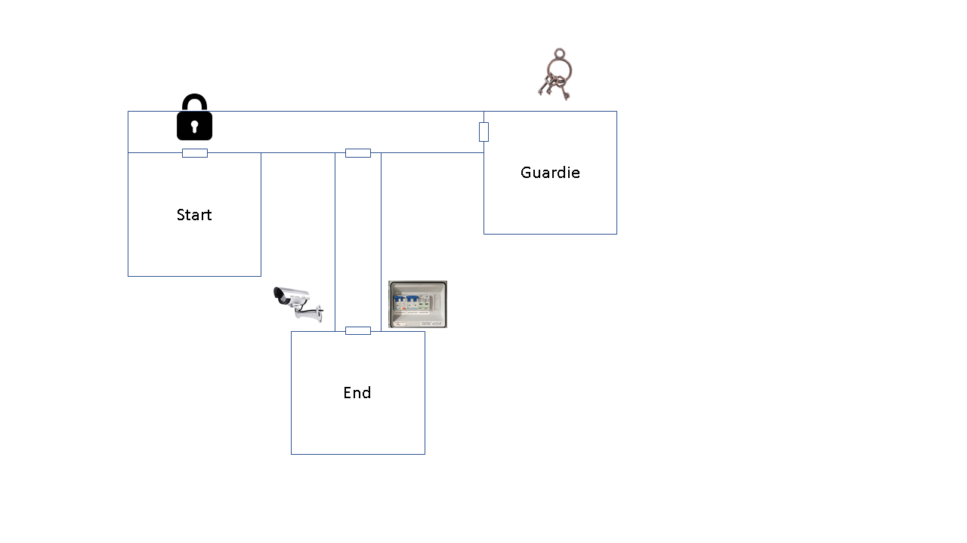

At the very beginning player, Jack, meets other characters Charlie and Hannah. They start to talk about why they are there. Charlie uses his super power, which make him go through wall, to unlock the door. To do that he has to use another super power, the invisibility, to steal keys from the guard room. Then Jack, the player, and the other two are free to go out. In the corridor before the ending room there are some video cameras, to avoid them Hannah uses her super power stopping the time and going to electrical cabinet to disable video cameras. The tutorial ends with the group, Jack, Charlie and Hannah, going upstairs.