Find the best place for a Restaurant in Pavia Province (IT)

Davide Tagliacarne

August 8th ,2021

1. Introduction

1.1 Background
The Pavia province is an area in the north of Italy that belong to Lombardia region. It is bounded to the north by the provinces of Milan and the Lodi, to the southeast by the Province of Piacenza (Emilia-Romagna), and to the southwest it is bounded by the Province of Alessandria (Piedmont).
The area is crossed by two rivers : Ticino & Po and it’s mostly flat, but passed Po going south we encounter a hill covered territory called OltrePo. So in this region we had different type of person , the ones going everday to Milan for his jobs and the farmers that cultivate rice in flat zones or grape on the hills. So this environment create different culinary request and needs. With this project I wanna try to provide insight and advise to everyone who wanna open a restaurant or food store.

1.2 Problem
Data that might contribute to determining where open a restaurant could be location, population and density in the area , but also the type of activities and cousine. Also the number of positive review for existing restaurant could influence our analysis and the proximity to a city center or to an interested area

2. Data acquisition & cleaning

2.1 Data Source
To do a segmentation in the area we need to get the principal cities of the province. To made this I scrapped the wikipedia page of the province and get data from municipalities table, I also added some other cities to made a best coverage of the area.

To get the restaurants that already exist i used an api call from Foursquare (https://api.foursquare.com/v2/venues/search) filter by location and categories. To get the categories i used another Foursquare module (https://api.foursquare.com/v2/venues/categories)

I also get data about the “Art & Enterteiment” place from Foursquare.

The review count for the restaurant is also provide from Foursquare with the api function : https://api.foursquare.com/v2/venues/{venue_id}/likes?

2.2 Data Cleaning
Once I got the data I needed to combine them in a unique dataframe for restaurants and a dataframe for the art and entertainment raw data.
The result of the cleaning and aggregation process is the following dataframe about restaurants:
- RefCity : The name of the nearest city
- RefCityLat : Latitude of the nearest city
- RefCityLon : Longitude of the nearest city
- RefCityPopulation : Population of the nearest city
- RefCityArea : Area of the nearest city (Km2)
- RefCityDensity : Population density of the nearest city (inhabit/Km2)
- RefCityAltitude : Altitude of the neares city (Km from level sea)
- Name : Name of the restaurant or food store
- Lat: Latitude of the restautant or food store
- Lon: Latitude of the restautrant of food store
- Category : Type of cuisine or service
- DistanceRefCityCenter : Distance from restaurant and the RefCity (Km)
- ArtNear : It is 1 if exist an art or enterteiment places in a 1 Km radius
- CityCenterNear : It is 1 if the venue is in a range of 1 Km radius from the principal cities (the ones I scrapped – didn’t consider the ones I manually added)
- NearCompetitor : Number of food places that are in a 200 meters radius from the venue and have the same category
- Likes : Number of people that review positively the venue.
To get this result I cleaned and aggregate data in different way.

For exemple getting data from Foursquare some places are duplicated because they are near to many cities. So I remove the duplicates and take the record with less distance.
Getting the data from Foursquare and plotting them I discovered that was restaurants that are “out” of the province area, but I see that Foursquare provide only city name and region, so i could exclude restaurant of Piemonte and Emilia Romagna but i couldn’t exclude the ones that are in the Milano or Lodi province so I choose a range a 10 km to do the request to get the major cover of internal area and less cover of external one.

Once I have the data of the cities , of the food places and the art places , I needed to get the distance between them , so I maded a function to calculate the distance between couple of coordinates and apply them to get ArtNear and CityCenterNear

Plotting the categories provides by Foursquare I seen that there was so many different categories that could aggrete in macro-categories to better rappresent data. So I created a function to map them with a new group of categories and use them to calculate NearCompetitor with the distance function

Once the data was cleaned I merged all information above in a unique dataset.

3. Methodology

3.1 EDA
Once we prepared data I started to look at them. Firts I search any relation between the numeric feature specially against the number of like. I don’t find nothing relevant doing this here the graphs.
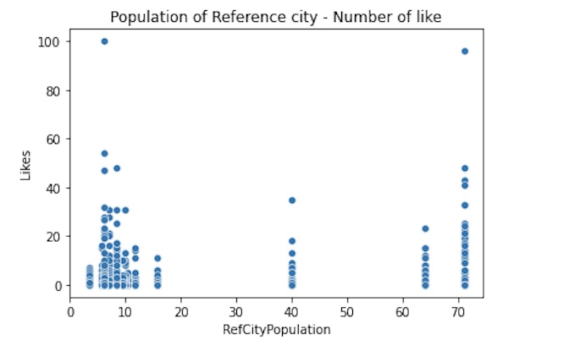
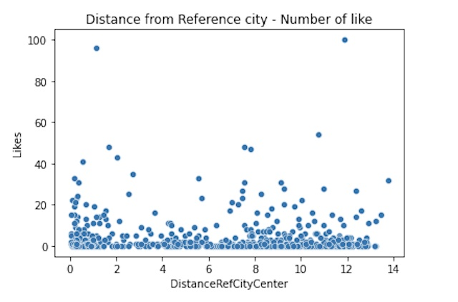
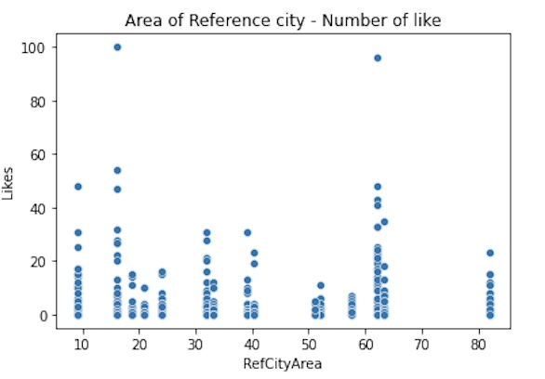

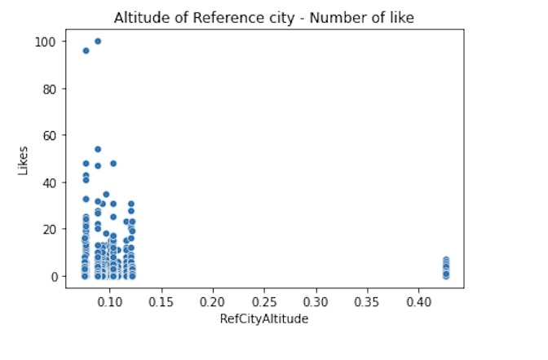
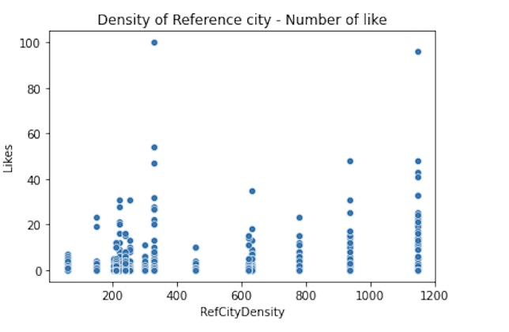

From these we get some informations:
- It doesn’t exists a direct relation between distance from the city center and number of likes
- It doesn’t exists a particolar correlation between Area/Density and number of likes
- Most of the samples are placed at low altitude

After looked at numeric feature I moved to the categorical ones. Here I explore the categories against the number of likes :
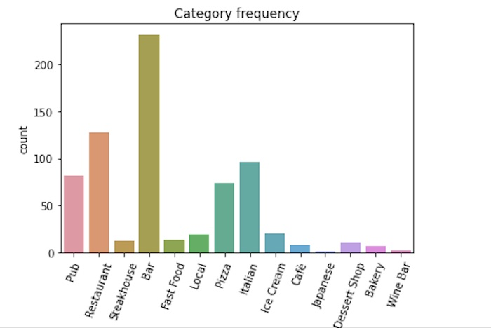
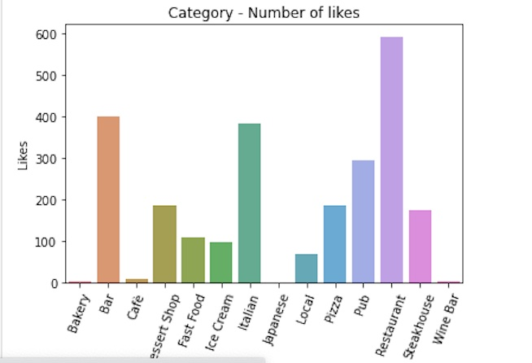

I discovered that:
- The most liked categories are : Restaurant , Italian and Bar
- The most frequency are : Bar, Restaurant and Italian
- A good to note is : Steakhouse, Dessert shop, Fast food have few restaurant but the number of likes is not so low

I made the same analysis for the cities
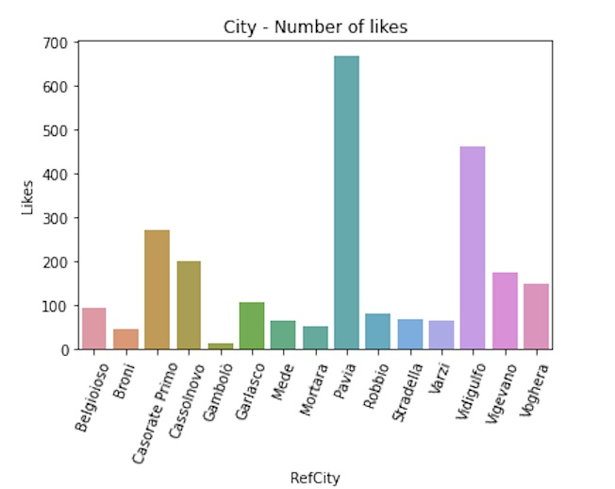
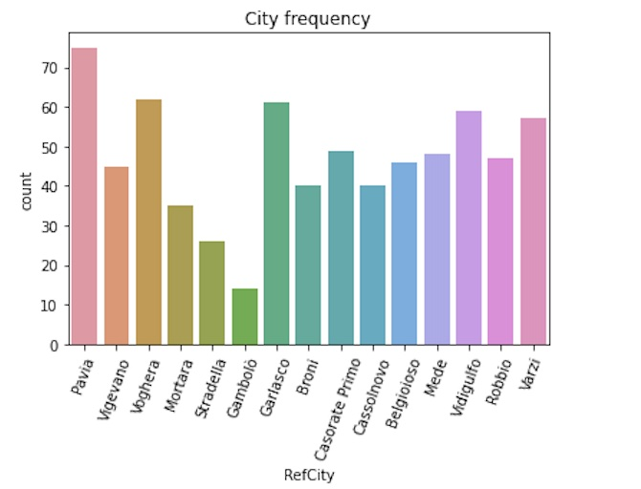

Note:
- Pavia and Vidigulfo are the Cities with more likes
- The frequency of the cities is homogeneous distributes
- These tell us that the zone south Milan is the one with more likes

Exploring the Proximity to the Art-Entertainment and to the City Center :
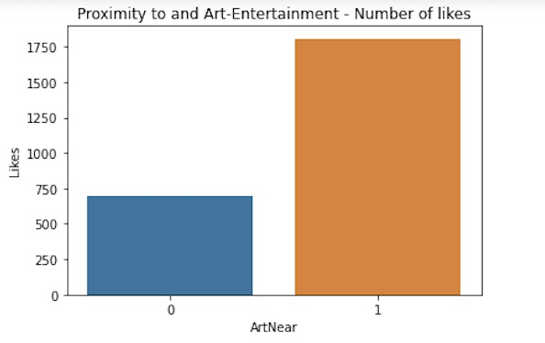
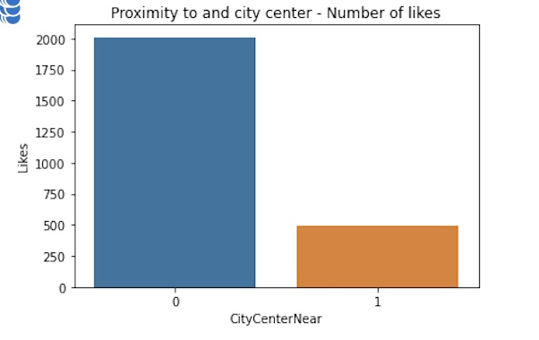

Note:
- Venue that are near to Art – Enterteinment receive more likes
- Venue that are far to the cities center receive more likes

So I used the Art -Enterteinment venues datasets to find the candidate places excluding the ones that are far from the cities center less of a Km

3.2 ALGORITHMS

Now to procede in analysis I supposed to be a restaurant that wanna open a Pizza Restaurant in the Voghera Zone. So I calculated for every candidate place the minor distance from the place and the restaurant with category “Pizza”.

After this I calculate the mean of this distance and discard every place that have a min distance under this value.

So to find the best 3 zones where to place a Pizza restaurant I used a K-means clustering algorithm and plot centers on the map. This is the result

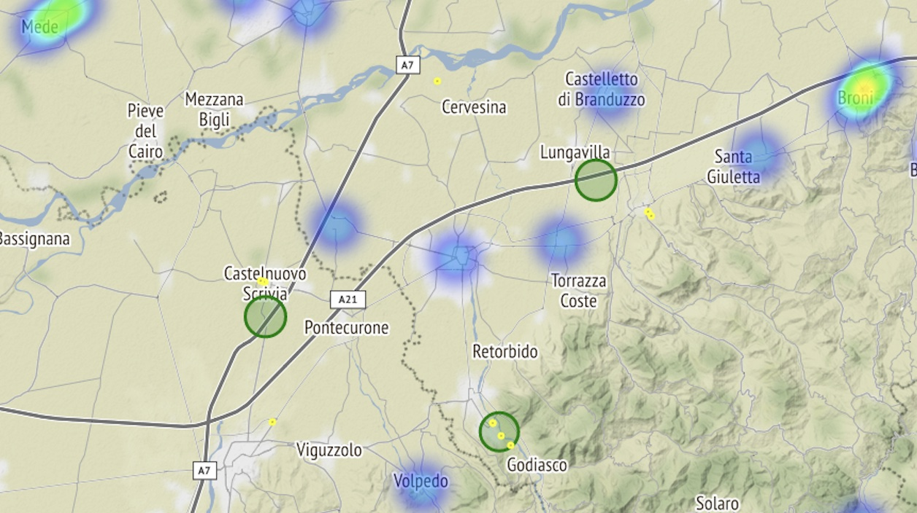

I add an Heatmap to our map to shows the major concentration of restaurant of the choosen type, The scale his from blue to red ( red high concentration )
The yellow dots identify the Art-Entertainment places that are possible candidate for our pupose.
The green zone are the cluster centers provide by the algorithm.

- The most appetitable zone is south of Voghera near Rivanazzano where we have 4 candidate places and no pizza near
- The second one is near Lungavilla because the proximity to the Casteggio candidate places
- And the third is south of Castelnuovo Scrivia

After made this real problem I prepare 3 function to apply the same logic to other interesting cases:
- Prepare the art-venue candidate places
- Applying the algorithm
- Plotting the results

The 3 cases zone that I choose to do some more analysis was :
Local : typical cuisine of the zone
Fast food: the food of the frenetic cities
Italian restaurant : mediterranean cuisine that are present across all the country

To get more informations from the data I also prepare 3 similar functions but applying a DBSCAN algorithm
with 0.1 eps and a min_samples = 3.
With this algorithm we wanna cluster the candidate places to see the macro-zones where place different type of restaurant
I ran the algortihm to the same 3 cases.
Let’s compare and see the results

4. Results

4.1 – Local Restaurants
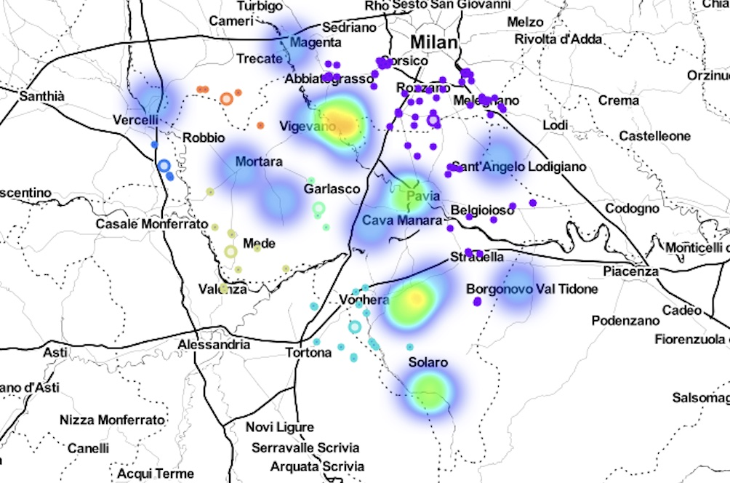
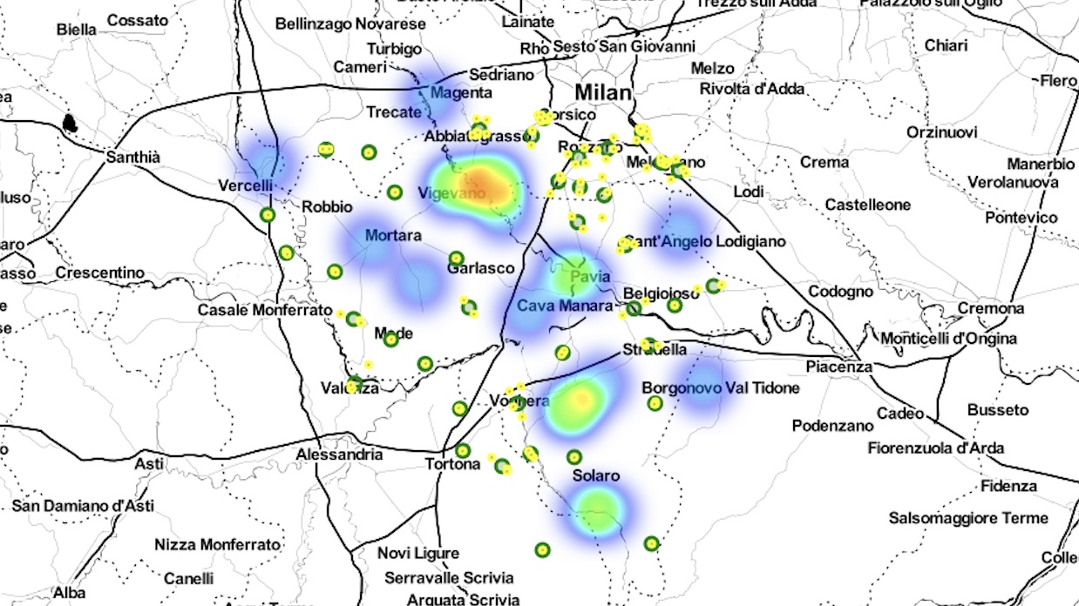

We have on the left the map generate with K-means algorithm and on the right the one generate with DBSCAN

From this plotting we realize:
- The K-means algorithm suggest us to open a local (restaurant that produce tipical food of the area) restaurant in the zone of North Pavia or near Milan
-This because major of tipical product are produce in Oltrepo', Varzi zone and Lomellina (Mortara, Vigevano) --> this coincedes with the reality and with a personal opinion : there are few place where we can eat tipical food in the cities area
- The DBSCAN divide our candidate 6 macro-zone : South-Milan, Voghera, Mede,Garlasco and two Zone out of the region near Vercelli
-It also discard some point identify them as outlier : for exemples the ones south Solaro

4.2 – Fast Food
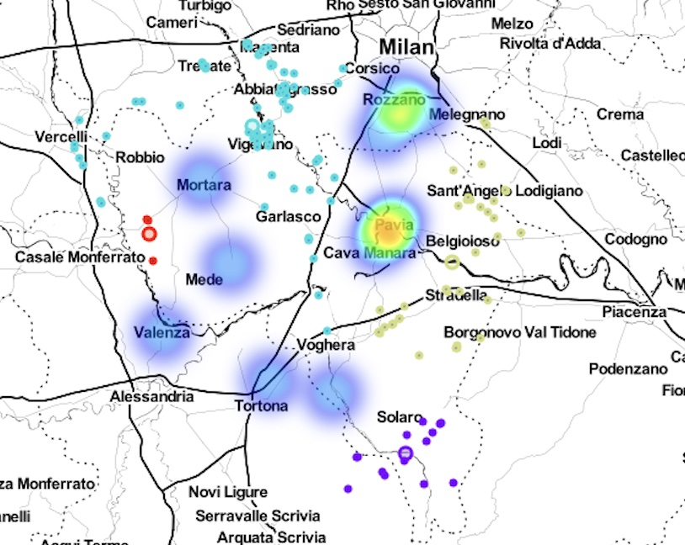
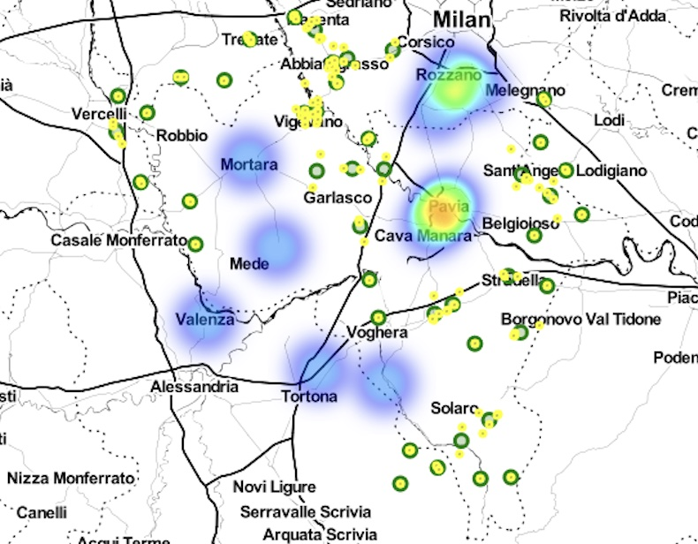

- For Fast Food category k-means suggest us to open in the area far from the big cities , maybe because these are already “taken”

- The DBSCAN divide our candidates in 4 region : Vigevano & Southwest Milan ; East Pavia, Varzi (Solaro) and a little one near Casele Monferrato

- Maybe the Vigevano & Southwest Milan is a little bit area that give not us a gain of information

4.3 – Italian Restaurants
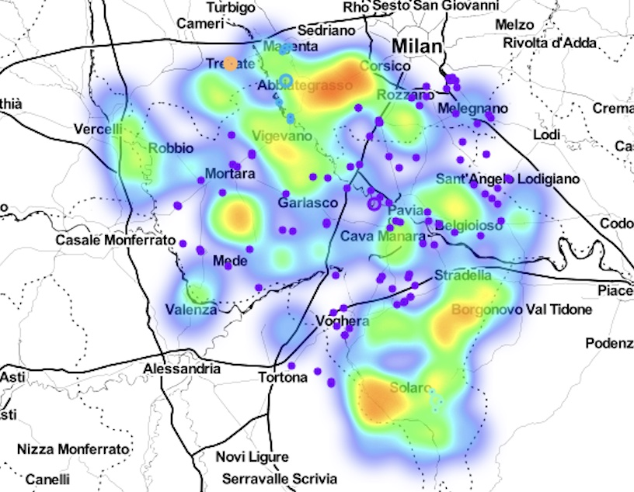
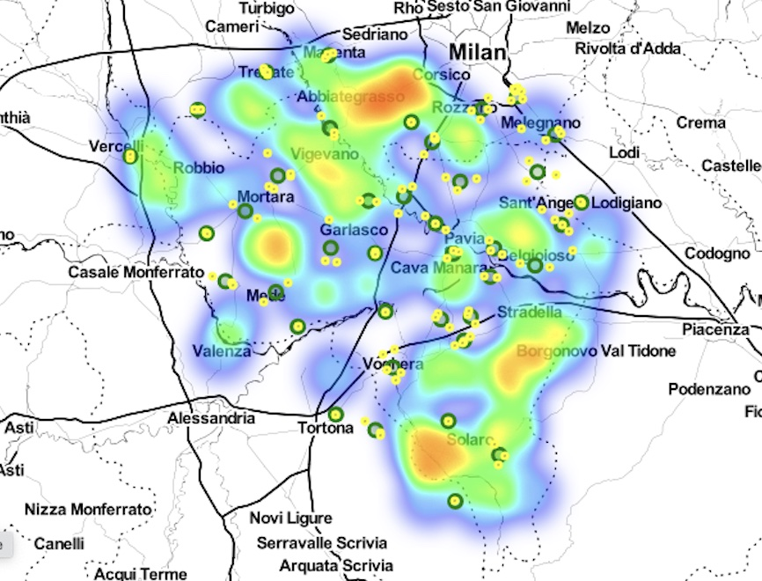

For Italian restaurants we can see they covered al the region :
- The K-means algorithm suggest us many different place across the region but nicely exclude the are with high contenctration of italian restaurant : for exemples we can see a nice zone from Mede following the Po flow and a zone between Pavia and South Milan.

- The DBSCAN divide our points in 4 groups : Trescate, Abbiategrasso, The Big, Solaro

- Here DBSCAN doesn’t work very well because create very small zone (Trescate,Solaro in the south green zone) and a big one that cover all the area. This because the candidate point for this category cover all the region with not so much distance between them

5. Discussion
To summarize to find the bast place for open a restaurant in Pavia province, we need to identify the type of restaurant we wanna take. One it is taken we need to use the results of a K-means and DBSCAN algoritms that work on the proximity to Art-Entertainment point and Cities Center.
The first one help us to find some specific point near the principal activities, the second help us to identify the macro-zone where (for exemple) we can launch a restaurant chain or a advertising campaign. The last one seems to doesn’t work very well if the region is full of restaurant of the specific type.

6. Conclusion
At the end I wanna put some advises to myself that could help to improve the results.
To improve the results we can better divide the category of Art-Entertainment to retrive information like:
- If a particular type of entertainment influence the number of like of a specific type of cuisine
- Or if the number of likes of an entertainment category influence the number of like of specific type of cuisine

