**Section 1**

**Introduction**

* **1.1 Purpose**
* The structure of the following document is divided into two sections:

1. Design Document (main section)

2. Integration Test Plan Document (secondary section)

* The Design Document (DD) is intended to provide a more detailed functional description of the *Travlendar +* system – to - be by providing technical details and describing the main architectural components, their interfaces, and their interactions.
* The relationships among the different modules are highlighted using UML standards and other useful diagrams that show the structure of the system.
* The document has to guide the software development team to implement the project architecture, providing a stable reference and a unique view of all parts of the software, defining their operation.
* The second part of the document is intended to provide guidelines to adequately carry out the planning of the integration test phase.
* The document includes determining which necessary tools, drivers and data structures that will be useful during the test process.

* **1.2 Scope**
* The system aims to support a personal event management service, providing features for choosing the best path, means of transport, and insertion of the break. The system must also make sure there are no overlap among events and among events and pauses.
* The system is structured with a four-layer architecture. The purpose of the document is to describe this architecture in detail.
* The system described is suitable for different types of customers: different actors that interact with the system - to – be by generating a client-server dualism, so the flow of requests and responses.
* The architecture must be designed with the intention of being maintainable and extensible, to make future possible changes.
* This document aims to guide the implementation phase so that cohesion and decoupling are increased as much as possible. In order to do this, individual components must not include too many independent functions and reduce interdependence.
* This document will follow specific architectural styles and design templates used for future implementation, as well as common design paradigms that combine useful features of this concepts.
* **1.3 Definitions, Acronyms, Abbreviations**
* **ACID:** Atomicity, Consistency, Isolation and Durability. This is the set of properties of database transactions.
* **DD:** Design Document.
* **DBMS:** DataBase Management System.
* **E-R diagram:** entity – relationship diagram
* **ITPD:** Integration Test Plan Document.
* **JAX - RS**: Java API that provides support in creating web services according to the REST pattern.
* **JPA:** Java Persistence API.
* **MVC:** Model-View-Controller.
* **RASD:** Requirements Analysis and Specification Document.
* **REST**: REpresentational State Transfer. It is a way of providing interoperability between computer systems on the Internet.
* **RESTful**: a REST compliant system
* **UML:** Unified Modeling Language
* **UX:** User Experience.
* **1.4 Revision history**
* **v0.1** Construct basic document’s structure, add Overview.
* **v0.2** Add the purpose and scope of Design Document, definitions, acronyms, abbreviations, reference documents and document structure.
* **v0.3** Add bibliography part and appendix
* **v0.4** Add high - level components and component view parts.
* **v0.5** Add new definitions, Runtime View, Architectural styles and patterns and component interfaces parts.
* **1.5 Reference documents**
* This document follows the guidelines provided by ISO/IEC/IEEE 1016:2009 [3] related to system design and software design descriptions for complex software systems.
* The indications given in this document are based on those given in the previous delivery for the project, the RASD document [1].
* This document is strictly based on the RASD assignment [2] and the test plan example [4] presented during the lessons for the project of Software Engineering II, course held by Elisabetta Di Nitto and Matteo Giovanni Rossi at the Politecnico di Milano, A.Y. 2017/2018.
* **1.6 Document structure**
* This document consists of six sections:
* **Section 1: Introduction.** This section provides a general introduction and overview of the Design Document and the covered topics that were not previously taken into account by the RASD.
* **Section 2: Architectural Design.** This section shows the main system components together with sub-components and their relationship. This section is divided into different parts whose focus is mainly on design choices, interactions, architectural styles and patterns.
* **Section 3: Algorithm Design.** This section focuses on the definition of the most relevant algorithms to be implemented by the system – to – be.
* **Section 4: User Interface Design.** It provides an overview on how the user interface will look like.
* **Section 5: Requirements Traceability.** This section explains how the requirements you have defined in the RASD map to the design elements that you have defined in this document.
* **Section 6: Implementation, Integration and test plan**. This section identifies the order in which the developer plan to implement the subcomponents of the system and the order in which he plans to integrate such subcomponents and test the integration.
* At the end of the document are an **Appendix** and a **Bibliography**, providing additional information about the sections listed above.

**Section 2**

**Architectural Design**

**2.1 Overview**

This section gives a detailed overview of physical and logical infrastructures of the system-to-be and describes the main components and their interactions.

A top-down approach is adopted for the description of the architectural design of the system:

**High level components**: A description of the high-level components and their interactions.

**Component view**: A detailed vision of the components described in the previous section.

**Deployment view**: A set of indications on how to deploy the components on physical tiers.

**Runtime view**: A detailed vision of the dynamic behavior of the software.

**Component interfaces**: A description of the different interfaces.

**Architectural styles and patterns**: A set of Architectural styles, design patterns and paradigms used in the design phase.

**Other design decisions**: A list of all relevant decisions taken during the design process and not mentioned before.

**2.2 High level components**

The high-level components of the system are the following:

**Database**: The Data Layer of the system; All the data structures and entities concerning data storage. This level does not contain any application logic.

**Application Server**: The layer that contains all the application logic and key algorithms of the system.

**Web Server**: The Layer that provides all the web pages to the web-based application. This level does not contain any application logic.

**Mobile Application**: The Presentation Layer of the mobile application; This level does not contain any application logic.

**Web Browser**: The Presentation Layer of the web-based application; It just renders the pages obtained from the Web server and executes its scripts.

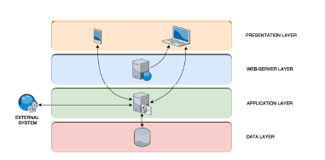

**Figure 1**: Layer structure of the system.



**2.3 Component view**

**2.3.1 Database**

The database layer must include a DBMS component in order to manage the insertion, modification, deletion, and registration of data transactions within the storage memory.

The DBMS must guarantee the correct functioning of simultaneous transactions and ACID properties; the DBMS must be relational because the requirements of the application in terms of data storage do not require a more complex structure than the one provided by the relational data structure.

The data layer must be accessible only through Application Server via a dedicated interface. The Application Server must provide a persistence unit to handle the dynamic behavior of all persistent application data.

The database must be optimized during the implementation phase to ensure security by granting access to data according to the applicant's privilege level. Sensible data, for example passwords and personal information, must be encrypted correctly before being stored. Users must be granted access only on the provision of correct and valid credentials.

**Figure 2**: The E-R diagram of database schema.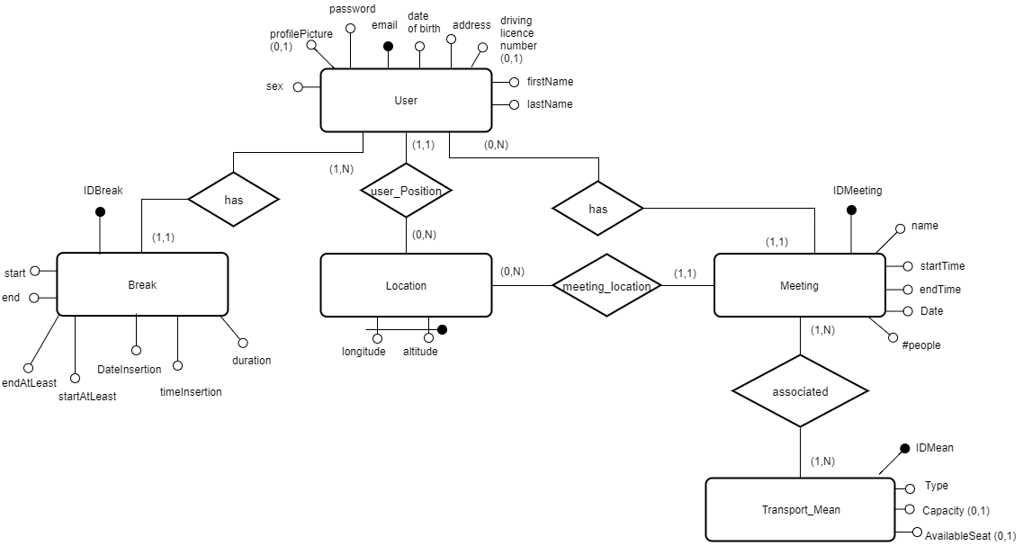

**2.3.2 Application Server**

This layer must handle business logic, data layer connections, and application access modes from different clients and external systems.

The main feature of Application Server is the specific business logic modules that describe business rules and workflows for each feature provided by the application itself.

The interface with the data layer must be managed by a dedicated persistence unit to ensure that only the Application Server can access the database.

Application Server must provide a means of interfacing with the Web server and mobile clients through specific APIs in order to separate the different levels from their individual implementation. It must provide a way to communicate with external systems by adapting the application to existing external infrastructures.

The main business logic modules must include:

**UserManager**: This module must manage all the logics concerning to user account creation, login and management.

**EventManager**: This module must contain all the logic needed to create and modify meetings and breaks. It must guarantee the consistency of the model preventing from overlapping among events.

**MapManager**: This module must contain all the logic used to locate users and meetings.

**TravelInformationProvider**: This module must be able to interface with external agents such as Travel information providers (i.e., ATM, Trenord, Alitalia, etc.).

**NotificationManager**: This module must be able to notify the user when it is necessary to do so (e.g., an user tries to insert a meeting that overlaps with a previous one).

**2.3.3 Web Server**

The Web Server Layer is responsible to provide the web pages to the users that intends to access the application’s services via web.

This layer does not contain any application logic; it only provides static web pages that, through propers Javascript scripts, are able to access the REST APIs of the Application Server and make it accessible to end users.

The scripts must be able to consume all the API’s endpoints for the functionalities intended to be accessible via web. The communication with the APIs must be through textual data files over HTTPS (e.g. XML or JSON), as previously specified in Application Server section**.**

**2.3.4 Mobile Application Client**

The Mobile Application Client must be designed to allow easy communication and implementation independent with the Application Server.

The mobile application user interface should be designed following the guidelines provided by Android and iOS producers.

The application must provide a software module that manages the GPS connection so that it can track location data by providing it to application servers.

**2.3.5 Web Client**

A Web Application Client is any modern browser (eg. IE, Firefox, Chrome, Safari) able to run Javascript to allow the pages to consume the REST APIs of the Application Server.

**2.3.6 Implementation Choices**

**Database Implementation**

The Data Layer must respect the following constraints:

• Relational DBMS;

• MySQL 5.7 as DBMS implementation;

• JPA (Java Persistence API) as database interface in the Application Server.

**Application Server Implementation**

**Web Server Implementation**

The main choice for this layer is to use NGINX 1.12 as web server.

NGINX is the most widely used web server implementations, is event-driven and will grant us relia-

bility and efficiency handling HTTP(S) requests.

The web server will serve static files i.e. html, css, javascript files, that will be interpreted client-side.

Web pages must be able to connect to the application server’s REST APIs and allow the user to access all the functionalities of the system through a web interface.

**Mobile Application Implementation**

There must be two mobile application client implementations to support both iOS and Android OSs: iOS: This implementation must be written in Swift using UIKit.

Android: This implementation must be written in Java.

Both of them must:

• Communicate with the application server through the REST APIs over HTTPS.

• Follow the design guidelines provided by the devices’ vendors.

**2.4 Deployment view(Davide)**



**2.5 Runtime view (Alessandro)**

This section describes the dynamic behavior of the system in the most relevant cases.

The sequence diagrams, shown below, highlight the runtime interactions between client, server, and database.

Interactions are expanded and analyzed in detail when there are internal interactions between subcomponents of the Application Server.

Direct interactions between Application Server and Database are not explicitly represented because they are abstract by the persistence unit of the Application Server.

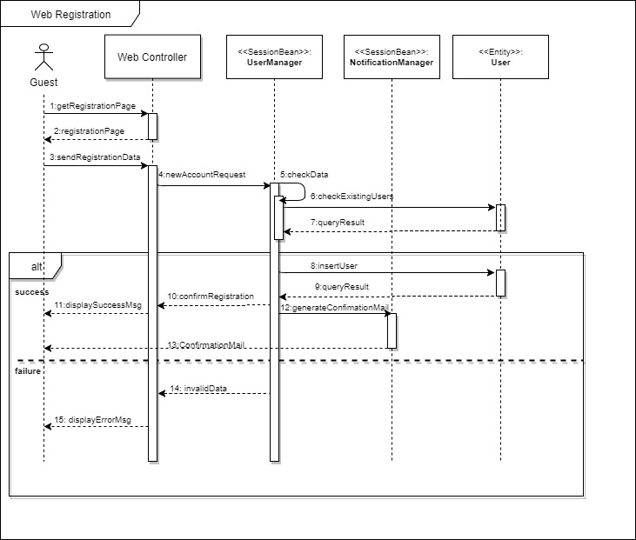

**Figure 2.1:** Sequence diagram of the registration process



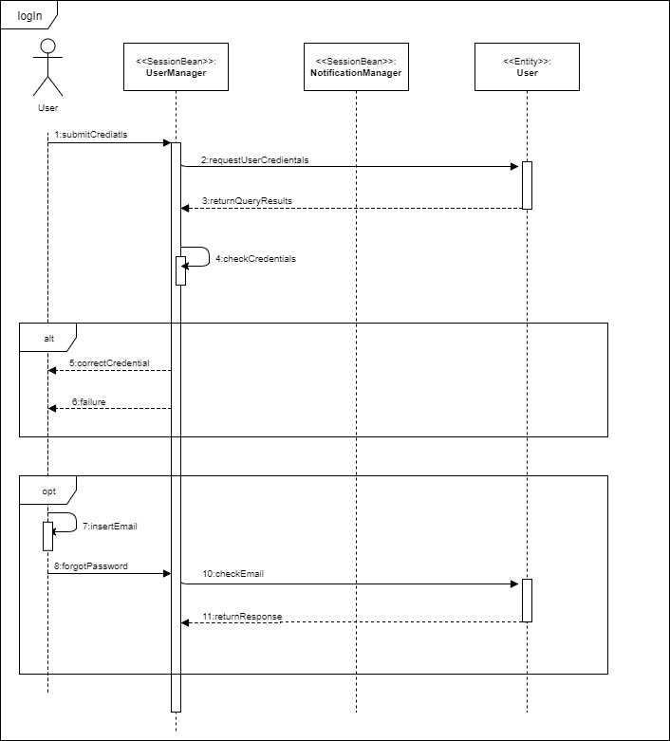

**Figure 2.2**: Sequence Diagram of the login process and recovery credentials

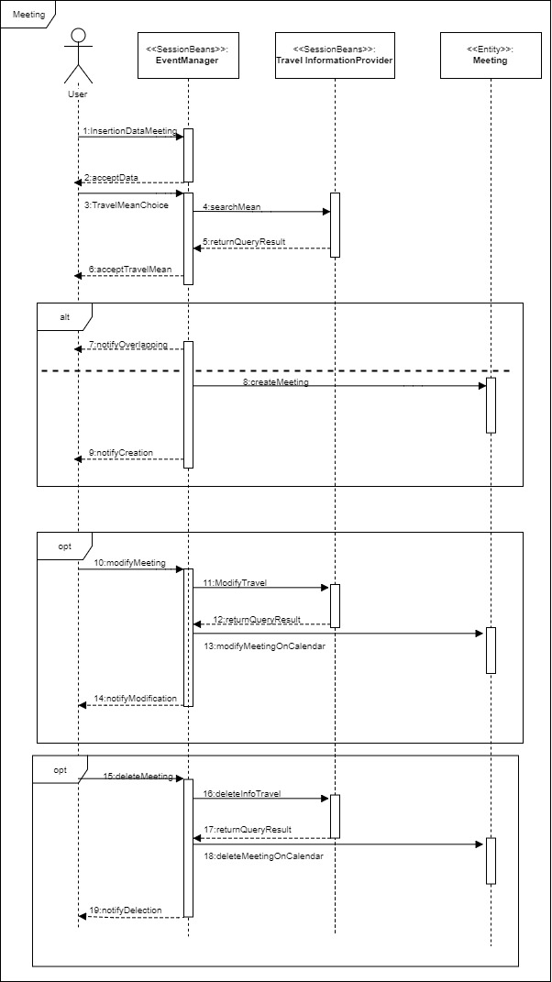

**Figure 2.3**: Sequence Diagram of Creation, Modification and Removal of Meeting

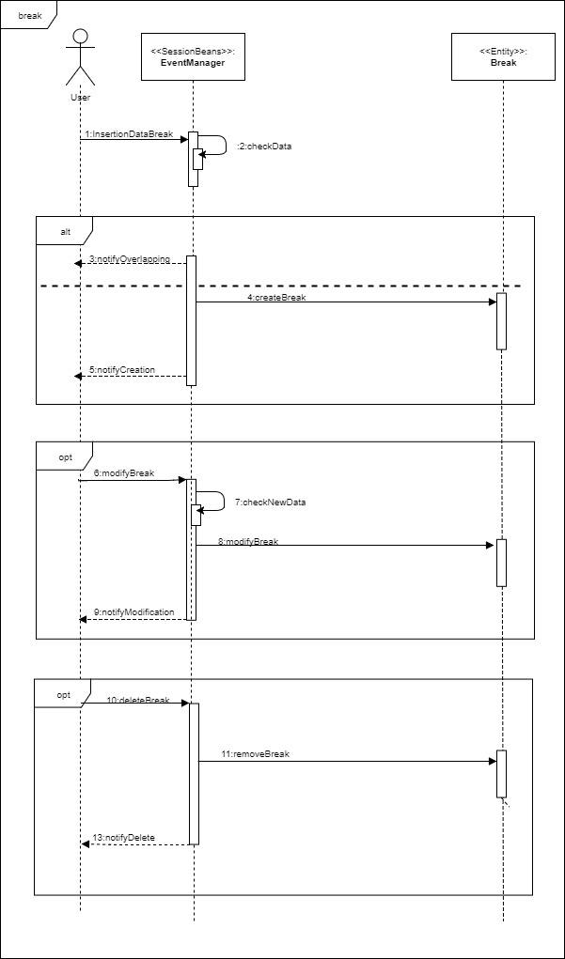

**Figure 2.4**: Sequence Diagram of Creation, Modification and Removal of Break

**2.6 Component interfaces (prima parte Ale)**

This section of the Design Document describes in detail the interfaces of the various components of the system. The various sections underline the relevant details about the interfaces required to use and interact with each component of the Application Server.

**2.6.1 Database - Application Server**

The Application Server is the only one that can access the Database directly through the Java Persistence API mapping between objects and actual relations.

**2.6.2 Web Server - Web Browser**

As described in the RASD document, interactions between client’s browsers and Web Servers are based on the HTTPS protocol.

**2.6.3 Application Server - Web Server and Clients**

The communication between the Application Server and the clients (both via Web Server) must take place via the RESTful APIs provided by the Application Server and implemented using JAX-RS.

**2.6.4 Application Server - External Systems**

Application Server must connect with the following external system:

* One or more travel and transport operators that use the interface APIs to which the Application Server must adapt in order to deal with or search for travel solutions.

**2.6.5 Internal interfaces for Application Server Components**



**2.7 Architectural styles and patterns (Alessandro)**

The following architectural styles and patterns have been used:

**Client and server**

The client-server architecture is used at different levels in the *Travlendar +* system design.

* The mobile application is client with respect to the Application Server that receives and processes requests.
* The user’s browser, which is a system client, communicates with the Web Server, which has the task of providing the requested web page. Additionally, the Web Server communicates with the Application Server to create user requests.
* The Application Server assumes client role when querying the database.

**Multi - tiered architecture**

The multi - tiered client - server architecture allows to physically separate presentation, application processing, and data management operations.

Moreover, in case of a Web Server failure, the system is accessible from the mobile application, so the number of system levels will increase in the availability of the service.

**Thin client**

The thin client approach has been following during the design phase for the interaction among the users machines and the system itself.

System logic is implemented by Application Server, which has sufficient computing power and can manage concurrency issues in an efficient way.

Mobile application and user browser does not contain a decision logic, but only the presentation function is performed.

This architectural choice allows users to enjoy the service through devices with limited computing power and easy updating software.

**Thick client??**

**Model View Controller**

The web and mobile applications follow the Model - View - Controller software design pattern.

It divides the application into three interconnected parts. This is done to separate internal representations of information from the ways information is presented to, and accepted from, the user.

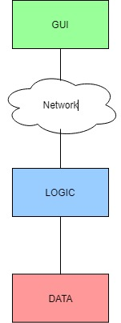

**Figure 2.7.1**: The remote presentation architectural style that inspired the design of web/mobile application.



**2.8 Other design decisions (Davide)**



**Section 3**

**Algorithm Design**

**Section 4**

**User Interface Design**

**4.1 UX diagrams**

**4.2 User interface**

**4.2.1 Web interface**

**4.2.2 Mobile interface**

**Section 5**

**Requirements Traceability**



**5.1 Functional requirements**



**5.2 Non-functional requirements**



**Section 6**

**Implementation, Integration and test plan**

**Section A**

**Appendix**

**A.1 Software and tools used**

The software and tools used during the drawing of this document are:

**LaTex**: used to build this document.

**Google Drive / Google Documents**: used to always update and share the documents.

**draw.io**: used to draw diagrams (https://www.draw.io).

**Marvel**: used to build the mockups (https://marvelapp.com).

**GitHub**: used as version control and to keep it shared between group members and teachers (<https://www.github.com>).

**A.2 Hours of work**

Most of the work on this document was made in the presence of both members of the group. The approximate number of hours worked by each member of the group is as follow (including hours spent in group work):

Davide Rossetto: about hours

Alessandro Tatti: about hours

**Section B**

**Bibliography**

[1] AA 2017/2018 Software Engineering 2 - *Requirements Analysis and Specification Document* - Davide Rossetto, Alessandro Tatti

[2] AA 2017/2018 Software Engineering 2 - *Project goal, schedule and rules*

[3] IEEE Standard 1016:2009 *System design - Software design descriptions*

[4]