|  |  |
| --- | --- |
| **Architetture dei Sistemi**  **di Elaborazione** | Delivery date:  Friday 10/12 |
| **Laboratory**  **8** | Expected delivery of lab_08.zip must include:   * zipped project folder of exercise 1 * this lab track completed and converted to pdf format. |

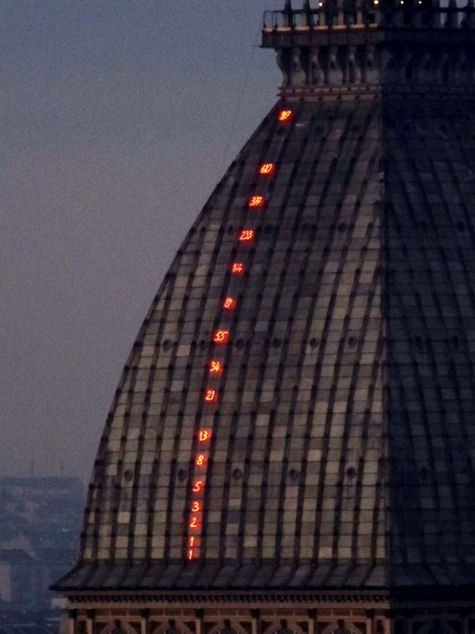Solve the following problems by starting from the *sample_BUTTON_LED* project (open the file project from the uVision menu)

**Exercise 1)** Implement a system on the LANDTIGER board that displays the Fibonacci series on 8 LEDs. The software uses buttons to update the displayed value (either moving forward or backward) and LEDs to show the current value. Start by using emulation capabilities (later, flash your firmware on the board) to implement the following functionalities:

* at every KEY1 button pressure, move to the next value of the series. If the maximum value, i.e., 233, is already displayed, do nothing,
* at every KEY2 button pressure, move to the previous value of the series. If the minimum value, i.e., 1, is already displayed, do nothing,
* at INT0 pressure, reset the value to the initial 1 in the Fibonacci series.

LEDs show the current count in a binary representation.

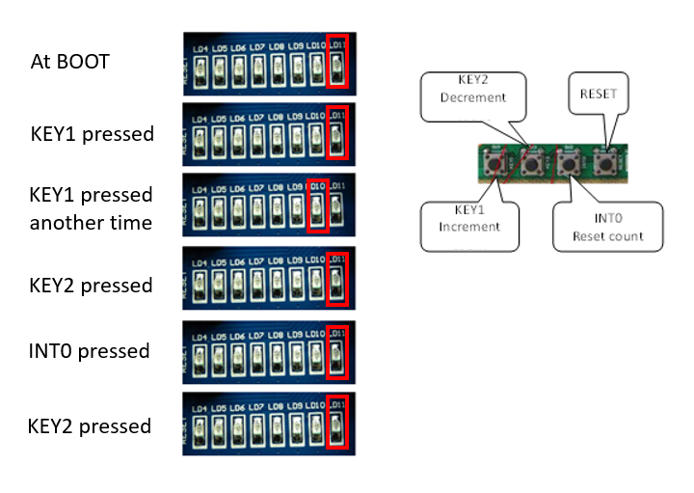

**HINT**: It could be useful to use two global variables to keep track of the information about the series. For example, you could define two unsigned integer variables called “uint8_t old_value” and “uint8_t curr_value” in the main function, to be updated by the button interrupt handler execution.

**Q1:** Do you observe on the board any behavior that unexpectedly differs from the SW emulation? Please describe.

Nell’esecuzione simulata (con bouncing disattivato) il funzionamento del programma è ideale e corretto. Quando lo si fa girare sulla scheda fisica, si osserva il problema del bouncing: non essendo presente il condensatore anti rimbalzo, quando premiamo i bottoni il segnale elettrico varia molteplici volte tra 0 e 1 (logico) e questo causa l’attivazione multipla degli interrupts, per cui risulterà che abbiamo premuto il pulsante un numero n >= 1 di volte.