ULedger’s Enterprise Blockchain Platform

ULedger has developed a cutting-edge blockchain platform that enables the creation of permanent, independent, multi-party record of any type of data, while maintaining full data privacy, at a scale necessary for enterprises of all sizes.

ULedger adds blockchain capabilities to your existing technology infrastructure. By leveraging blockchain technology to create an immutable history of data. ULedger allows the generation of a provable, tamper-proof record of your data’s content over time.

Why Blockchain?

Despite the advances in data-management technologies, enterprises are still faced with an inconvenient fact: their data is not verifiable. The ability for a user to forge, copy, delete, or modify a company’s data remains, and can be very difficult to detect. Whether accidentally or maliciously, both hackers and trustworthy employees can destroy the integrity and trustworthiness of your data history. Efforts to make business decisions, maintain compliance with government standards, or address legal challenges are therefore hindered.

*Whether your data is a document, image, contract, journal entry, email, electronic medical record, or any other type of discrete data element, its content can be verified on ULedger’s blockchain. This history of data content is mathematically provable and unchangeable, which in turn gives data greater integrity and makes it easily verifiable in the event of an audit, legal challenge, or regulatory inquiry.*

ULedger’s Blockchain Approach is Unique

Adapted for enterprise, ULedger is different from traditional blockchains in several key areas:

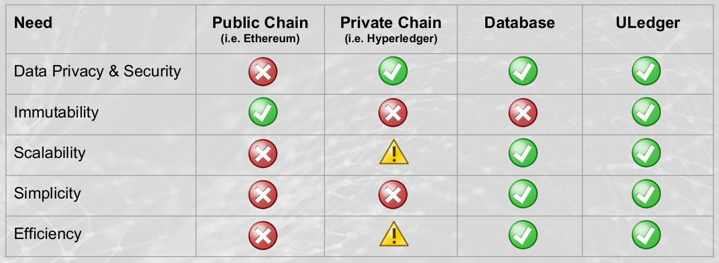

**Data Privacy and Security**. ULedger leverages a network of multiple nodes, each of which provides data-certification responses to other nodes as they build an immutable history. However, the data that is being certified does not need to be shared with other nodes. Unlike public blockchains (Bitcoin, Ethereum, etc.) where all nodes in the network maintain a complete history of all transactions, ULedger creates its audit trail using only the cryptographic signature of the data being certified.

**Immutability.** Despite keeping data private, ULedger secures independent 3rd party corroboration of the content of data transactions by means of a cryptographic hash. This is attested to by other nodes on the network. Unlike a private blockchain (HyperLedger, etc.) in which immutability cannot be guaranteed, ULedger’s network corroborates all transactions based on those cryptographic signatures. In this respect ULedger is a “hybrid” - providing the immutability of a public blockchain, and the security of a private blockchain.

**Scalability**. One advantage of the ULedger’s hybrid model is the exchange of cryptographic signatures, rather than the underlying data itself, drastically reducing the volume of data that must be shared between nodes on the network. Additionally, this model allows ULedger to operate in a “stateless” mode, meaning data transactions can be certified by nodes on the network without knowledge of the full prior history of that data. Instead, every node generates their own view of the state of the world. The nodes timestamp and verify transactions of neighboring nodes with whom they regularly interact. This is accomplished by using a process whereby each node can see evidence of its own Merkle roots in the communications it receives from other nodes. Certifications happen very quickly, without the computationally-intensive proof-of-work algorithms utilized by stateful blockchains like Bitcoin or Ethereum.

This process of cross-verifying audits not only ensures the integrity of all neighboring node audits, but also “weaves” audits together. It becomes extremely impractical to “untangle” this network of cross-audits. Through the use of what ULedger calls Cross-Merkelized Vector Clocks, certifications are independently verifiable by other nodes on the network very quickly, with minimal computational overhead.

**Ease of Integration**. ULedger has built an open-standards, REST-ful API to allow for easy integration into existing IT infrastructure. By leveraging a cloud-based instance of ULedger’s blockchain platform, and a web-service API, integrations can be completed in a fraction of the time required for a typical enterprise installation. (On-premise options are also available.)

**Relative Ordering of Events**. All other blockchain technologies operate in a “timestamping” model, where the network certification of transactions is accompanied by a timestamp, which then allows the audit trail to know the order in which events occurred. ULedger technology allows nodes to agree on the relative ordering of events regardless of the absolute time of each node on the network.

### Advantages of ULedger’s Approach:

• ULedger does not necessarily need access to the underlying data

• Compatibility with all blockchain platforms and apps

• Highly Scalable

• Dynamic reporting of Blockchain proof

• Data tied to the source of the creator or editor

• Easy integration

• Privacy & security advantages – data not universally shared

• Participants do not need to trust ULedger since the proof is mathematical

• Extends to regulatory uses cases

• Extendable to any data format and file size

• Stateless blockchain approach

• Possibility for encryption at rest

• Approval from other parties is not needed

To learn more and to find out how to leverage ULedger in your environment, contact us at:

[info@uledger.co](mailto:info@uledger.co)

208-954-6874