System Interfaces

According to the presence of different actors (as said in point xxx), the system has several kind of interface, each one dedicated to specific actor.

User-Interfaces

The user has the possibility to access the system in two ways: via mobile app or via web app.

Each one has the same features, only the design template change.

HOMEPAGE for a guest (not logged in)

If a customer access to website or open the mobile app, he can do login or sign up, by default sign-up option is enabled. He can also registered via Facebook.

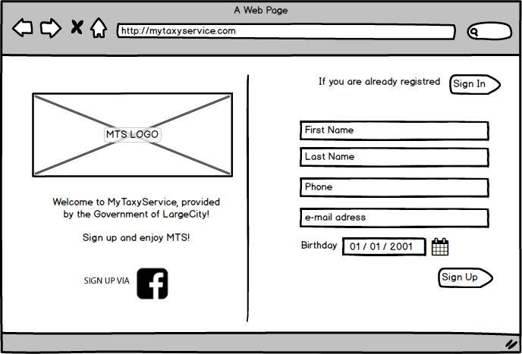 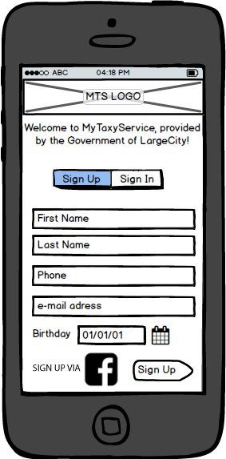

LOGIN page

If the customer is already registered, he can do login. If he is registered via Facebook he has to do login via Facebook too.

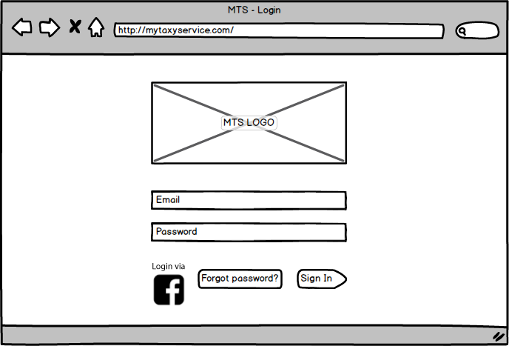 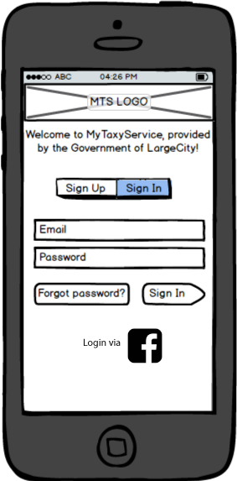

HOMEPAGE for authenticated user

After the login, a user can choose between two services, call taxi now or schedule a ride. He also opens the delete scheduled reservation page and the chronology of his travels.

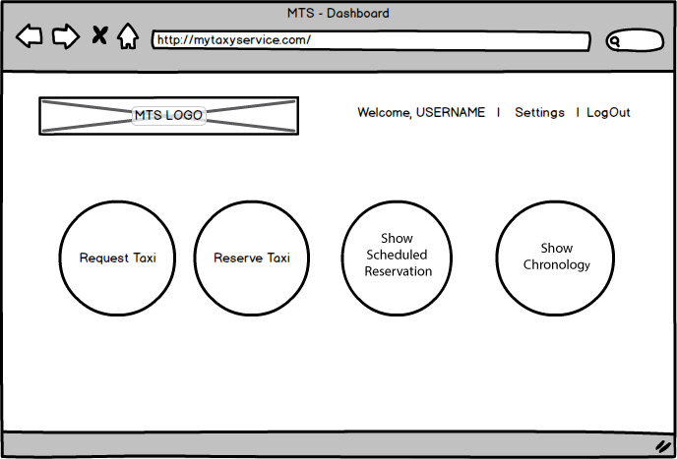 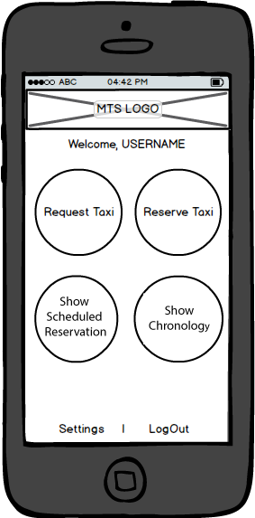

TAXI REQUEST page

If a user chooses the “request taxi” option, he has to entry the address where taxi will waiting for him.

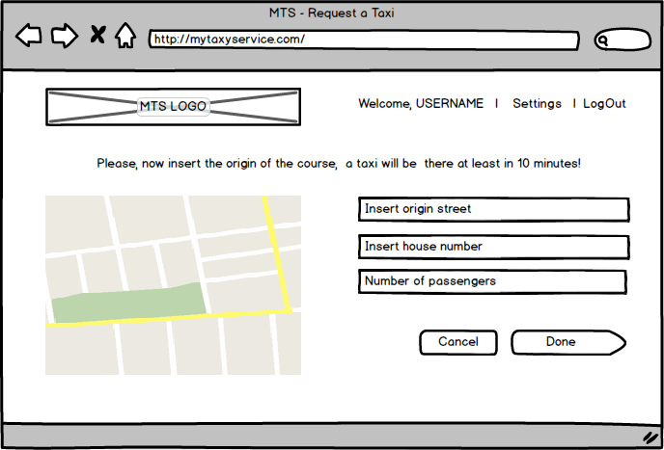 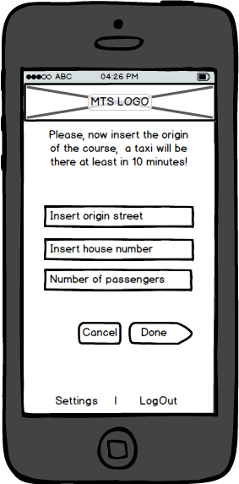

TAXI RESERVATION page

If a user chooses the “make a reservation” option he has to entry the origin and destination addresses where taxi has to bring him, the number of passengers and the start time.

He can choose the “sharing option”, by default it is disabled.

If the customer switches “sharing option” on, the system automatically computes sharing course and the customer hasn’t to do anything.

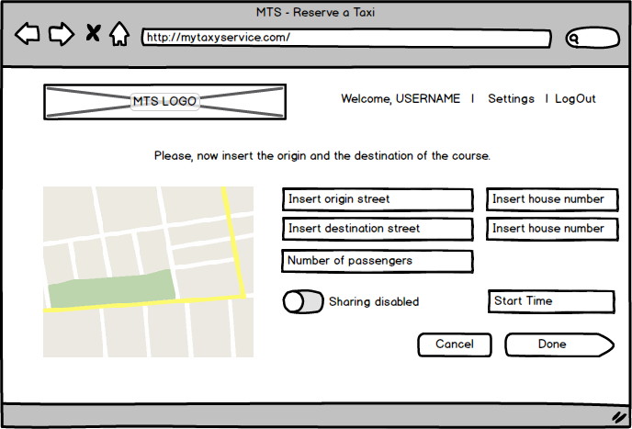 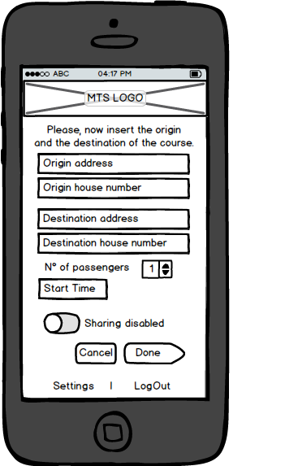

ERROR page

When customer insert addresses that are not registered in system, a message will notify that. 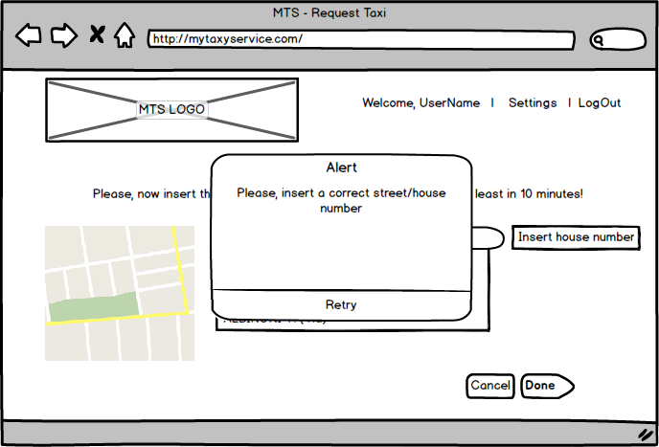 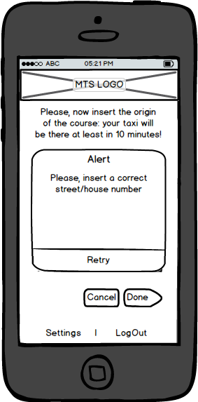

CONFIRMATION screen

After submission of the request, the system shows the confermation alert.

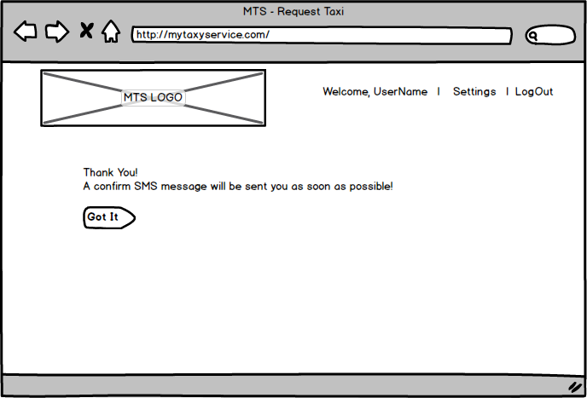 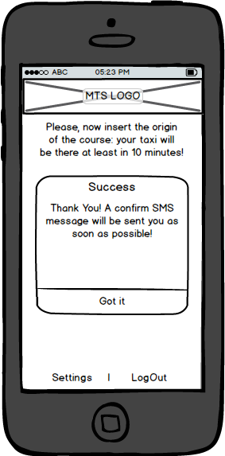

Taxi-driver interfaces

Taxi drivers has all-in-one touch-screen device that allows to access the system. It has the below interfaces.

LOGIN page

When a taxi driver switch on the device, he system asks to log in, using his credentials.

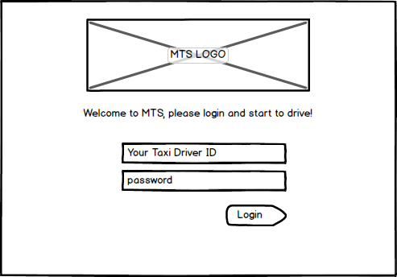

ONLINE/OFFLINE page

After the login, the driver has to switch on the “online” button. In this way, the system can assign him some course

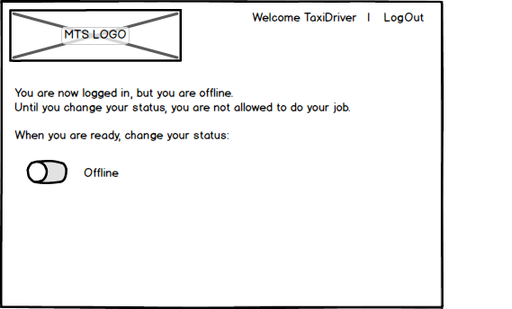

WAIT-FOR-A-CALL page

Until a customer makes a request, a waiting-for screen appears on the device.

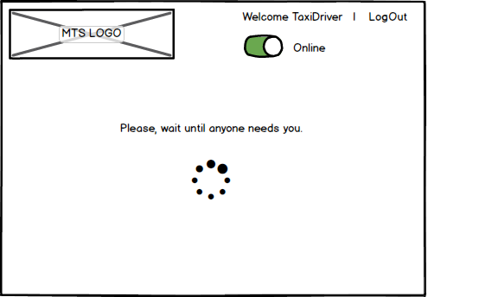

ACCEPTANCE SCREEN

When a customer makes a request, system asks to taxi driver if he want to accept that.

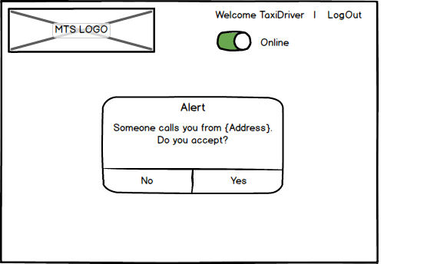

MAP ROUTE to the passenger page (REQUEST TAXI CASE)

When taxi driver accepts the request, on the device appears the map with the indications of the start place. When the driver arrives at the origin place and he finds the passenger he tap the start button, otherwise if there isn’it passenger he taps the report button.

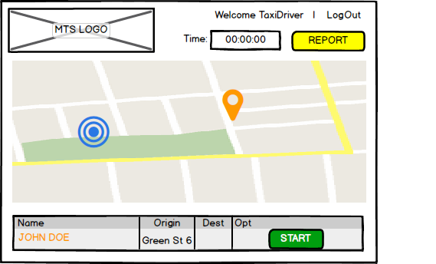

INSERT DESTINATION PAGE (REQUEST TAXI CASE)

If the call is for a request then after the start button is pressed system asks to driver to insert the destination.

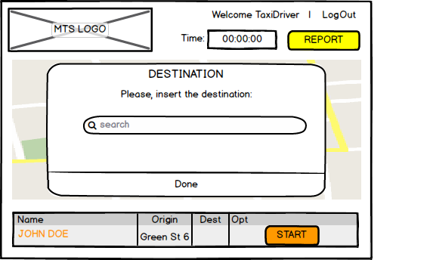

MAP ROUTE page

After the tap of start button, on the screen appears the map of the route. When taxi arrives at destination, the driver taps the finish button. This screen is also shown immediately after the acceptance alert if the call is for a reservation, because the system already know the destination.

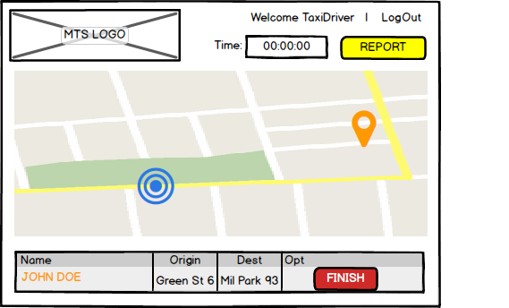

MAP page (SHARING CASE)

When arrives a sharing call, after the acceptance, on the screen appears the map and the list of user. When taxi takes on board one user, driver has to tap the start button. When a user is arrived on destination driver has to tap the finish button.

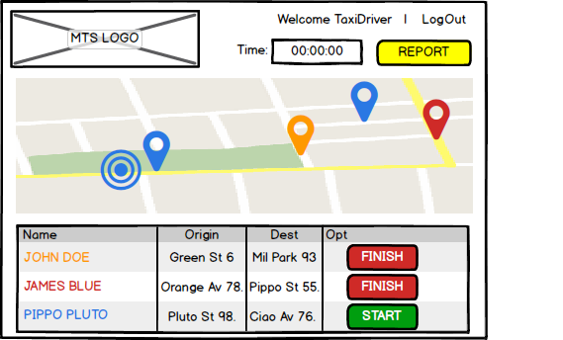

END OF COURSE page

When the taxi driver tap the finish button system shows him the total time and price.

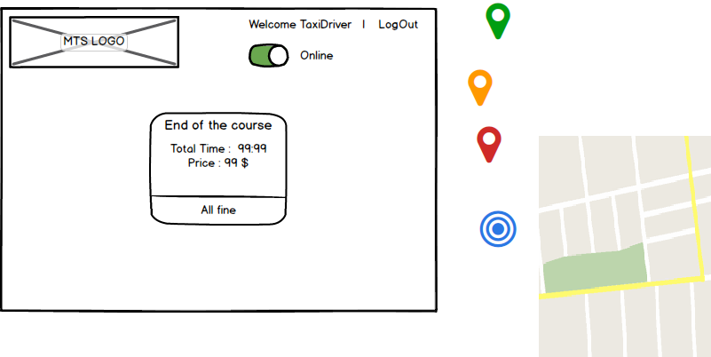

COME BACK page

After the payment (when driver taps All Fine button), system shows to driver the map of the new destination of the waiting-place. When the driver arrives at destination he tap the ready button and the waiting for a call page appears.

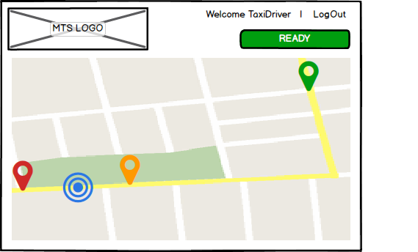

Administration interfaces

The admin of the system has the possibility to see in real time the distribution of taxi on the town.

MAIN-SCREEN

There is the map of the town and system shows the position of each taxi that are logged in.

The System shows the list of all taxi online, listed by zone with relative status, and the button for having the info of current ride and position.

There is also links to the list of real-time course, the scheduled ones and for the past ones

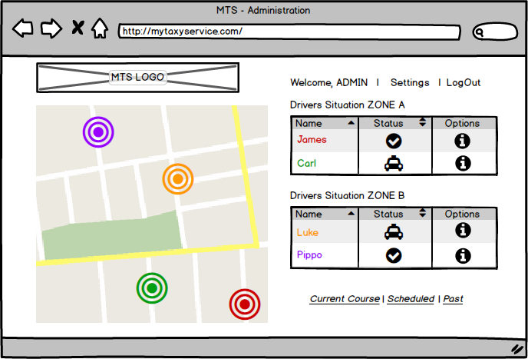

SETTING PAGE

Here the admin is allow to change some parameters used by the system.

