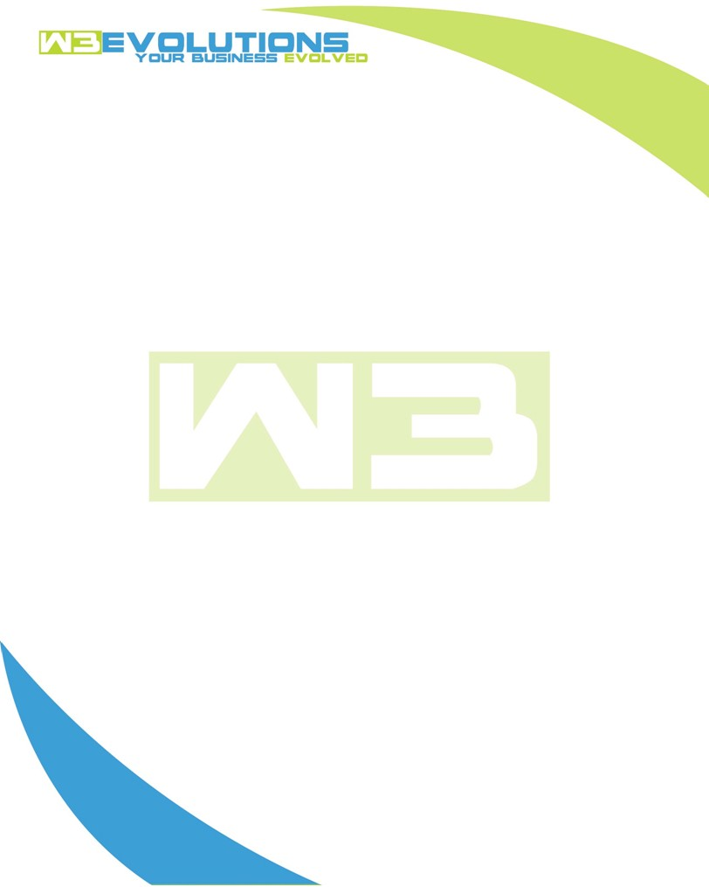

INVOICE

|  |  |
| --- | --- |
| **Bill To:** National Exemption Service, LLC  604 Packard Ct  Safety Harbor, FL 34695 | Invoice No.: NES01-5451  Customer ID: NES01 |

|  |  |  |  |  |  |  |
| --- | --- | --- | --- | --- | --- | --- |
| Date | Invoice No. | Sales Rep. | Ship Via | Terms | Date Due |  |
| 04/17/2023 | NES01-5451 | Brandon Kozak | Email | DOD | DOD |  |

|  |  |  |  |  |  |  |
| --- | --- | --- | --- | --- | --- | --- |
| Quantity | Item | Description | Discount | Taxable | Unit Price | Total |
| 8 | Software  Development | Discovery for AIDA repairs and improvements | $49 / hr  off $175 / hr | No | $126 | $1008.00 |
| 7 | Environment setup | Create github branches, set up nginx configuration, aida configuration on development server | $49 / hr  off $175 / hr | No | $126 | $882.00 |
| 10 | Software  Development | Processor status fields, New Billing Fields for management co and processor only | $49 / hr  off $175 / hr | No | $126 | $1260.00 |
|  |  |  |  |  |  |  |
|  |  |  |  |  |  |  |
|  |  |  |  |  |  |  |
|  |  |  |  |  |  |  |
|  |  |  |  |  |  |  |
|  |  |  |  |  |  |  |
|  |  |  |  |  |  |  |
|  |  |  |  |  |  |  |

|  |  |
| --- | --- |
| Subtotal: | $3,150.00 |
| Tax: | 0.00 |
| Balance Due: | $3,150.00 |

**Please make all checks payable to:** W3Evolutions LLC

**Please send checks to:** 4826 TROYDALE RD TAMPA, FL 33615

**Zelle**: chase.zelle[@w3evolutions.com](mailto:brandon@w3evolutions.com)

Additional forms of payment available upon request.