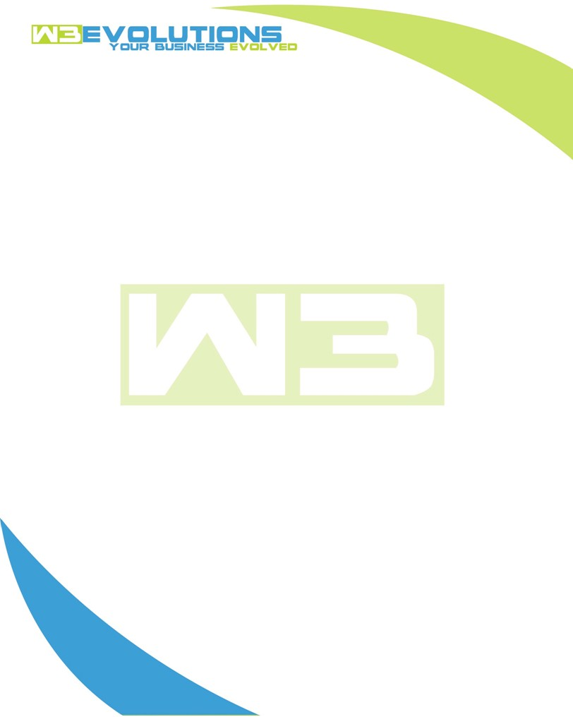

INVOICE

|  |  |
| --- | --- |
| **Bill To:** National Exemption Service, LLC 604 Packard Ct  Safety Harbor, FL 34695 | Invoice No.: NES01-5452  Customer ID: NES01 |

|  |  |  |  |  |  |  |
| --- | --- | --- | --- | --- | --- | --- |
| Date | Invoice No. | Sales Rep. | Ship Via | Terms | Date Due |  |
| 04/28/2023 | NES01-5452 | Brandon Kozak | Email | NET 30 | - |  |

|  |  |  |  |  |  |  |
| --- | --- | --- | --- | --- | --- | --- |
| Quantity | Item | Description | Discount | Taxable | Unit Price | Total |
| 9 | Software  Development | Discovery for AIDA repairs and improvements | $49 / hr off $175 / hr | No | $126 | $1,134.00 |
| 12 | Environment setup | Create GitHub branches merge with updated code from Peter | $49 / hr off $175 / hr | No | $126 | $1,512.00 |
| 7 | Software  Development | Billing screen R&D | $49 / hr off $175 / hr | No | $126 | $882.00 |
| 15 | Production Release | Syncing Production server with GitHub repository | $49 / hr off $175 / hr | No | $126 | $1,890.00 |
| 12 | Environment setup | Disabling outbound communications on the development server | $49 / hr off $175 / hr | No | $126 | $1,512.00 |
| 4 | Software  Development | Rent Manager API communications | $49 / hr off $175 / hr | No | $126 | $504.00 |

|  |  |
| --- | --- |
| Subtotal: | $7,434.00 |
| Tax: | 0.00 |
| Balance Due: | $7,434.00 |

**Please make all checks payable to:** W3Evolutions LLC **Please send checks to:** 4826 Troydale Rd Tampa FL 33615 **Zelle**: chase.zelle[@w3evolutions.com](mailto:brandon@w3evolutions.com)